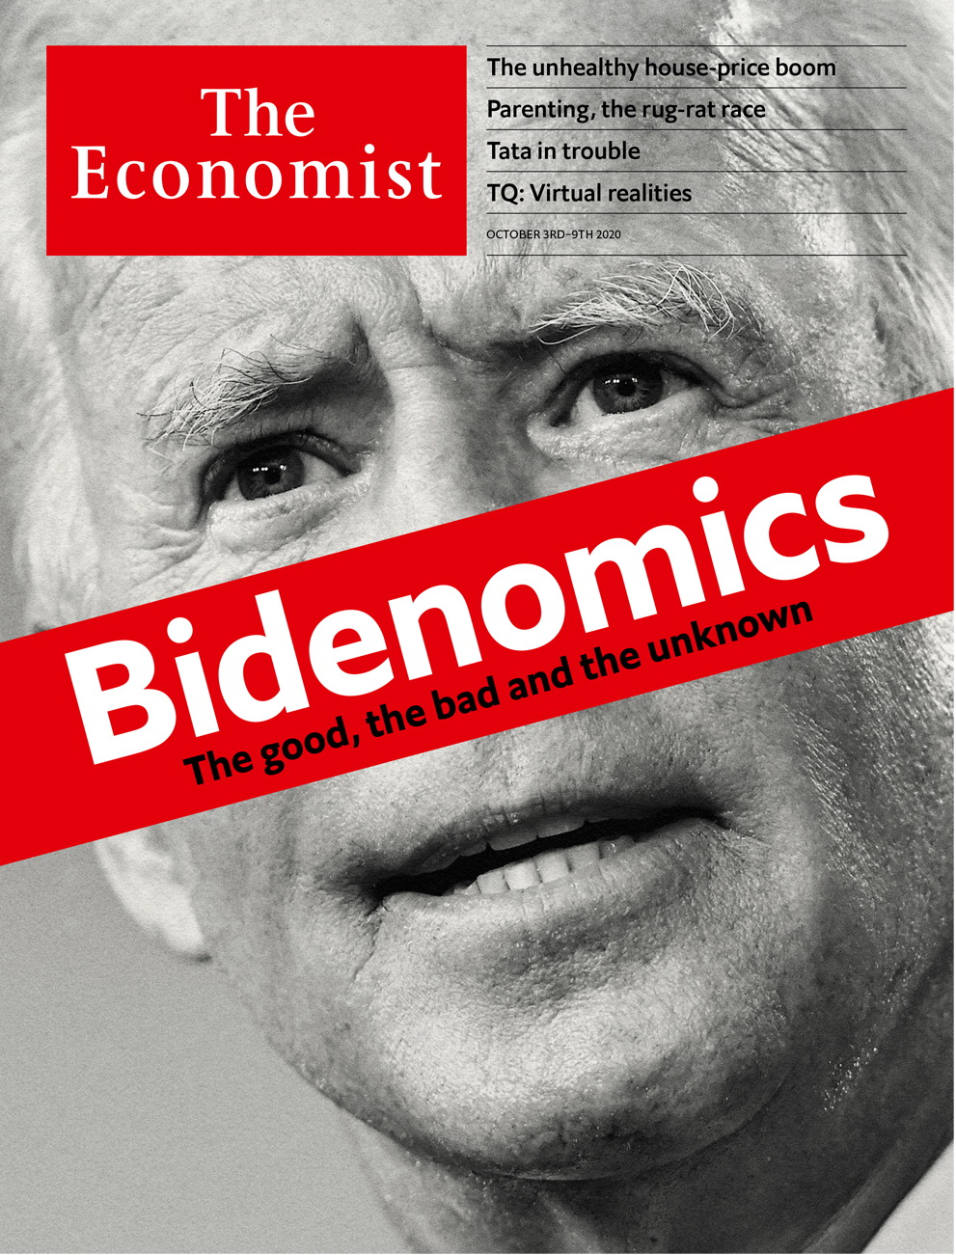

# Table of Contents

The world this week

Politics this week

Business this week

KAL’s cartoon

Leaders

America’s election: Bidenomics

Global housing: The house party returns

Famine in Yemen: An avoidable tragedy

Germany: Growing up at last

China’s countryside: Mass destruction

Letters

On working from home, land reform, scientific management: Letters to the editor

Briefing

Joe Biden’s economic plans: The pragmatist

United States

Florida and the election: Key largo

Supreme Court and the election: Not so fast

Election troubles: Rashomon, with ballots

Measuring poverty: And the poor get poorer

Catholic priests and politics: Render unto Caesar

Lexington: The end of the debate

The Americas

Canada: Justin’s timing

Mexico: Tabascan onomastics

Peru: Patient, don’t heal thyself

Bello: The missing local links

Asia

The coronavirus in South Asia: India v Pakistan v covid-19

Natural resources in Uzbekistan: Colourless, odourless, buyerless

Elections in New Zealand: Jacindarella

Investing in Myanmar: No time for details

Banyan: Always the man of the future

China

Consolidating villages: On Harmony Road

Betel nuts: Hard to crack

Chaguan: When China fought America

Middle East & Africa

Competition law: No contest

Somaliland and Taiwan: Outcasts united

Kuwait: A king of co-operation

Yemen: Unsafe Safer

Iraq and covid-19: Out of control

Europe

Reunified Germany, 30 years on: Waking Europe’s sleeping giant

Armenia and Azerbaijan: The cauldron bubbles again

Hungary: Taking on Viktor Orban

Spain: Dancing with death

Pop music: The Albanian all-stars

Charlemagne: The revenge of strategic yogurt

Britain

Race: Not black and white

Cars in the capital: Road warriors

Covid-19 in universities: Freshers’ covid

Skills: How the other half learns

Lithium: Wheels within wheals

Scotland: In their sights

Bagehot: We shall fight them on the airwaves

International

Parenting: The rugrat race

Technology Quarterly

Virtual realities: Reaching into other worlds

Simulation: Reality bytes

Hardware: The promise and the reality

Health care: Getting better

Brain scan: Lord of the Metaverse

The future: What is real, anyway?

Business

Tata Sons: Endangered species

Epic v Apple: Storing up trouble

Fracking: Shelling out on shale’s sale

A luxury tiff: Letting go lightly

Measuring sustainability: In the soup

Bartleby: Why we need to laugh at work

Schumpeter: All the president’s moolah

Finance & economics

Global housing markets: The three pillars

Evergrande: Not forever grand

Digital payments: If you can’t bill them

Investment banking: Spoof proof

Employment in Germany: Nature v nurture

Investment in India: Sticking plaster

Buttonwood: Gifts that keep giving

Free exchange: Marching bans

Science & technology

Hybrids and evolution: Match and mix

Books & arts

Mexico’s chroniclers: The other half of history

The CIA and the cold war: Original sins

Geography and imagination: Water all around

Japanese fiction: I don’t belong here

Johnson: Justice and just slips

Economic & financial indicators

Economic data, commodities and markets

Graphic detail

Wealth and schooling: A rising tide

Obituary

Harold Evans: Attacking the devil



### Friday, October 2, 2020

|  |  |
| --- | --- |
| The world this week | 3 |
| Leaders | 5 |
| Letters | 1 |
| Briefing | 1 |
| United States | 6 |
| The Americas | 4 |
| Asia | 5 |
| China | 3 |
| Middle East & Africa | 5 |
| Europe | 6 |
| Britain | 7 |
| International | 1 |
| Technology Quarterly | 6 |
| Business | 7 |
| Finance & economics | 8 |
| Science & technology | 1 |
| Books & arts | 5 |
| Economic & financial indicators | 1 |
| Graphic detail | 1 |
| Obituary | 1 |

|  |  |  |
| --- | --- | --- |
|  | Sections | Leaders |

The world this week

Politics this week

.

Business this week

.

KAL’s cartoon

.

|  |  |  |
| --- | --- | --- |
|  | Sections | Leaders |

|  |  |  |  |
| --- | --- | --- | --- |
|  | Articles | Sections | Next |

# Politics this week

Oct 3rd 2020 |

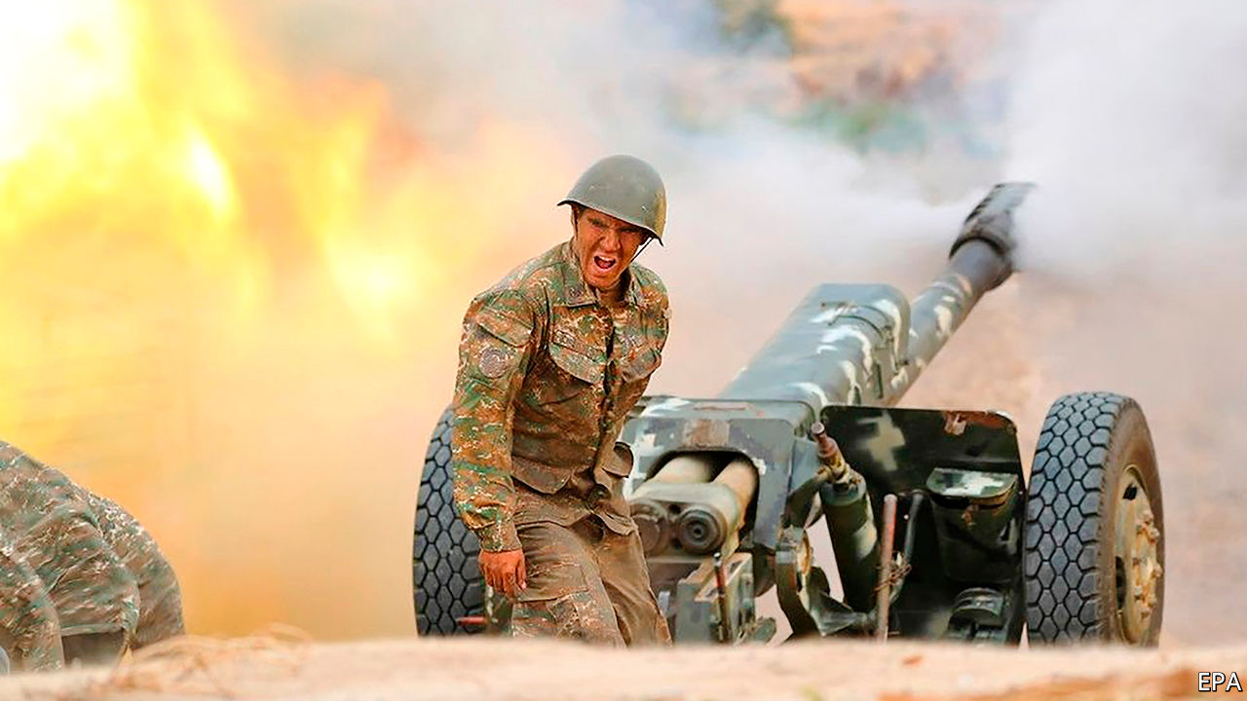

Fighting erupted in and around Nagorno-Karabakh, a disputed enclave inside Azerbaijan, mostly populated by ethnic Armenians and backed by Armenia. More than 100 people, mostly soldiers, are thought to have been killed. Turkey’s president, Recep Tayyip Erdogan, Azerbaijan’s main supporter, urged his fellow Muslims to wrest back control of the area, whose inhabitants are largely Christian. The fighting was the worst since a ceasefire in 1994. The two countries, which were both subjugated by the Red Army in the 1920s, fought each other after the Soviet Union collapsed. See [article](https://www.economist.com/node/21792362).

On a trip to Lithuania France’s president, Emmanuel Macron, visited an exiled opposition leader, Svetlana Tikhanovskaya, who many people believe won the recent presidential election in Belarus. Alexander Lukashenko, the Belarusian dictator who rigged the vote, seems determined to stay in power despite huge protests at home and gestures like Mr Macron’s.

El Salvador’s president, Nayib Bukele, announced an inquiry into whether El Faro, a digital newspaper, had engaged in money-laundering. El Faro recently reported that Mr Bukele’s government secretly asked imprisoned leaders of MS-13, a big criminal gang, to reduce violence in exchange for privileges.

Protests broke out across Venezuela against power cuts and shortages of fuel and water. Among the demonstrators were teachers demanding higher pay and patients wanting better conditions in hospitals. Security forces fired rubber bullets and tear gas.

West Africa’s regional bloc, ECOWAS, said sanctions will remain in place against Mali until the leaders of a coup hand power to a civilian administration. The appointment as president of Bah Ndaw, a retired colonel, does not satisfy this demand, it said.

Doctors and others working for the World Health Organisation and aid agencies fighting an Ebola outbreak in Congo were accused of sexually exploiting local women. Allegations include rape and demanding sex from job applicants.

A French court agreed to extradite Félicien Kabuga, a Rwandan businessman, to face trial in Tanzania on charges that he financed militias that carried out the genocide in Rwanda in 1994.

Lebanon’s prime minister-designate, Mustapha Adib, failed to form a government. He had reportedly met resistance from Shia parties who want to control the finance ministry.

The emir of Kuwait, Sheikh Sabah al-Sabah, died after a long illness. He was 91. His 83-year-old half-brother, Nawaf al-Sabah, has been named as his successor. See [article](https://www.economist.com/node/21792380).

Israel’s parliament gave the government the power to ban mass protests, one of a range of measures aimed at curbing the spread of covid-19. Critics accused the prime minister, Binyamin Netanyahu, of trying to silence critics who have called on him to resign over his handling of the pandemic and alleged corruption.

The Australian Strategic Policy Institute, a think-tank, said it had identified 380 suspected detention centres for ethnic Uighurs in China’s Xinjiangregion,about 40% more than previous estimates. It found that building work had been taking place in dozens of them over the past two years, despite official claims that all internees had “graduated” by 2019.

Amnesty International, a human-rights watchdog, shut its offices in India, complaining that the government had made its work impossible by closing its bank accounts, among other things.

Police in Pakistan arrested Shehbaz Sharif, the titular leader of the main opposition party and brother of its actual leader, Nawaz Sharif, who is in exile in London. A court had revoked Mr Sharif’s bail on corruption charges. A former president, Asif Zardari, was indicted for corruption in a separate case. The two politicians say the charges are politically motivated.

North Korea unexpectedly apologised for the killing of a South Korean fisheries official intercepted at sea by a North Korean patrol. The victim was shot and his body burned, in an apparent effort to prevent the spread of covid-19. Kim Jong Un, the North’s dictator, said he was “deeply sorry”.

Amy Coney Barrett, Donald Trump’s pick to fill the vacancy on the Supreme Court left by the death of Ruth Bader Ginsburg, met Republican leaders in the Senate, who hope to confirm her in the job before the election. A devout Catholic, Ms Barrett has said that abortion is immoral, but also that Catholic judges should not try to align the legal system with their faith. See article.

“He’s a liar.” “You’re the liar.” “Will you shut up, man.” Joe Biden and Donald Trump sparred in the first presidential debate. The atmosphere was unedifying. The rules may be changed for the two remaining debates, to make it harder for candidates to interrupt each other. See [article](https://www.economist.com/node/21792394).

## Coronavirus briefs

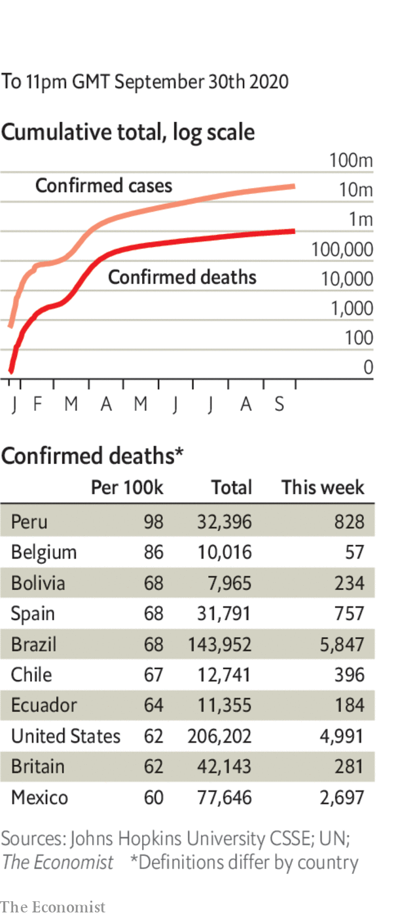

The number of people worldwide who have died from covid-19 officially passed 1m. The true figure is much higher.

The WHO announced a plan to provide 120m testing kits to poorer countries. The kits cost $5 and can provide a result in 15-30 minutes.

Russia reported its most daily infections since June.

Kenya’s national curfew will last another two months, though it won’t start now until 11pm. Bars can start reopening, but schools remain closed.

Authorities in Brussels announced a ban on prostitution to limit the spread of covid-19.

Hopes that the world’s longest- running play, “The Mousetrap”, could reopen soon were dashed. Agatha Christie’s classic whodunnit had run continuously in London’s West End since 1952, until covid-19 closed theatres in March.

This article was downloaded by calibre from <https://www.economist.com/the-world-this-week/2020/10/03/politics-this-week>

|  |  |  |  |
| --- | --- | --- | --- |
|  | Articles | Sections | Next |

|  |  |  |  |
| --- | --- | --- | --- |
| Previous | Articles | Sections | Next |

# Business this week

Oct 3rd 2020 |



Disney decided to lay off 28,000 workers at its theme parks. Last year the parks accounted for more than a third of Disney’s profit, income that vanished when they were ordered to close during the pandemic. Those that have reopened have seen visitor numbers plummet because of social distancing. Disney’s parks in California remain shut, which one executive said had “exacerbated” the situation. Most of the jobs being shed are part-time.

Shell said it would cut 9,000 jobs, more pain for an oil industry beset by falling demand and low prices. bp’s share price dropped to a 25-year low, evidence that it is finding it hard to convince investors that its ambitious switch to low-carbon energy will be profitable.

LVMH filed a lawsuit arguing that it was walking away from the deal it struck last November to take over Tiffany because the American jeweller’s performance has been disastrous during the pandemic and its prospects are poor. Tiffany wants the French luxury-goods company to complete the $17bn agreement. See article.

A judge granted TikTok a reprieve from a ban by the American government, hours before it was due to be imposed. Donald Trump had ordered a halt to downloads of the Chinese-owned video-sharing app. But the judge found that the act from the 1970s on which the president based his order does not cover “informational materials”, including film, photographs or artwork. TikTok argued that 100m Americans use its platform to share those very materials.

Democrats in America’s House of Representatives unveiled a revised pandemic stimulus package with a lower price tag of $2.2trn, around $1trn less than the bill they presented in May that Republicans deemed too costly. Most of the savings in the new bill come from reductions in aid to state and local governments.

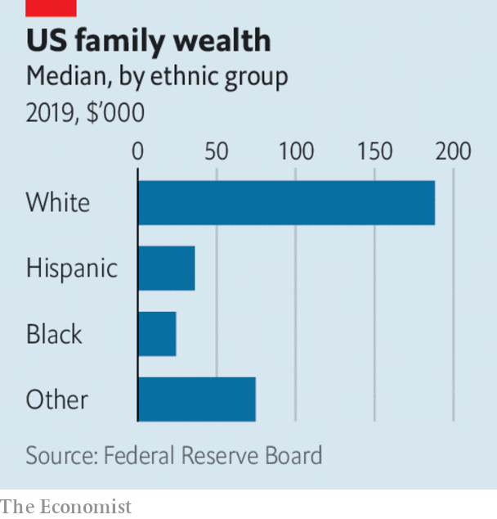

Despite the gains of past decades, the median wealth of black families in America was still some 85% below that of white families last year, according to the Federal Reserve’s Survey of Consumer Finances. Conducted every three years, the survey listed the factors, such as intergenerational transfers and homeownership, that explain the gap. The median wealth of black households has risen by 33% in real terms since 2016 (and by 65% for Hispanic ones), compared with 3% for white families. But that cannot make up for the loss of wealth during the recession a decade ago, which hit blacks and Hispanics the hardest.

Palantir Technologies, a secretive software provider founded in the aftermath of the 9/11 terrorist attacks of 2001, floated its shares in New York. A highly complex shareholder structure means its three founders—Peter Thiel, Alex Karp and Stephen Cohen—will retain control.

## The penalty is no spoof

American authorities slapped JPMorgan Chase with a $920m fine for placing hundreds of thousands of spoof orders in precious metals and other contracts on three exchanges. Spoofing is the illegal practice of placing and cancelling orders rapidly in order to fool markets about the demand for an asset. The fine is the largest ever for such a tactic. See [article](https://www.economist.com/node/21792381).

NTT, Japan’s legacy telecoms company, announced a deal to buy the remaining shares it does not own in NTT DoCoMo, the country’s biggest mobile operator, for ¥4.3trn ($41bn). The company dismissed reports that the takeover is linked to pressure from the new prime minister, Suga Yoshihide, to lower phone charges, but said there “will be room to cut the fees”.

The Tokyo stock exchange suspended trading for at least a day because of a glitch in its system for communicating market information. It was the worst disruption the Japanese bourse has experienced since going fully electronic in 1999.

Ramping up its ambition to overtake Tesla as the world’s premier maker of electric cars, Volkswagen said it was investing €15bn ($17bn) on “e-mobility” in China with its three Chinese joint-ventures.

Caesars Entertainment, which owns casinos and hotels in Las Vegas, took a bet on expanding its sports-gambling ventures when it agreed to buy William Hill for £2.9bn ($3.7bn). Listed in London, William Hill’s business has grown rapidly in America as states loosened some restrictions on gambling; its British and other European operations are to be sold off by Caesars.

## The streets of London

Uber can continue operating in London, after a judge upheld its appeal against the suspension of its licence last year by the city’s transport authority, the latest battle in a long-running saga between the ride-hailing giant and the regulator. The new licence is valid for 18 months. London is a very different place since the outbreak of covid-19 and its famous black cabs have struggled because of absent customers. Uber drivers may be roaming the streets of the capital, but their passengers are not.

This article was downloaded by calibre from <https://www.economist.com/the-world-this-week/2020/10/03/business-this-week>

|  |  |  |  |
| --- | --- | --- | --- |
| Previous | Articles | Sections | Next |

|  |  |  |  |
| --- | --- | --- | --- |
| Previous | Articles | Sections | Next |

# KAL’s cartoon

Oct 3rd 2020 |

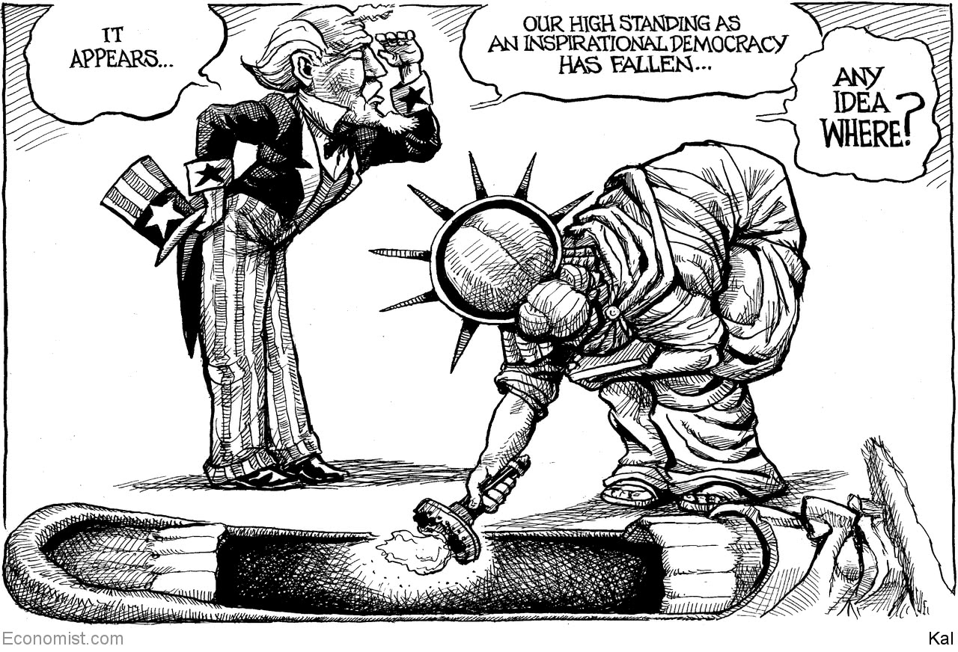

This article was downloaded by calibre from <https://www.economist.com/the-world-this-week/2020/10/03/kals-cartoon>

|  |  |  |  |
| --- | --- | --- | --- |
| Previous | Articles | Sections | Next |

|  |  |  |
| --- | --- | --- |
| The world this week | Sections | Letters |

Leaders

America’s election: Bidenomics

.

Global housing: The house party returns

.

Famine in Yemen: An avoidable tragedy

.

Germany: Growing up at last

.

China’s countryside: Mass destruction

.

|  |  |  |
| --- | --- | --- |
| The world this week | Sections | Letters |

|  |  |  |  |
| --- | --- | --- | --- |
|  | Articles | Sections | Next |

#### America’s election

# Bidenomics: the good the bad and the unknown

Joe Biden should be more decisive and ambitious about America’s economy

Oct 3rd 2020 |

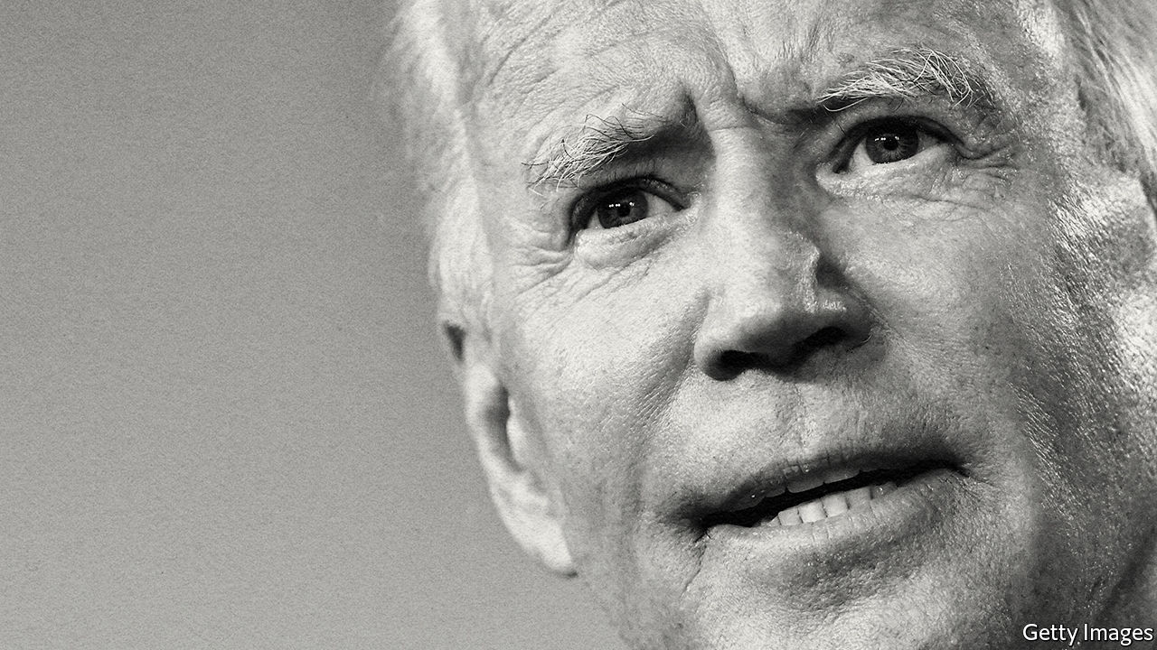

THE TWO presidential contenders squared up this week in the first debate before America votes on November 3rd. President Donald Trump set out to make it a brawl, even throwing a punch at the validity of the electoral process itself (see article). Joe Biden spent the evening jabbing at Mr Trump for bringing the country to its knees. And the president went for what he hoped would be a knockout blow, accusing his opponent of being a weak man who would succumb to the left’s plans to dramatically expand government and cripple business.

Fear of just such a leftward lurch under Mr Biden is circulating among some American business leaders. However, as we explain (see article), the charge is wide of the mark. Mr Biden has rejected the Utopian ideas of the left. His tax and spending proposals are reasonable. They imply only a modestly bigger state and attempt to deal with genuine problems facing America, including shoddy infrastructure, climate change and the travails of small business. In fact, the flaw in Mr Biden’s plans is that in some areas they are not far-reaching enough.

When Mr Trump took power in 2017 he hoped to unleash the animal spirits of business by offering bosses a hotline to the Oval Office and slashing red tape and taxes. Before covid-19, bits of this plan were working, helped by loose policy at the Federal Reserve. Small-business confidence was near a 30-year high; stocks were on a tear and the wages of the poorest quartile of workers were growing by 4.7% a year, the fastest since 2008. Voters rank the economy as a priority and, were it not for the virus that record may have been enough to re-elect him.

Yet, partly owing to the pandemic, Mr Trump’s shortcomings have also become clear. Long-term problems have festered, including crumbling infrastructure and a patchy social safety-net. The underlying dynamism of business remains weak. Investment is muted and fewer firms have been created even as big ones gain clout. Mr Trump’s chaotic style, involving the public shaming of firms and attacks on the rule of law, is a tax on growth. Deregulation has turned into a careless bonfire of rules. The confrontation with China has yielded few concessions, while destabilising the global trading system.

As the 46th president, Mr Biden would alleviate some of these problems simply by being a competent administrator who believes in institutions, heeds advice and cares about outcomes. Those qualities will be needed in 2021, as perhaps 5m face long-term unemployment and many small firms confront bankruptcy. Mr Biden’s economic priority would be to pass a huge “recovery” bill, worth perhaps $2trn-3trn, depending on whether a stimulus plan passes Congress before the election. This would include short-term money, boosting unemployment insurance and help for state and local governments, which face a budget hole. Mr Biden would also extend grants or loans to small businesses which have not received as much aid as big firms. He would ease tensions with China, soothing the markets. And if a vaccine arrives, his co-operative rather than transactional approach to foreign relations would make its global distribution easier and allow borders to reopen and trade to recover faster.

The recovery bill would also aim to “build back better” by focusing on some long-term problems for America that have also been Biden priorities for many years. He is keen on a giant, climate-friendly infrastructure boom to correct decades of underinvestment: the average American bridge is 43 years old. Government research and development (R&D) has dropped from over 1.5% of GDP in 1960 to 0.7% today, just as China is mounting a serious challenge to American science. Mr Biden would reverse that, too, with more R&D in tech and renewable energy. He would scrap Mr Trump’s harsh restrictions on immigration, which are a threat to American competitiveness. And he wants to raise middle-class living standards and social mobility. That means more spending on education, health care and housing and a $15 minimum wage, helping 17m workers who earn less than that today.

This is hardly the agenda of a socialist. Mr Biden has ignored the Panglossian fantasies of the left, including Medicare For All, a ban on nuclear energy and guaranteed jobs. His plans are moderate in size as well as scope, adding up to an annual increase in public spending of 3% of GDP, assuming they could all pass the Senate. That compares with 16-23% for those of Elizabeth Warren and Bernie Sanders. He would raise taxes to pay for about half of the spending that is approved, with higher levies on firms and the rich. Even if all of his tax plan were enacted, which is highly unlikely, studies suggest corporate profits after tax might drop by up to 12% and the income of the top 1% of earners by up to 14%. If you are rich that would be an irritant, but not a catastrophe.

The real risk of Bidenomics is that his pragmatism will lead him to be insufficiently bold. Sometimes he fails to resolve competing objectives. For example, he rightly supports ladders for social mobility as well as a better safety-net for workers who lose their jobs; his plans range from more affordable housing to free public universities. But equipped with these safety buffers, he should be willing to welcome more creative destruction so as to raise long-run living standards. Instead Mr Biden’s instinct is to protect firms, and he has too little to say on boosting competition, including prising open tech monopolies. Incumbent firms and insiders often exploit complex regulations as a barrier to entry. His plans are wrapped in red tape.

## Making trade alliances great again

Mr Biden’s climate policy represents real progress. Building green-power grids and charging networks makes sense because the private sector may hold back. But, again, its effect will be blunted by the rule that 40% of spending must favour disadvantaged communities and by perks for domestic suppliers: a recipe for inefficiency. His plan to cut emissions involves targets, but shies away from a carbon tax which would harness the power of capital markets to reallocate resources. That is a missed opportunity. Just last month the Business Roundtable, representing corporate America, said it supported carbon pricing.

This lack of boldness also reflects the lack of a fully developed strategy. Mr Biden has a record as a free trader, but he will not remove tariffs quickly and his plan indulges in petty protectionism by, say, insisting that goods are shipped on American vessels. That would complicate the daunting task ahead of him: to create a new framework to govern the economic relationship with China, which involves persuading America’s allies to sign up even as they flirt with protectionism, too (see article).

It is the same with fiscal policy. To his credit, Mr Biden wants to pay for some of his spending—a novelty these days. Nonetheless, by 2050 public debt is on track to hit almost 200% of GDP. There is little reason to fret now, when interest rates are near zero and the Fed is buying up government debt. But America would benefit if the next president faced up to this long-term challenge. That would mean beginning to build a harder-nosed consensus on entitlement spending and a sustainable tax base.

Mr Biden still has to win in November, so his ambiguity is understandable. But there is a risk he assumes that victory and a return to growth and competence will be sufficient to set America on the right track. If he wants to renew America’s economy and ensure it leads the rich world for decades to come, he will have to be bolder than that. On the threshold of power, he must be more ruthless about his priorities and far-reaching in his vision.■

Dig deeper:  
Read the [best of our 2020 campaign coverage](https://www.economist.com/us-election-2020) and explore our [election forecasts](https://projects.economist.com/us-2020-forecast/president), then sign up for Checks and Balance, our [weekly newsletter](https://www.economist.com/checksandbalance/) and [podcast](https://play.acast.com/podcasts/2020/01/24/checks-and-balance-our-new-weekly-podcast-on-american-politics) on American politics.

This article was downloaded by calibre from <https://www.economist.com/leaders/2020/10/03/bidenomics-the-good-the-bad-and-the-unknown>

|  |  |  |  |
| --- | --- | --- | --- |
|  | Articles | Sections | Next |

|  |  |  |  |
| --- | --- | --- | --- |
| Previous | Articles | Sections | Next |

#### The house party returns

# Booming house prices spell more trouble for the social contract

Low interest rates and changing preferences explain housing’s strength during the pandemic

Oct 3rd 2020 |

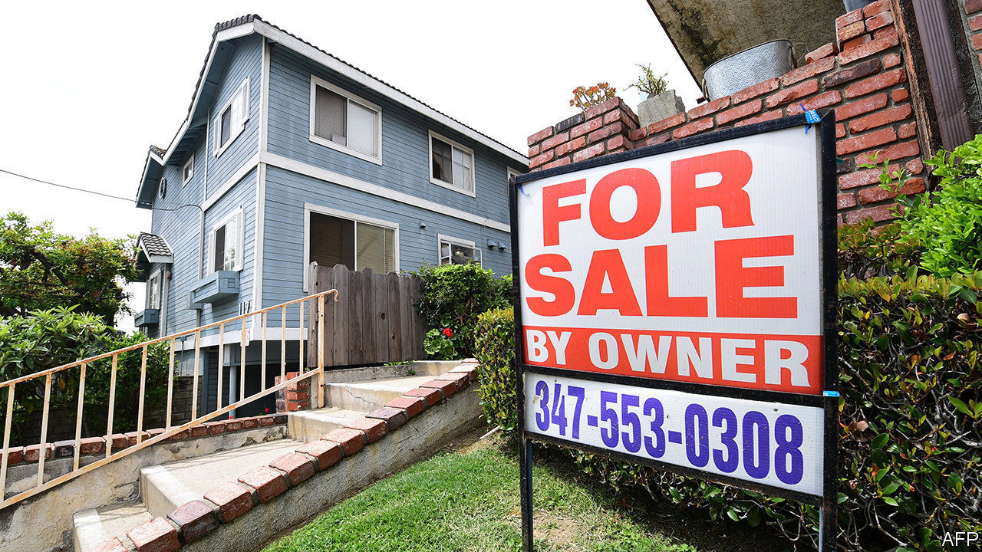

STOCKMARKETS HAVE not had a good September, but their strength for the year as a whole remains a source of wonderment. Less noticed has been the equally remarkable buoyancy of another asset class: housing. Many rich countries are seeing house prices surge even as their rate of infections is rising for a second time. In the second quarter, although economies were under lockdown, house prices rose in eight out of ten high- and middle-income countries. According to unofficial series—which are timelier though less accurate than government data—America’s house prices are up 5% on a year ago. Germany’s are 11% higher. Britain’s hit an all-time high, in nominal terms, in August. The boom shares some causes with the strength of stockmarkets, but reveals more about the pandemic’s effect on economies. It is also more consequential.

Like stocks, house prices are being supported by loose monetary policy. In the past year the rate at which Americans can obtain 30-year fixed-rate mortgages has fallen by roughly a quarter, to about 2.9%. As well as making monthly mortgage payments more affordable, low rates make houses more attractive, because they depress the returns on alternative safe investments. Other economic policies are also helping. Mass government support for household incomes, as well as mortgage-repayment holidays, have saved jobless workers from having to sell their homes, as they otherwise might. Britain has temporarily suspended stamp duty, a tax on buying houses.

The house-price boom is not just a result of policy, however. Structural forces are at work, too (see article). Job losses this year have been concentrated among low-paid service-sector workers, who are more likely to rent than buy. Professionals who have carried on working from home but cut back on their spending have accumulated cash to splash—and, with time spent at home rising, what better moment to buy a bigger pad? The unequal effects of the pandemic have allowed prices to surge even as banks have curtailed their riskiest loans. In America the share of lending going to the most creditworthy borrowers has been growing. In Britain the boom seems to be being driven by a bidding war among existing homeowners, rather than by first-time buyers who, because they are younger, are more exposed to the economic downturn.

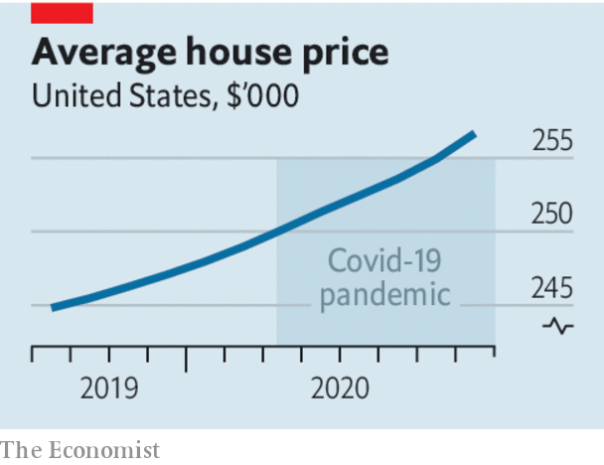

Housing is a bigger asset class than equities and its ownership is more dispersed. Booming stockmarkets lead to grumbles about the growing riches of billionaires. Pricey houses make life tangibly harder for swathes of would-be homebuyers who struggle to raise the minimum down-payment necessary to get a mortgage and join the club that can benefit from low rates. The problem is most acute in countries that see home ownership as a rite of passage. In such places high prices drive young people towards leftist populists and threaten the social contract. It is reasonable to hope that the trend towards working from home will help ease the housing shortages around the most vibrant cities, which have been most economically damaging. Yet so far this is not apparent in prices.

Perhaps the boom will cool as government support for the economy falls. However, the effect of the pandemic on long-term interest rates is unlikely to change; nor is the desire for roomier homes. Higher house prices could turn out to be an enduring legacy of covid-19. If so, in the 2020s they will deepen the intergenerational tensions that were already emerging in the 2010s. The fact that the economic costs of fighting the disease are mostly being borne by the young mostly to protect the lives of the elderly makes the problem knottier still.

In the 2010s politicians failed to get to grips with high house prices. They often responded to them by further subsidising home-buying. They should indeed cut stamp duty, which distorts the market, as much as possible. But it is futile to fight long-term price rises caused by low rates and shifts in households’ preferences. Rather, governments should cease to indulge national obsessions with owning property.

That means creating a well-regulated rental sector which offers security of tenancy, removing subsidies for owner-occupation and easing planning restrictions to the point where housing no longer looks like a magic money tree accessible only to those fortunate enough to start out with pots of cash. Taxes on property values—and ideally on land values—should also rise. Such levies are an efficient way of plugging budget shortfalls. They would also recoup some of the windfall gains that lucky homeowners have enjoyed.

To the extent that robust house-price growth represents confidence in the prospects for an economic recovery, it is welcome. But in no other context would the contrast between asset prices and the present condition of labour markets cause as much discomfort for those who are missing the party. ■

This article was downloaded by calibre from <https://www.economist.com/leaders/2020/10/03/booming-house-prices-spell-more-trouble-for-the-social-contract>

|  |  |  |  |
| --- | --- | --- | --- |
| Previous | Articles | Sections | Next |

|  |  |  |  |
| --- | --- | --- | --- |
| Previous | Articles | Sections | Next |

#### An avoidable tragedy

# Famine in Yemen need not happen

Millions of people are on the brink of starvation. Yemen’s warring parties can save them

Oct 3rd 2020 |

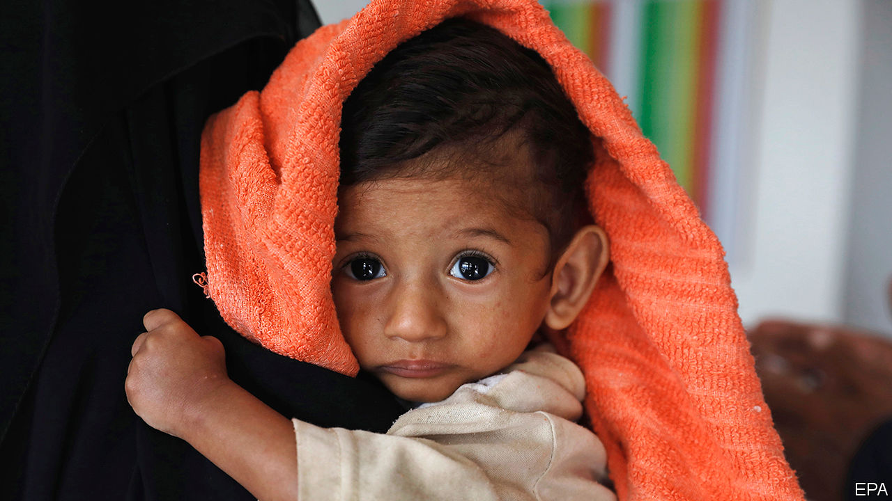

THE WAR in Yemen seems to play on an endless loop. Atrocity follows atrocity. The government is backed by a Saudi-led coalition that bombs civilians; the Houthi rebels are backed by Iran, and recruit children and fire shells indiscriminately into cities. Efforts to make peace go nowhere. A swap of 1,081 prisoners, agreed on at the end of September, raised only faint hopes. A similar exchange, involving 15,000 detainees, was arranged in 2018 but never fully implemented. The loop is unbroken.

In the past six years the conflict has killed tens of thousands of people and gravely harmed millions more. Now it is escalating again. Civilians died in August in greater numbers than in any other month this year. The economy is collapsing, covid-19 is spreading unchecked and a rusting tanker off the western coast, laden with roughly 1.1m barrels of oil, risks causing an ecological catastrophe (see [article](https://www.economist.com/node/21792385)).

Amid this litany of suffering, Yemen’s most pressing problem is famine. About two-thirds of its 30m people need food aid. Many millions, the UN says, are on the brink of starvation. It should be possible to feed them. International bodies have sounded the alarm; relief groups know what to do. The question is whether Yemen’s rich neighbours, who have sustained the fighting with arms and money, will have the decency also to sustain the country’s people with food and medicine—and whether the war’s stubborn and self-interested combatants will allow the aid to get through.

Two years ago the UN requested billions of dollars for the relief effort. It was a good time to ask. The Saudis were eager to repair their image, tarnished by the war and the killing of Jamal Khashoggi, a dissident journalist. The United Arab Emirates (UAE), which led the coalition’s ground war in Yemen until last year, was also on a publicity drive. Along with Kuwait, they both gave generously. As a result, countless lives were saved.

Lately the Saudis, Emiratis and Kuwaitis have had other priorities. Saudi Arabia hosted an international pledging conference in June, after it vowed to give $500m this year (down from $750m last year). The kingdom has since lowered its commitment to $300m—better than the UAE, which so far this year has pledged nothing. “It is particularly reprehensible to promise money, which gives people hope that help may be on the way, and then to dash those hopes by simply failing to fulfil the promise,” says Mark Lowcock, the UN’s emergency-relief co-ordinator.

The resulting decline in Yemenis receiving food aid is being aggravated by the coalition, which has cut off fuel supplies to Houthi-controlled areas. Its blockade has pushed up prices and shut down vital services for lack of fuel. Saudi Arabia deposited $2bn in Yemen’s central bank in 2018. Now it is nearly all gone and the currency is collapsing, making food, most of which is imported, even less affordable. Neither do Saudi Arabia’s alleged air strikes on farms help Yemen’s harvest.

Saudi Arabia, desperate for a face-saving way out of the war, may be turning the screws on the Houthis. Starving the north is unlikely to work. But the Houthis will not like the loss of revenue—they themselves divert aid and sell it for profit. They even tried to impose a 2% levy on aid shipments. To ensure food reaches the right people, the UN wants to introduce a biometric ID system. The Houthis, though, are loth to cede control.

Neither the government nor the Houthis seem to care about the people they hope to rule any more than their backers do. To prevent famine would not take much—more money from the Gulf states, a lifting of the blockade and co-operation from the Houthis. Alas, if the belligerents were at all moved by the suffering of Yemenis, the war would have ended long ago. ■

This article was downloaded by calibre from <https://www.economist.com/leaders/2020/10/03/famine-in-yemen-need-not-happen>

|  |  |  |  |
| --- | --- | --- | --- |
| Previous | Articles | Sections | Next |

|  |  |  |  |
| --- | --- | --- | --- |
| Previous | Articles | Sections | Next |

#### The sleeping giant wakes up

# Thirty years after reunification, Germany is shouldering more responsibility

But it has is a lot more to do

Oct 3rd 2020 |

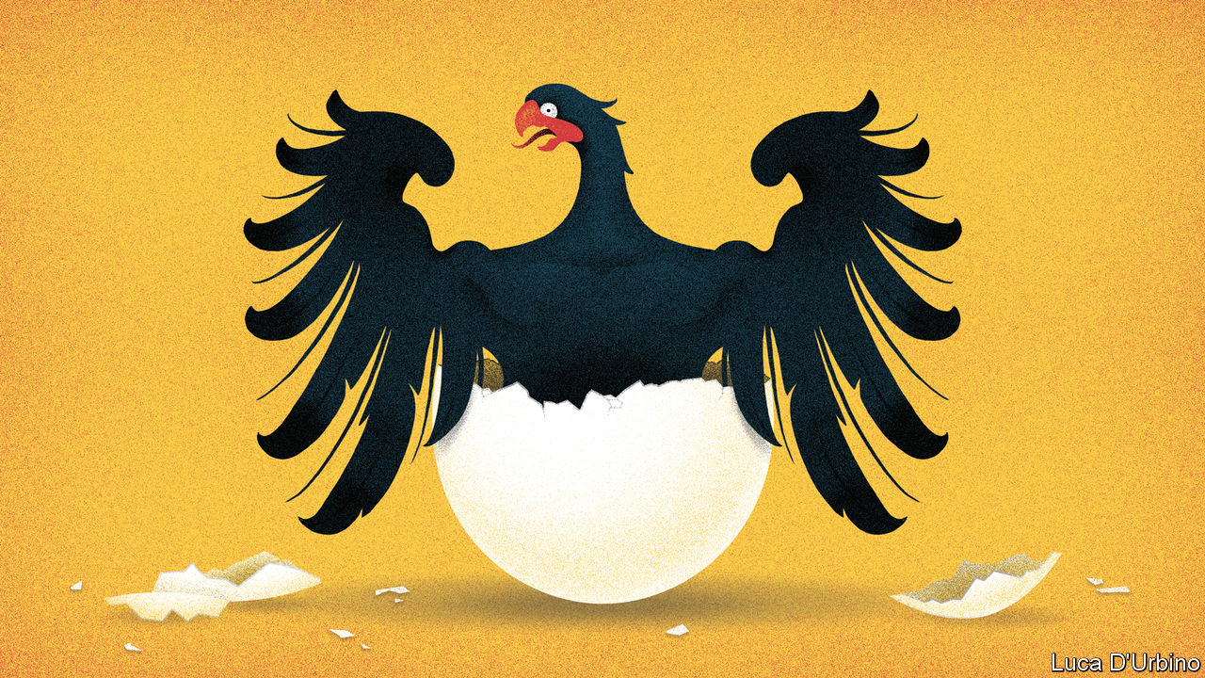

MARGARET THATCHER feared and openly opposed the reunification of East and West Germany. François Mitterrand was said to have shared her worries, though he accepted it was inevitable. Giulio Andreotti repeated a popular quip: that he loved Germany so much, he “preferred it when there were two of them”. Yet despite the reservations of the British, French and Italian leaders in 1990, a new country came into being 30 years ago on October 3rd. With 80m people, it was immediately the most populous country and mightiest economy in a Europe that until then had had four roughly equal principals. Ever since, statesmen and scholars have grappled with the problem of how to deal with the reluctant hegemon at the heart of Europe. How should Germany lead without dominating? Indeed, after the enormities of Nazism, can it be trusted to lead at all?

Thirty years on, German reunification has been a resounding success. East Germans were freed from the dull yoke of communism. With just three chancellors in three decades, the new, liberated Germany has been steady and pragmatic. It has championed the expansion of the European Union to the east and the creation of the euro. It has powered solid if unspectacular growth across a continent—at least until covid-19. Europe survived the economic crisis of 2007-08, the euro panic of 2010-12 and the migration surge of 2015-16. Germany has thrown its weight around less than sceptics feared, though indebted southern Europeans are still sore about crisis-era austerity.

Under its next chancellors, Germany needs more ambition. The need is most acute when it comes to security. Military spending is rising in Germany, but remains far below the 2% of GDP that NATO members are supposed to contribute. Even within Chancellor Angela Merkel’s Christian Democrats this is a touchy issue; it is even more so for her coalition partners, the Social Democrats, and for the Greens, who may help form the ruling coalition after next year’s election. More important, Germany has been too cautious in its policy towards Russia and China, tending to put commercial interests ahead of geopolitical ones. The construction of Nord Stream 2, a gas pipeline connecting Russia and Germany, is a case in point. It undermines the interests of Ukraine, Poland and the Baltic states, but until now Mrs Merkel has refused to cancel it, despite the outrageous behaviour of President Vladimir Putin. Nor has she listened much to those in her own party who warn that it is too risky to allow Huawei, a Chinese firm, to supply Germany with 5G telecoms equipment.

Still, there are signs of a shift. This week it emerged that Mrs Merkel had gone to visit the Russian opposition leader Alexei Navalny in hospital in Berlin, where he was recovering from being poisoned (by himself, Mr Putin claims). Huawei is to face steeper bureaucratic hurdles in Germany than previously envisaged, and Mrs Merkel is showing doubts, albeit faint, about Nord Stream 2. She increasingly accepts Emmanuel Macron’s argument that America is becoming an uncertain ally, and that Europe will have to do more to help itself no matter who wins November’s presidential election. This does not yet add up to a more assertive Germany leading a more assertive Europe, but it is a shift in the right direction.

Likewise, Germany needs to do more on the economic front. The pandemic has accomplished what the euro crisis did not, forcing the EU’s richer countries to show more solidarity with the poorer. The agreement over the summer to set up a €750bn ($880bn) recovery fund to be financed by common debt has been a crucial shift that Germany until recently would not have allowed. More than half of the fund will be given as grants rather than adding yet more debt to the highly indebted. The fund may yet be delayed; but it is a sign that Germany is at long last shouldering its responsibilities. More of this will be needed in the next 30 years if Europe’s currency union, and perhaps even the EU itself, are to survive. But the Bundesrepublik is growing up. ■

This article was downloaded by calibre from <https://www.economist.com/leaders/2020/10/03/thirty-years-after-reunification-germany-is-shouldering-more-responsibility>

|  |  |  |  |
| --- | --- | --- | --- |
| Previous | Articles | Sections | Next |

|  |  |  |  |
| --- | --- | --- | --- |
| Previous | Articles | Sections | Next |

#### Mass destruction

# China is demolishing villages and forcing people into bigger ones

The suffering of millions far outweighs any benefits

Oct 3rd 2020 |

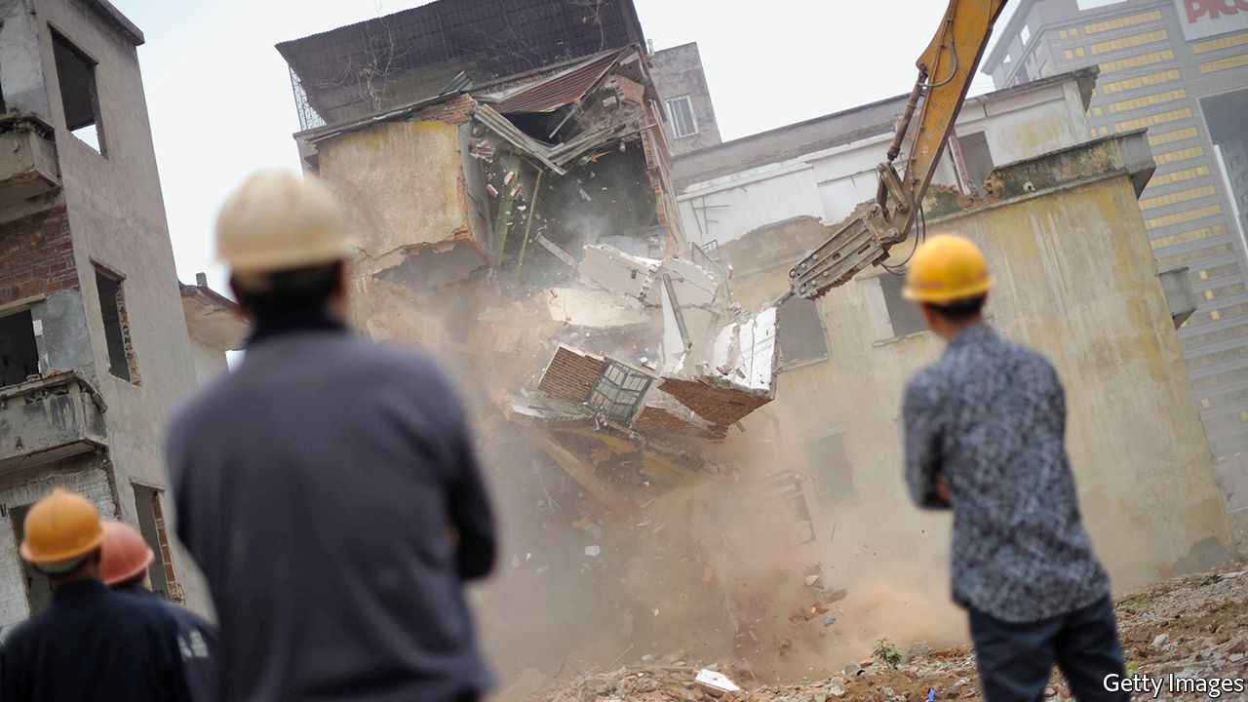

IN THE PAST 30 years tens of millions of Chinese farmers have moved to cities to work. While these have boomed, villages have hollowed out. Often the elderly share them with the children left in their care. Houses lie empty. With too few pupils, many rural schools have closed, forcing children to trek long distances daily or attend often grim state-run boarding schools.

Many provinces have devised a remedy for this malaise. It involves knocking down villages and building new, bigger ones, to accommodate the residents of several scattered hamlets. The land where demolished houses stood can then be ploughed up and sown with crops—a boon for a country that has one-fifth of the world’s population but less than one-tenth of its arable land.

Many elderly villagers remember the famine in 1959-61 after Mao Zedong forced them onto collective farms in his disastrous Great Leap Forward. The merging of villages is causing another man-made calamity. It is rarely lethal, but still causes vast suffering (see [article](https://www.economist.com/node/21792391)).

Experiments with “village consolidation”, conducted in many parts of China over the past two decades, have shown that the scheme is flawed. The officials who order it are often motivated by greed and a desire to impress their superiors. Local governments have a financial incentive to destroy rural housing. By creating more arable land, they can sell greenfield sites near cities to developers without reducing their province’s stock of farmland—an amount ordained by the central government. Urban expansion promotes economic growth, which helps officials’ careers. And when developers and officials are in cahoots, corruption breeds.

Powerless villagers become victims. Millions of them have been turfed out of their homes, or are due to be. They sometimes have to move before new accommodation is ready. Even when it is, new communities are far from the fields or main urban centres. The new housing is often cramped—no more the spacious courtyards that even some poor villagers used to enjoy. What if they refuse to move? Along come officials and their thugs. In 2015 the fate of a villager who was burned to death when goons threw petrol bombs into his home (officials say he lit the fire himself) caused a national outcry. But horrors persist. Reports of beatings are common, as are accounts of people left with nowhere to live but tents or shacks—which is especially hard on the elderly.

Last year the eastern province of Shandong launched a village-flattening programme that led to protests by residents and outrage in the state-controlled press. China’s leader, Xi Jinping, has long insisted that the “rural revival” must not involve “mass demolition and mass building”, but local officials have reason to push on.

Mr Xi could do more to stop the brutality by giving people a genuine say in the running of their villages. His Communist Party claims it has done much to build village-level democracy. Yet most people in the country, as in the cities, are at the mercy of party bosses. If an official decides they must move out, they have no choice. Mr Xi has made matters worse by demanding that the party must take the lead. That gives officials all the authority they need.

Another problem is that rural residents, unlike their urban counterparts, have only a vague assurance of rights to the property they live in. They can rarely sell it to people outside the village or mortgage it. The party calls their land “collectively owned”. Many officials take that to mean they can seize it when they like. Farmers should be given clear rights to their homes and be allowed to sell them freely, as city dwellers have been allowed to since the 1990s. Governments could buy them if they wish, at a price agreed on with the owners. The law should protect the weak from big men with bulldozers, not vice versa. ■

This article was downloaded by calibre from <https://www.economist.com/leaders/2020/10/03/china-is-demolishing-villages-and-forcing-people-into-bigger-ones>

|  |  |  |  |
| --- | --- | --- | --- |
| Previous | Articles | Sections | Next |

|  |  |  |
| --- | --- | --- |
| Leaders | Sections | Briefing |

Letters

On working from home, land reform, scientific management: Letters to the editor

.

|  |  |  |
| --- | --- | --- |
| Leaders | Sections | Briefing |

|  |  |  |  |
| --- | --- | --- | --- |
|  | Articles | Sections | Next |

#### On working from home, land reform, scientific management

# Letters to the editor

A selection of correspondence

Oct 3rd 2020 |

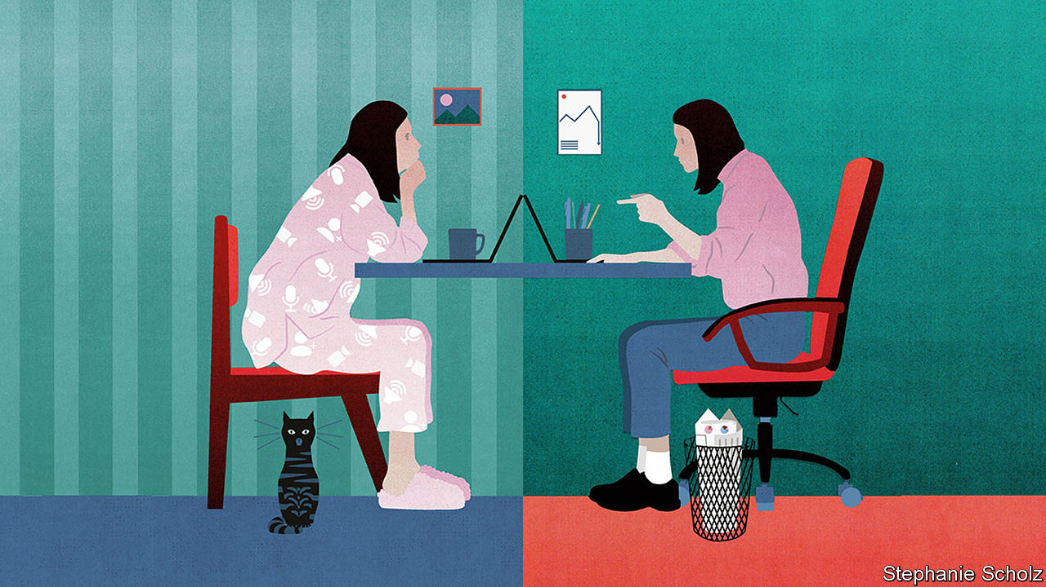

Letters are welcome via e-mail to

letters@economist.com

The office

I enjoyed your briefing on the future of the office (“[What a way to make a living](https://www.economist.com/briefing/2020/09/12/covid-19-has-forced-a-radical-shift-in-working-habits)”, September 12th). Running the world’s largest provider of flexible workspace, I have seen many of the radical shifts in working behaviour that you explored. The debate should focus less on working from home versus the office, and more on the shift to hybrid working, which was already taking place before the pandemic struck.

People have enjoyed working from home and the relative luxury of not having to commute. At the same time, companies still need offices that employees can drop in to for social interaction, meetings and business reviews.

It is also fair to say that very few people have the discipline to work from home all of the time. And we have seen the rise of “Zoom fatigue”. Video-conferencing can be more draining than in-person interactions, as it requires a higher degree of energy to process non-verbal cues such as facial expressions, voice tone and pitch and body language.

What employees need is a hybrid workplace, where they can split their working time between home, a local office and their company’s headquarters. As a result, more companies will have distributed workforces.

The pandemic won’t lead to the demise of the city-centre office, as companies still need somewhere that characterises corporate identity and a place that allows people to congregate, but it will mean greater economic opportunities in smaller towns, where local businesses can grow supported by increasing numbers of home workers. The hybrid office rather than the “optional office” is the future.

MARK DIXON  
Chief executive  
IWG  
Zug, Switzerland

The executive-search firm I work for recently carried out a survey across Asia Pacific. One, admittedly cheeky, question asked whether the respondents thought co-workers who worked from home were taking advantage and not fulfilling their responsibilities: 53% thought there was definitely some hookey being played. But commenting on themselves, 60% said they were working longer hours at home. Office politics indeed.

RICHARD LETCHER  
Hong Kong

Communication, both informally across desks and in organised meetings, is far richer when conducted in person. Most ideas occur when you are not sitting at a computer screen. At home, the instant you walk away from your computer you are surrounded by your home life and your mind will be engaged with family and domesticity.

As a business owner, I am aiming for 100% efficiency and effectiveness. Do you really think I should accept less than this so my staff don’t have to travel to work? That is a dangerous concept for businesses to adopt and one I suspect you won’t find in places like China. I worry about our work ethic and its impact on our output.

However, we do need creative solutions to reduce the cost of commuting. In Britain, how about waiving stamp duty on homes less than 30 minutes travel from one’s place of work, encouraging people to live closer to the office.

LUKE DASHPER  
London

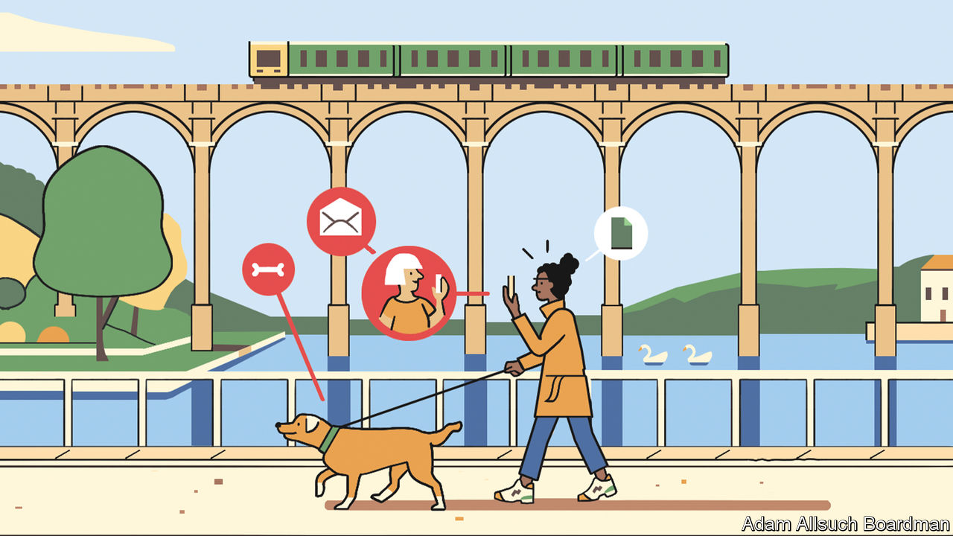

The most important question is this: is my corporate culture strong enough to adapt to this new way of working? A company with a clearly articulated and effectively deployed corporate culture can thrive in any configuration, be it remote, office-based, or a blend of the two. In fact, organisations that are longing for a return to the office are trying to mask a weak corporate culture.

Too often, business leaders mistake presence for performance, which is why the use of productivity-tracking software has surged during the pandemic. Strong organisations aren’t built through micromanagement or surveillance. They are built on a foundation of trust. The future of work is about results, not time spent at a desk, and this is true whether that desk is in an office or in someone’s home.

What began as an emergency has become an opportunity. There is no one correct answer to the balance of remote and in-office work. There are a wide range of choices that require creative reflection. If bosses approach it in this manner, and with a hard look at their work culture, their company and their employees will be the better for it.

TASO DU VAL  
Chief executive  
Toptal  
New York

We should consider our social nature. In humans’ evolutionary history, our survival depended on being able to live together in groups. We needed to figure out how to keep track of who is friends with whom, what others are trying to achieve, and when those around us are angry or happy. We learned to pay attention to how others move, where they look, and how they react to what is going on around them.

This requires that we are physically near each other. I cannot know if you are happy or angry with me if I am not sure if your facial expression is triggered by what I said or by an unexpected tap on your leg. I cannot read your body language if all that I see is your facial expression on a screen. Because of this bio-social psychological inheritance, there is good reason to think that, as the threat of infection recedes, people will look to leave their home offices and return to their real offices.

ARMIN SCHULZ  
Professor of philosophy  
University of Kansas  
Lawrence, Kansas

Many thanks for the issue on office politics. It makes a great mouse mat when working at the kitchen table.

CHRIS MIJNSSEN  
Brisbane

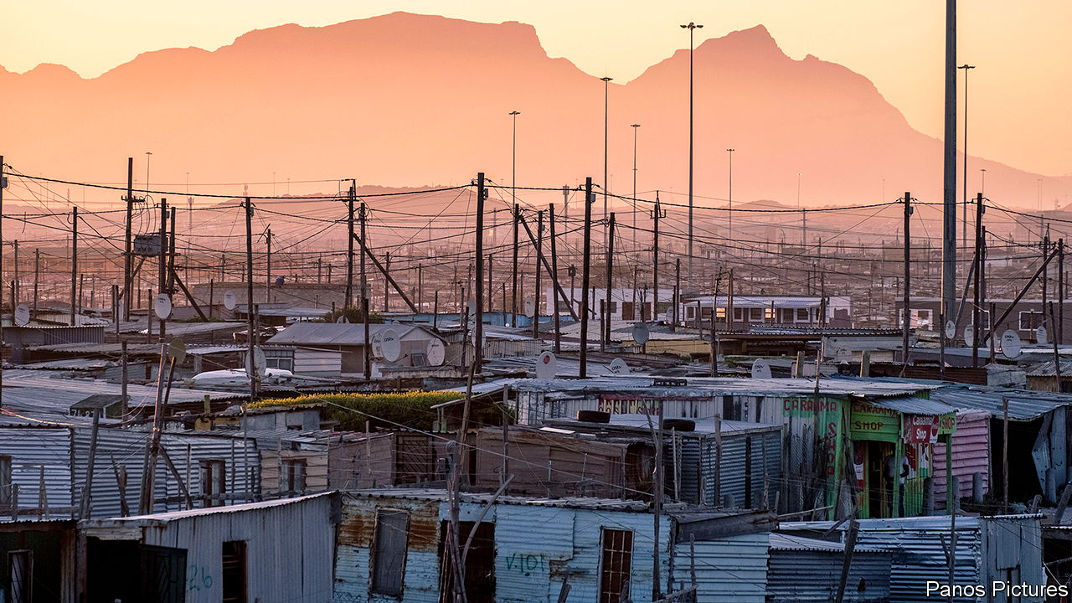

## Helping women to buy land

Land reform is indeed difficult (“[Parcels, plots and power](https://www.economist.com/middle-east-and-africa/2020/09/12/the-quest-for-secure-property-rights-in-africa),” September 12th) but there are reasons to be encouraged about changes in Africa and there are practical policy recommendations that can address some of the continuing problems. For example, governments should ensure that women are aware of and able to register claims for land, both jointly and as sole owners. That would give them a sound foundation for farming, opening a business or providing a home and shelter. The digital gender divide makes it difficult for many women to access technologies and newer online land registries. We should also help women implement the land rights they do hold by using legal professionals.

There are signs of progress. In Liberia a land-reform bill in 2018 included provisions to strengthen marital property rights for women and to formalise customary land rights for millions. And in Tanzania paralegals are using a mobile app to dispense legal advice and help women settle disputes over land rights.

KAROL BOUDREAUX  
Chief programme officer  
Landesa  
Washington, DC

## Taylor-made after all

With all due respect to the correspondent who credited Louis Brandeis with coining “scientific management” in 1910 ([Letters](https://www.economist.com/letters/2020/09/19/letters-to-the-editor), September 19th), Frederick Taylor used the term in his paper “Shop Management”, presented at the meeting of the American Society of Mechanical Engineers in June 1903. So Bagehot was correct.

ANDREW WYNER  
Northern Virginia Community College  
Manassas, Virginia

This article was downloaded by calibre from <https://www.economist.com/letters/2020/10/03/letters-to-the-editor>

|  |  |  |  |
| --- | --- | --- | --- |
|  | Articles | Sections | Next |

|  |  |  |
| --- | --- | --- |
| Letters | Sections | United States |

Briefing

Joe Biden’s economic plans: The pragmatist

.

|  |  |  |
| --- | --- | --- |
| Letters | Sections | United States |

|  |  |  |  |
| --- | --- | --- | --- |
|  | Articles | Sections | Next |

#### The pragmatist

# Joe Biden would not remake America’s economy

He would improve its fortunes, though

Oct 3rd 2020 |

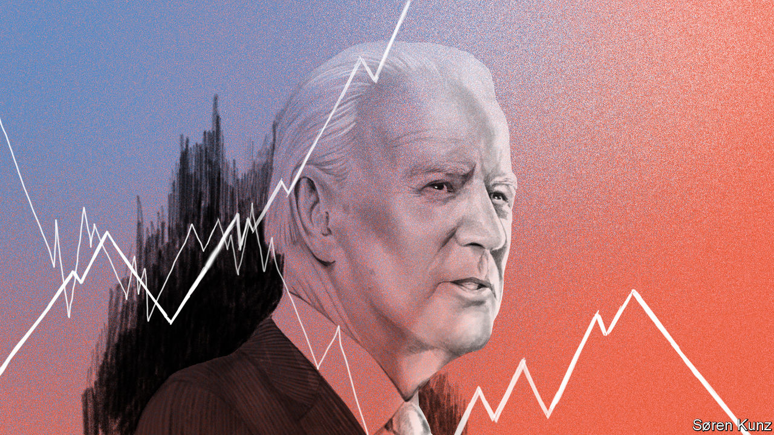

SOME LEADERS, when they come into office, have a powerful economic vision for transforming how their country creates wealth and distributes it. Others approach power as pragmatists whose goal is to subtly shape the political and economic forces they inherit. Joe Biden is firmly in the second camp. He is a lifelong centrist whose most enduring economic belief is his admiration for hard-working Americans and who has shifted with the centre of gravity in his party. But Mr Biden’s ability to go with the flow means that, at the moment, both the left and the right are anxious about the prospect of Bidenomics.

Indeed, if Mr Biden wins the election in November and enters the Oval Office in January 2021 he will confront an extraordinary set of circumstances that will put a huge amount of pressure on him. The economy is clawing its way back from the sharpest slump in living memory following covid-19. The legacy of the pandemic will include millions of long-term unemployed, public debts that will soon exceed their all-time high of 106% of GDP, more bankruptcies and accelerated digital disruption in many industries.

At the same time Mr Biden will head up a party that has indeed shifted more to the left and that has a more radical wing that, while not dominant, is influential and thinks America’s economic model is broken and that the answer is a vastly bigger state. Combined with this, the public is bitterly divided and many people are wary of globalisation. Under President Donald Trump, America’s standing in the world has slumped.

Because of this chaotic backdrop and Mr Biden’s own lack of a fixed economic doctrine, the range of outcomes attributed to a Biden presidency is bewildering and not always benign. To some Republicans on Wall Street and in boardrooms he would enable a hostile takeover by the radical left. “The country is running the risk of structural changes under the guise of social justice which would take the US into a place where it won’t know how to function,” claims one. To the left Mr Biden is a timid figure whose moderation means he would be crushed by an obstructive Congress and conservative courts.

## Born to run

Neither view is especially convincing once you consider Mr Biden’s goals. He says he will seek to tilt the balance of American capitalism in favour of workers, not the rich. He will offer competent administration; he is no fan of social experiments or trampling on institutions. His priority would be a stimulus bill to revive growth, though he is likely to pull America somewhat further to the left than either of his Democratic predecessors, Barack Obama or Bill Clinton (see chart 1). He would leave the economy greener, with a more active industrial policy, somewhat higher public spending and borders open to skilled migrants. He would not reverse America’s new protectionism, nor does he have a plan to resolve the country’s long-term fiscal problems.

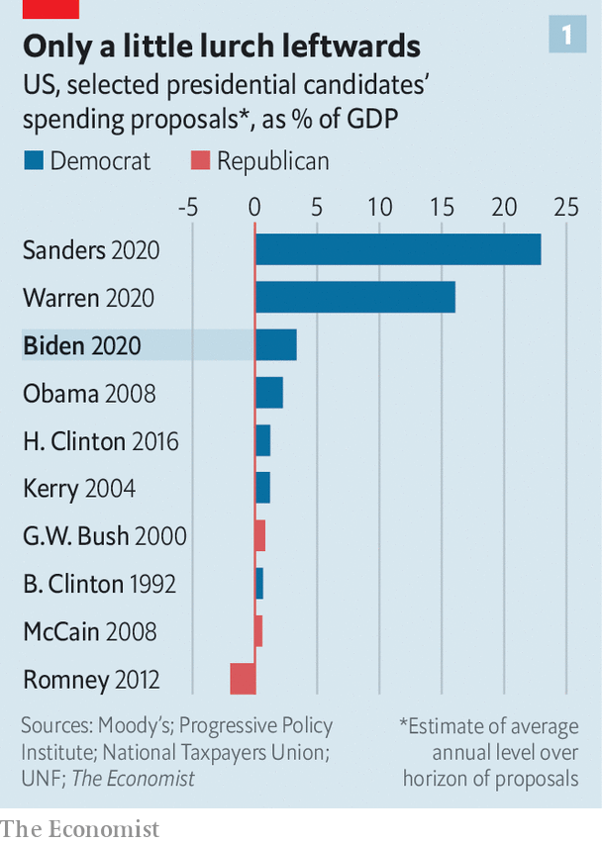

Mr Biden’s long career does not exactly suggest much enthusiasm for economics. During his 36 years in the Senate his main passions were the justice system and foreign policy. By instinct he is an admirer of the middle-class more than the country’s glittering plutocratic elite or its downtrodden. He grew up in, and later represented, Delaware, a diminutive state which relies on big business to make its crust. Over two-thirds of Fortune 500 firms are legally registered there thanks to its shareholder-friendly laws and tax rules. The Diamond State is home to the headquarters of some icons of 20th-century industry, including DuPont, some of whose workers lived in the suburb Mr Biden spent his teens in. His exposure to such folk may help explain his fondness for manufacturing and a more paternalistic capitalism.

As vice-president in 2009-17 Mr Biden helped implement the stimulus package of 2009 and strike budget deals. But his strength was as a negotiator with Congress, not as a visionary. Allies from his Senate and White House years make up a big share of his advisers and entourage now, with additional advice coming from centre-left economists such as Jared Bernstein, Heather Boushey and Ben Harris. Unlike Mr Obama, he has not appointed a dominant economic figure to his team so far.

## Jack of all trades

As a result, in order to understand where a Biden presidency might take the economy it is necessary to consider the three external forces that he will have to deal with, each of which could in theory push him down a more radical path. The first is the covid-19-induced recession. America has bounced back faster than was originally feared. GDP is now expected to shrink by 4% this year; at one point a decline of 7% had seemed likely. But the recovery could stumble, not least because Congress has so far failed to agree on a further stimulus bill.

What is already clear, however, is that the slump has hit the poor worst, amplifying inequality. Many business figures warn of a surge in defaults among small firms which have found it hard to secure government help: less than 1% of the misfiring $600bn Main Street lending scheme backed by the Federal Reserve and Treasury has been dispersed. State and local governments face a funding crunch. The disruption is not simply a matter of a temporary downturn. Whole industries, including travel and retail, will be transformed.

And the normal laws of economics have been upended. Interest rates are at rock-bottom levels, making borrowing almost free for now. America will run a fiscal deficit of 16% of GDP this year. Asset prices, meanwhile, are sky-high with the stockmarket at its most expensive level since the dotcom bubble of 2000, based on its ratio of price to cyclically adjusted profits.

As he grapples with this topsy-turvy economy, Mr Biden will have to deal with a second force in the form of the left wing of his party. Over a third of voters in the Democratic primaries supported Bernie Sanders or Elizabeth Warren, whose plans involved a giant expansion in annual government spending. Since then Mr Biden has skillfully flattered the more radical left while ignoring their more ambitious proposals, such as nationalised health care and the “Green New Deal”, a package promoted by Alexandria Ocasio-Cortez, a congresswomen, among others, which includes a guaranteed job for all. In July a joint Biden-Sanders task force agreed on watered-down policy recommendations. Some of these Mr Biden then further diluted into his own proposals. Even so, the left will still demand jobs in any administration. And the centre of the party remains to the left of public opinion. Opinion polls suggest the typical American is more worried about climate change and China than they used to be, and more relaxed about government borrowing (see chart 2). But 87% of them still believe in free enterprise.

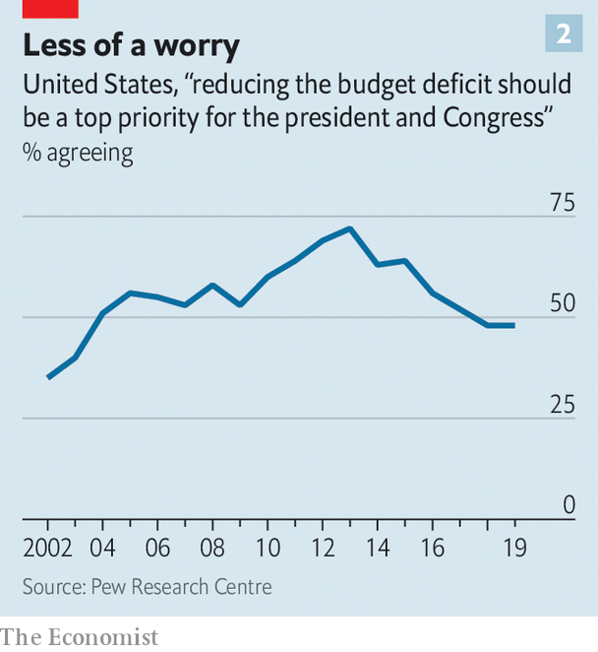

The final external force Mr Biden would face is Congress. The Economist’s election model gives the Democrats a 98% chance of holding control of the House of Representatives and 69% chance of winning the Senate, with any swing bringing new moderate Democrats in. Assuming the normal rules are in play the Senate will limit what can be done. If Mr Biden’s party ends up with between 50 and 59 seats and sticks to normal Senate protocol over the use of the filibuster, it will only be able to get through tax and spending legislation that either has bipartisan support or can be passed using a process known as reconciliation. This typically limits the number of bills to three a year (one each on spending, tax and debt-limits), does not permit changes to social security and normally requires that the impact on the deficit is neutral within ten years, either because the spending measures expire or are balanced by tax rises. But the Democrats could ditch procedural rules over the filibuster so that they can pass major bills with only 50 votes (plus one from the vice-president who can cast a deciding vote). This might also allow them to pursue other goals including expanding the number of Supreme Court judges.

Faced with these external influences, what would Mr Biden do? He would have three main ways to exercise power: through legislation, job appointments and executive action including regulation. Start with legislation, where Mr Biden has proposals that would raise spending by $7trn over a decade. Congress will almost certainly act as a constraint on this. The Democratic Party’s centre of gravity in the House is still centrist: the largest caucus, with over 100 members, is the moderate New Democrat Coalition. Most new seats won would probably be occupied by moderates, and they also hold key jobs, including the head of the Ways and Means committee, which controls tax legislation.

In the Senate, meanwhile, even if the Democrats won a big enough majority to try to ditch the filibuster, which is unlikely (a rough yardstick is they would need 55 seats), Mr Biden might well resist: his affection for the institution is such that he kept a Senate gym locker when he was vice-president, and any change in the filibuster rules would be a dramatic constitutional escalation in the war between the two parties. Any Democratic swing will see moderates win seats.

## Land of hope and dreams

All this means Mr Biden will have to compromise and might only get two big priorities passed through Congress. That suggests that any increase in the size of the state would be limited. Ms Warren and Mr Sanders proposed spending increases equivalent to 16-23% of GDP, taking it towards Swedish levels seen in the 1970s. Mr Biden’s formal proposals amount to just a 3% increase and in all probability he might get only half of that passed: so a spending increase of $3trn-4trn over ten years, worth 1-2% of GDP.

The burning priority will be a jumbo “recovery” bill of perhaps $2trn-3trn aimed at revving up the economy and meeting a key strategic priority, more green-tinged infrastructure spending (see chart 3). The latter could command some Republican support because it creates jobs, while also pleasing Mr Biden’s more climate-aware base. Short-term stimulus measures may include cash for state and local governments, a boost to unemployment benefits, a rise in the minimum wage to $15 an hour and further support for small companies.

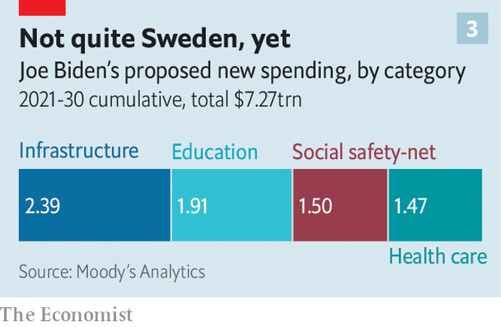

The green infrastructure element might include upgrades to electricity grids and charging stations for electric cars. In order to cut emissions Mr Biden’s plan aims for power generation to be carbon neutral by the mid-2030s. He is keen to spend tens of billions of dollars a year on research and development into renewable-energy technologies and other areas such as 5G, with the aim of establishing an American edge to rival China’s.

If the jumbo recovery bill goes well, there may be room for a Biden administration to pursue one other big legislative priority. One possibility is immigration reform. Another candidate is boosting middle-class social mobility, where Mr Biden proposes universal pre-school education, tax-credits for child care and free public-university education for families earning less than $125,000 a year. In total spending on an ambitious social-mobility agenda might amount to another $1trn over a decade.

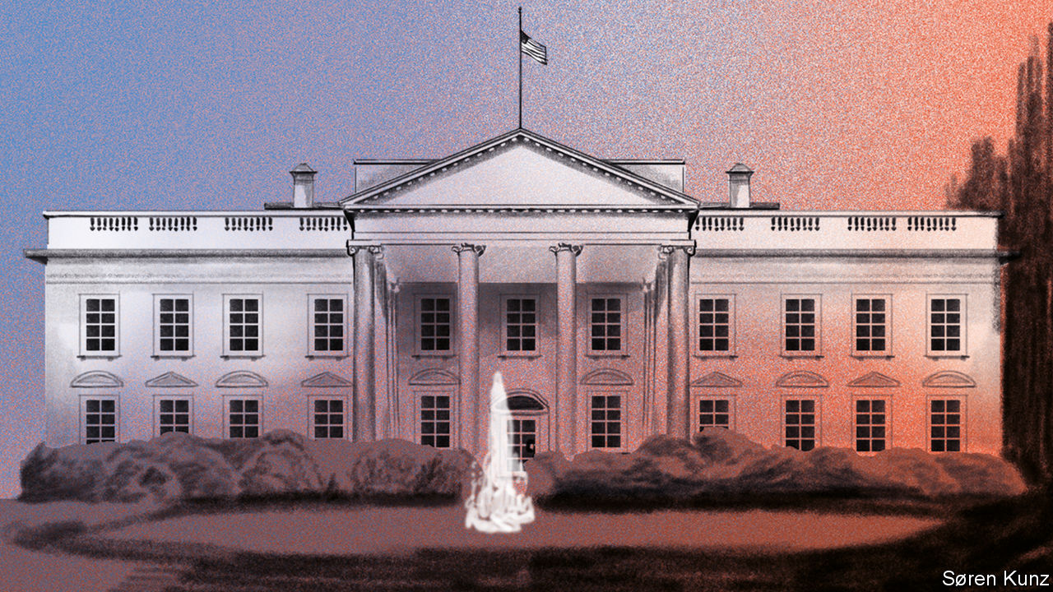

Congress has only limited capacity so Mr Biden will also need to decide what not to do. He does not seem to have a burning appetite to reinvent Obamacare, which was not his first priority when vice-president (although like most politicians he wants to push down drug prices). He will have to hope that the Supreme Court does not force his hand: on November 10th it will begin considering the legality of Obamacare, which could unwind a system millions of people use. Were this to happen Mr Biden might be forced to try to legislate for a replacement. A push to modernise America’s decrepit antitrust apparatus, meanwhile, is on the backburner. Without new legislation, it will be hard to do much about the rising concentration of business or the big tech monopolies, given the courts are reluctant to take action. Kamala Harris, Mr Biden’s running-mate, was friendly towards tech as California’s attorney-general in 2011-17.

## Tougher than the rest

Mr Biden’s proposals suggest that roughly half of his spending might be covered by tax rises. Once again the formal plan points to tax hikes of $4trn, but as with spending, in reality a figure half that size or less, of $1.5trn-2trn, is more likely. Big changes to social-security levies are probably off the cards since they are not eligible for the reconciliation process in the Senate. Many Democrats in Congress are wary of raising capital-gains tax too high. So business-tax rises will do much of the work with a partial reversal of the 2017 Trump tax cuts.

Mr Biden would raise the headline rate on corporate income from 21% to up to 28%, levy minimum taxes on foreign earnings and remove tax perks for real-estate and private-equity firms. Individuals earning more than $400,000 would see the top band of income tax rise to up to 39.6%, and those earning more than $1m might have to pay a capital-gains rate that is nearer the one they pay on their income.

A second way Mr Biden could influence the economy, and give licence to his party’s more radical impulses, is through job appointments. Yet it seems unlikely that he will appoint Ms Warren as treasury secretary, or even attorney-general. That would send an alarming signal to the business community when the economy is fragile. It would also trigger a special election to fill her Senate seat in Massachusetts. Instead the front-runners to become treasury secretary are centrists. They include Lael Brainard, a centre-left member of the Federal Reserve Board; Jeff Zients, a co-head of Mr Biden’s transition team; Sylvia Mathews Burwell, a former Obama official and Sarah Bloom Raskin, a former Fed governor and treasury official. If a business figure is needed then Ruth Porat, the finance chief of Alphabet, a tech giant, is also thought to be a contender.

Based on Mr Biden’s own experience as vice-president, in which he acted as a key counsellor to Mr Obama, Ms Harris would have an important voice in his administration. She sits to the left of him on tax and spending, although she is within the mainstream. And having rejected its signature policies and outmanoeuvred its star figures, Mr Biden might try to placate the left of his party by giving it lots of jobs in the regulatory apparatus where they would emit a cacophony of left-sounding signals.

The final tool Mr Biden has to get his way is executive orders, which Mr Trump and Mr Obama both used. Yet here, too, Mr Biden will be restricted by the courts which have become substantially more conservative than they were in the Obama era. Mr Biden would try to use this power to reverse some of Mr Trump’s own executive orders. Top of this list is probably the ban on some migrants and the president’s clampdown on refugees and undocumented workers that has intensified this year. The rules for visas for skilled workers would be eased. Yet despite his support for immigration, his stance on protectionism is more ambiguous, and here the president has sway and discretion. Mr Biden has been a free trader in the past and would certainly be politer to China than Mr Trump has been. He would rally America’s allies to put in place a co-ordinated response to deal with China’s economic model under Xi Jinping in which even notionally private Chinese firms are often acting under the strategic direction of the Communist Party.

But he will only go so far. This reflects a shift in public opinion. According to the Pew Research Centre, fully 73% of Americans now have an unfavourable view of China, a new high. Mr Biden would not quickly withdraw the tariffs that are now in place (the average tariff on goods imported from China is about 19%). While he has been critical of the Trump administration’s botched effort to rein in TikTok, a Chinese social-media app, he would probably stick with the embargo on Huawei and be wary of high-tech trade with China.

Similarly, new trade deals will not be a priority even though Mr Biden supported the Trans-Pacific Partnership and USMCA, the revised US-Mexico-Canada deal passed in 2020. (Ms Harris was opposed to both.) Mr Biden’s industrial strategy is laced with soft protectionism, including promises to bring supply chains back to home, adopt a “buy American” government-procurement policy, tighten rules on the labelling of products, use American steel for transport projects and singing the praises of the Jones Act which requires that only American-flagged ships carry goods between domestic ports.

A Biden presidency therefore promises moderately higher taxes and more spending, especially on green infrastructure, more industrial policy and not much change to trade policy. Who would benefit? In terms of individuals his policies are aimed squarely at the middle classes and lower paid who would benefit from a raft of measures such as cheaper education, perks to get on the housing ladder and a higher minimum wage. Mr Biden’s tax rises are squarely levied on the richest Americans: if fully enacted they would mean the income of the top 1% of earners would drop by 14%, and the income of the top 0.1% by 18%, according to the Penn Wharton Budget Model. In reality these proposals will not be passed in their entirety. Either way, the impact of the tax changes on the 99% would be minimal (see chart 4).

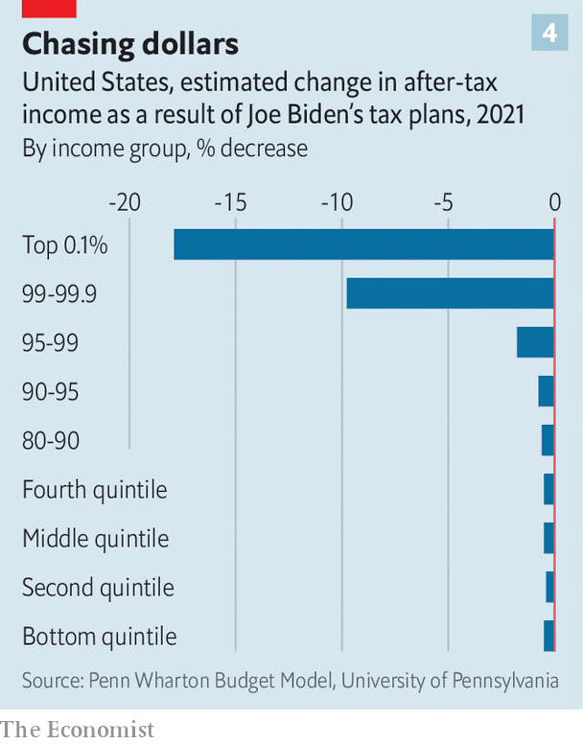

What about business? Which firms would gain and which would suffer? One estimate suggests corporate profits would fall by about 12% because of the tax rises. Investors have already begun to discount this and to bid up the shares of renewable-energy firms and construction and infrastructure companies which might benefit from a Biden presidency. The shares of fossil-fuel energy firms which might suffer under a Biden presidency have dropped. Tech stocks have soared this year even as the odds of a Biden win have risen, suggesting investors don’t worry about antitrust action against Silicon Valley. The stockmarket has risen by 4.5% this year despite the recession; hardly a sign of an imminent lurch towards big-state socialism.

Even so, there would be risks to the economy from a Biden presidency. One is that he loses control of the party and there is a lurch even further to the left, spooking the business world. Were the Democrats to abandon the Senate filibuster, a path might be open to an expansion in the size of the Supreme Court or, some bosses fear, more radical legislation. But Mr Biden would probably resist this.

More likely is that a regulatory apparatus stuffed with left-wing appointees ends up damaging his relationship with business. Many of the Trump administration’s most reckless regulatory decisions, for example its push since 2017 to stop the Environmental Protection Agency from limiting the use of coal, need to be reversed. The danger is that new rules are churned out in unco-ordinated fashion on unions, inequality and the like, accompanied by volleys of confrontational rhetoric. Democrats tend to think that business is just crying wolf. But small firms consistently complain about regulation, and badly designed rules after the financial crisis of 2008-09 helped cause serious problems in the mortgage market.



The second danger is fading dynamism. Some of Mr Biden’s agenda, including infrastructure and more research and development, will boost America’s long-term competitiveness. But a lack of antitrust policy and more red tape could continue to give too much power to large, incumbent companies, which have seen their market share rise in two-thirds of industries over the past two decades, creating oligopolies in industries from mobile telecoms to credit cards. The undercurrent of protectionism in Mr Biden’s plans could insulate the economy from competition abroad, sapping its vitality. Ultimately there exists a tension between Mr Biden’s desire to build new infrastructure quickly and cheaply and his plan to favour domestic workers and supply chains, that is likely to become far more acute over time.

The final risk is America’s long-term fiscal position (see chart 5). Even after the covid-19 stimulus fades, and before any deficit-widening steps that the next president makes, America’s deficit was projected to soar above 5% of GDP in perpetuity, with public debt reaching about 200% of GDP by 2050. Today the Federal Reserve is buying much of the net new debt issuance by the government, as fiscal and monetary policy begin to merge.

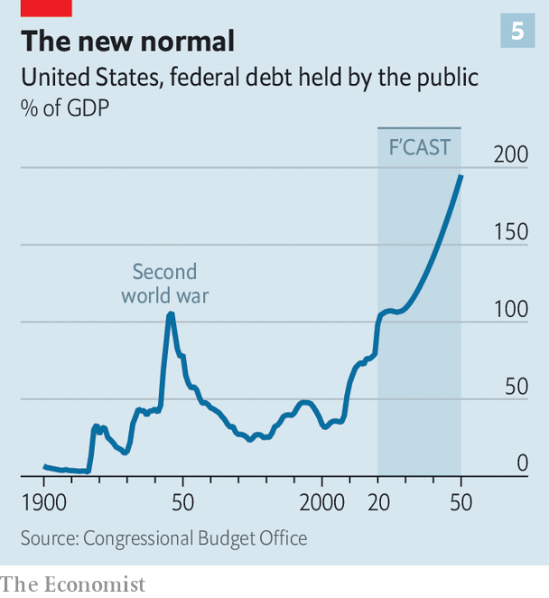

For now this strange new fiscal regime seems sustainable. But over time the risk of the politicisation of the Fed will increase. And the economy and financial system will become vulnerable to any eventual rise in inflation. A debate over these risks looks likely to occur when the first term of Jay Powell, the Fed’s chairman, finishes in early 2022. But so far Mr Biden has no major plan for redesigning the macroeconomic architecture or for getting America’s long-term finances on a stable footing.

## Better days

Mr Biden, a life-long pragmatist, looks likely to govern as one. Stylistically that means getting sensible advice, behaving consistently and working with America’s institutions. While he may lack a formal economic doctrine, his goal will be to get the economy out of its covid-19 slump, improve social mobility and build a better safety net. He will place his biggest bet on giving a long-term boost in infrastructure and climate policy, and then try to moderate the wilder forces swirling around America’s electorate and polity, including the more socialist ideas of the hard left, chauvinistic protectionism and the indifference of the right towards America’s social fabric. The claim that a Biden presidency would destroy American capitalism is silly. If he can restore competent management and make the economy work better for ordinary people Mr Biden’s last job in politics will be done. ■

Dig deeper:  
Read the [best of our 2020 campaign coverage](https://www.economist.com/us-election-2020) and explore our [election forecasts](https://projects.economist.com/us-2020-forecast/president), then sign up for Checks and Balance, our [weekly newsletter](https://www.economist.com/checksandbalance/) and [podcast](https://play.acast.com/podcasts/2020/01/24/checks-and-balance-our-new-weekly-podcast-on-american-politics) on American politics.

This article was downloaded by calibre from <https://www.economist.com/briefing/2020/10/03/joe-biden-would-not-remake-americas-economy>

|  |  |  |  |
| --- | --- | --- | --- |
|  | Articles | Sections | Next |

|  |  |  |
| --- | --- | --- |
| Briefing | Sections | The Americas |

United States

Florida and the election: Key largo

.

Supreme Court and the election: Not so fast

.

Election troubles: Rashomon, with ballots

.

Measuring poverty: And the poor get poorer

.

Catholic priests and politics: Render unto Caesar

.

Lexington: The end of the debate

.

|  |  |  |
| --- | --- | --- |
| Briefing | Sections | The Americas |

|  |  |  |  |
| --- | --- | --- | --- |
|  | Articles | Sections | Next |

#### Kay largo

# Why Donald Trump is doing surprisingly well in Florida

The president probably cannot win without his adopted home state

Oct 3rd 2020 | LAKE MARY AND WILDWOOD

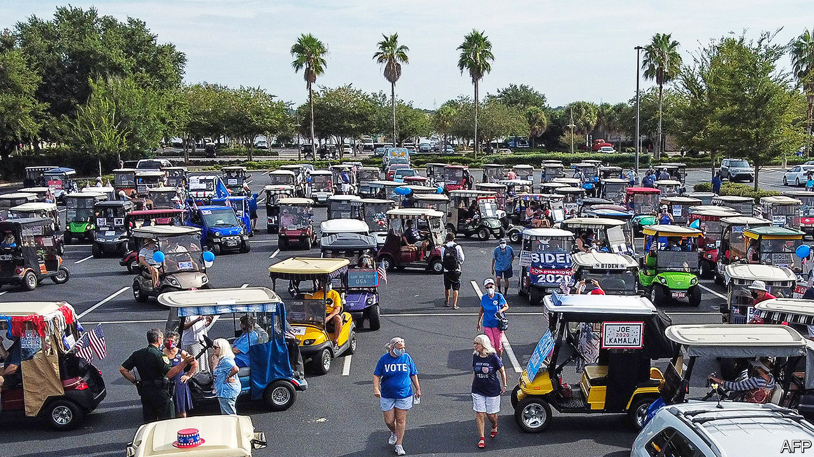

ON A SWELTERING Saturday afternoon, Joe Gruters and Linda Trocine, Republican party chairmen respectively for Florida and for Seminole County, were hunting for votes the old-fashioned way: by knocking on doors. Armed with an app that aggregates masses of voter and consumer data, they were targeting NPAs (no party affiliation) and persuadable Democrats in Lake Mary, a northern suburb of Orlando, and they were hitting their targets. A rangy, sandy-haired NPA with a deep smoker’s voice handed the flyers back: “Don’t waste ‘em on me. I’m voting Republican straight down the ticket.” A Latino NPA mowing his lawn enthused about President Donald Trump, as did a 50-ish Democrat watching a college football game in his garage. “We’re out there pounding the pavement every day,” says Mr Gruters. “We’ve knocked on more than 1.7m doors...while Joe Biden and his team are basically trying to win this campaign from their basements.”

That is not entirely true. Mr Biden visited central Florida on September 15th, and at weekends his Hispanic supporters have been organising raucous parades of cars decked out in Biden flags in south Florida. But his campaign relies on contacting voters virtually rather than in-person, reasoning that during an epidemic people would rather be called or texted than visited. That may change as election day approaches. Mr Biden has increased his spending in-state, and some of the $100m that Michael Bloomberg, entrepreneur, former mayor of New York and briefly a candidate in the Democratic presidential primary, plans to spend in Florida on Mr Biden’s behalf will go towards the ground game.

Only two states, California and Texas, offer more electoral votes and, unlike them, Florida swings. Barack Obama and George W. Bush each won it twice; Mr Trump beat Hillary Clinton by less than two points in 2016. Just once in the past 12 presidential elections (1992) has Florida voted for the loser. Should Mr Trump win his adopted home state, our model reckons he would be about 50:50 to win in the electoral college. Should he lose Florida, he has almost no chance. The state will probably announce its results on election night, so a win for Mr Biden would make Mr Trump’s inevitable doubt-casting about the results that much hollower. Polls show a tight race—much closer than the overall national picture. Between now and November 3rd, Floridians should prepare themselves for an onslaught of ads, attention and hand-wringing from the two campaigns.

Two groups hold the keys to Florida’s fortunes: Latinos and the elderly. Mr Trump is overperforming with the first group and underperforming with the second. A recent Univision poll showed Mr Biden winning 52% and Mr Trump 36% of Latino voters in Florida (other polls show narrower leads). By comparison, the poll showed Mr Biden winning 65% of Latino voters in Arizona and 66% in Texas.

That partly reflects the difference between Florida’s sizeable Latino population—comprising one in four Floridians—and Latinos in other states. Roughly one-third of Florida’s Hispanics are Cuban, a group that traditionally votes Republican. It also has sizeable Venezuelan, Colombian and Nicaraguan communities—all groups more favourable to Republicans than Mexican-Americans, who tend to vote more reliably for Democratic candidates.

But Hillary Clinton won 62% of Florida’s Latino vote in 2016, and Mr Obama took 60% in 2012. Republicans, taking a page from Mr Obama’s playbook, have invested time and money in Latino-voter outreach. That was partly why, in 2018, Rick Scott and Ron DeSantis, both Republicans, won their Senate and governor’s races, fending off the Democratic wave that crested across the rest of America that year. Mr Trump is doing the same. Fernand Amandi, a pollster who heads a Miami-based market research firm, says that the president has been in “permanent campaign mode” in Florida since 2016, whereas “the Democratic strategy has been we’re going to parachute in and see if we can win late”.

Many Democrats worry that when Mr Trump labels them as socialists that may particularly deter Cuban-, Venezuelan- and Colombian-Americans, many of whom have experienced socialism first-hand. Carlos Odio, who worked in Mr Obama’s White House before co-founding Equis Labs, a political consultancy, notes that Mr Trump, like Mr Scott, uses “targeted appeals to peel off votes” from various Latino constituencies. He is unlikely to win the Latino vote in Florida, but those messages could help hold down his losses, increasing pressure on Mr Biden elsewhere.

To counter that weakness, Mr Biden can look at least partly toward grey-haired Floridians. A recent AARP poll shows Mr Trump narrowly leading Mr Biden, 50%-47%, among all voters over 50, but Mr Biden leading 49%-48% among voters over 65, who comprise 21% of Florida’s population, and a higher share of the state’s electorate. No Democrat has won their support since Al Gore convinced them that George W. Bush was coming for their Social Security in 2000. Mr Biden is unlikely to do so this year, either in Florida or nationally. But he may limit his losses enough to balance a poor performance with Latinos.

On Saturdays Chris Stanley, who heads the Democratic Club in The Villages, a retirement community in central Florida, waves Biden signs with other club members along the main drag in nearby Wildwood. She cites Mr Trump’s “mishandling of the covid crisis” as the reason “we have a constant stream of Republicans coming in and saying, ‘I’m a Republican, and I’m going to stay a Republican, but what can I do to help you get rid of that guy?’ ”

Mr Trump may also do worse than last time among white Floridians. In 2016 Hillary Clinton won a paltry 32% of them, while a recent poll shows Mr Biden on 38%. Such shifting allegiances make Florida in 2020 more complex than the traditional political picture, in which Democrats try to run up their numbers in diverse south Florida to offset losses in the whiter north, Republicans do the opposite, and both sides brawl over the I-4 corridor, which runs through Tampa and Orlando.

Florida is protean, shaped by waves of immigration from inside and outside America. Conservative midwestern pensioners who would otherwise have gone to Arizona have moved to places such as The Villages. An influx of Puerto Ricans into Orlando and Kissimmee has pushed central Florida farther left than it was, and Mr Trump’s weakness with suburban voters means the street-by-street brawl has moved to the exurbs. Republican efforts have made the south less of a vote-bank for Democrats. In 2018, Andrew Gillum, the Democratic candidate for governor, won usually Republican Duval County, up north, but failed to carry the state.

Florida’s demography—larger than average shares of African-Americans and Latinos—would seem to favour Democrats. Yet too often that has been a curse in disguise, leading Democrats to assume votes rather than hustle for them. Republicans are taking no such chances. Says Mr Gruters, “I was the Trump co-chairman in 2016 for the state, and at the very peak we had 62 staffers. We have 190 on the ground right now...Usually we have multiple events going on across the state on a daily basis.” Republicans are fighting for Florida as though Mr Trump’s presidency depends on it—which it probably does. He will be hard to beat on his home ground.■

Dig deeper:  
Read the [best of our 2020 campaign coverage](https://www.economist.com/us-election-2020) and explore our [election forecasts](https://projects.economist.com/us-2020-forecast/president), then sign up for Checks and Balance, our [weekly newsletter](https://www.economist.com/checksandbalance/) and [podcast](https://play.acast.com/podcasts/2020/01/24/checks-and-balance-our-new-weekly-podcast-on-american-politics) on American politics.

This article was downloaded by calibre from <https://www.economist.com/united-states/2020/10/03/why-donald-trump-is-doing-surprisingly-well-in-florida>

|  |  |  |  |
| --- | --- | --- | --- |
|  | Articles | Sections | Next |

|  |  |  |  |
| --- | --- | --- | --- |
| Previous | Articles | Sections | Next |

#### Courting votes

# Would the Supreme Court hand Donald Trump a second term?

His wish may not be the justices’ command

Oct 3rd 2020 | NEW YORK

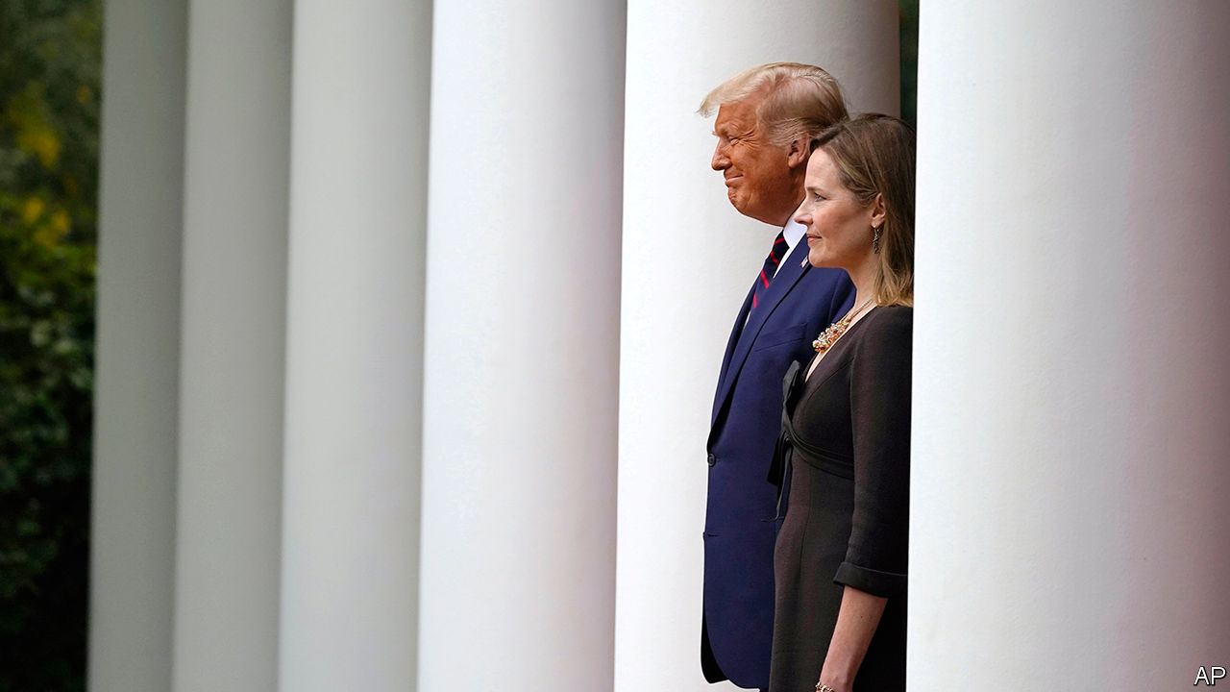

“I THINK [the election] will end up in the Supreme Court”, Donald Trump said on September 23rd, a forecast he reiterated during his debate with Joe Biden on September 29th. It is “very important that we have nine justices” in place before the election, Mr Trump said, and he is “counting” on them to “look at the ballots”. With his deficit in the polls stuck at about eight points nationally, Mr Trump has baselessly impugned the integrity of mail-in voting and refused to commit himself to a peaceful transfer of power if he loses. He expects America’s high court to come to his rescue should he fail to win a clear victory on November 3rd. But the president may find peril in what he believes to be a safe harbour—even if his choice to succeed Ruth Bader Ginsburg, Judge Amy Coney Barrett, dons her robes in time.

There are a few reasons to doubt that a Supreme Court populated with three of Mr Trump’s appointees would be a lock to usher him into the White House for four more years. One is that Bush v Gore, the Supreme Court ruling that in effect gave George W. Bush the nod over Al Gore 36 days after the fraught 2000 election, may not be a good guide to 2020. The circumstances leading to that contest—the race coming down to a tight battle for Florida’s 25 electoral votes—are less likely to be repeated this year. The Economist’s model currently suggests Mr Biden would win 335 electoral votes, giving him a buffer.

Yet if Mr Trump appears to be losing on election day, or if he is winning before the expected deluge of postal ballots is counted—“we might not know for months” who wins, he lamented at the debate—the president seems determined to continue his campaign in court. In order to challenge “fraud like you’ve never seen”, Mr Trump is primed to line up lawyers to try to stop vote-counting in states where he holds provisional leads. It is a travesty, he suggested during the debate, that rules in states “run by Democrats” allow absentee ballots to be counted “seven days after the election”. Some battles will be fought in federal court; others in state court. And if he is dissatisfied with the results, he will try his hand at the Supreme Court he has reshaped since 2016.

But if his pleas get that far, Mr Trump may be hampered by justices whose first fidelity is to the law, not to him. A specific, credible charge of postal-ballot chicanery may get a hearing. But general shouting about too much counting or unfounded accusations of fraud—like his calls in 2018 to stop tallies in two key Florida races when they began to narrow—will be difficult to adapt into legal briefs. As steward of a court he aims to insulate from charges of politicisation, Chief Justice John Roberts will have no interest in handing Mr Trump a win on such weak grounds. Neither may any of his colleagues. Mr Trump’s first two appointees, Neil Gorsuch and Brett Kavanaugh, showed an independent streak in July when they largely sided with the New York district attorney in his quest to get access to years of Mr Trump’s financial records. Displaying objectivity will also be a priority for Mr Trump’s pending nominee. Ms Barrett would tarnish her reputation on the court if—especially so early in her tenure—she joined a party-line vote to abet the re-election of the president who appointed her weeks earlier. And she may yet decide to recuse herself from such cases.

If the Supreme Court is to give Mr Trump a leg-up, it is more likely to come in the weeks before the election. The Republican Party is fighting in a host of states to rein in postal voting by—among other tactics—insisting on witness and postage requirements, narrowing the window for posting and receiving ballots, removing ballot drop boxes and limiting curbside voting. The five Republican-appointed justices do not have a robust record of standing up for voting rights, or for blessing voting rules eased because of covid-19, to make it safer for voters to exercise the franchise. In April they blocked, by a 5-4 vote, a lower-court order that would have extended mail-in voting deadlines in the Wisconsin primary. They have handled related questions similarly in Alabama, though not in Rhode Island.

A pair of Republican challenges to counting un-postmarked absentee ballots in Pennsylvania three days after November 3rd arrived at the Supreme Court on September 28th. How the justices handle these applications may be a harbinger of their approach to the lawsuits Mr Trump’s team will continue to bring. But it is one thing to throw a wrench into judicially created voting accommodations, and quite another to dispute or halt vote counts after the fact. If he loses and the Supreme Court does not resuscitate his presidency, the question becomes whether Mr Trump accepts the result without further drama. At this week’s debate Mr Trump did not convey a reassuring message. “This”, he said, “is not going to end well.”■

Dig deeper:  
Read the [best of our 2020 campaign coverage](https://www.economist.com/us-election-2020) and explore our [election forecasts](https://projects.economist.com/us-2020-forecast/president), then sign up for Checks and Balance, our [weekly newsletter](https://www.economist.com/checksandbalance/) and [podcast](https://play.acast.com/podcasts/2020/01/24/checks-and-balance-our-new-weekly-podcast-on-american-politics) on American politics.

This article was downloaded by calibre from <https://www.economist.com/united-states/2020/10/03/would-the-supreme-court-hand-donald-trump-a-second-term>

|  |  |  |  |
| --- | --- | --- | --- |
| Previous | Articles | Sections | Next |

|  |  |  |  |
| --- | --- | --- | --- |
| Previous | Articles | Sections | Next |

#### Rashomon, with ballots

# Why do voters in Georgia face so many hurdles to voting?

Republicans see hiccups, Democrats see racism

Oct 3rd 2020 | ATLANTA

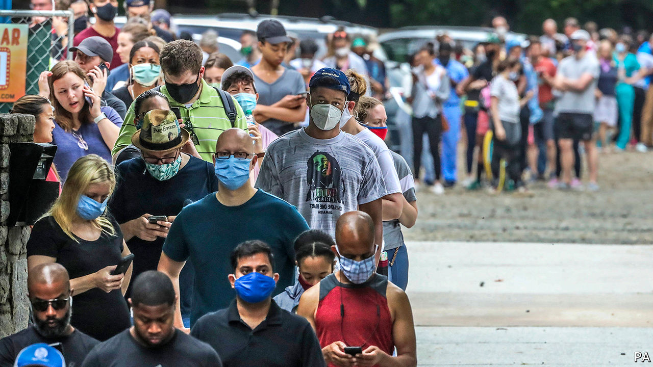

PARK TAVERN anchors the south-east corner of Atlanta’s charming Piedmont Park. It offers eclectic bar food, home-brewed beer, abundant outdoor seating, and a warm welcome to dogs. Like most bars, it usually comes to life in late afternoon. But on June 9th this year the queue stretched out of the door and round the building before 7am, and did not thin out until well after the dinner rush ended.

Atlantans were lined up not for Cowboy Rolls or (shudder) Unity Triple-Goddess Ginger Kombucha Beer. They were lined up to vote. No polling place served more Georgians in the June primary than Park Tavern, though the experience of waiting hours to cast a ballot was sadly common across the state. Whether this experience is repeated in November could matter a great deal.

In Georgia the secretary of state’s office certifies candidate eligibility, oversees voter registration and creates ballots, but leaves electoral administration to the state’s 159 counties—more than any state except Texas. The state maintains voter rolls, which many complain it does too rigidly, rejecting registrations, for instance, because, in the judgment of an election official, an applicant’s signature fails to precisely match a signature already on file. But counties choose and staff polling places, set electoral budgets and tabulate results.

Georgia was one of just nine states wholly subject to the “pre-clearance” requirement of the Voting Rights Act of 1965—meaning it had to seek federal approval for any changes to its voting practices—imposed on jurisdictions with a history of racially discriminatory voting practices. Since the Supreme Court invalidated that requirement in a ruling in 2013, Georgia’s counties have closed hundreds of polling places; between 2012 and 2018, only Texas and Arizona closed more.

According to data-crunching by Georgia Public Broadcasting News, more than 10% of Georgia’s polling places in the June 9th primary had to remain open past official closing time to accommodate voters (anyone in line when polls officially close can still vote). Two-thirds of them were in majority-minority precincts. Many black Georgians have grown accustomed to waiting hours to vote. Wanda Mosley, Georgia’s senior coordinator for Black Voters Matter, visited a precinct in a wealthy suburb north of Atlanta on June 9th. “When we pulled up,” she explained, “I thought we were in the wrong place. There were no lines. That’s not something I’m used to seeing.”

Georgia’s secretary of state’s office has a benign explanation for this. First, the primary took place during a pandemic; voters in other states also faced long waits because of higher-than-expected turnout, poll-worker shortages and a reduction in voting machines to maintain social distancing. For November’s election, Georgia has recruited more poll workers. Many of its counties have added polling places and will have trained technicians on hand to help with voting-machine problems. Second, in June’s primary, all Georgia’s counties used new voting machines for the first time. Some poll workers had problems operating them, which led to delays.

All this may be true. But many Georgians—particularly Democrats—view them sceptically. They remember, for instance, 2018, when the then secretary of state, Brian Kemp, defeated Stacey Abrams in an election plagued by irregularity that he oversaw. They may also remember Mr Kemp’s devotion to a regulation that rejected voter-registration applications because of discrepancies between names. A professor named Carlos del Rio, for instance, was erroneously registered as “delRio,” and, according to a lawsuit filed by Ms Abrams’s group Fair Fight, had to “navigate a lengthy process” to be able to vote. This exact-match system tends not to affect voters with names like Brian Kemp.

Perhaps the closures were a budgetary matter, and measures such as exact signature-matching are needed to prevent voter fraud. That is what Georgia’s Republicans would like their voters to believe. Perhaps the governor’s race was stolen, and Georgia’s electoral system is tainted by systemic racism. That is what Democrats would like their voters to believe. The state’s two Senate races (one is a special election) are on a knife’s edge: a lot hangs on which story motivates more voters.■

Dig deeper:  
Read the [best of our 2020 campaign coverage](https://www.economist.com/us-election-2020) and explore our [election forecasts](https://projects.economist.com/us-2020-forecast/president), then sign up for Checks and Balance, our [weekly newsletter](https://www.economist.com/checksandbalance/) and [podcast](https://play.acast.com/podcasts/2020/01/24/checks-and-balance-our-new-weekly-podcast-on-american-politics) on American politics.

This article was downloaded by calibre from <https://www.economist.com/united-states/2020/10/03/why-do-voters-in-georgia-face-so-many-hurdles-to-voting>

|  |  |  |  |
| --- | --- | --- | --- |
| Previous | Articles | Sections | Next |

|  |  |  |  |
| --- | --- | --- | --- |
| Previous | Articles | Sections | Next |

#### The other half

# Measuring poverty in the midst of America’s Covid-19 epidemic

After a temporary reprieve, poverty and hardship are increasing

Oct 3rd 2020 | WASHINGTON, DC

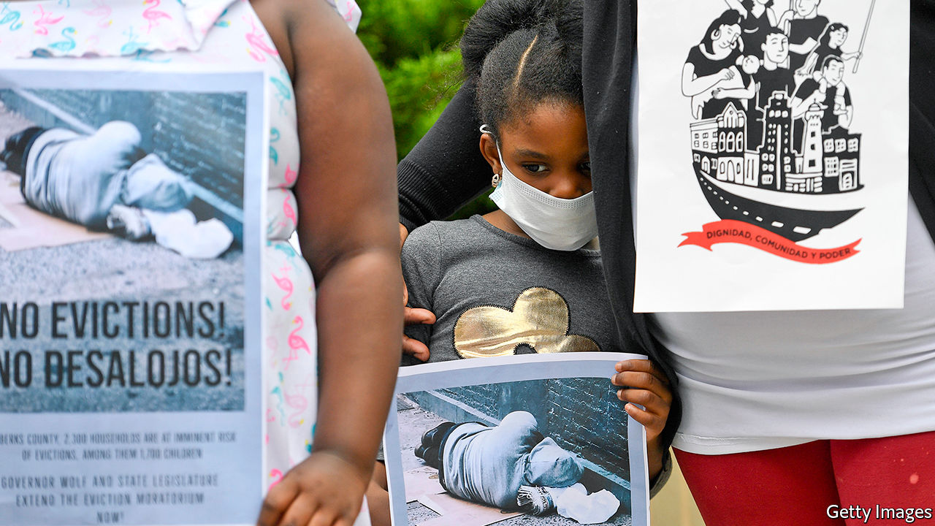

AT FIRST, A remarkable thing happened in the midst of an epidemic and the lockdown-induced recession. Poverty declined in America. A gargantuan stimulus package, which sent most households one-off cheques worth $1,200 or more and topped up unemployment benefits by $600 a week, buoyed millions of families above the official poverty line (set at $21,720 for a family of three). Ariel Kalil, a developmental psychologist at the University of Chicago, was conducting a long-running study on parental behaviour among poor parents (mostly single mothers) of young children in the city before the pandemic struck. Surveying these parents again when families were somewhat protected from the economic shock, she found parents and children getting along better despite the added stress from job losses.

Those supports expired in July, even as the pandemic persisted. And the reprieve proved transient. By August, poverty levels had nearly returned to their pre-pandemic levels. Other measures of hardship—like difficulties in affording food and housing—are at eye-popping levels, especially for less-educated workers and non-Asian minorities. The consequences for poor children might become apparent years from now in the form of reduced education, earnings and opportunity. With schooling, a theoretically equalising force, still disrupted and no vaccine yet, how can the extent of the damage be assessed?

Poverty measurement is usually a staid and slow affair. The Census Bureau issues an official number once a year. Using data from the monthly unemployment survey, however, economists have recently developed a procedure for generating timelier estimates to give real-time feedback. “We can explain the entire decline in poverty from April to June by the stimulus package,” says Bruce Meyer of the University of Chicago. His recent work, published with James X. Sullivan of the University of Notre Dame and Jeehoon Han of Zhejiang University, shows a nearly 15% drop in the poverty rate that then reversed after the stimulus lapsed (see chart). As before the pandemic struck, these rates are higher for African-Americans, workers without college degrees and children.

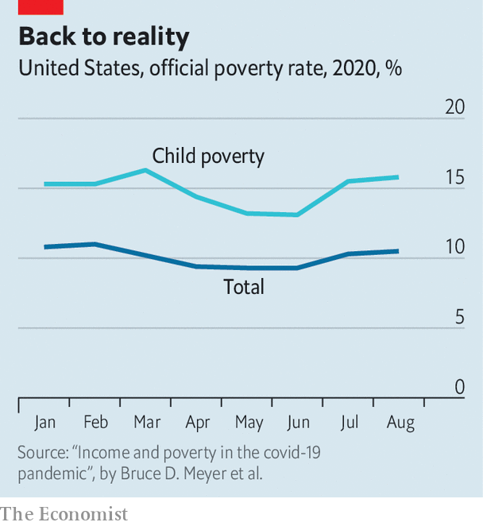

The Census Bureau has a new, more frequent survey which is designed to measure food insecurity, housing instability and other forms of distress. Among households with children, 14.4% reported not having enough to eat sometimes or often in the preceding seven days. For black and Hispanic households, this share rises to above 22%. Among those making less than $25,000 a year (and probably counting as officially poor), 35% report difficulty meeting this most basic need. These figures are high despite increased private and public attempts at relief. Food banks have reported operating at double capacity, and sometimes more. To compensate for children no longer receiving subsidised lunches at school, the federal government launched a programme to top up the nutrition-assistance benefits (“food stamps”, colloquially) for affected families. Though this amounted to just $5.70 per day of school missed, a recent analysis of that policy, published by the Hamilton Project, found that it reduced food hardship among children by 30%.

When food is difficult to afford, so is housing. Among renting families, 28% have little or no confidence in being able to pay next month’s rent (and some have already deferred it). Among Hispanic households who are renting, the share is 40%. This need not result in soaring homelessness. Citing the risk to public health of forced relocation during the pandemic, the Centres for Disease Control and Prevention (CDC) has announced a nationwide moratorium on eviction. Many states and cities have issued their own moratoria as well. But these are temporary salves. Under the CDC scheme, rent missed is not forgiven.

## No federal rescue

The picture from official government surveys matches that in self-reported ones. More than 40% of black, Latino and Native- American households said they had exhausted most or all of their savings (compared with 25% of whites) in a poll released by the Robert Wood Johnson Foundation. Robert Blendon of Harvard, who helped conduct the survey, likened the results to others he has conducted in the immediate aftermath of natural disasters like hurricanes. “I’m worried that there’s this false sense as the stockmarket does incredibly well that people’s lives are doing well,” says Richard Besser, the president of the foundation and former director of the CDC. “I’m worried coming into colder weather that there are so many people in America who have trouble paying for their utilities and putting food on the table.”

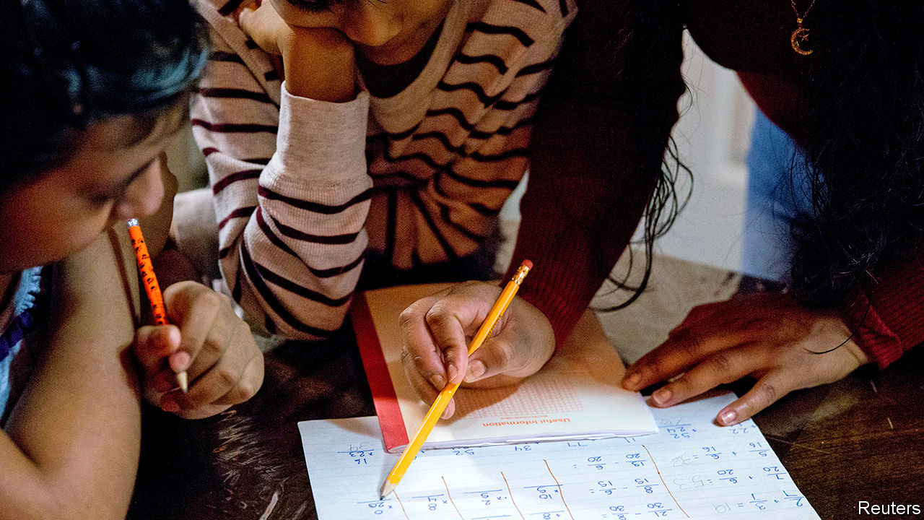

Indeed, all this is happening even as the stockmarket, President Donald Trump’s preferred economic barometer, has nearly recovered its yearly losses. The impact of the pandemic on economic growth overall is now expected to be more modest than once feared. These averages are encouraging, but a narrow focus on them ignores the serious problems for those at the bottom of the income distribution. “If we know anything about recessions, it’s that workers with low levels of education take a while to recover. And with kids out of school too, we can be sure that it will be bad for them too,” says Diane Schanzenbach, an economist at Northwestern University whose work has shown that government-nutrition programmes for children lead to better health and job-market opportunities later in life.

What chance is there of the federal government coming to the rescue? Talks between the House and the Treasury Secretary continue, but Congress is even less likely to put through a compromise package now that a Supreme Court battle looms. Even the programme to give boosted food stamps for children missing school came close to being scuppered during negotiations to fund the federal government.

States, cities and school districts are trying to cushion the blow. And charities are doing much more. Robin Hood, a large charity in New York City, has distributed $50m in relief since the city was hammered by the virus in March. Of that, $20m went to direct cash assistance for the most vulnerable—such as families whose breadwinner had died and undocumented immigrants, who don’t quality for aid. The City University of New York had 50,000 or more students who lost their jobs “overnight”, says Deb McCoy, who runs early childhood and youth programmes for Robin Hood. As extensive as these efforts are, they are little substitute for the fiscal firehose of the federal government. But those spigots are likely to stay closed for a few months more.■

This article was downloaded by calibre from <https://www.economist.com/united-states/2020/10/03/measuring-poverty-in-the-midst-of-americas-covid-19-epidemic>

|  |  |  |  |
| --- | --- | --- | --- |
| Previous | Articles | Sections | Next |

|  |  |  |  |
| --- | --- | --- | --- |
| Previous | Articles | Sections | Next |

#### Render unto Donald

# Priestly guidance on voting is dividing the Catholic church in America

In theory priests shouldn’t tell their flock how to vote. In practice they often do

Oct 3rd 2020 |

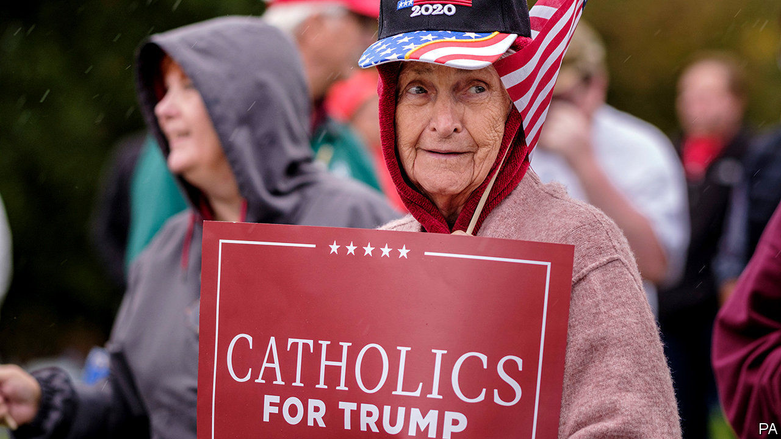

CAN A CATHOLIC vote for Joe Biden and avoid damnation? Bishop Joseph Strickland of Tyler, a diocese covering 33 counties in east Texas, doesn’t think so. Last month he endorsed a video made by a priest in Lacrosse, Wisconsin, which urged Catholic Democrats to “repent of your support of that party...or face the fires of hell”. In a tweet, Bishop Strickland thanked the priest for his courage and urged his followers to “HEED THIS MESSAGE”.

America’s political polarisation is reflected in the leadership of the Catholic church, which constitutes the country’s biggest single religious voting group. But the nomination of a Catholic as the Democratic candidate has accelerated the process. Although the church says clergy should not tell the faithful how they should or should not vote—such activity also imperils churches’ exemption from certain taxes—several prominent priests have castigated Mr Biden, claiming his pro-choice position on abortion means he is no Catholic. When Mr Biden announced his running mate, Kamala Harris, Thomas Tobin, the bishop of Providence tweeted: “First time in a while that the Democratic ticket hasn’t had a Catholic on it. Sad.”

In so doing they echo President Donald Trump’s efforts to play down his rival’s faith. The president has described Mr Biden, a practising Catholic, as following “the radical-left agenda…no religion, no anything, hurt the Bible, hurt God”. Some clerics have endorsed Mr Biden and rebuked Mr Trump, though they have been slapped down. When a priest in the archdiocese of Boston said he backed the former vice-president, explaining that although he was pro-life he believed women had the right to choose (a position he believed Mr Biden held too), he was forced to apologise.

It is not surprising that the church in America has become infected by partisan politicking. But the US Conference of Catholic Bishops (USCCB) has played a role in this. In 2009 many of the bishops signed the Manhattan Declaration, an agreement between socially conservative Catholics and Protestants that they would work together for traditional family values, that is, against gay marriage and abortion. Only the latter remains a live issue, but the bishops’ insistence that it is more important than any other has meant that tacit approval for Republican candidates—especially Mr Trump, who has embraced the pro-life cause—has become increasingly explicit.

That has led to rows. Though the church teaches that abortion is unequivocally wrong, it does not elevate it above other issues. It also has a strong tradition of emphasising issues of social justice. In a recent article in America magazine, a Catholic weekly, John Carr, a former adviser to the bishops, described how a small group of relatively progressive bishops argued against the USCCB’s plan to add a phrase to its voter-guidance document describing abortion as the “pre-eminent priority”. They also wanted it to include a paragraph by Pope Francis, explaining that “the lives of the poor, those already born, the destitute, the abandoned” were “equally sacred” as those of the “innocent unborn”. The bishops dismissed both proposals.

The partisanship this policy has encouraged among conservative priests increasingly extends to issues beyond abortion. A recent weekly newsletter at a church in Damascus, Maryland, rued the spate of Black Lives Matter protests without mentioning the cause of them.

## Sold into Egypt

How might all this affect the election? There is no homogenous Catholic vote: the church’s members vote along a jumble of social and demographic lines. Yet they will play a decisive role in the election. White Catholics are disproportionately represented in many battleground states, especially in the Midwest. Some 21% of the population is Catholic; in Wisconsin, which Mr Trump won by around 20,000 votes, that rises to 25%. In 2016 white Catholics voted for Mr Trump, though by a much smaller margin than white evangelicals did. Recent polls suggest Mr Biden may be stealing some of that support.

That is why Cardinal Timothy Dolan, the archbishop of New York, who has described Mr Trump as “a great friend of mine”, was invited to say the opening prayer at the Republican convention in August. The Democrats, meanwhile, showcased liberal Catholics: their convention featured a closing prayer by Father James Martin, who lobbies to make the church more welcoming to LGBT people (his appearance at the convention earned him a particular mention in the hell video). He was not a perfect fit: having prayed for the unemployed, poverty-stricken and desperate, he added “the unborn child in the womb”.■

Dig deeper:  
Read the [best of our 2020 campaign coverage](https://www.economist.com/us-election-2020) and explore our [election forecasts](https://projects.economist.com/us-2020-forecast/president), then sign up for Checks and Balance, our [weekly newsletter](https://www.economist.com/checksandbalance/) and [podcast](https://play.acast.com/podcasts/2020/01/24/checks-and-balance-our-new-weekly-podcast-on-american-politics) on American politics.

This article was downloaded by calibre from <https://www.economist.com/united-states/2020/10/03/priestly-guidance-on-voting-is-dividing-the-catholic-church-in-america>

|  |  |  |  |
| --- | --- | --- | --- |
| Previous | Articles | Sections | Next |

|  |  |  |  |
| --- | --- | --- | --- |
| Previous | Articles | Sections | Next |

#### Lexington

# The end of the debate

The president turns a globally respected American institution into a national embarrassment

Sep 30th 2020 |

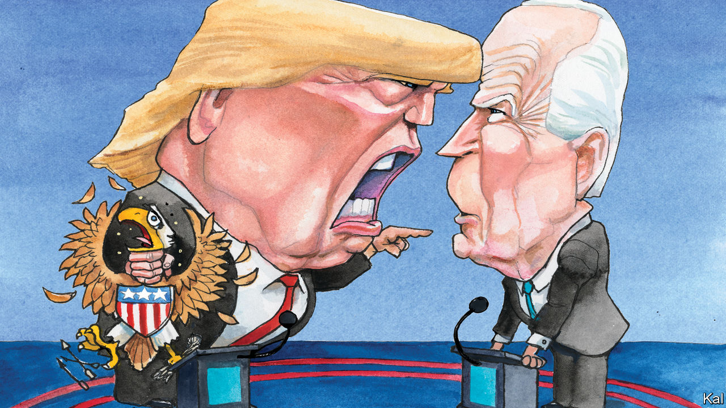

AMONG THE institutions Donald Trump has attacked in the past three and a half years, the televised presidential debate might not seem much. It does not guarantee the rule of law, protect the environment or defend the homeland. It has hardly ever been electorally significant. Maybe only the first televised duel, which pitted a sweaty, shady looking Richard Nixon against a youthful, make-up wearing John Kennedy in 1960, materially affected a race. Yet at a time when some of the most basic assumptions about American democracy are being challenged by Mr Trump’s scorched-earth presidency, as he illustrated with a debate performance of stunning brutishness in Cleveland on September 29th, the merits of the format are worth recalling.

Before this week they were threefold. The president, setting aside the exalted status and electoral advantages of incumbency, must submit to the same pre-agreed rules as his challenger. (No president since Nixon, following his humiliation in 1960, has ducked the format.) Second—and notwithstanding a mountain of evidence that most people do not vote on the basis of such things—debates affirm the importance of plans and ideas. This projects a degree of seriousness that is otherwise largely absent from most political coverage.

The candidates’ competing proposals also underline the degree to which elections are a choice. And because they are essentially making their pitches to a vast television audience, the debates also underline how that the choice falls to ordinary Americans. Boosted by a paucity of campaigning because of covid-19, the 90-minute, ad-free event in Cleveland was watched by an estimated 80m, over half the electorate. Millions more watched around the world—which speaks to a third quality of the presidential debate.

Combining democracy and mass culture, the format is archetypally American, yet has proved to be highly exportable. Even more people likely watch their own pre-election debates abroad—including, with encouragement from America’s non-partisan Commission on Presidential Debates, in fledgling African and Eastern European democracies—than tune in to America’s. These are not trivial accomplishments. Setting aside many moments of dullness and inanity, the four-yearly televised event is an enactment of American democracy and an advertisement for it of which Americans should be proud. But they can forget that for now.

Debating Hillary Clinton in 2016, Mr Trump strained the rules to the limit; he interrupted and physically intimidated his opponent (and promised to jail her). In Cleveland he largely ignored them. He interrupted, contradicted and traduced Joe Biden, and sometimes also the moderator, Chris Wallace of Fox News. He cavilled and scowled; he huffed and he ranted. The ferocity of his claimed grievances was formidable. It was also ludicrous. It might once even have seemed comical, were he not America’s president.

His criticisms of his Democratic rival were familiar, mostly or wholly inaccurate, and often contradictory. He accused Mr Biden of being so tough on crime that he had alienated African-Americans and so weak on it that he refused even to utter the phrase “law and order”. He accused him of being so enslaved to the left that he was pushing the left-wing policies, such as Medicare for All and the Green New Deal, that belonged to the Democratic rivals he trounced in his party’s primaries. When Mr Biden pushed back, Mr Trump crowed that he had “just lost the left”.

But many of his attacks were more personal. He suggested Mr Biden was unintelligent and levelled unsubstantiated corruption allegations at his surviving son. At times Mr Biden responded in intemperate kind—he called the president a racist, a liar, a clown and enjoined him: “Will you shut up, man?” But this was not a two-way fight. Mr Biden’s rehearsed chuckling forbearance was more striking in the moment than his insults. And Mr Wallace’s increasingly desperate remonstrations were almost exclusively aimed at the president.

Mr Biden also tried to lay out the traditional policy case, including, by his flubby standards, with some half-decent answers on policing and climate-change policy. For his part, Mr Trump made a handful of disjointed, mostly defensive, claims for his administration’s achievements: on the subject of insulin pricing, for example, he said “I’m getting it for so cheap it’s like water.” But he did not describe any policy or future plan wholly or in detail.

Was there a strategy to this beyond his usual refusal to be constrained by rules and need to dominate? Maybe not; those urges explain most of what Mr Trump does. But the strategic implications of his thuggery look no less dire for being, in all likelihood, unplanned. Ahead of an election he appears on course to lose, he is telling his supporters that Democrats are not merely hostile opponents but somehow illegitimate. He also repeated in Cleveland his unfounded claim that the election will “be a fraud like you’ve never seen”. Asked to condemn the violent white supremacists who have already taken to the streets on his behalf, in Oregon and elsewhere, he failed to do so. None of this seemed likely to help his electoral prospects. It is the kind of behaviour that has turned a small majority of Americans against him. And yet over 40% are still with him to the hilt.

## Flashing red

In “How Democracies Die”, published early in Mr Trump’s tenure, two Harvard scholars, Steven Levitsky and Daniel Ziblatt, described a slippery slope that starts with a trampling of democratic norms—thereby ending the degree of mutual trust between rivals that democracy requires—and proceeds through damage to institutions, especially those related to elections, to lawlessness and extremism. It is always possible to underestimate the shock absorbers in America’s vigorous, multi-tiered system. Yet at the federal level, it must be admitted, many of the warning lights they described are already flashing.■

Dig deeper:  
Read the [best of our 2020 campaign coverage](https://www.economist.com/us-election-2020) and explore our [election forecasts](https://projects.economist.com/us-2020-forecast/president), then sign up for Checks and Balance, our [weekly newsletter](https://www.economist.com/checksandbalance/) and [podcast](https://play.acast.com/podcasts/2020/01/24/checks-and-balance-our-new-weekly-podcast-on-american-politics) on American politics.

This article was downloaded by calibre from <https://www.economist.com/united-states/2020/09/30/the-end-of-the-debate>

|  |  |  |  |
| --- | --- | --- | --- |
| Previous | Articles | Sections | Next |

|  |  |  |
| --- | --- | --- |
| United States | Sections | Asia |

The Americas

Canada: Justin’s timing

.

Mexico: Tabascan onomastics

.

Peru: Patient, don’t heal thyself

.

Bello: The missing local links

.

|  |  |  |
| --- | --- | --- |
| United States | Sections | Asia |

|  |  |  |  |
| --- | --- | --- | --- |
|  | Articles | Sections | Next |

#### Justin’s timing

# Life is about to get harder for Canada’s minority government

The prime minister, Justin Trudeau, may be contemplating an early election

Oct 3rd 2020 | OTTAWA

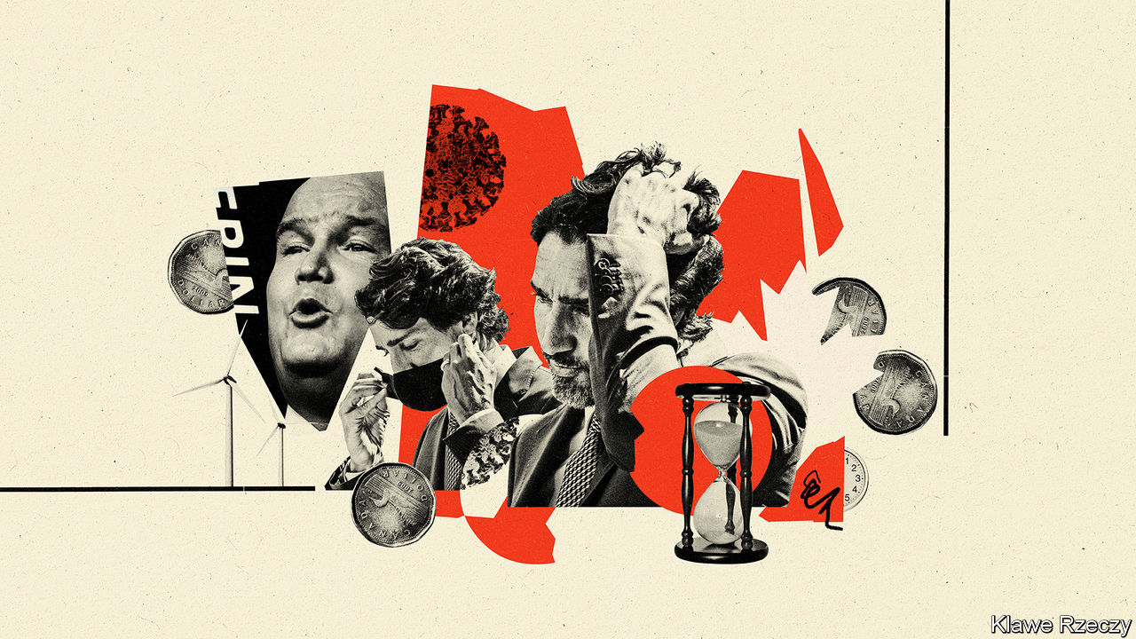

JUSTIN TRUDEAU, Canada’s prime minister, can be sure of passing the next test he faces. This month Parliament will hold a vote of confidence in his government. Although his Liberal Party is in a minority and Mr Trudeau has been weakened by scandal, the left-leaning New Democratic Party (NDP) will back the government. The prime minister has promised enough to families and businesses hurt by recession to keep the legislature’s fourth-largest party from voting against him.

After that, things will get harder. The Conservative Party picked a new leader on August 23rd: Erin O’Toole, a former air-force helicopter navigator and minister of veterans’ affairs. He will give new energy to the parliamentary opposition. Seven of the ten provincial premiers belong to his party or lean towards it. They are at odds with Mr Trudeau over spending priorities, the environment and the role the federal government plays in provincial affairs. The NDP will push for more concessions from the prime minister, for example higher taxes on the rich. He may be preparing for a national election as early as spring 2021 in which he will hope to win a majority.

The speech from the throne outlining the government’s plans, delivered on September 23rd by the governor-general, Julie Payette, was a programme for muddling through the pandemic and winning an election. It ignored or barely mentioned Mr Trudeau’s boldest ideas, such as a universal basic income and extending unemployment insurance to the gig economy.

Even so, his plans are expensive. With reported cases of covid-19 spiking since August, Ms Payette said that the government would spend “whatever it takes” to support workers and businesses. It wants to create a million new jobs, train more workers, set standards for care homes (where 80% of deaths from covid-19 have taken place), develop an early-learning and child-care programme and launch a scheme to help people pay for drug prescriptions.

The government has said nothing about how much this will cost. It has yet to present a budget for the current fiscal year, which ends in March. Chrystia Freeland, the finance minister, has promised a bare-bones “fiscal update” before January. The parliamentary budget office (PBO) expects this year’s deficit to reach C$330bn ($250bn), or 15% of GDP. Public debt will rise by 17 percentage points to 48% of GDP.

While the pandemic rages, the government will not encounter much resistance. On September 30th Parliament unanimously passed legislation to give more aid to workers. Mr O’Toole warns that “there is not an unlimited pot of ever-increasing deficit spending” but is not calling for immediate cuts. It helps that much of the current rise in spending is temporary. The PBO expects the deficit to drop to C$40bn by 2024-25. Mr O’Toole proposes to eliminate it within a decade of taking office.

The battles will be about issues beyond economic life support. Mr Trudeau will face opposition “in a host of ways from virtually all the provincial premiers”, says Graham Fox, president of the Institute for Research on Public Policy, a think-tank in Montreal. Most of what the prime minister proposes in such areas as child care and job training are mainly provincial responsibilities. Provinces are eager for more federal money—they want the government to raise its contribution to health-care spending to 35% of the total from 22%, for example—but not for more federal influence over how it is spent. The throne speech ignored such demands.

The government promised to end net emissions of greenhouse gases by 2050. Jason Kenney, Alberta’s Conservative premier, complains that it is doing too little to support the oil and gas industry, on which the province depends. These tensions will worsen, warns Mr Fox, unless the federal government co-operates more closely with the premiers than it has done until now.

Shaping the protagonists’ plans is the knowledge that the average lifespan of minority governments is two years. Mr Trudeau’s is about to celebrate its first birthday. Its ageing process was delayed by the pandemic. Senescence resumed over the summer, with revelations that the families of Mr Trudeau and the then-finance minister, Bill Morneau, had taken benefits from a charity that got government contracts (Mr Morneau resigned in August). It may speed up if the economy worsens. Although growth bounced back during the summer, a second wave of covid-19 and a tapering off of fiscal stimulus in the United States could end the recovery, warns Douglas Porter, the chief economist of BMO, a bank.

As he contemplates when to call a new election, Mr Trudeau will watch closely the fate of the NDP-led minority government in the western province of British Columbia. Its premier, John Horgan, triggered an election a year early, on October 24th, after saying he would not. Like Mr Trudeau, he prepared the way by boosting spending. If Mr Horgan wins a majority, that may embolden Mr Trudeau to gamble on an election sooner rather than later. Until then, he will have to check his ambitions.■

This article was downloaded by calibre from <https://www.economist.com/the-americas/2020/10/03/life-is-about-to-get-harder-for-canadas-minority-government>

|  |  |  |  |
| --- | --- | --- | --- |
|  | Articles | Sections | Next |

|  |  |  |  |
| --- | --- | --- | --- |
| Previous | Articles | Sections | Next |

#### Tabascan onomastics

# A Mexican state with a tradition of giving children odd names

The saints didn’t march all the way in

Oct 3rd 2020 | VILLAHERMOSA

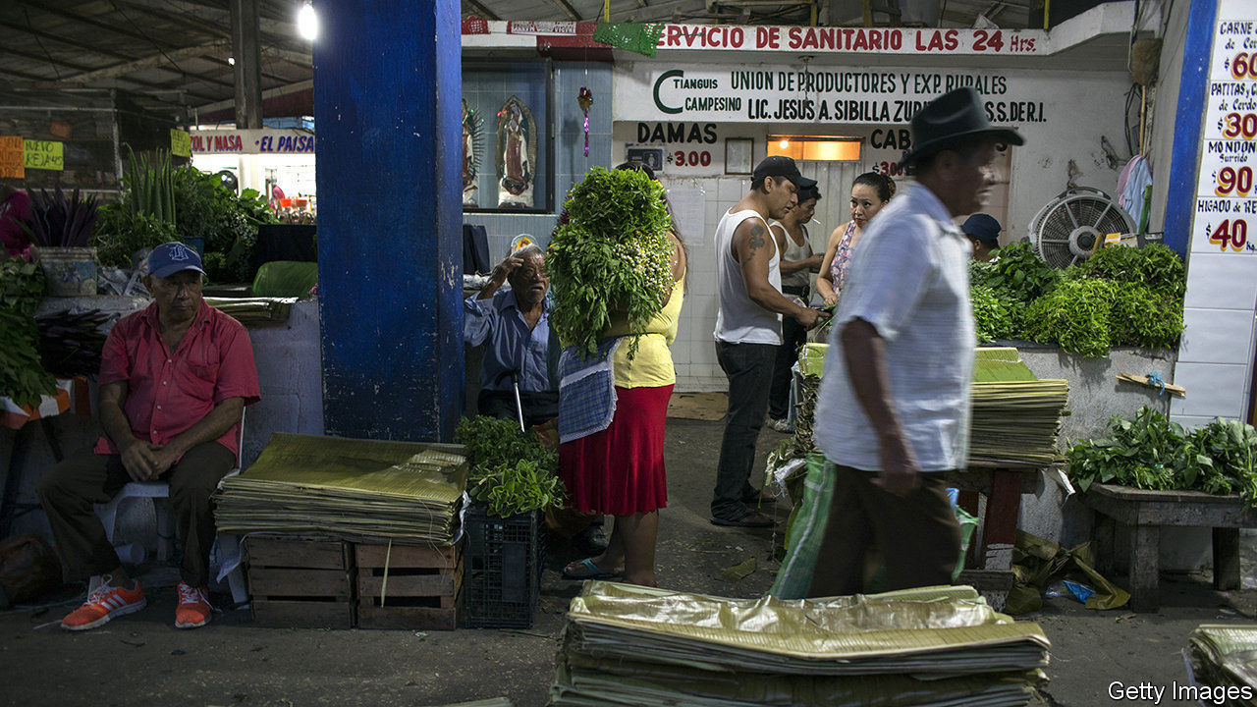

ON A SCORCHING Saturday in Jonuta, a poor region of the tropical Mexican state of Tabasco, a woman sits in the shade by a river cradling her granddaughter. The child’s name is Sirse, a twist on Circe, a Greek sorceress who turned her enemies into animals. “I saw the name in a novel and I liked it,” explains Sirse’s mother, Nabil. The trend towards greater variety in names is a global one. In Tabasco, giving babies unusual names, often based on Greek ones, is a proud tradition.

It impressed Amado Nervo, a Mexican poet. In every family “there is a Homer, a Cornelia, a Brutus, a Shalmanasar and a Hera,” he wrote in “The Elysian Fields of Tabasco”, which was published in 1896. Rather than scour the calendar for saints’ names, he wrote, parents of newborns “search for them in ‘The Iliad’, ‘The Aeneid’, the Bible and in the history books”. Andrés Iduarte, a Tabascan essayist of the 20th century, concurred. Tabasco is a place “of Greek names and African soul”, he wrote, endorsing the cliché that the state has similarities with Africa.

Nearby Yucatán and Veracruz also have a fondness for unusual names. But it is strongest in Tabasco, the home state of Mexico’s president, Andrés Manuel López Obrador. It may have originated as a creative way to resist pressure from the Catholic church to name children after saints. Tomás Garrido Canabal, an anticlerical governor in the 1920s and 1930s, christened his farm animals Dios (God), Jesús and María. He named his son Lenin. Alejandro Rojas Díaz Durán, a candidate to lead Morena, the Mexican president’s political party, proposes changing the name of the state itself to Tabasco de López Obrador.

Some attribute the state’s inventiveness to the weather. As its climate boils, “so too it boils our tongues and drives us to talk up to our elbows. Otherwise, we would burst,” observes the introduction to a dictionary of Tabascan slang, published in 2010.

Although Greek names are less popular than they were, the taste for non-Spanish ones continues. “I am not Arabic,” says Abderraman Ortíz, a street seller in Villahermosa, the state capital, “but once an Arab told me that my name means something about a caliphate.” If so, it is probably a reference to Abd al-Rahman III, the first caliph of Córdoba in Spain, who ruled a thousand years ago. “My name comes from the Russian astronaut,” explains Aldrin Guadalupe Díaz Castro, an insurance agent. “But my mother was a teacher. She had a pupil named Aldrin in her class and she liked it.” The pupil was probably named after the American moonwalker Buzz Aldrin.

“People get offended when you get their names wrong,” says Livny Isabel Morales Jiménez, who encounters plenty of odd ones as she scribbles them for coffee drinkers on Starbucks cups. One regular is called Uba, “like the fruit uva [grape], but with a ‘b’”. Ms Morales’s first name is a variation of Libni, a son of Gershon, who is mentioned in Exodus. Geney Torruco, Villahermosa’s official chronicler (see [article](https://www.economist.com/node/21792324)), recalls a friend, a “well-read traveller”, whose daughter, Penicilina, was born ill but cured by a dose of antibiotics.

Some Mexican states discourage “pejorative” names that might hurt children in later life. On Sonora’s blacklist are Burger King, Usnavy, Christmas Day and Aniv De La Rev (short for “anniversary of the revolution”). Should Tabasco follow suit? Even there, onomastic originality exacts a price. “They bully the kids here in the school, from primary until university,” says Gerald Washington Herrera, a legislator in Tabasco. Last year he proposed a law that would restrict what names parents could give their children and make it easier for adults with awkward names to change them. The legislature did not debate his idea. Tabascans revel in marvellous monikers. The more boys there are called Yonefequénedi (say it aloud) the less they will suffer in the playgrounds.■

This article was downloaded by calibre from <https://www.economist.com/the-americas/2020/10/03/a-mexican-state-with-a-tradition-of-giving-children-odd-names>

|  |  |  |  |
| --- | --- | --- | --- |
| Previous | Articles | Sections | Next |

|  |  |  |  |
| --- | --- | --- | --- |
| Previous | Articles | Sections | Next |

#### Patient, don’t heal thyself

# Self-medication increases pandemic deaths in Peru

The gullible gobble steroids and anticoagulants

Oct 3rd 2020 | LIMA

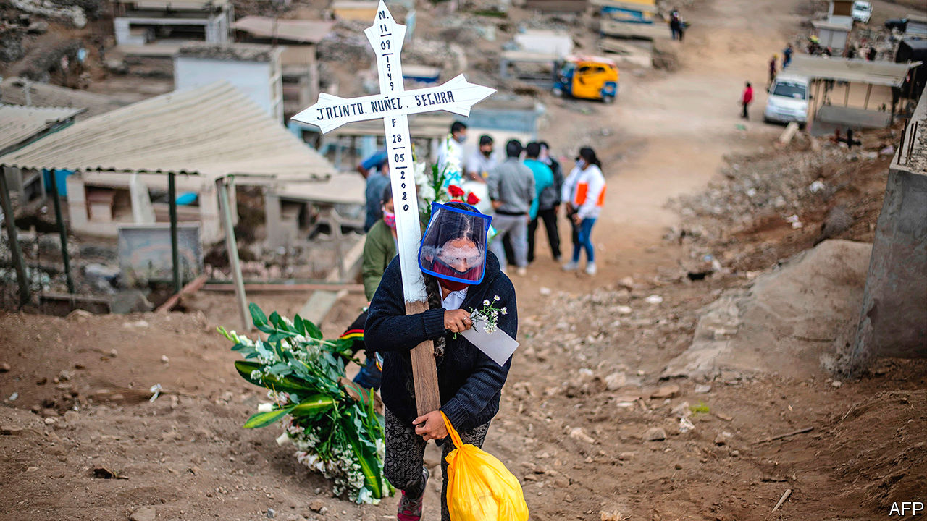

LUIS ESPINOZA has been battling covid-19 in Peru since March. A doctor specialising in tropical medicine and infectious diseases, he was sent by the health ministry to Iquitos, in the northern jungle, when the pandemic began, then moved to Sullana, a sweltering northern city. Both cities have high numbers of deaths from covid-19. Many, says Dr Espinoza, were avoidable. “Patients who should not be dying are dying because of complications caused by self-medicating,” he says. That may help explain why Peru has had more deaths from the disease as a share of its population than all but one other country.

Self-medication is not a new problem. A third to a half of Peruvians use medicines that are not prescribed by a doctor, studies show. Against a variety of maladies they swallow antibiotics, steroids, anti-clotting medicines and the veterinarian version of ivermectin, which is used against parasites such as intestinal worms. Chlorine dioxide, a disinfectant, is also popular.

More than half of Peruvians think ivermectin and chlorine dioxide are possible remedies for covid-19, according to a poll by the Peruvian Studies Institute, a think-tank. In Sullana patients take steroids, which suppress the immune system, wear a mask, “and think they are totally protected”, says Dr Espinoza. “When I see them it is usually too late.” In Iquitos at least half the 700 who died in the hospital where he worked could have been saved, had they not taken steroids and ivermectin.

Early in the pandemic many Peruvians, having heard that the coronavirus causes blood clots, gobbled anticoagulants. Some bled to death, says Percy Mayta-Tristán, editor of Acta Medica, a magazine published by the Peruvian medical association. Some politicians push chlorine dioxide as a cure. Union for Peru, a populist left-wing party, called for the formation of a committee to study its effects.

Peru has laws to prevent misuse of medicines, but they are hard to enforce. Carol Avalos, a clerk at a pharmacy in Lima, the capital, says customers object to being told they need prescriptions. The pandemic has made them more aggressive, she says. Some pharmacists are reluctant to argue. Alberto Tutaya, a paediatrician who worked on a government plan to curb self-medication, says it is a response to a shortage of clinics and doctors. Peru has just 13 doctors per 10,000 people, among the lowest rates in South America. “Self-medication shows the limits of our health system,” he says. “The desperation caused by the virus has only made it worse.”■

This article was downloaded by calibre from <https://www.economist.com/the-americas/2020/10/03/self-medication-increases-pandemic-deaths-in-peru>

|  |  |  |  |
| --- | --- | --- | --- |
| Previous | Articles | Sections | Next |

|  |  |  |  |
| --- | --- | --- | --- |
| Previous | Articles | Sections | Next |

#### Bello

# The growing importance of Latin America’s mayors

Decentralisation would cure some of what ails the region

Oct 3rd 2020 |

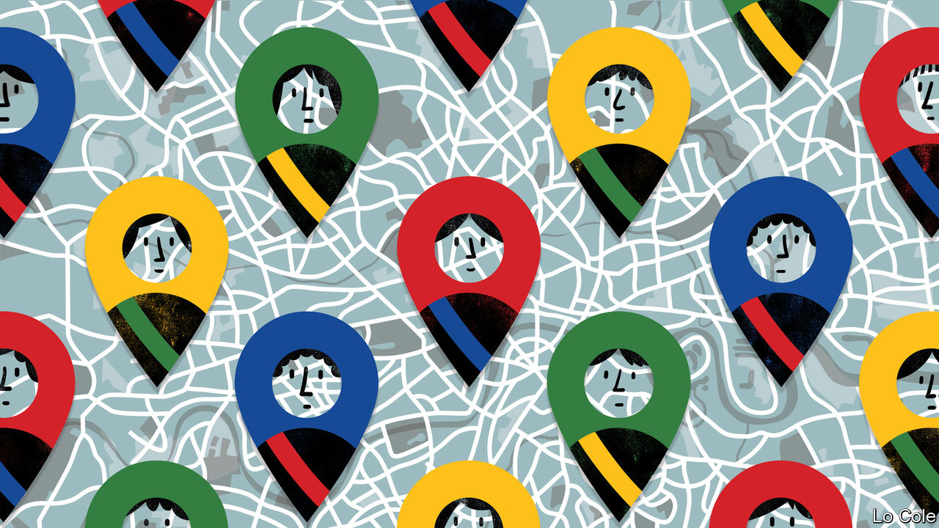

CHILE’S PRESIDENTIAL election is still 14 months away. But it is striking that the early front-runners in the opinion polls are the mayors of three districts of Santiago, the capital: Joaquín Lavín, a mildly populist conservative; Evelyn Matthei, a more orthodox one; and Daniel Jadue, a communist. Their prominence is a sign that in Chile, where disillusion with the political class was behind a huge wave of protests a year ago, mayors are less discredited than parliamentarians or ministers.

With the exception of Brazil, long a genuinely federal country, Latin American government has been highly centralised. According to a database prepared by the OECD, an intergovernmental research group, spending by subnational governments in Latin America is equal to only 6% of GDP, compared with almost 10% in the Asia-Pacific region and 12% in Europe and North America. Mayors and governors are responsible for 18% of total government spending in Latin America, compared with more than 35% in the Asia-Pacific. Local governments in Latin America raise little of their own revenue, which means mayors are not fully accountable for the money they spend.

This centralisation is rooted in history, in Spanish colonialism and in the struggle of fledgling republics to impose the authority of the state. But it is a poor fit for the present. Latin America is now highly urbanised. Its megacities are violent, unequal and have lousy infrastructure. The pandemic has highlighted many of these problems. In many places, local as well as national governments were overwhelmed. But not everywhere.

In Chile, mayors pushed for the schools to close, for lockdowns of their districts and for the government to consult them. In Colombia the mayor of Medellín, Daniel Quintero, used data and an app to distribute aid during lockdown and trace the contacts of infected people. Horacio Rodríguez Larreta, the mayor of Buenos Aires, has steered a course between collaborating with Argentina’s Peronist president, Alberto Fernández, a political foe, and cautiously reopening the city. Mayors in Huancavelica, a department in Peru’s high Andes, have worked with health officials and schools to set up community-based contact tracing. In Brazil’s municipal elections, due in November, many big-city mayors are likely to be re-elected because of their visibility during the pandemic, according to several political consultants.

The rise of mayors is a global trend. In Latin America, as elsewhere, it owes much to their closeness to the populace. “People empathise with mayors,” says Carolina Tohá, a political scientist who was a centre-left mayor of central Santiago from 2012 to 2016. “They see them demanding things [from central government] every day, and trying to do their best in difficult circumstances.” She thinks that many of the flaws exposed by the pandemic—such as inequality in access to services, reliance on overcrowded public transport and lack of good housing—can be alleviated by decentralisation. Carlos Moreno, a Colombian urbanist at the Sorbonne, a university in Paris, has promoted the idea of the “15-minute city”, in which everyone is within a quarter of an hour’s walk of services and leisure facilities. Even if only partly applied, this could transform Latin American cities. And Latin Americans, like people elsewhere, want more influence over the natural environment in their area.

Greater decentralisation is no panacea. It can increase regional inequality unless accompanied by redistribution of revenue. As the poor relation, the municipality tends to lack good managers and is often corrupt. In Peru more than 2,000 mayors have been charged with graft since 2002. While Chile is generally cleaner than its neighbours, municipalities there are more corrupt than other levels of government. Yet these problems are themselves consequences of centralism. Watchdogs are remote, and local governments are unable to offer good career prospects for the ambitious.

At a time when many Latin Americans are fed up with their democracies, more decentralisation could be a way to refresh them. Chile is the country to watch. This month it is set to vote to draw up a new constitution. This is likely to devolve more power and money to mayors. Both Mr Lavín and the left pay lip-service to that. Across the political spectrum the centralist instinct is strong. But “there is a citizen demand for more decentralisation”, says Ms Tohá. The trick will be to achieve it while making Latin America more, rather than even less, governable.

This article was downloaded by calibre from <https://www.economist.com/the-americas/2020/10/03/the-growing-importance-of-latin-americas-mayors>

|  |  |  |  |
| --- | --- | --- | --- |
| Previous | Articles | Sections | Next |

|  |  |  |
| --- | --- | --- |
| The Americas | Sections | China |

Asia

The coronavirus in South Asia: India v Pakistan v covid-19

.

Natural resources in Uzbekistan: Colourless, odourless, buyerless

.

Elections in New Zealand: Jacindarella

.

Investing in Myanmar: No time for details

.

Banyan: Always the man of the future

.

|  |  |  |
| --- | --- | --- |
| The Americas | Sections | China |

|  |  |  |  |
| --- | --- | --- | --- |
|  | Articles | Sections | Next |

#### India v Pakistan v covid-19

# Is Pakistan really handling the pandemic better than India?

It appears to be, though the official data do not tell the whole story

Sep 30th 2020 | ISLAMABAD

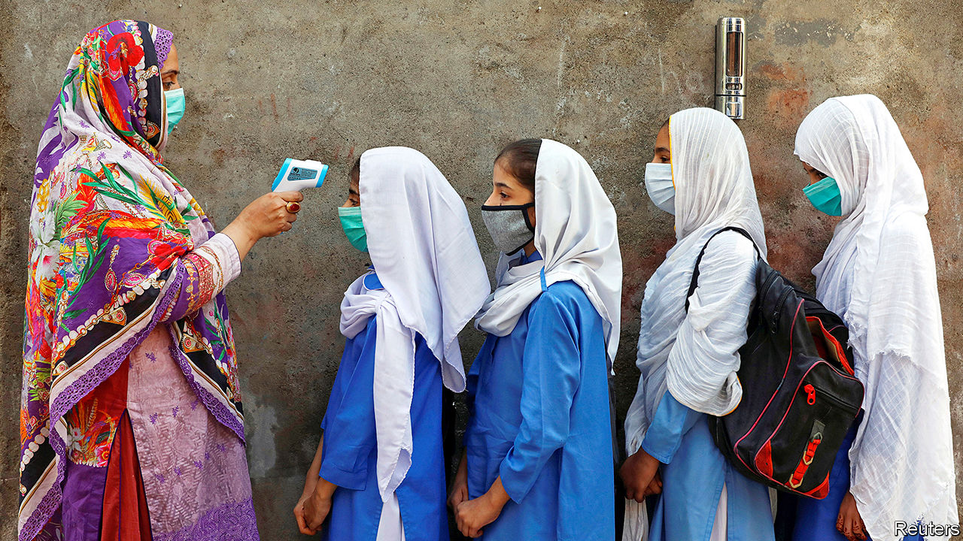

IN STATISTICS IF not in cricket, India tends to trump its perennial rival Pakistan. It is four times larger in area, seven times in population and ten times in GDP. Yet in the dismal realm of covid-19, bigger numbers are nothing to boast of. According to both countries’ official tallies, every week of the past month has claimed more Indian lives than the entire nine months of the pandemic have in Pakistan—some 6,500.

Whereas India’s burden is still rising by 70,000 new cases a day, Pakistan’s caseload seems to have peaked three months ago. Its daily total of new cases has remained in the mere hundreds since early August. India’s economy has also fared far worse. The Asian Development Bank predicts that its GDP will shrink by fully 9% in the current fiscal year, compared with a contraction of 0.4% for Pakistan.

“We have not only managed to control the virus, stabilise our economy, but most importantly, we have been able to protect the poorest segment of our society from the worst fallouts of the lockdown,” crowed Imran Khan, Pakistan’s prime minister, in a recent video address to the UN General Assembly. Meanwhile, ordinary Pakistanis are doffing masks and disregarding social-distance rules. “I didn’t fall sick and neither did anyone I know,” declares Irfanullah Khan, a grocer in Islamabad’s Najam market. “Now it’s over.”

Experts loudly chorus that such conclusions are wrong, yet they do concur that Pakistan is enjoying an unexpected reprieve. For weeks in late summer, international health officials were reluctant to accept that the rapid fall in cases as revealed by testing data could really be correct. Yet the proportion of tests coming back positive was also falling, as were the numbers of people being taken to hospital or being kept in intensive care.

All this is puzzling, considering that, although both countries spend painfully little on public health, Pakistan’s health infrastructure is considerably flimsier than India’s. Odder still is that whereas India’s covid policies have been sharp and strict, Pakistan’s have been relatively lax. In the same week in March when Narendra Modi, India’s prime minister, won praise for sealing borders, stopping trains and slapping his 1.3bn fellow citizens under a harsh lockdown that ended up lasting two months, Mr Khan attracted wagging fingers for objecting that many of his own countrymen were too poor to endure such strictures. Rather than shut down the whole country, Pakistan adopted a piecemeal approach that focused on isolating areas where there were outbreaks and on providing cash handouts to the poorest.

Mr Khan’s supporters say this policy’s success was aided by the creation of a national command centre to co-ordinate regional policies and by enlisting the army, including its tentacular security apparatus, for contact-tracing efforts. Others say efficient redeployment of a national polio-eradication campaign provided more vital boots on the ground to combat covid.

There are less heroic reasons for Pakistan’s lower covid toll, too. Some, ironically, stem from its relative backwardness. “Basically, it is undertesting on a massive scale,” contends Ramanan Laxminarayan of Princeton University. He notes that Pakistan tests for covid at less than a quarter of India’s rate, per person, adding that the relatively poor Indian state of Uttar Pradesh, with a population equal to Pakistan’s and a similar failure to test widely, has also registered similar numbers of cases and fatalities (see chart). “Test not, find not,” says Mr Laxminarayan. “It’s the same with authoritarian regimes the world over.”

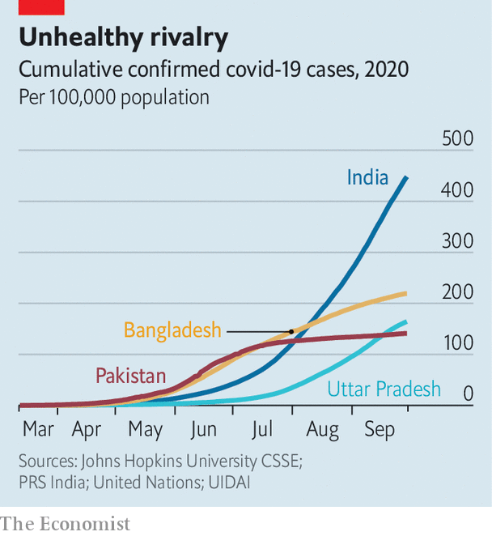

Demography is another factor. Both Pakistan and India have a far smaller proportion of old people than rich countries do. Just 4% of Pakistanis are over 65, for example, compared with 23% of Italians. Yet the median age in Pakistan, 23, is four years lower than India’s, and its average life expectancy, 67, is two years shorter. This puts a far smaller proportion of Pakistanis in the age bracket most vulnerable to covid.

Although both countries remain largely rural, Indians are much more mobile, both domestically and internationally. Some 160m Indians travel by air annually compared with fewer than 10m Pakistanis; passenger traffic on Indian railways is 130 times greater. Mr Modi’s lockdown, ironically, first bottled tens of millions of migrant workers inside cities that were often reservoirs of covid and then, as pressure mounted to let them return to their villages, distributed the epidemic more widely. Pakistanis, by and large, have instead stayed put at home, which more often means a family home in a village, and less often the kind of crowded workers’ colonies that ring Indian cities. The laxness of Pakistan’s lockdown meant that most small businesses stayed open, whereas nearly all in India were forced to close.

In a further irony, relative prosperity has made not just India’s health but also its economy more vulnerable to covid. The pandemic has slammed not just the huge informal sector, but such big drivers of growth as carmakers and airlines. Pakistan, in contrast, has fewer industries to attract and then dismiss migrant labour, fewer planes and trains to idle, fewer and less complex supply chains to sever. Not surprisingly, the ADB foresees India’s more sensitive economy springing back next year with 8% growth, whereas Pakistan’s is expected to grow just 2%.

Despite the starkly different trajectories covid has taken so far in India and Pakistan, experts warn against drawing firm conclusions. “Our lockdown may have hurt India more than the disease itself, but in other respects we are much like Pakistan,” says Jayaprakash Muliyil, an adviser to India’s National Institute of Epidemiology. None of the numbers coming from either country is likely to present a true picture, he suggests: “We both really cannot see what is happening in villages, where most people live, and we share the same disdain for proper data.”

Serological studies, which detect covid antibodies rather than active infections, have in both countries suggested a vast gap between actual and declared caseloads. A study in Islamabad in June estimated that 14.5% of the 2m people in Pakistan’s capital had already been infected—as many as the official number for the entire country at the time. A nationwide serological survey by India’s government, the results of which were inexplicably delayed until September, suggests that India had in fact already reached its current official covid tally of some 6m cases by early May, well before official numbers surged. The Lancet, a medical journal, charged India with putting misleading “positive spin” on data. Health professionals warn that Pakistan, like its other big neighbour Iran, could soon find itself experiencing a second wave. Zulfiqar Bhutta, a professor at Aga Khan University in Karachi, Pakistan’s biggest city, advises against complacency: “At this point in time nobody should be crowing, and nobody should be declaring game over.” ■

This article was downloaded by calibre from <https://www.economist.com/asia/2020/09/30/is-pakistan-really-handling-the-pandemic-better-than-india>

|  |  |  |  |
| --- | --- | --- | --- |
|  | Articles | Sections | Next |

|  |  |  |  |
| --- | --- | --- | --- |
| Previous | Articles | Sections | Next |

#### Colourless, odourless, buyerless

# Unable to export its natural gas, Uzbekistan tries using it itself

The government plans to turn gas into petrol and plastics

Oct 3rd 2020 | QARSHI

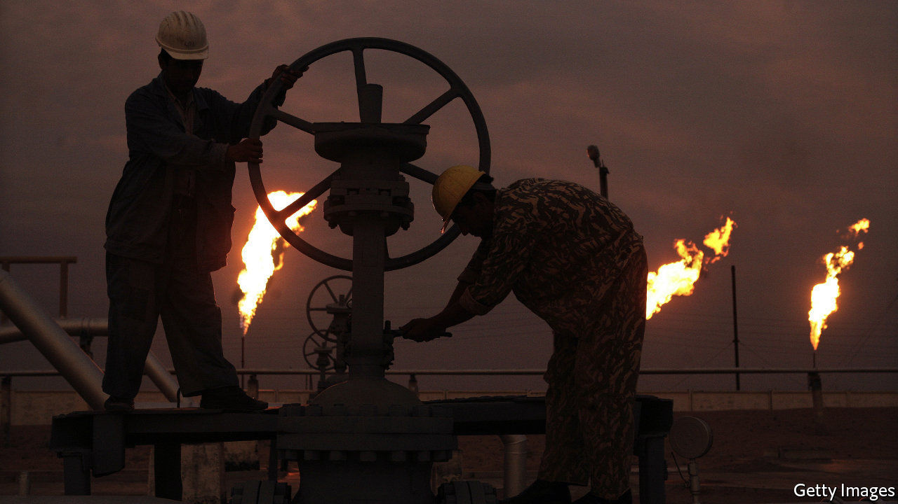

UZBEKISTAN, AS ANY pub-quiz regular can attest, is doubly landlocked: landlocked itself, and surrounded by landlocked countries. That is unfortunate, given that one of its main exports, natural gas, is increasingly traded by sea. What is more, the trend to liquefy gas and ship it around the world in giant tankers has given importers much more choice about where to buy. The result has been more competition, lower prices and thus a much more difficult market for countries like Uzbekistan that export their gas the old-fashioned way, by pipeline. As if to underline the idea that exporting gas by pipeline was an unreliable way to earn a living, China cut its imports of Uzbek gas by two-thirds this year amid the coronavirus-induced economic slowdown, and Russia shut them off altogether. Those two countries sucked up 80% of Uzbekistan’s $2.3bn of gas exports last year, leaving Uzbekistan with lots of gas it has no way of selling.

The government’s solution is to consume the gas itself. Near the industrial city of Qarshi, it is pouring $3.6bn into a plant that will turn Uzbekistan’s gas into petrol and other liquid fuels, a process called gas-to-liquids. It is also encouraging the construction of factories that use gas as a feedstock to make plastics and other petrochemicals. A Chinese-owned PVC factory, for instance, opened late last year about 140km from Qarshi. The plan is to end all gas exports by 2025, even as production of gas grows.

The global market for gas is volatile, complains Ulugbek Sayidov, chairman of the state-owned company that runs the country’s pipelines: “It’s better for us to use this gas on the domestic market as opposed to exporting it.” The government reckons it can make more money by processing the gas, as well as creating jobs and attracting investment. It believes manufacturing polythene, for instance, should generate eight times the value of simply selling the gas used to make it. It wants plastic production to grow 20-fold by 2030. Gas is not the only resource the government wants to put to better use: it hopes to end the export of raw cotton this year, as well.

But gas-to-liquids, at least, is a capital-intensive technology that is usually viable only when oil prices are high, notes David Ramberg, a former academic. Only four other countries use it: Malaysia, Nigeria, Qatar and South Africa. The government, however, insists that even with the oil price at the current $40 or so a barrel, it will save $1bn a year on fuel imports. Oltin Yo’l (Golden Road), the gas-to-liquids plant, will be profitable when it opens next year, promises Bekhzot Normatov, a deputy energy minister. Even sceptics concede that its output is more valuable than unsold gas, stranded untouched below the steppe.

This article was downloaded by calibre from <https://www.economist.com/asia/2020/10/03/unable-to-export-its-natural-gas-uzbekistan-tries-using-it-itself>

|  |  |  |  |
| --- | --- | --- | --- |
| Previous | Articles | Sections | Next |

|  |  |  |  |
| --- | --- | --- | --- |
| Previous | Articles | Sections | Next |

#### Jacindarella

# A fairy-tale election result beckons for New Zealand’s prime minister

But the more popular she gets, the less transforming Jacinda Ardern becomes

Oct 3rd 2020 | SYDNEY

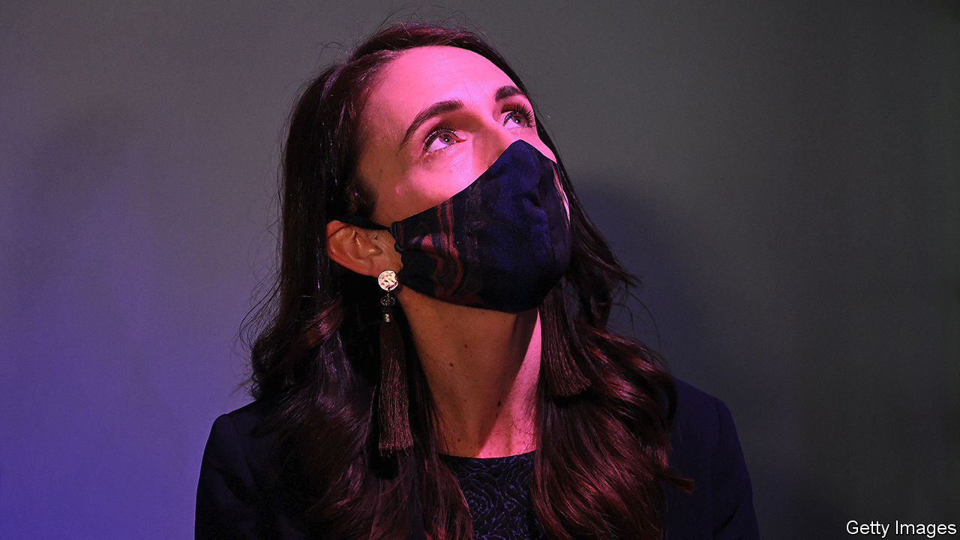

JACINDA ARDERN’S staff ran into a problem after she declared New Zealand free of the coronavirus in June. It was impossible to keep the prime minister on schedule, they griped, because she was constantly mobbed by supporters. Patrons jumped up to applaud her when she went out for dinner. Passers-by hung out of car windows to yell their thanks. At the convention of her party, Labour, one eulogiser declared her “our nation’s saviour”.

Even after a modest resurgence of the disease, New Zealanders continued to commend Ms Ardern for averting the worst. She closed their borders to foreigners and rallied a “team of 5m” (ie, everyone in the country) to support one of the toughest lockdowns in the world. As a result, New Zealand has seen only 25 deaths from covid-19. Many voters, says Ben Thomas, a former government staffer under the opposition National Party, feel that Ms Ardern has “literally saved them”.

All this puts the prime minister on track for a big victory in an election on October 17th. The latest polls suggest that Labour may win 47% of the vote, which would give it 59 seats in the unicameral parliament. It needs 61 seats in the 120-seat chamber for an outright majority—a feat never achieved since New Zealand adopted a proportional voting system in 1996.

Either way, Ms Ardern will be in a far stronger parliamentary position than she is now. Labour actually lost the most recent election, in 2017, securing just 46 seats to National’s 56. Ms Ardern was able to form a government only with the support of New Zealand First, a populist party. Even then, she needed backing from the Greens, not formally part of the coalition.

This time around, New Zealand First is unlikely to win any seats: it is polling well below the 5% minimum needed to guarantee a seat in parliament. Ms Ardern will not be losing any sleep about that. Winston Peters, New Zealand First’s leader, has obstructed her plans on everything from stronger hate-speech laws to a capital-gains tax. If Ms Ardern falls short of a majority, she will find a more compliant coalition partner in the Greens. Together, they might form the first wholly left-wing coalition to run the country in 20 years.

What makes such a prospect all the more striking is that, before the pandemic, Ms Ardern was on track to lose the election. She came into office with lofty plans to “build a fairer, better New Zealand” by reducing child poverty, ending homelessness and erecting 100,000 cheap houses—none of which she has managed to do. She is lauded overseas for her forthright defence of immigrants after a massacre at two mosques in Christchurch in 2019, as well as for her upbeat, no-nonsense demeanour, especially regarding her pregnancy and maternity leave while in office. Many New Zealanders, however, used to grumble that she had achieved little of substance. “On almost every front, this government has been a failure,” says Oliver Hartwich of the New Zealand Initiative, a think-tank.

New Zealand’s rebuffing of covid-19 has put paid to that complaint. It helps, too, that the opposition has been in turmoil. National has churned through three leaders since May, and several of its senior MPs have resigned. Its latest boss, Judith “Crusher” Collins, is trying to look even tougher than Ms Ardern on the virus. She complains that the government allowed covid-19 back into New Zealand because it did not test officials who came into contact with returning travellers. National would guard the borders more fiercely, she says.

National typically relies on votes from people who worry about the economy, which is in recession. To pep it up, Ms Collins pledges to cut income tax temporarily, returning NZ$3,000 ($2,000) to middle-income earners. But she undermined her own credibility on the subject by releasing an “alternative budget” which was subsequently found to include accounting errors of as much as NZ$8bn (2.5% of GDP). In contrast, the finance minister, Grant Robertson, has won acclaim by spending carefully before the pandemic, and then creating a popular wage-subsidy scheme. Polling suggests that Kiwis now have more faith in Labour than National to steer the economy.

If things go well for Ms Ardern, it might follow that she would pursue a more radical agenda. Some right-wing voters shudder at the thought of what she could do if unshackled from a relatively conservative partner. Yet Labour’s policies are far less ambitious than last time round. The most contentious is a plan to increase income taxes. It applies only to people earning more than NZ$180,000—the top 2%—and even then at a rate of 39%, much lower than in many rich countries. This points to a potential conundrum. Ms Ardern positioned herself as a transforming leader. But to win enough seats to bring about sweeping change, she must secure votes from centrists who are wary of grandiose ideas. The more successful she becomes, the less radical she is likely to be. ■

This article was downloaded by calibre from <https://www.economist.com/asia/2020/10/03/a-fairy-tale-election-result-beckons-for-new-zealands-prime-minister>

|  |  |  |  |
| --- | --- | --- | --- |
| Previous | Articles | Sections | Next |

|  |  |  |  |
| --- | --- | --- | --- |
| Previous | Articles | Sections | Next |

#### No time for details

# Myanmar’s government makes life difficult for Western investors

Its short deadlines and awkward rules do not put off Chinese firms, however

Oct 3rd 2020 | YANGON

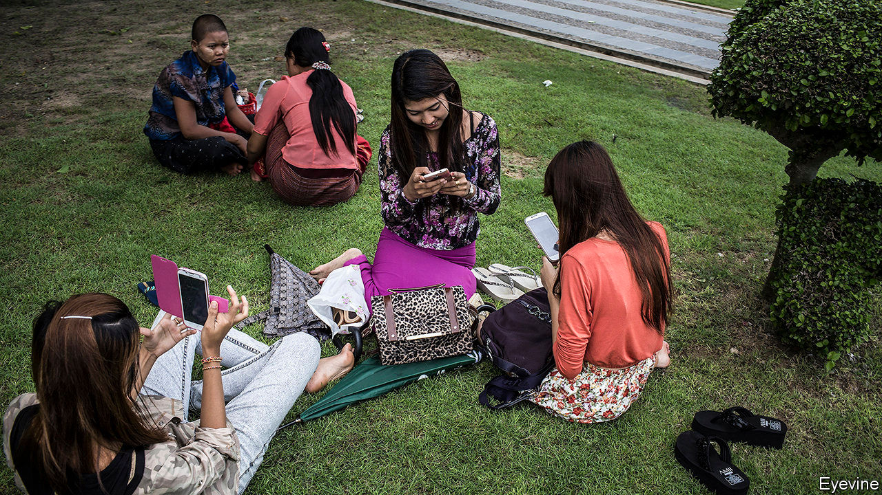

IN A SPEECH last year, Aung San Suu Kyi, Myanmar’s president in all but name, laid out the many reforms her government had undertaken to attract foreign investors. In return, she went on, “we only ask our investors to ensure that their investments are responsible, by incorporating environmental, social and governance factors”. The subtext, although she did not mention it, was that the biggest source of investment in Myanmar, Chinese firms, have never paid much attention to such things and have stoked popular resentment as a result. When Ms Suu Kyi was still an opposition leader, she called for the scrapping of the biggest Chinese investment in the country, a huge dam to be built on its main river, the Irrawaddy, precisely because of misgivings about its environmental and social impact and the murky role of the Chinese state in the governance of the project. Yet since she gave the speech, Ms Suu Kyi’s government has been making life difficult for the sorts of firms she says she wants to attract, often to the benefit of their Chinese rivals.

The power industry is a good example. A giant tender to build solar farms announced in May originally gave bidders only a month to apply, even though most foreigners could not enter the country at the time because of a coronavirus flight ban. After complaints, the energy ministry extended the deadline by a month. Investors worried that recent changes to the law on land ownership might end up classifying as vacant and ripe for development land that in fact had been used by poor minorities for generations. The short bidding period, coupled with covid-19, gave them no chance to resolve their concerns. As a result, big Western firms shunned the tender. All but one of the 29 contracts went to Chinese firms and local partners.

Something similar happened last year, when the ministry of energy awarded five contracts for the speedy construction of power plants, to alleviate a shortage of electricity. Again, there was a one-month bidding period, and all the contracts went to firms based in China.

Meanwhile, rules that are awkward for investors who take seriously concerns about corporate conduct are proliferating. For over a year Ms Suu Kyi’s government has limited internet access and blocked critical websites in parts of the country afflicted by an insurgency. Telenor, a Norwegian firm that runs one of Myanmar’s mobile providers, at first resisted the restrictions before acquiescing. Meanwhile, opposition politicians in Britain have urged CDC Group, the British government’s development-finance arm, to dissociate itself from the shutdown by selling its stake in Frontiir, a Burmese internet provider. A group of European chambers of commerce warns that the internet restrictions could undermine foreigners’ view of Myanmar “as a responsible investment destination”.

Ms Suu Kyi does not want that. But policy-making is overseen by ageing ministers who grew up under a socialist regime that demonised the private sector. Senior bureaucrats are much the same. Optimists hope for a new leaf after elections in November—but if change comes, it will not be as quick as a government tender. ■

This article was downloaded by calibre from <https://www.economist.com/asia/2020/10/03/myanmars-government-makes-life-difficult-for-western-investors>

|  |  |  |  |
| --- | --- | --- | --- |
| Previous | Articles | Sections | Next |

|  |  |  |  |
| --- | --- | --- | --- |
| Previous | Articles | Sections | Next |

#### Banyan

# Anwar Ibrahim is in a familiar place, close to leading Malaysia

Can the perennial prime-minister-in-waiting claim the job at last?

Oct 3rd 2020 |



WHEN ANWAR IBRAHIM declared in late September he had a “strong, formidable majority” of MPs ready to unseat the government of Muhyiddin Yassin, some in Malaysia wondered whether Mr Anwar’s moment had come at last. Others groaned. Mr Muhyiddin’s government, which itself came to power in a parliamentary coup, is just seven months old. How would more upheaval help contain the pandemic, revive the battered economy, or improve the country’s dismal politics of patronage and race? Mr Anwar had once cared about policy. This seemed a naked power-grab.

Mr Anwar hates being called Asia’s eternal prime minister-in-waiting. In the late 1990s, when financial crisis laid bare the cronyism over which Mahathir Mohamad, the prime minister at the time, presided, it looked like Mr Anwar’s moment. The young high-flyer, already deputy prime minister, had long called for an end to the cosy ties between business and politics under the United Malays National Organisation (UMNO). In 1997 Time put him on the cover: “Anwar and the Future of Asia”. Yet within a year, Dr Mahathir had fired his uppity protégé and thrown him in jail on flimsy charges of abuse of office and sodomy.

Fast forward to 2018, when Dr Mahathir came out of retirement at the head of a new party, Bersatu, with the aim of defeating UMNO and his successor-but-one as prime minister, Najib Razak, who had presided over stupendous corruption. Even more surprising than the 93-year-old’s comeback was his choice of ally: Mr Anwar. Mr Najib, too, had thrown him in jail on sodomy charges. From behind bars, Mr Anwar commanded an opposition coalition that included many from the Chinese and Indian minorities, but he needed the votes that Dr Mahathir, still popular among the ethnic-Malay majority, could bring. Together, the two won an election in 2018, kicking UMNO from power for the first time. A week after the general election, Mr Anwar was out of jail with a royal pardon.

Yet as they had done in the 1990s, the pair began to squabble over how soon Dr Mahathir would give way to Mr Anwar. Dr Mahathir set his sidekicks to work negotiating a coalition of Malay parties, including UMNO, so that he could sideline Mr Anwar, whose own party is multiracial and whose coalition rests heavily on the largely Chinese Democratic Action Party (DAP). In the event, Dr Mahathir was the biggest victim of the machinations, overthrown by Mr Muhyiddin.

In turn, Mr Muhyiddin has ruled like the former UMNO guy he is, spreading patronage, pleasing Malay chauvinists by pursuing corruption charges against a former finance minister who is the country’s most prominent Chinese politician, Lim Guan Eng of the DAP, and employing repressive laws to go after critics. To his credit, he has resisted pressure from UMNO cronies to drop the charges against Mr Najib, who has now been convicted on several counts. He has also just burnished his reputation by assembling a winning coalition in state elections in Sabah, part of the Malaysian bit of Borneo—denting Mr Anwar’s claim that his government is a spent force.

Mr Anwar’s confidence that he can topple Mr Muhyiddin seems to derive from the backing he has secured from several members of UMNO who also face corruption proceedings, including the party president, Ahmad Zahid Hamidi, who is battling 87 charges. So much for Mr Anwar’s claim to the moral high ground. Yet even such a pact may not win him the votes he needs. UMNO aristocrats with cut-glass English look down on the rough-spoken Mr Zahid and calculate that, with Mr Najib gone, they can claim the party has had a makeover. They look forward to an election, on the assumption that Dr Mahathir, Mr Anwar and Mr Muhyiddin have feuded so grotesquely that voters will turn back to UMNO.

That leaves Malaysia in limbo, with few believing Mr Anwar can topple the government but only one man able to dispel his claim: the king, who can appoint as prime minister anyone he believes enjoys the support of a majority of MPs. He has been undergoing such intensive treatment for sore knees and ankles in hospital for the past 11 days, he has not found time to receive Mr Anwar. Mr Muhyiddin has assiduously courted the seven Malay sultans who take turns serving as Malaysia’s monarch, not just by defending Malay prerogatives, but also by backing grand projects like a high-speed railway to Singapore from which several of them may benefit as big landowners. Meanwhile, the prime minister-in-waiting waits on.

This article was downloaded by calibre from <https://www.economist.com/asia/2020/10/03/anwar-ibrahim-is-in-a-familiar-place-close-to-leading-malaysia>

|  |  |  |  |
| --- | --- | --- | --- |
| Previous | Articles | Sections | Next |

|  |  |  |
| --- | --- | --- |
| Asia | Sections | Middle East & Africa |

China

Consolidating villages: On Harmony Road

.

Betel nuts: Hard to crack

.

Chaguan: When China fought America

.

|  |  |  |
| --- | --- | --- |
| Asia | Sections | Middle East & Africa |

|  |  |  |  |
| --- | --- | --- | --- |
|  | Articles | Sections | Next |

#### On Harmony Road

# To put idle land to use, Chinese officials want to erase many villages

Their methods could cause millions to suffer

Oct 3rd 2020 | BINZHOU

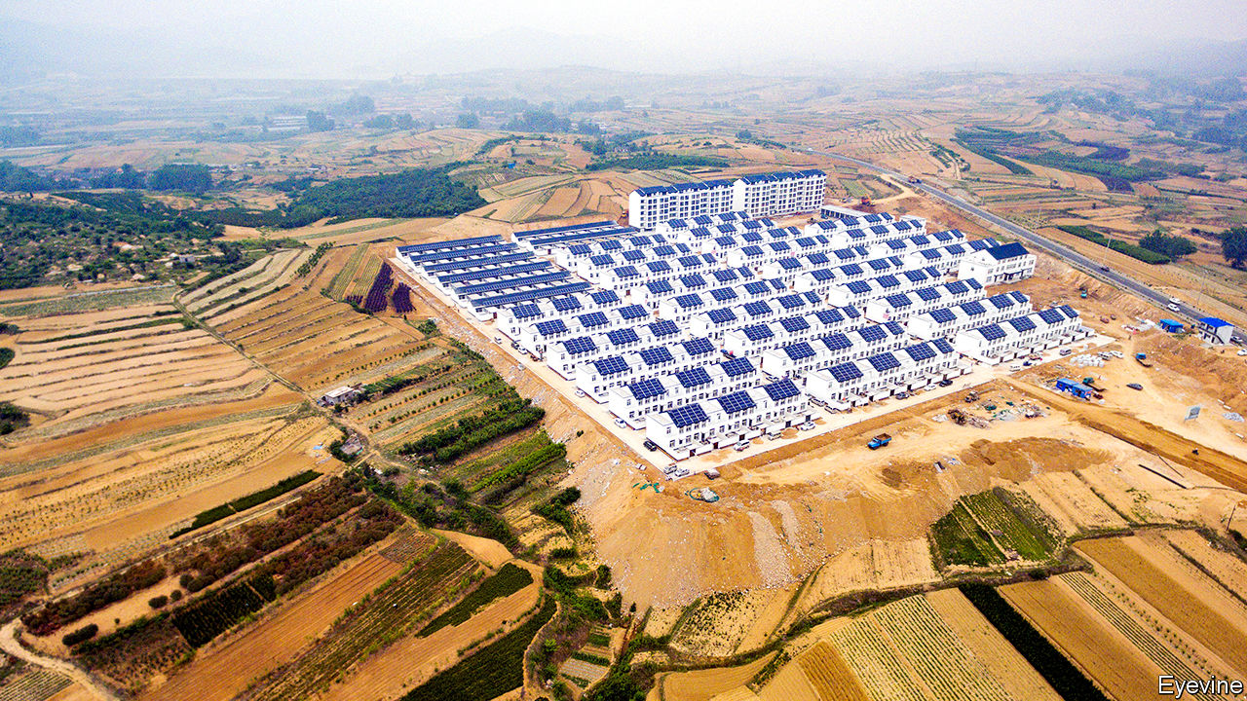

THERE IS A surprising amount of earth-moving equipment on the otherwise sleepy rural back roads of Binzhou prefecture in the eastern province of Shandong. Some of it is being used to build an irrigation channel to draw in water from the nearby Yellow river. But much of it is being used for destruction. At a turning off a county highway, a sign points to Zhaibo village. It no longer exists. The machines have already done their job of levelling Zhaibo and carrying away the debris.

Before the end of May, the village was home to about 70 households who made their living growing maize and cotton and tending fruit trees. Now most of the former residents are in newly built flats on the outskirts of Weiji, a town about seven kilometres away. “We’re improving the soil and a lot of them will be able to come back and work the same land,” says a worker.

Similar scenes have been common in rural areas across China in recent years. Villages are being destroyed and their former residents moved elsewhere, often into clusters of houses or blocks of flats built by local governments to accommodate the populations of what were once several scattered hamlets.

Governments give several explanations for carrying out what they call hecun bingju, or “village consolidations”. Sometimes they talk of promoting urbanisation (some of the new communities are on the edges of towns like Weiji), or of helping villagers out of poverty. But a very common motive is to make more efficient use of rural land. Over the past three decades the movement of tens of millions of people from the countryside into cities has left many villages with few people except the elderly and the migrants’ children. Local officials want to convert the space occupied by empty houses into farmland so they can develop greenfield sites near cities without affecting their province’s overall stock of fields used for crops. The central government, ever fearful of having too little arable land to feed the country’s 1.4bn people, requires provinces to maintain specified areas of it. Pictured is Gongshan New Village in Shandong, to which the inhabitants of nearby houses have been moved to form a much tighter concentration, using far less land.

For some of those relocated, the new settlements may have advantages. The hollowing out of villages left many rural schools with hardly any students. Local governments responded by closing many of them: between 2000 and 2015 more than 300,000 primary schools—nearly three-quarters of the countryside’s total—were shut. This forced many children to trudge long distances to class, or attend state boarding schools. The new consolidated communities are in part intended to allow villagers to enjoy ready access to schooling and other government services.

But villagers often have no choice but to move into these settlements. Sometimes officials use brutal tactics to force them, including sending in thugs to beat those who refuse to leave their houses. This year Shandong embarked on an unusually large-scale and aggressive campaign to consolidate one-fifth of the province’s 70,000 or so villages by the end of 2020. Citing local officials, state media say Shandong (which is China’s second-most-populous province, with more than 100m people) ranks third in economic output, but only 11th in its urbanisation rate. It is eager to move up the tables.

The zeal of local officials has caused widespread suffering. Many homes were demolished before replacement apartment blocks were ready for occupancy. In numerous villages across northern Shandong, villagers describe the same phenomenon: xianchai houjian, meaning “first demolish, then build”. The practice has left many scrambling to find relatives to stay with. Some have built simple shacks or erected tents near their fields.

In a widely read essay Lu Dewen, a rural-affairs specialist at Wuhan University, described the abuses suffered by villagers in Shandong. He said that unlike the coronavirus pandemic—a “haze that will eventually pass”—the village consolidation campaign has been a “man-made disaster” with no regard for human emotions, and with fearsome psychological effects that will last a lifetime. Remarkably, state-owned media joined the chorus of criticism.

Local officials blocked your correspondent from approaching Weiji to speak to villagers relocated from now-flattened Zhaibo. But there have been numerous accounts, including in China’s press, of its residents having been beaten and intimidated to make them leave their homes. Some were threatened with dismissal from their jobs and some were detained while their houses were destroyed.

Shandong’s government has not acknowledged such abuses. But it has tried to sound emollient. In recent weeks, the province’s Communist Party chief, Liu Jiayi, has toured several villages, admitting that some residents had been treated “unfairly”. He has called on officials to “think from others’ point of view” and to protect farmers’ “legal rights”.

Mr Liu may not have considered a problem with his plan. Building new villages is expensive. Theoretically his government could offset the cost using proceeds derived from increasing the province’s stock of farmland: any area in excess of the mandated amount can be sold to developers. But as Chinese media have pointed out, the price depends on supply and demand. Shandong’s massive village-demolition scheme would create a glut of farmland that may prove hard to sell at the price the government had been hoping for.

Mr Liu has not announced the abandonment of his project to build “beautiful and liveable homes” for farmers—ie, move them into smart-looking new settlements. But there are signs that the government is proceeding more cautiously. Take Linjia village in Dezhou prefecture. It is due for demolition but remains intact, for now. Several residents say they have been promised there will be no move until their new dwellings are ready. “No one is happy about it but we are being allowed to negotiate so far,” says Mr Lin, a resident.

Work on the new accommodation, several kilometres away, is well advanced. Huge billboards show drawings of planned blocks of flats. A showcase building is already finished, as is a new thoroughfare leading to it called Harmony Road. Back in Linjia, Mr Lin describes its tight-knit community and worries that old friendships will be disrupted. He wonders also about what he will do after a lifetime spent farming. “I’d rather just stay here if I could,” he says, “but I know it’s not possible.” ■

This article was downloaded by calibre from <https://www.economist.com/china/2020/10/03/to-put-idle-land-to-use-chinese-officials-want-to-erase-many-villages>

|  |  |  |  |
| --- | --- | --- | --- |
|  | Articles | Sections | Next |

|  |  |  |  |
| --- | --- | --- | --- |
| Previous | Articles | Sections | Next |

#### The peddle betel battle

# A risky stimulant thrives in China’s capital of chewing

Despite the danger to health, the betel-nut industry is booming

Oct 3rd 2020 | XIANGTAN

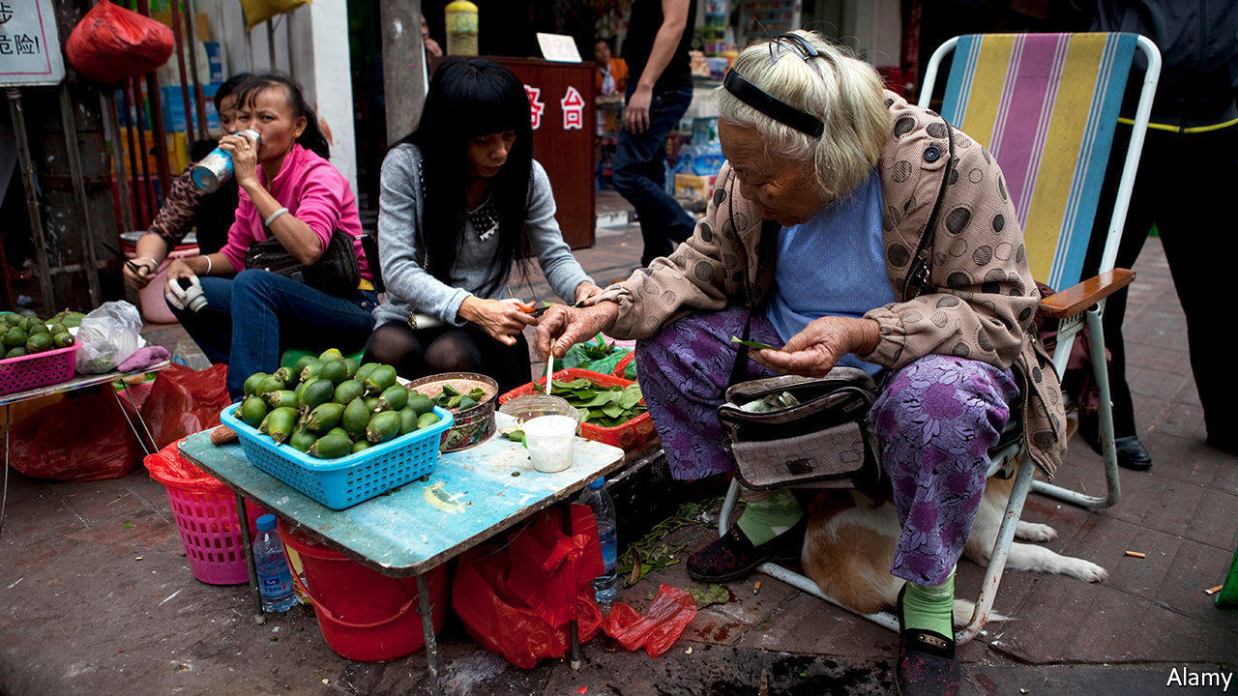

BETEL NUTS assail the nostrils before they thrill the tongue. At a shop in Xiangtan, a city in the central province of Hunan, they are sold in a dried form—dark and wrinkled in blue-and-white porcelain bowls, with flavourings of spice, mint, orange and cinnamon oil. They sell for a few yuan apiece (under $1). A local song celebrates their ability to induce a bit of a buzz: “The more you chew the betel nut, the livelier you’ll feel...Spit one out and pop another in.” People in Xiangtan exchange them in greeting. From teenagers to elderly mah-jong players, the city’s residents chomp furiously to get their fix of the nut’s main stimulant, arecoline.

In 2017 China’s regulators named arecoline as a carcinogen (long after the World Health Organisation had done so). Also that year doctors in Hunan published findings that oral submucous fibrosis, a disease from chewing betel nuts that often leads to cancer, was “widespread” in the province, with rates much higher than elsewhere in China. They predicted oral-cancer cases would become a “humanitarian catastrophe” in Hunan, rising from almost 25,000 in 2016 to 300,000 in 2030. Something to chew on, you would think.

Yet demand for the nut is swelling. Sales at the largest firms are growing at a yearly rate of 10%, according to the Hunan Betel-Nut Association in Xiangtan, where the industry took off in the 1980s (it was already well-established across the Asia-Pacific). The business employs over 2m of Hunan’s 41m working-age adults. Most of them are involved in processing the betel nuts, which are the berries of areca palm trees. These are mainly grown on Hainan, a tropical-island province 1,000km away (where a peddler selling fresh nuts is pictured).

In February, as cases of covid-19 soared in China, the National Health Commission even included betel nuts in a prescription based on traditional Chinese medicine for removing “dampness in the lung”. Firms in Hunan province handed out mask-and-betel-nut care packages to taxi drivers and street cleaners. The head of a betel-nut association on Hainan island told state media a story often recounted in Xiangtan: a monk there survived a plague in the 17th century by continuous chewing of the nut.

The sector is adept at deflecting concerns. In March 2019 the association in Xiangtan said it was banning advertisements by local betel-nut firms. That seemed encouraging—until it emerged that, even under questioning by state media about the purpose of the move, the group would not admit to health concerns. Compliance with the order was patchy. Since August a comedy show, “Deyun Laugh Club”, has been watched 500m times. Among its sponsors is Wu Zi Zui (“Five Drunk Men”), one of Hunan’s biggest betel-nut producers. Opening ads for its goji-flavoured betel nut promise that chewing it will make watching the show “even more fun”.

This article was downloaded by calibre from <https://www.economist.com/china/2020/10/03/a-risky-stimulant-thrives-in-chinas-capital-of-chewing>

|  |  |  |  |
| --- | --- | --- | --- |
| Previous | Articles | Sections | Next |

|  |  |  |  |
| --- | --- | --- | --- |
| Previous | Articles | Sections | Next |

#### Chaguan

# China is celebrating 70 years since it entered the Korean war

Its rulers portray the conflict as a Chinese victory against the West

Oct 3rd 2020 |

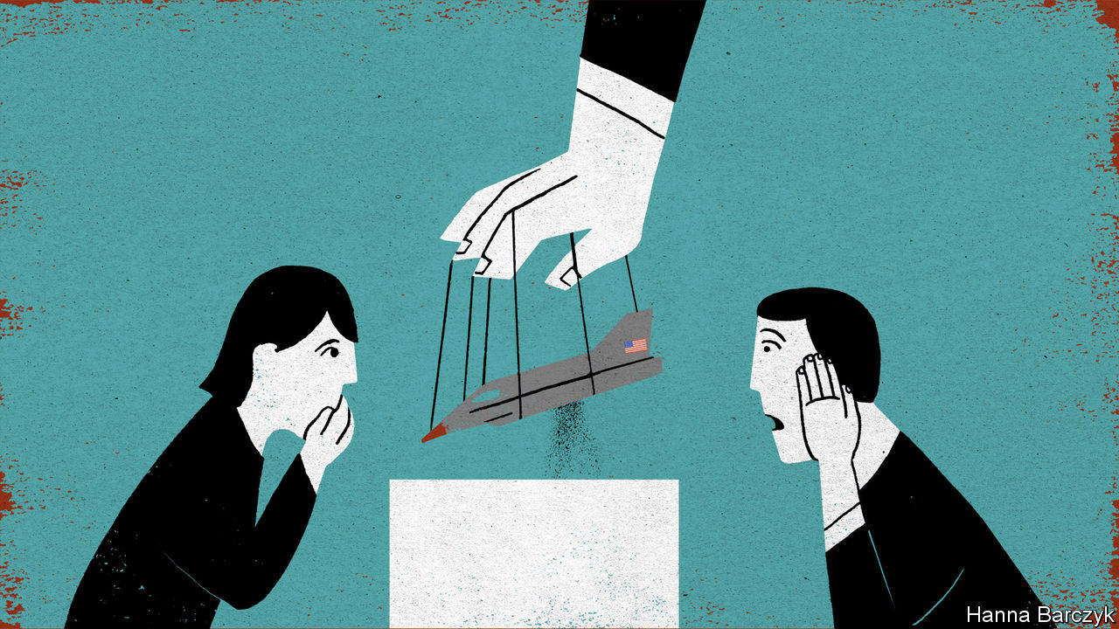

AN OPTIMIST MIGHT call it progress that China’s national memorial to the Korean war, newly reopened after years of renovations, has reduced the space devoted to a Mao-era hoax—the charge that America used the plague and cholera as bio-weapons during that conflict, thereby committing a war crime.

It is dismaying that the allegations remain on display at all in the memorial, a hilltop complex overlooking the Chinese border city of Dandong and, across the Yalu river, the North Korean town of Sinuiju. The memorial reopened in late September, ahead of the 70th anniversary of China’s entry into the conflict that laid waste to the Korean peninsula from 1950 to 1953, and that Chinese leaders call “The War to Resist America and Aid Korea”. Still, hopeful sorts might note that the hoax was once a much bigger deal. The allegations of germ warfare were worldwide news in the first months of 1952. Chinese and North Korean leaders saw a chance to challenge the legitimacy of the American superpower. In Europe, Soviet-bloc governments and Western sympathisers staged protest marches involving millions of people, accusing American warplanes of dropping bombs packed with bacteria-laced insects on Korea and northern China.

The new memorial in Dandong charges America with crimes against international law in a single display panel, offering few details. A glass case offers supposed evidence: an old bomb casing, and dusty test-tubes containing “bacteria-carrying insects scattered by the US forces”. In reality the tale was long ago debunked, notably by documents that emerged from Soviet archives decades after the war. The papers included a resolution by the Soviet government in 1953 that called reports of American germ warfare in Korea “fictitious”. A study by Milton Leitenberg for the Woodrow Wilson Centre in Washington cites memoirs by Wu Zhili, a former head of China’s military medical service in Korea. Wu called talk of germ warfare a “false alarm” that did not make sense: some alleged drop-zones were just metres from American lines, and the winter weather was far too cold for bacteriological warfare.

Cheerful souls might conclude that modern China’s rulers are embarrassed by this old propaganda but cannot easily disown it, so are taking a middle path. Chaguan draws a different lesson from a recent visit to the memorial. The new museum may tone down its anti-Americanism, eschewing the previous memorial’s statements about American imperialism being exposed as a “paper tiger”. But in its place is something that may prove just as disruptive: a deep disdain for the West, which is portrayed as unable to match the efficiency and order of Communist Party rule. Indeed, America’s germ-warfare campaign is called a military failure, thanks to clever Chinese and North Korean anti-epidemic work.

The museum has reflected political trends since it first opened in 1958. Back then, its displays followed North Korea’s line that the war began with a surprise attack by South Korea—a reversal of the historical truth. Today, in 2020, the museum in Dandong says coyly that “On June 25th 1950 the Korean civil war broke out,” without assigning blame. The memorial closed in 1966 when the commander of Chinese forces in Korea, Peng Dehuai, purged for questioning Mao and later rehabilitated, came under renewed attack. It did not reopen until 1993, a year after China normalised relations with South Korea—a rapprochement that enraged the North and made it urgent for China to assert its version of history. The hall closed again in 2014, ostensibly for repairs, amid Chinese anger at missile tests and nuclear-weapons research by North Korea.

The latest memorial has an intensely domestic focus. Its dioramas, enlivened with the bright lights of projected explosions and the boom of recorded gunfire, feature American soldiers in two roles: fleeing and dying. North Koreans are glimpsed mostly as helpless civilians, thanking Chinese troops for rescuing them.

Chinese students are taught that their country entered the war in self-defence against American invasion threats, sending “Chinese people’s volunteers” in canvas shoes and thin cotton uniforms against swaggering Americans armed with tanks and warplanes. Textbooks describe these Chinese troops hurling rocks when ammunition ran out, teaching the world to respect the young People’s Republic of China. In reality, the war was a bloodbath that ended where it started, with Korea divided along the 38th parallel, at a cost of perhaps 400,000 Chinese lives (the memorial admits to less than half that number). In this 70th anniversary year, those events have been distilled into a simple moral about not fearing America’s strength. State media stress how weak and poor China was in 1950. They praise Communist pioneers for daring to attack America, and for realising that, faced with such a bully, they had to seek “peace through fighting”.

## The party’s worldview: endless struggle

Chaguan did not hear nostalgia for war among the museum’s visitors. He did find admiration for the willingness of previous generations to accept hardship. A local man, Xiu Dexiang, had brought a five-year-old son dressed in a miniature army uniform. “I want to let him know that this life we have did not come easily, and he needs to cherish it,” he explained.

Li Quanxin, a 90-year-old Red Army veteran, drew lessons from the memorial about Chinese self-discipline. “Take this pandemic. Two hundred thousand people died in America! What’s their leader doing? Look at how calm China is now,” he growled. “China’s decision-making is really something. From the Korean war to covid, the path we choose is sure, and the world is in awe.”

Later in October China will award medals to surviving veterans of Korea. Big-budget films about the conflict are heading to cinemas and television screens. Talk of resisting America can hardly be avoided: it is in China’s name for the war. Elaborate challenges to America’s legitimacy will not be needed. To China’s rulers, their system’s superiority and the West’s decline are self-evident.■

This article was downloaded by calibre from <https://www.economist.com/china/2020/10/03/china-is-celebrating-70-years-since-it-entered-the-korean-war>

|  |  |  |  |
| --- | --- | --- | --- |
| Previous | Articles | Sections | Next |

|  |  |  |
| --- | --- | --- |
| China | Sections | Europe |

Middle East & Africa

Competition law: No contest

.

Somaliland and Taiwan: Outcasts united

.

Kuwait: A king of co-operation

.

Yemen: Unsafe Safer

.

Iraq and covid-19: Out of control

.

|  |  |  |
| --- | --- | --- |
| China | Sections | Europe |

|  |  |  |  |
| --- | --- | --- | --- |
|  | Articles | Sections | Next |

#### No contest

# How big firms rip off African consumers

Competition law alone may not be enough to break their grip

Oct 3rd 2020 | KAMPALA

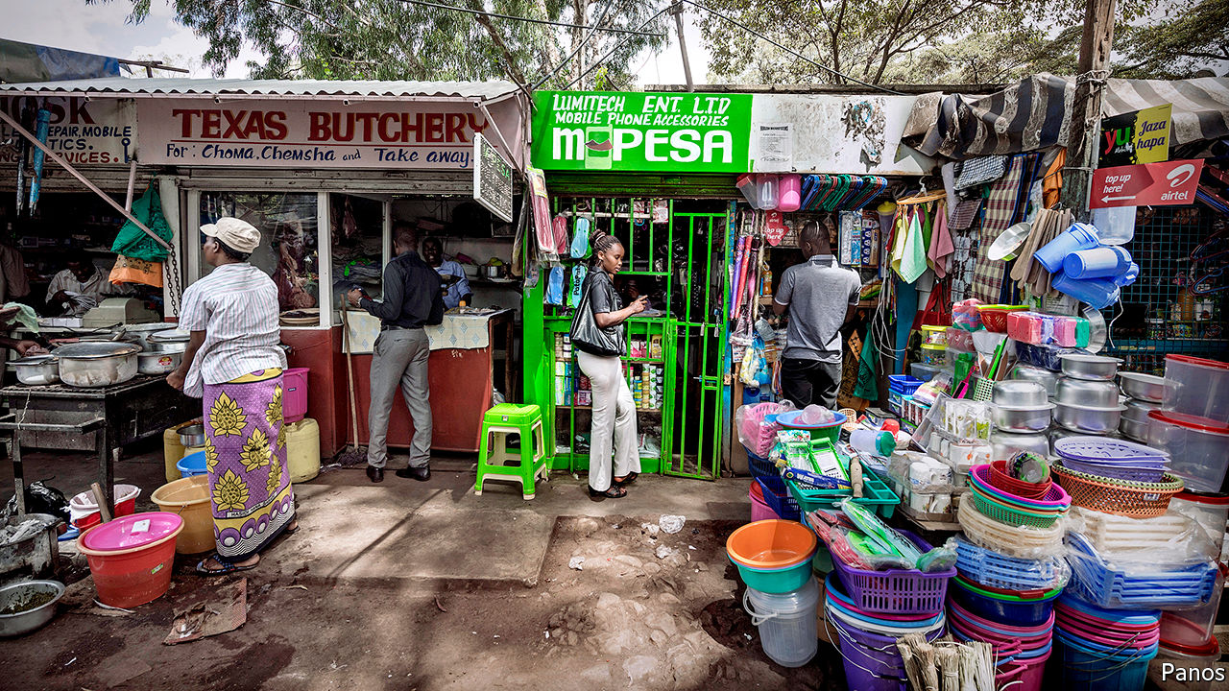

KOKO MINGI VIII, king of the Nembe people, had a vigorous approach to trust-busting. In 1895 he led a pre-dawn raid on the headquarters of the Royal Niger Company, a British firm that had monopolised the palm-oil trade in the Niger delta. Koko captured 60 hostages and demanded to be allowed to trade freely. The British sent in the gunboats instead, and monopolists have had the upper hand in Nigeria ever since: the country did not enact an overarching competition law until last year.

King Koko’s trust-busting heirs have their work cut out, and not just in Nigeria. In much of Africa formal economies are dominated by large firms that rip off consumers. The IMF reckons that firm markups are about 11% larger in sub-Saharan Africa than in other developing regions, and that prices are 20% higher. The challenge for African governments is not only to make markets more efficient, but also to undo a history of economic exclusion.

Colonial economies were built around European trading firms, with licensing rules that hindered the emergence of black African capitalists. That logic was taken to extremes in South Africa, where just six conglomerates controlled 87% of the stockmarket at the end of apartheid. “The structure of our economy was designed to keep assets in a few hands,” noted Cyril Ramaphosa, the president, in his state-of-the-nation address last year. Change has been slow. An IMF working paper released in September argued that South Africa could boost annual GDP growth by 2.5 percentage points by encouraging competition.

Politics continues to stifle competition. Public contracts are not always won fairly: in 2012, for example, Zambian authorities accused two fertiliser companies of dividing up the market and rigging tenders to supply a state subsidy scheme, costing taxpayers $21m. In other cases, governments use protective regulations to cosset state firms, such as national airlines. Some 70% of all air routes to, from or within sub-Saharan Africa have only one carrier flying them, according to Cirium, a data firm. New entrants are often kept out of the skies by regulatory barriers or are unable to compete with subsidised incumbents.

Economic factors are also at work. Most African markets are too small to sustain more than a few competitors in heavy industries such as steelmaking or cement (which is much more expensive in sub-Saharan Africa than elsewhere). In emerging sectors such as telecommunications there are network effects, as consumers opt for the same service as their friends. In Kenya one mobile phone firm, Safaricom, holds 99% of the market for mobile money through its M-Pesa service.

Policymakers acknowledge the problem. Last year 31 countries in the region had competition laws, up from 12 in 2000. But many competition agencies “just exist by name” and lack the resources to do their job, says Mor Bakhoum of the Max Planck Institute for Innovation and Competition. Those in South Africa and Kenya, the regional leaders, investigate several hundred cases a year; the average agency in Africa investigates just two.

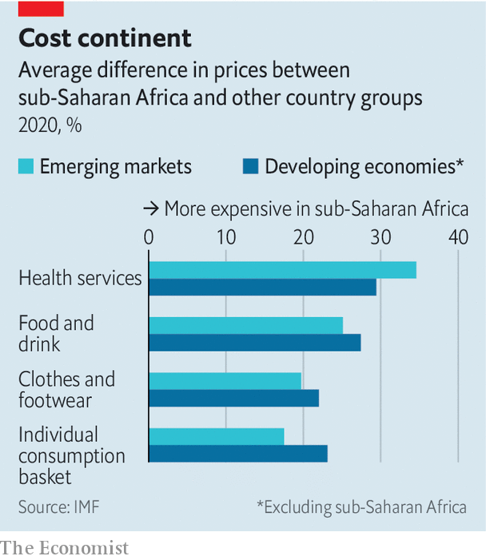

There is debate about what competition law should do. African countries have borrowed from European and American models, which prioritise market efficiency. But they also try to promote development and “make markets more inclusive”, says Grace Nsomba of the Centre for Competition, Regulation and Economic Development at the University of Johannesburg. South African authorities put unusual weight on public-interest criteria, such as how a merger will affect jobs or the growth of black-owned enterprises. A landmark case was the takeover in 2012 by Walmart of Massmart, a South African retailer. The deal was approved with conditions, including the reinstatement of retrenched workers and the creation of a fund to support small businesses.

Other countries also consider public-interest factors. Francis Kariuki, director-general of the Competition Authority of Kenya, says he is mindful of the country’s “economic topography” including the likely effect on small businesses, whenever he considers a merger. The authority is probing supermarkets that pay their suppliers late. And it showed flexibility during the covid-19 crisis, allowing airlines to club together for cargo flights to cope with a drop in volumes. “We didn’t need to change our laws,” says Mr Kariuki. “We just employed the public-interest criteria.”

But some lawyers worry that competition policy is being asked to do too much. In South Africa the law has become politicised, says John Oxenham of Nortons, a law firm, especially after it was amended in 2019 to increase the scope for ministerial intervention. He argues that introducing vague notions of fairness into the technical field of antitrust law makes court decisions opaque and unpredictable.

Even those who favour an activist approach recognise that competition law has its limits. “It can help prise open markets,” says Nimrod Zalk, who advises the South African government on industrial policy, but “it can’t on its own stimulate firm creation and firm development.” If small firms are to break the grip of incumbents they will need additional support and access to finance, Mr Zalk says.

There may even be a case for tolerating temporary monopolies where they reward firms that have invested in new skills and capacity. The problem arises when incumbents become entrenched. Aliko Dangote, a Nigerian tycoon, has used nous and political connections to build an industrial empire, manufacturing products locally that were once imported from abroad. But his cement business holds nearly two-thirds of the market and earns margins of 59%. Customers may grumble, but in the words of Burna Boy, a Nigerian singer, “Dangote still dey find money o.” ■

This article was downloaded by calibre from <https://www.economist.com/middle-east-and-africa/2020/10/03/how-big-firms-rip-off-african-consumers>

|  |  |  |  |
| --- | --- | --- | --- |
|  | Articles | Sections | Next |

|  |  |  |  |
| --- | --- | --- | --- |
| Previous | Articles | Sections | Next |

#### Outcasts united

# Somaliland and Taiwan establish diplomatic ties

A hunt for recognition sometimes makes for strange bedfellows

Oct 3rd 2020 |

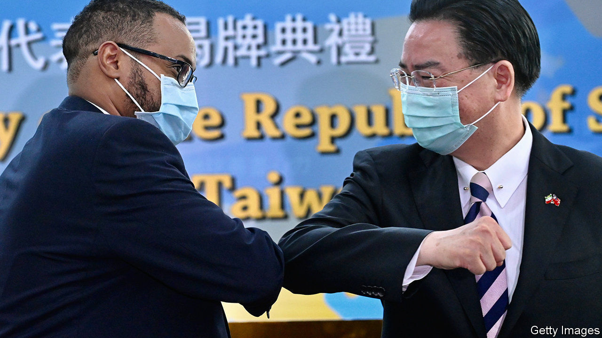

ONE IS A small, surprisingly successful and relatively democratic country bullied by a larger, dictatorial neighbour which considers it to be part of its own territory. The other is Taiwan. On September 9th Somaliland, a breakaway republic in the north of Somalia, opened a “representative office” in Taipei, the capital of Taiwan. It followed the opening in August of a similar Taiwanese office in Hargeisa, Somaliland’s capital.

The exchange of diplomatic relations is a coup for Somaliland, which declared independence in 1991 after the fall of Somalia’s last dictator, Siad Barre. Like Taiwan, it is a country in all but name. It has a government, an army and borders. It holds elections and, unlike the rest of Somalia, has been mostly peaceful for the past 30 years. It issues passports.

Yet Somaliland has struggled for recognition. Barely a dozen countries recognise its passports (a government minister with dual British citizenship confesses that he does not use his Somaliland one: he has less explaining to do when presenting one issued by Her Majesty’s Passport Office). Not one considers it an independent country, and it has no seat at the United Nations. In Mogadishu, the bombed-out capital of Somalia, foreign diplomats studiously ignore Somaliland’s existence lest they upset the squabbling local politicians who consider it part of their country.

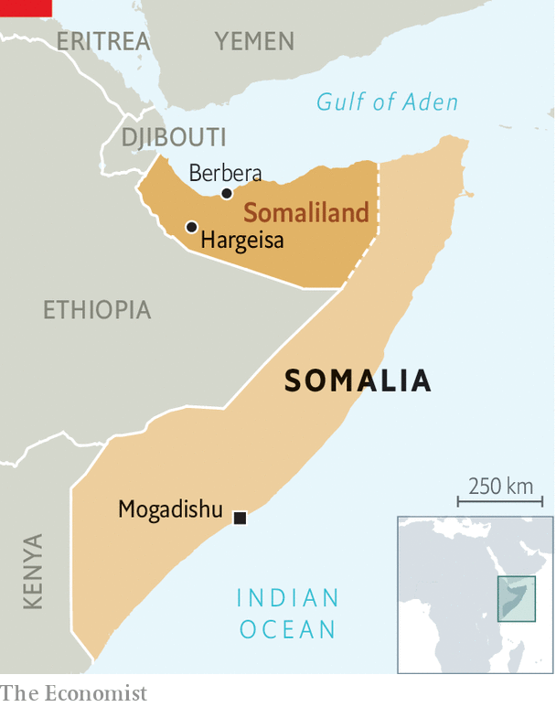

According to Liban Yusuf Osman, Somaliland’s deputy foreign minister, Taiwan can be a valuable ally for his country. “Taiwan…has economic advancement we can learn a lot from,” he says. He points out that Somaliland doctors have been training in Taiwan for more than a decade, travelling on their Somaliland passports. He hopes that formal relations may bring more such benefits. At Berbera, Somaliland’s dusty second city on the Gulf of Aden, DP World, an Emirati company, is building a colossal new port. Mr Osman hopes that Taiwanese firms may open up there too, perhaps to develop oil or mining.

Yet it is geopolitics, not economics, that drives the relationship. A few decades ago Taiwan still had a handful of diplomatic relationships across the continent, including with South Africa under apartheid. Loans and aid projects helped seal Taiwan’s ties to poor countries such as Niger, Burkina Faso and the Gambia. But China insists that countries choose relations either with Beijing or with Taipei. As its economic might has grown, so even these holdouts have switched their recognition to China. By 2018 Eswatini (a tiny monarchy formerly known as Swaziland) was Taiwan’s last friend in Africa. Now it has two.

This article was downloaded by calibre from <https://www.economist.com/middle-east-and-africa/2020/10/03/somaliland-and-taiwan-establish-diplomatic-ties>

|  |  |  |  |
| --- | --- | --- | --- |
| Previous | Articles | Sections | Next |

|  |  |  |  |
| --- | --- | --- | --- |
| Previous | Articles | Sections | Next |

#### A king of co-operation

# The death of Kuwait’s emir robs the Gulf of a real diplomat

Sheikh Sabah al-Sabah’s calming influence will be missed

Sep 30th 2020 | BEIRUT

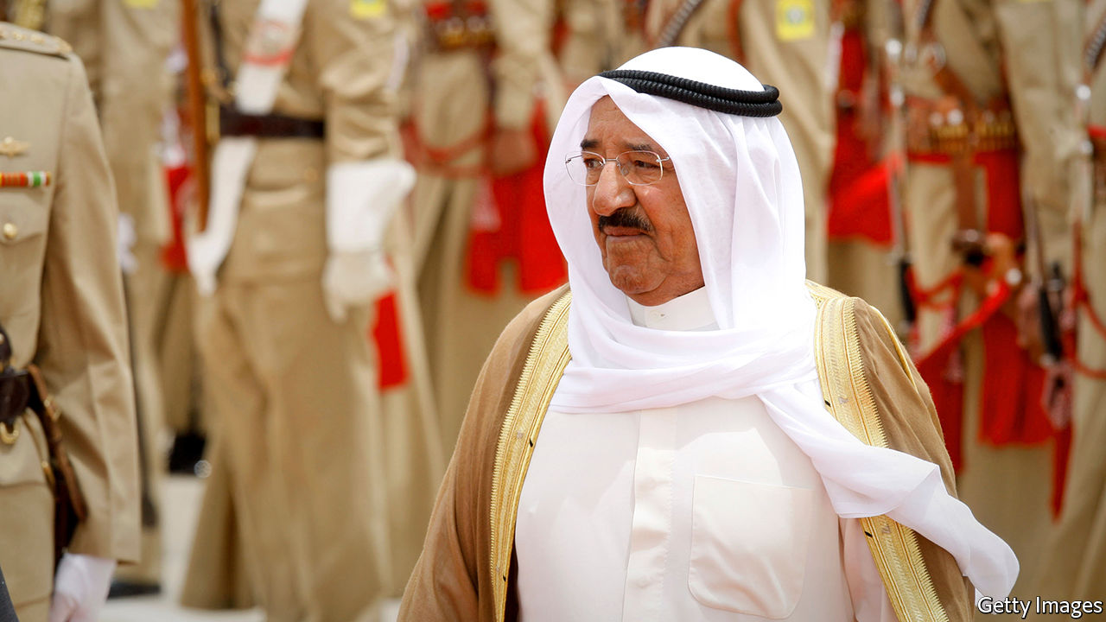

HIS LAST role was as a monarch, but it was his longest, as a diplomat, that defined him. Before he ascended the throne in 2006, Sheikh Sabah al-Sabah (pictured) spent decades as Kuwait’s foreign minister. Rather than letting Kuwait slip into the undertow of Saudi Arabia, its larger neighbour, he helped turn a small country—with fewer than 5m people today, mostly migrant workers—into an influential player. On September 29th, after a long illness, Sheikh Sabah died at the age of 91.

He was born in a different Kuwait, one that relied on a pearl trade soon to collapse. Oil discovered nine years later transformed it into one of the world’s richest states. Sheikh Sabah became its foreign minister in 1963 and held the post for 40 years, a period that included the loss of his country when Saddam Hussein, the Iraqi despot, invaded in 1990. The occupation gave him an enduring appreciation for America, which led the coalition that liberated Kuwait. When he fell ill in July it was an American air-force plane that ferried him to the Mayo Clinic in Minnesota for treatment.

The war also reinforced a belief in multilateralism. Sheikh Sabah was one of the architects of the Gulf Co-operation Council, a six-member club founded in 1981. It never quite became the tight political and economic union its founders intended. Still, it is more than a talking-shop, and Sheikh Sabah was keen to protect it. When three of its members—Saudi Arabia, the United Arab Emirates (UAE) and Bahrain—imposed a blockade on a fourth, Qatar, in 2017, Kuwait refused to take part, and the emir tried to mediate in the dispute.

Perhaps the diplomacy was a welcome distraction: politics at home could be tumultuous. Unique among the Gulf monarchies, Kuwait has a raucous parliament with genuine power. Sheikh Sabah dissolved it more than once because of disputes with lawmakers. In recent years, as low oil prices blew a hole in Kuwait’s finances, he has also had to grapple with budgetary problems. The treasury now has only enough cash on hand to pay public-sector salaries until the end of October.

The emir, however, remained a popular figure. In 2015, when jihadists bombed a Shia mosque in Kuwait City and killed 27 people, he rushed to the scene to console victims—a personal, emotional display rare among the region’s aloof rulers.

The crown prince, Nawaf al-Sabah, a half-brother of the late emir, ascended the throne hours after Sheikh Sabah’s death was announced. He is an untested leader, and already 83; his time in office will be defined largely by his choice of a successor. Aspirants have waged an unusually public struggle in recent years, some swapping allegations of corruption. Here, too, Kuwait’s parliament has a role: it may reject the new emir’s chosen successor. (Sheikh Sabah himself took power after his infirm predecessor was voted out of office.)

Kuwait is the second Gulf country to change rulers this year. Sultan Qaboos of Oman died in January. Both men commanded great respect in the region, which gave them the freedom to pursue independent foreign policies. Like his Omani counterpart, Sheikh Sabah preferred diplomacy to belligerence in dealing with Iran. With their passing, power in the Gulf will slip further into the hands of Saudi Arabia and the UAE, led (in practice) by younger, headstrong princes. The Gulf has lost its most effective diplomat at a time when diplomacy is badly needed. ■

This article was downloaded by calibre from <https://www.economist.com/middle-east-and-africa/2020/09/30/the-death-of-kuwaits-emir-robs-the-gulf-of-a-real-diplomat>

|  |  |  |  |
| --- | --- | --- | --- |
| Previous | Articles | Sections | Next |

|  |  |  |  |
| --- | --- | --- | --- |
| Previous | Articles | Sections | Next |

#### The good ship Safer: unsafe

# A possible oil leak in the Red Sea adds to Yemen’s crises

As if war and famine were not bad enough

Oct 3rd 2020 | BEIRUT



FOR FIVE years the Safer, a tanker, has been slowly corroding in the Red Sea, a time-bomb waiting to go off. Or perhaps it already has. Built in 1976, sent to Yemen in 1988, it has served ever since as a floating storage unit and export terminal. It sits off the coast of Ras Issa at the terminus of a 430km oil pipeline (see map). Since 2015 the ship and its cargo, more than 1.1m barrels of oil, have been in the hands of the Houthis, a Shia rebel group fighting a Saudi-led coalition in Yemen. On September 24th the Saudi ambassador to the United Nations warned that an “oil slick” had been spotted 50km west of the vessel.

Diplomats, shipping experts and environmentalists had warned for years that the ship was a danger. Sea water is doing what sea water does, eating away at its hull and tanks, a process that happens faster than normal in the salty Red Sea. Photos taken on board last year showed leaking pipes and rusted seals; there are fears the whole thing may explode.

But the Houthis have blocked any maintenance work. The vessel, in their imagination, is a useful obstacle to a Saudi-led assault on Hodeida, the nearby port that handles most of Yemen’s imports. Never mind that a spill would be an environmental disaster: the Safer’s cargo is four times that of the Exxon Valdez, which blighted hundreds of miles of Alaskan coast when it ran aground in 1989. Such short-sighted thinking, from both the Houthis and their foes, has turned the war into an intractable humanitarian catastrophe.

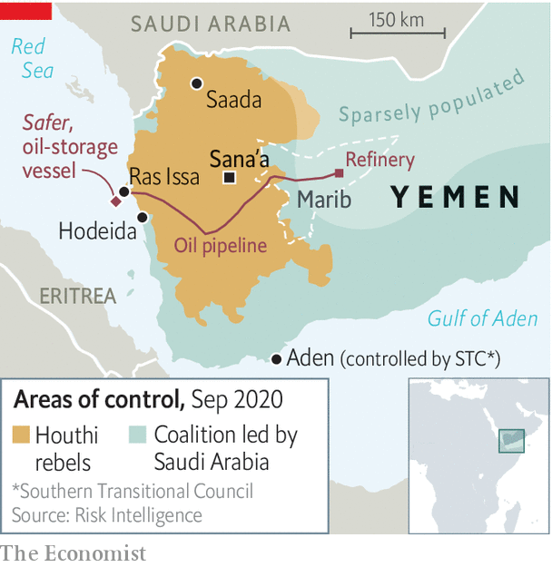

More than 100,000 Yemenis have died as a result of the conflict since 2015, when the Saudis and their allies invaded to fight the Houthis, who had seized control of the capital, Sana’a. Famine and disease stalk the population; the economy has collapsed. A year ago, though, there was guarded optimism that the fighting was near an end. In the summer of 2019 the United Arab Emirates (UAE) withdrew most of its troops, depriving Saudi Arabia of its most effective partner. The kingdom began indirect talks with the Houthis in Oman, a frequent mediator in Gulf disputes.

But those talks (now virtual, because of covid-19) have not produced a deal. The fighting, meanwhile, has grown more complicated. This spring separatists in the south aligned with the UAE began fighting the Saudi-backed government, pitting two ostensible members of the coalition against each other. Then the Houthis began a push to seize Marib, a province that holds much of Yemen’s oil. It has been a place of relative stability, which has made it a hub for civilians displaced from other provinces. Its population has grown perhaps tenfold since the war began, to an estimated 3m. The Houthis have lost thousands of fighters trying to seize it. Their offensive is getting in the way of peace talks.

Even away from the front lines, life is miserable. Fuel shortages are widespread in northern Yemen. Both sides are guilty of exacerbating them: the coalition has barred fuel tankers from unloading at Hodeida, while the Houthis play up shortages to boost a lucrative black market in fuel. Yemen’s currency, the rial, has lost 70% of its pre-war value, including a 25% drop this year. Prices have soared, leaving many civilians unable to afford even food. Most rely on aid, but aid agencies are short of cash. Since March the UN’s World Food Programme has been able to provide only half-rations in Houthi-controlled areas. It estimates that hunger rates have increased from 28% to 43%. It will need $500m in extra funding just to continue that meagre assistance for the next six months.

Yemen has few sources of hard currency: years of war have left little in the way of exports, tourism or investment. A $2bn deposit in the central bank from Saudi Arabia in 2018 is almost depleted. The country’s last remaining lifeline is remittances, which totalled $3.8bn last year. About three-fifths of that comes from the 2m-odd Yemenis working in Saudi Arabia. But their numbers have thinned as the Saudi government tries to evict migrants to free up jobs for citizens. So remittances have dropped by an estimated 70-80% this year.

Diplomats are still hopeful they can broker a truce in Yemen. They are working on a slate of trust-building measures, from a prisoner swap to reopening the airport in Sana’a and shipping lanes. Neither side will gain much from continued fighting: the war is ruinous for Yemenis and costly for Saudi Arabia, in both money and reputation. Yet neither seems ready to stop. ■

This article was downloaded by calibre from <https://www.economist.com/middle-east-and-africa/2020/10/03/a-possible-oil-leak-in-the-red-sea-adds-to-yemens-crises>

|  |  |  |  |
| --- | --- | --- | --- |
| Previous | Articles | Sections | Next |

|  |  |  |  |
| --- | --- | --- | --- |
| Previous | Articles | Sections | Next |

#### The most infected Arab state

# Iraq is too broken to protect itself from covid-19

As the country spirals downwards, the disease spreads

Oct 3rd 2020 |

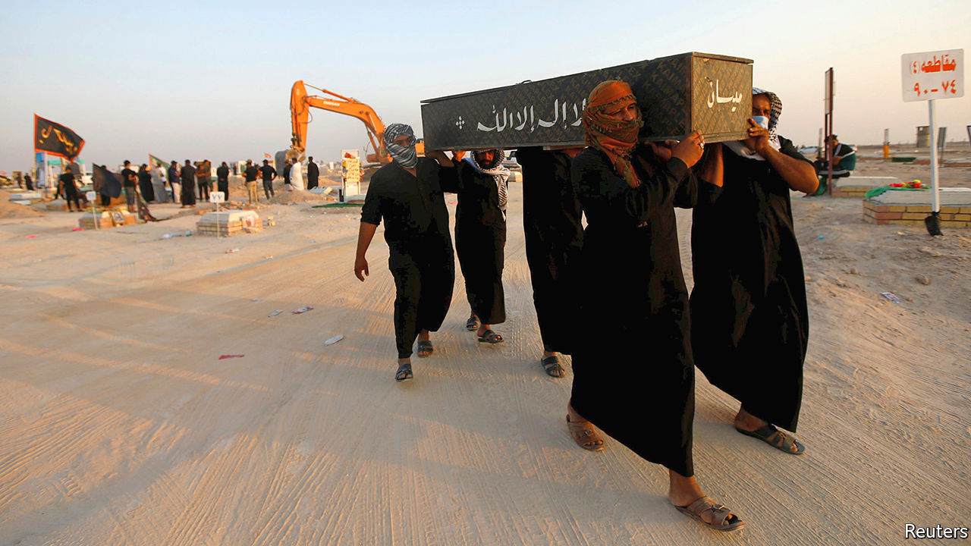

PITY THE doctors of Iraq. Thousands are thought to have contracted covid-19. If the disease doesn’t get them, local tribesmen might. “Every time a patient dies we all hold our breath,” says Dr Tariq al-Sheibani, the director of a hospital in southern Iraq. A month ago a young man from the Hasnawi tribe died of covid-19 in his hospital. That night, as Dr Sheibani left work, 20 of the dead man’s relatives beat him unconscious. The doctor is trying to press charges (CCTV cameras captured the scene), but officials told his family that they would be safer if he did not.

Most Arab regimes have dealt with covid-19 by tightening their grip. Not Iraq. It gave up on lockdowns long ago. The government seems powerless to enforce social distancing or the wearings of masks (some men see the coverings as an insult to their virility). It has little money to spend on a health service gutted by war and corruption. Clergymen still organise mass gatherings. Officially the virus has infected more than 350,000 Iraqis and killed more than 9,000. That is surely an undercount, yet it is still more than in any other Arab country.

Like Iraq’s tribes, the country’s Shia ayatollahs set their own rules. They are going ahead with Arbaeen, an annual pilgrimage to Karbala, a holy city. Thousands of Shia faithful have already begun walking the 500km from Basra, eating and bedding down together in wayside huts. The risk of transmission will increase further when hundreds of thousands more converge on Karbala on October 7th. The surrounding province already has the country’s second-highest infection rate, probably because of a pilgrimage in August.

The government has tried to limit foreign pilgrims by closing Iraq’s land borders and restricting flights from Iran. But there is only so much it can do. “People believe visiting the tomb of Hussein [in Karbala] cures covid-19,” sighs a former government health adviser. Muqtada al-Sadr, a firebrand cleric, has led a campaign to keep the shrines open and defied a ban on Friday prayers. Lately Iraqis have been haphazardly digging up relatives who were buried in a special “coronavirus cemetery” so that they can be given proper funeral rites.

Better medical care would help. Iraq spends about half as much per person as its poorer neighbour, Jordan, on health. A lot of it is wasted—or stolen. The health ministry is led by a technocrat, but it is full of Mr Sadr’s men, who stand in the way of reform. Just ask Alaa al-Alwan, who tried to clean it up. The former health minister resigned last year, citing excessive pressure from within the ministry. Other officials persuaded him to stay on—but he resigned again months later, citing corruption, blackmail and defamation.

Today there are fewer hospital beds and doctors in Iraq than before the American invasion in 2003, though the population has almost doubled. Some 20,000 doctors have fled abroad, says the Iraqi Medical Association, the doctors’ syndicate. Many of those who remain recently went on strike over poor working conditions (basic items, such as masks, are lacking). Hospital directors are so short-staffed that they are loth to let infected doctors go into quarantine. Meanwhile, falling revenues caused by a collapse in the price of oil mean the government has no money to hire thousands of medical graduates. The prime minister, Mustafa al-Kadhimi, suggests they volunteer. The least the government could do is protect them from angry tribesmen. ■

Editor’s note: Some of our covid-19 coverage is free for readers of The Economist Today, our daily [newsletter](https://my.economist.com/user#newsletter). For more stories and our pandemic tracker, see our [hub](https://www.economist.com/news/2020/03/11/the-economists-coverage-of-the-coronavirus)

This article was downloaded by calibre from <https://www.economist.com/middle-east-and-africa/2020/10/03/iraq-is-too-broken-to-protect-itself-from-covid-19>

|  |  |  |  |
| --- | --- | --- | --- |
| Previous | Articles | Sections | Next |

|  |  |  |
| --- | --- | --- |
| Middle East & Africa | Sections | Britain |

Europe

Reunified Germany, 30 years on: Waking Europe’s sleeping giant

.

Armenia and Azerbaijan: The cauldron bubbles again

.

Hungary: Taking on Viktor Orban

.

Spain: Dancing with death

.

Pop music: The Albanian all-stars

.

Charlemagne: The revenge of strategic yogurt

.

|  |  |  |
| --- | --- | --- |
| Middle East & Africa | Sections | Britain |

|  |  |  |  |
| --- | --- | --- | --- |
|  | Articles | Sections | Next |

#### The reluctant hegemon

# Germany is being forced to take a leadership role it never wanted

But thirty years after reunification, it is finding its stride

Oct 3rd 2020 |

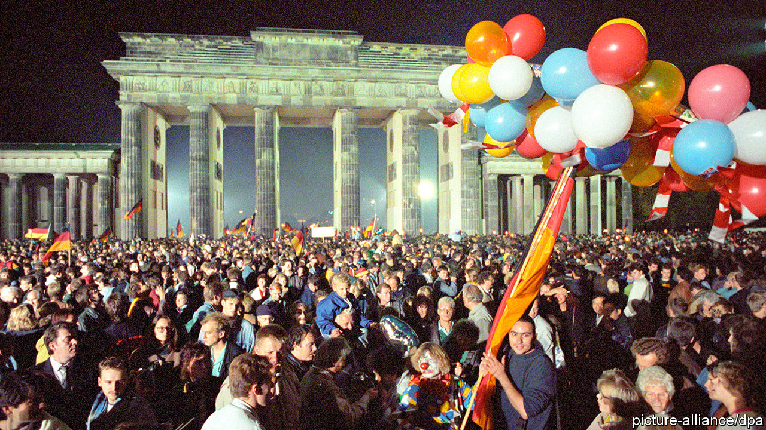

IN UNGUARDED MOMENTS, British and French diplomats 30 years ago might quietly admit that they could happily live with a divided Germany. Its partition, however unjust, contained the problem of a country that, in Henry Kissinger’s words, was “too big for Europe, too small for the world”. After the Berlin Wall fell in 1989, Margaret Thatcher sought to recruit François Mitterrand, France’s president, in a fruitless plot to block, or at least delay, reunification, fearing an enlarged Germany would upset Europe’s balance or even threaten its security. Among European leaders only Felipe González, Spain’s then prime minister, unequivocally backed a united Germany.

Thirty years on—unified Germany marks its birthday on October 3rd—the darker fears of Germany’s European partners have not come to pass. Indeed, as the European Union has battled to hold itself together through a cascade of crises, they have been more often troubled by German inaction than by German assertiveness.

In an essay last year, Thomas Bagger, a German government official, argued that post-reunification Germany adopted a naive reading of Francis Fukuyama’s “end of history” thesis. The end of the cold war seemed to vindicate the country’s commitment to a world in which national interests were a hangover from a brutish past and foreign policy would be subsumed into multilateral institutions. German ministers took to suggesting that German and European interests were the same.

These views committed Germany to the cause of EU integration, not only expansion to the east but working with France to deepen links among existing members. The goal of a “united Europe” was even inserted into the constitution. A Bundeswehr general said he hoped to see German troops swear oaths of loyalty to a European flag. It was from conviction, not to please the French, that Chancellor Helmut Kohl agreed to ditch his country’s cherished Deutschmark for the euro. The currency, however, was built on Teutonic foundations: strict fiscal rules and a (Frankfurt-based) central bank with a single mandate of price stability. The cost of absorbing the clapped-out former communist East Germany, and Germany’s sclerotic labour market and high taxes, left the economy gasping for air by the end of the 1990s. But it perked up in the 2000s thanks to labour reforms and growing export markets. When the global credit crunch spawned the euro crisis in 2010, Germany’s economic might condemned it to lead Europe’s response.

Its answer seemed to be that the currency was being undermined by fiscally incontinent governments. (Critics countered that it had in fact been Germany’s huge surpluses and suppressed domestic demand that had stoked the crisis.) Germans started to wonder about the wisdom of the enterprise: a poll in 2010 found that 44% of them wanted the Deutschmark back. Angela Merkel, temperamentally ill-suited to big leaps forward, had little room for manoeuvre. The bail-outs she pushed through the Bundestag were hugely controversial, yet by forcing austerity on debtor countries they compounded the misery, merely delaying a reckoning. The resentment in those southern countries was huge. The single currency, designed to bind Germany to Europe, seemed to be doing the reverse.

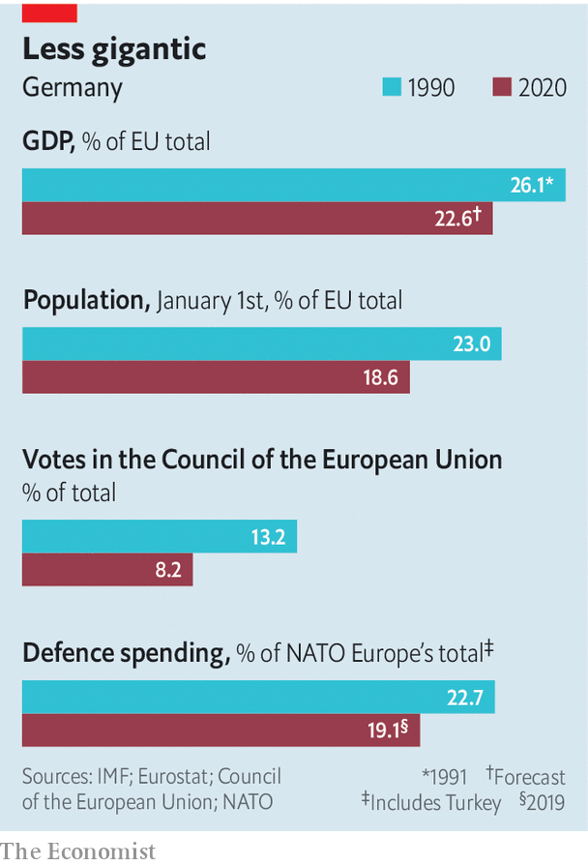

Germany’s reluctance to act assertively in the face of a grave challenge triggered an arcane debate over what sort of “hegemon” it was, or might hope to become. But it was not a discussion the Germans sought themselves. “I was one of the first to use that term,” says Dominik Geppert, a historian at the University of Potsdam, “and other Germans told me, ‘Don’t say it, it will cost us money!’” In 2011, with the euro crisis raging, Radek Sikorski, Poland’s foreign minister, said he feared German inactivity more than its power. This extraordinary statement got him into hot water at home but barely rippled in Germany.

In the end the euro-zone fire was quelled not by Germany but the European Central Bank’s vow to do “whatever it takes” to hold the currency together: a pledge heralding an activist monetary policy that riled Germans further. Then came other crises, each with Germany at their heart. After Russia’s assault on Ukraine in 2014 Mrs Merkel corralled other EU members into backing sanctions and worked with America and France to counter Vladimir Putin. Yet in the migrant crisis of 2015-16 Germany twice irritated its European partners: first by keeping its borders open, and then by unilaterally striking a deal with Turkey to keep them out. If this was leadership, it looked worryingly erratic.

Events chipped away further. Brexit, which was and remains a mystery to most Germans, left the country with more weight inside the EU but, oddly, less influence, as the club’s centre of gravity shifted southwards. Some “new” central European states took an authoritarian turn. Most important was the unconcealed disdain of Donald Trump’s administration for the EU and the implied threat of the withdrawal of its security guarantee, one of the historical conditions for European reconciliation.

France under President Emmanuel Macron adjusted to this more quickly than Germany. Yet German attitudes may be shifting. Mr Macron’s notion of “European sovereignty” would once have inspired smirks in Berlin, says an official, but today it is rapidly finding adherents, as Germany grapples with American unpredictability, a troubled European neighbourhood and a growing Chinese threat. Mrs Merkel has surprised many by agreeing that the EU should issue €750bn ($880bn) in common debt and distribute the proceeds, partly through grants, to covid-stricken countries. The contrast with the reluctance of 2010-12 is striking.

Yet European sovereignty without America is a chimera, reckons Timothy Garton Ash, a historian at Oxford University, who fears Germans have lost interest in the transatlantic idea. For optimists, a Joe Biden victory in November could presage a new deal in which Europe repositions itself as a partner to America, especially over China and security, in exchange for a renewed American commitment to multilateral arrangements—such as the Paris climate deal and the Iran nuclear accord—so cherished by Germany. (If Mr Trump wins re-election, all bets are off.)

This will not be easy. “We need the Germans to stop sitting on the fence, but they have a hard time because the world is not as they would like it to be,” says Jim Townsend, a former top official on Europe at the Pentagon. Germany’s defence spending is growing quickly but remains far from the NATO target of 2% of GDP, and parts of its armed forces are not fit for purpose. Mr Sikorski, now a member of the European Parliament, says his former criticism now applies to foreign and defence policy, where “Germany always does too little too late”.

Perhaps the hardest illusion for Germany to shed is that trade and economics can be insulated from geopolitics. As many of its allies argue, gas pipelines from Russia and Chinese-built 5G networks are political projects, too. “The rest of Europe won’t become more sovereign if Germany always takes the national way” on such matters, says Franziska Brantner, a Green MP. This will be an uncomfortable debate. But the sands are shifting, and next year’s election, at which Mrs Merkel will stand down, offers a chance to bring it to life. ■

This article was downloaded by calibre from <https://www.economist.com/europe/2020/10/03/germany-is-being-forced-to-take-a-leadership-role-it-never-wanted>

|  |  |  |  |
| --- | --- | --- | --- |
|  | Articles | Sections | Next |

|  |  |  |  |
| --- | --- | --- | --- |
| Previous | Articles | Sections | Next |

#### Bad blood in the Caucasus

# War returns to Nagorno-Karabakh

Armenia and Azerbaijan are at blows

Oct 3rd 2020 | ISTANBUL

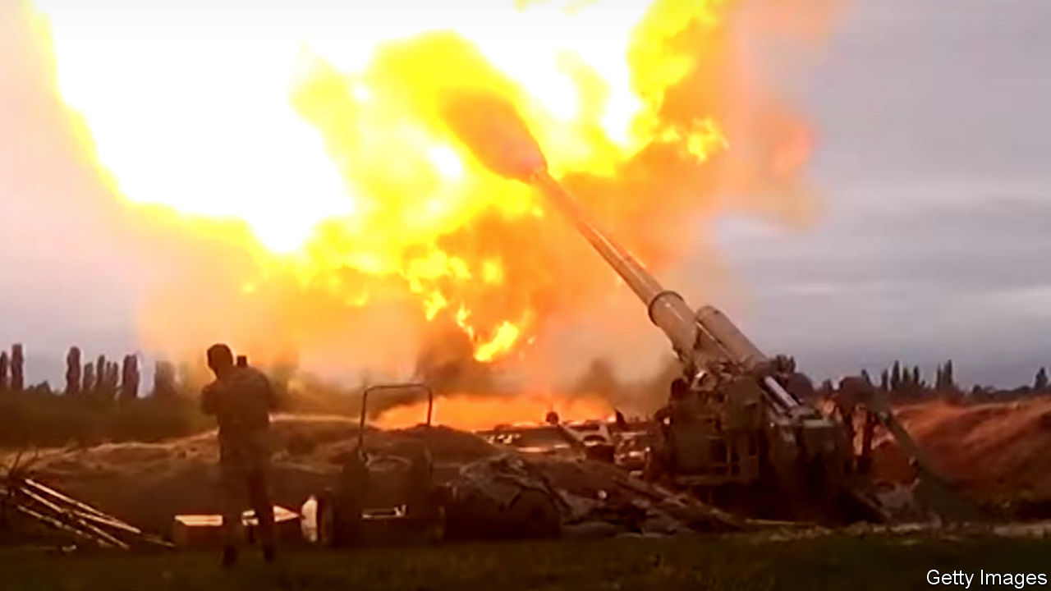

IN ONE VIDEO, an Azerbaijani tank stands in flames. In another, an Armenian one is pulverised by a drone. A hail of gunfire cuts into troops scaling a hillside. One of the world’s most intractable conflicts, over the disputed region of Nagorno-Karabakh, has blown up again, threatening to plunge Armenia and Azerbaijan into full-scale war. By the time The Economist went to press on October 1st, more than 100 people had been killed in five days of fighting.

Both sides blame the other for the violence, though it seems Azerbaijan had been preparing an offensive to recover at least part of Nagorno-Karabakh for some time. The fighting has awakened memories of a war that devastated the region in the 1990s. Missiles have rained down on Armenian positions across the separatist enclave, including Stepanakert, its main city. Azerbaijan said it had taken several villages. Both countries declared martial law and mobilised troops. Armenia accused Turkey, Azerbaijan’s main ally, of shooting down one of its warplanes; Turkish officials denied it.

Nagorno-Karabakh was part of Azerbaijan under the Soviet Union. As the empire crumbled, clashes broke out between its Armenian majority, which sought union with Armenia or independence, and its Azerbaijani minority. This descended into a war that saw atrocities on both sides. Some 30,000 people were killed and about 1m displaced before a ceasefire in 1994. The region has since been controlled by Armenian forces, though it is still internationally recognised as part of Azerbaijan. The Armenians also occupy surrounding areas, connecting the enclave to Armenia.

International mediation has failed to bring about a breakthrough. Nikol Pashinyan, Armenia’s prime minister since 2018, seemed open to talks when he came to office but has since reverted to a tougher position. In a speech last year he called for Nagorno-Karabakh to be unified with Armenia. Azerbaijan’s strongman president, Ilham Aliyev, has since ruled out negotiations. Skirmishes in the area occur regularly. At least 16 people, including an Azerbaijani general, were killed in clashes north of the enclave in July.

The fear is that Azerbaijan is now bent on taking back the entire enclave. “This is a more serious escalation, much better prepared, with more troops, and happening simultaneously on all parts of the front line,” says Olesya Vartanyan, a Caucasus analyst at the International Crisis Group, a Brussels-based think-tank. “In addition to heavy weaponry, we see infantry, we see many more helicopters, and masses of drones,” she says. The clashes threaten to spill over into civilian areas. Outright war could put key pipelines at risk. The region sits close to ones that bring oil and gas from Azerbaijan to Turkey through Georgia.

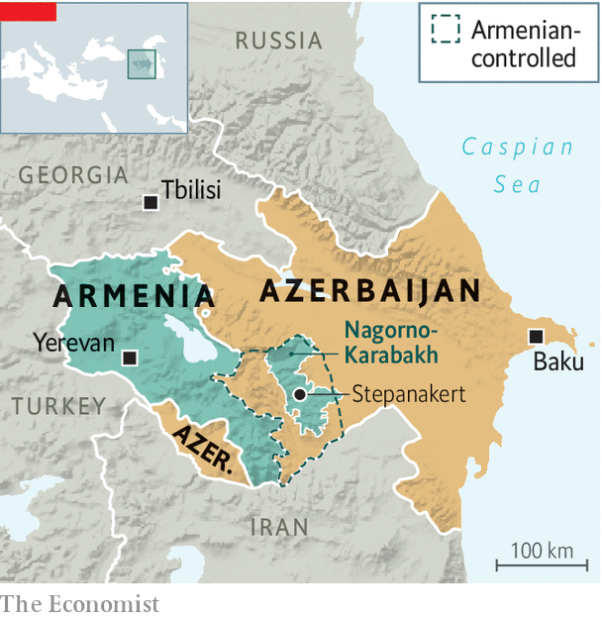

One new factor is Turkey’s greater involvement. Turkey has always backed Azerbaijan politically (Azeris are ethnically close to Turks) but now seems keener than ever to back it militarily, says Thomas de Waal of Carnegie Europe, a think-tank. Unlike other outside powers, including the EU, America and Russia, which have called for an end to the fighting, Turkey has urged Azerbaijan to fight on. Its president, Recep Tayyip Erdogan, said on September 28th that peace would come to the region only once Armenia withdrew from Nagorno-Karabakh. His spokesperson added a day later that Turkey was “fully ready” to help Azerbaijan recover the enclave. Turkey already supplies its ally with armed drones, which have been used in the fighting. Some reports say Mr Erdogan’s government has sent Syrian mercenaries to help.

Azerbaijan may settle for only partial gains. But escalation or deeper Turkish involvement could spark a confrontation with Russia, which also sells arms to Azerbaijan but has a mutual-defence pact with Armenia. In theory, since Nagorno-Karabakh is not formally part of Armenia, Azerbaijan can do “whatever it wants there” without provoking a Russian response, says Andrei Kortunov, head of the Russian International Affairs Council. “But that does not mean Russia will sit on its hands.”

So far Russia has only asked Turkey to back a ceasefire. “The Russians don’t want to be involved and prefer to play a balancing act and be a mediator,” says Mr de Waal. “But if Armenian territory is under attack, they have no option but to defend Armenia.” Turkey and Russia are already tangled up in two proxy wars, in Libya and Syria. They run the danger of fighting a third one in the Caucasus. ■

This article was downloaded by calibre from <https://www.economist.com/europe/2020/10/03/war-returns-to-nagorno-karabakh>

|  |  |  |  |
| --- | --- | --- | --- |
| Previous | Articles | Sections | Next |

|  |  |  |  |
| --- | --- | --- | --- |
| Previous | Articles | Sections | Next |

#### Taking on Viktor Orban

# A by-election shows why Hungary’s opposition struggles

The ruling party controls the state and the media

Oct 3rd 2020 | BORSOD

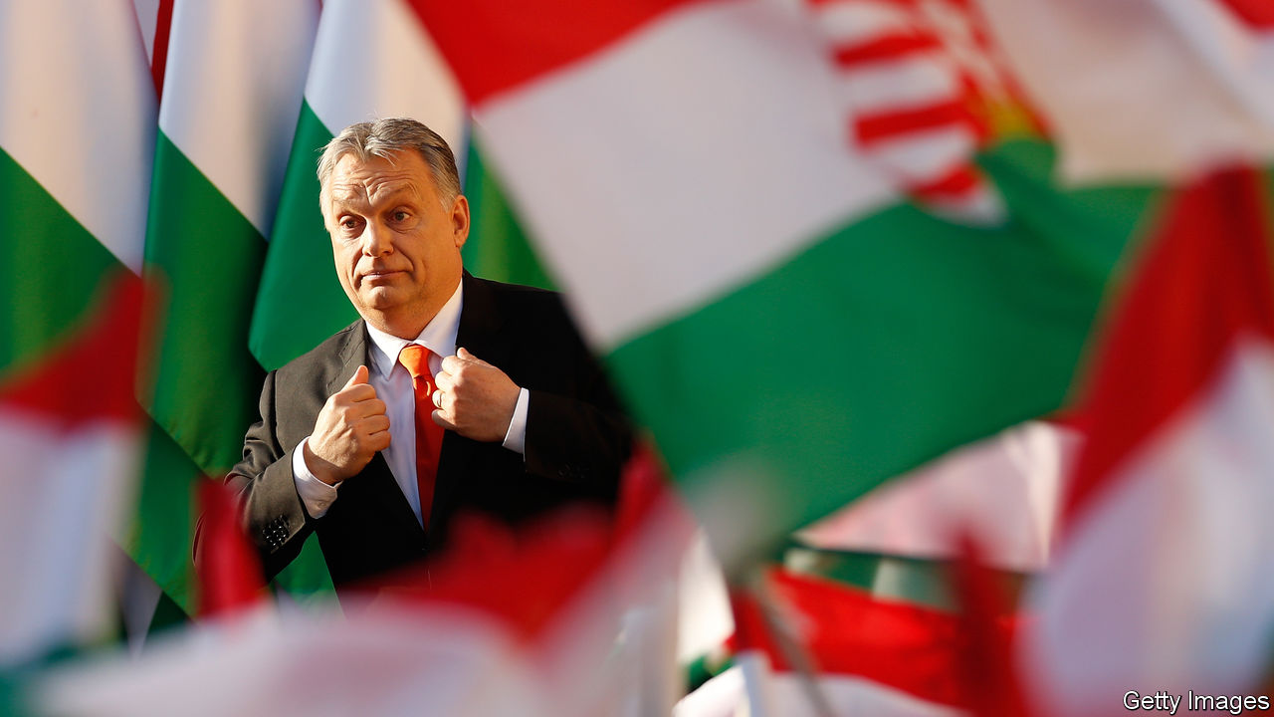

BORSOD IS A sweet spot in north-east Hungary, whichever way you look at it. It is home to a big chocolate factory (Szerencsi Bonbon), a caffeine-packed energy drink (Hell), and a pudding wine traditionally favoured by kings and queens on their wedding night (Tokay). It is also the place where the opposition to Viktor Orban, Hungary’s autocratic prime minister, is up against a challenge.

Opposition parties hope that a by-election on October 11th will give a boost to their efforts to combine and defeat Mr Orban’s Fidesz party at the general election scheduled for 2022. Success in Borsod 6, the constituency in question, would theoretically end Fidesz’s super-majority in the Hungarian parliament, which allows it to alter the constitution; it currently has 133 of the 199 seats. “This would be above all a symbolic victory,” says Peter Marki-Zay, a prominent critic of Mr Orban. “The result will determine the political mood of the next 18 months.”

The task will not be easy. The joint opposition candidate is Laszlo Biro, a local entrepreneur from the formerly far-right, though now centre-right, Jobbik party. Early in the campaign, openly anti-Semitic remarks surfaced from his Facebook page of two years ago. Since then, the campaign against him in the government-sponsored media has been relentless, while Hungary’s few remaining independent outlets have professionally reported the agonising among opposition parties over their choice of candidate. Fidesz chose a 30-year-old political novice, Zsofia Koncz, to defend the seat held by her father, who died in July in a car crash.

Borsod 6 illustrates the problems the opposition faces. Its 77,000 voters are spread among four towns and several dozen villages. Fewer than 10,000 of them have degrees, well below the national average. Opposition gains in last October’s local elections were mainly in larger towns. The rural poor, dependent on government work schemes initiated by Fidesz, are easily persuaded that only Mr Orban can improve their lot—one reason why a Jobbik candidate, no matter how unpalatable, has the best chance of taking the seat. But Fidesz’s stranglehold over regional media is almost total, and its influence through social media is far greater than in 2018.

Mr Biro has apologised for his racist comments, which included the word “Judapest”—a slur that originated in the early 20th century, when perhaps a quarter of the people in Budapest were Jewish. Jobbik makes other opposition voters uneasy, and working together hard. Yet Hungary’s new electoral system means that only close co-operation will work in 2022. ■

This article was downloaded by calibre from <https://www.economist.com/europe/2020/10/03/a-by-election-shows-why-hungarys-opposition-struggles>

|  |  |  |  |
| --- | --- | --- | --- |
| Previous | Articles | Sections | Next |

|  |  |  |  |
| --- | --- | --- | --- |
| Previous | Articles | Sections | Next |

#### Dancing with death

# Spain’s poisonous politics have worsened the pandemic and the economy

Its record is Europe’s worst on both counts

Oct 3rd 2020 | MADRID

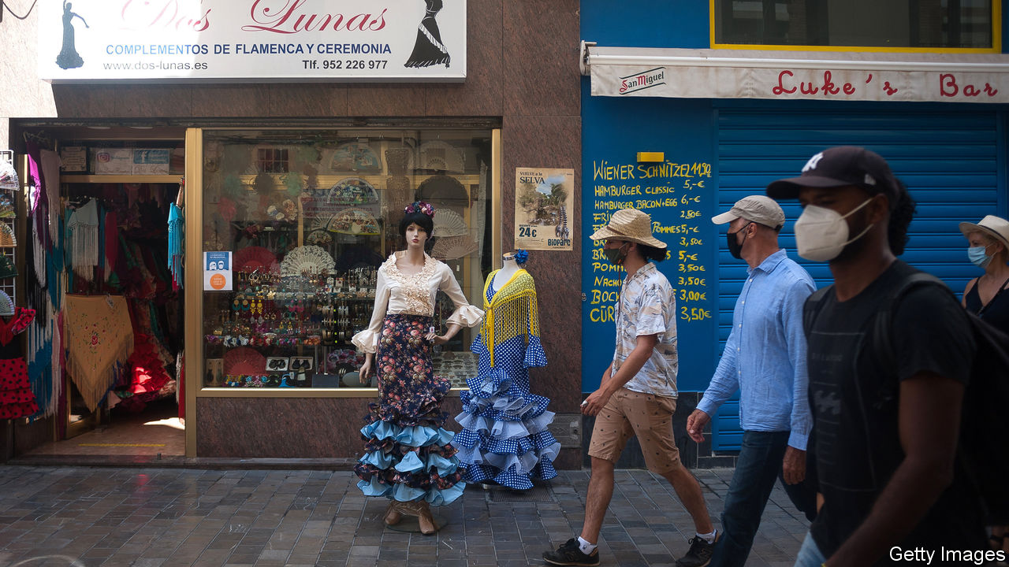

THE INFANTA LEONOR hospital, wedged between a motorway and a suburban railway, serves the dense working-class districts of south-eastern Madrid. Last month 402 of its 480 doctors signed a letter to the regional government warning that the hospital was in a state of “pre-collapse”, with 54% of its 361 beds and all 27 intensive-care spaces occupied by covid-19 patients. With 784 cases per 100,000 people in the past fortnight, Madrid is currently the worst-hit region in Europe.

This is part of a broader national failure. On July 5th Spain’s prime minister, Pedro Sánchez, proclaimed that “we have defeated the virus and controlled the pandemic.” Yet the country is once again Europe’s coronavirus black spot (see chart).

What went wrong? Health experts point the finger at a failure of government for which both Mr Sánchez’s left-wing minority coalition and the conservative opposition People’s Party (PP), which runs Madrid, carry the blame.

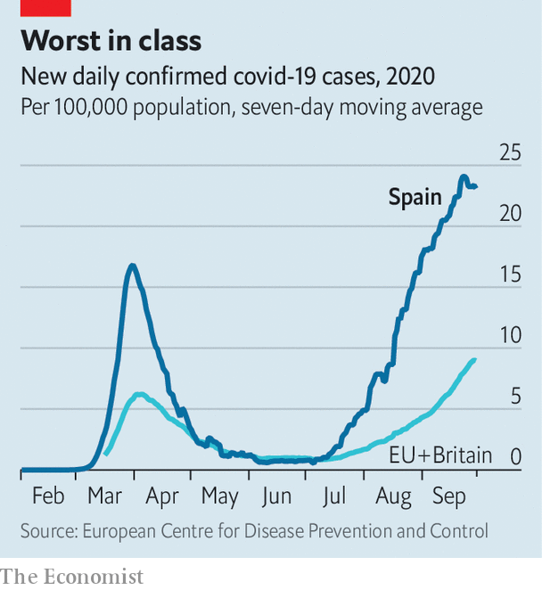

After Europe’s strictest lockdown, Spain rushed its release. The PP joined Catalan and Basque nationalists in refusing to support the renewal of the state of emergency under which the government could restrict activity. Rebuffed, Mr Sánchez handed control of the pandemic to the regions and went on holiday. Several of the regions, especially Madrid, failed to strengthen primary health care and contact-tracing. The government failed to require them to do so, nor did it fix clear rules for handling outbreaks of the virus. The summer did the rest: heeding Mr Sánchez’s triumphalism, Spaniards returned to their normal happy mingling in bars, nightclubs and at family gatherings.

Isabel Díaz Ayuso, Madrid’s regional president, opposes stricter measures that would hurt the economy. This week the government thought it had secured her agreement to extend to the whole of the capital restrictions on non-essential movement and gatherings she has placed on its southern areas. New rules would require all cities of more than 100,000 people to follow suit when new cases rise above 500 per 100,000, and other criteria are met. But three other PP-governed regions opposed them, and as The Economist went to press, the deal seemed to have fallen apart.

The failure to keep the pandemic under control has nipped the economic recovery in the bud. Forecasters now reckon the economy will contract this year by up to 13%, the worst figure in Europe. A hoped-for restart of tourism was curbed by the renewed outbreaks. Raymond Torres of Funcas, a think-tank, notes that the Spanish economy is particularly vulnerable because, all told, tourism and hospitality account for 26% of GDP—five points more than the European average.

Some 60,000 of Spain’s 315,000 bars and restaurants have shut down; another 40,000 are likely to do so by the end of the year, according to the sector’s lobby. The government this week extended until January 31st a furlough scheme which currently helps some 800,000 workers (down from a peak of 3.2m). It has granted €85bn ($100bn) in credit to businesses. More tools may be needed to prevent what Mr Torres fears may be a “cascade of bankruptcies”.

Spain is trusting in EU aid, but most of that will not arrive until 2022. It may be tied to reforms of the labour market, pensions, education and training. These require political consensus, which is in short supply. Mr Sánchez has repeatedly called for national unity, only for ministers to stick the knife into the opposition. His relations with Pablo Casado, the PP’s leader, are marked by mutual mistrust.

The coalition of Mr Sánchez’s Socialists and Podemos, a far-left party, was voted into office in January with the help of Basque and Catalan separatists. Officials complain that the right denies its legitimacy. The opposition accuses Mr Sánchez of endangering the constitution with his liaisons: Pablo Iglesias, Podemos’s leader, snipes at the monarchy and the judiciary.

With some delay, Mr Sánchez is likely to get a budget approved. That should allow the government to survive for the rest of the parliamentary term until 2023. But at a cost. The private sector is rattled by Spain’s political warfare and Podemos’s presence in government, although it has little influence over economic policy. “There’s a bull market in pessimism,” says a normally upbeat former minister with business ties. “I’ve never been so worried about the political situation.” The moderation of the Spanish middle class and the constraints imposed by the EU are his only solace. ■

Editor’s note: Some of our covid-19 coverage is free for readers of The Economist Today, our daily [newsletter](https://my.economist.com/user#newsletter). For more stories and our pandemic tracker, see our [hub](https://www.economist.com/news/2020/03/11/the-economists-coverage-of-the-coronavirus)

This article was downloaded by calibre from <https://www.economist.com/europe/2020/10/03/spains-poisonous-politics-have-worsened-the-pandemic-and-the-economy>

|  |  |  |  |
| --- | --- | --- | --- |
| Previous | Articles | Sections | Next |

|  |  |  |  |
| --- | --- | --- | --- |
| Previous | Articles | Sections | Next |

#### Balkan balladeers

# What do Dua Lipa, Rita Ora and Ava Max have in common?

Pop stars with Albanian roots conquer the world

Oct 3rd 2020 |



UNTIL RECENTLY the most famous ethnic Albanians were Mother Teresa (a nun who cared for orphans and lepers in India) and Enver Hoxha (a homicidal communist despot). Now to the saint and the sinner must be added the singers.

They are everywhere. Dua Lipa has 55m monthly listeners on Spotify, a music-streaming platform. Bebe Rexha has 24m. Rita Ora (pictured) has had five British number one singles and has been a judge on “the X Factor”. Era Istrefi sang at the football World Cup in 2018. Njomza Vitia, a singer-songwriter, and Labinot Gashi, a rapper, have global followings. Ava Max’s sexy single “Sweet but Psycho” is universally considered more fun than Hoxha’s literary offering, “Albania Challenges Khrushchev Revisionism”.

All these megastars of Albanian heritage except Ms Istrefi grew up in the diaspora. Ms Lipa, Ms Max, Ms Rexha and Ms Vitia were born, respectively, in London, Milwaukee, Brooklyn and near Stuttgart. Only Ms Max has roots in Albania itself; the rest are of Kosovar descent, save Ms Rexha, whose family come from North Macedonia.

Throughout history, says Dukagjin Lipa, Ms Lipa’s father, Albanians have been squashed, but the success of this generation of musicians shows that “given the chance, we excel.” The stars of the diaspora often perform back home, wrapping themselves in Kosovar or Albanian flags.

Besa Luci, editor of Kosovo 2.0, a magazine, says they clearly feel a need to represent the nation and in return earn an outpouring of love. “My heart bleeds Albanian blood,” said Ms Rexha on a visit to Albania. In July Ms Lipa courted controversy by tweeting a map associated with extreme Albanian nationalists showing a vast Greater Albania. She later said her post had been “misinterpreted”.

The parents of the stars who grew up abroad left the Balkans in the turbulent early 1990s. But it was not always a story of refugee rags to riches. The Ora and Lipa families were part of Kosovo’s elite. Both girls attended a top performing-arts school in London.

The pop stars, along with a clutch of Albanian footballers in top teams across Europe, play an “incredibly important role” in helping to change Albanians’ image from one of conflict, says Petrit Selimi, a former foreign minister of Kosovo. In 2016 an unusually demure Ms Ora performed in Rome to celebrate Mother Teresa’s canonisation.

This article was downloaded by calibre from <https://www.economist.com/europe/2020/10/03/what-do-dua-lipa-rita-ora-and-ava-max-have-in-common>

|  |  |  |  |
| --- | --- | --- | --- |
| Previous | Articles | Sections | Next |

|  |  |  |  |
| --- | --- | --- | --- |
| Previous | Articles | Sections | Next |

#### Charlemagne

# The revenge of strategic yogurt

How the EU started speaking French when it comes to the economy

Oct 3rd 2020 |

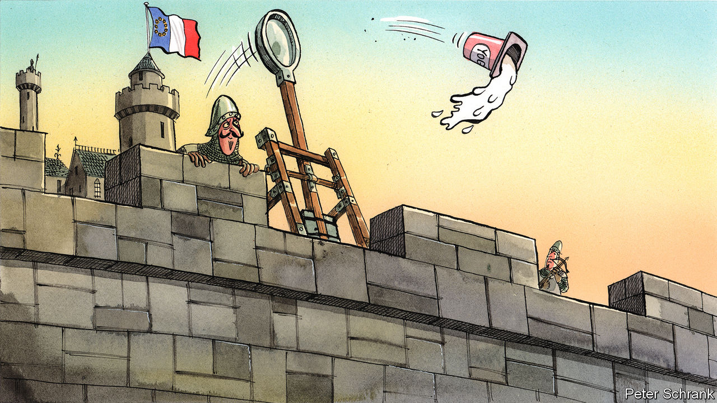

DANONE IS PROUD of its yogurts. The French company boasts that 4bn patented bacteria go into every pot, with each batch fermented for eight hours, or roughly a quarter of the French working week. France, understandably, is proud of Danone. When rumours emerged in 2005 that Pepsi was considering a bid for the company, the French political establishment howled. Dominique de Villepin, the then prime minister, pledged to defend the “interests of France”. Jacques Chirac, the president at the time, promised to be “vigilant and mobilised” against any potential predator of French business. Anglo-Saxon capitalists guffawed. In Brussels, European Commission officials rolled their eyes and delivered lectures on the merits of red-blooded competition. “Strategic yogurt” became a byword for the excesses of French protectionism.

After a decade of such jokes, French ideas are now the bedrock of the EU’s economic policy. In Brussels, industrial strategies for everything from hydrogen to car batteries have been developed. (Incidentally, Thierry Breton, the French finance minister during the Danone row, is now the commissioner responsible.) A carbon border tax—first seriously floated by Chirac—is on the cards, which would involve duties on products entering the single market from polluting countries. New rules are in the works to make it easier to block foreign takeovers—whether of yogurt manufacturers or not—if the buyer has benefited from unfair subsidies. Some of the buzzwords have changed. Whereas Mr de Villepin and Co spoke of “economic patriotism”, today’s economic Francophiles in the EU speak of “strategic autonomy” and “sovereignty”, which now litter the conclusions of European Council meetings. But the content is the same. How did the French worldview take over?

One reason is that the bloc’s usual band of free traders are in retreat, cowed by a backlash against trade deals. This has taken place in some unlikely spots. The year 2016 is remembered as when voters opted for Donald Trump and Brexit. But it was also the year that the Dutch in a referendum voted against a trade agreement with Ukraine and a band of Walloons threatened to bring down a similar one with Canada. Now politicians line up to criticise such deals. In June Dutch MPs backed a motion against the ratification of a deal between the EU and Mercosur, the South American trade bloc, as have their usually liberal Irish counterparts. The Dutch even issued a joint paper with the French, calling for strict enforcement of labour and environmental standards in such deals.

Britain’s departure has deprived the economic liberals of clout. Even if Britain had stayed, the EU’s Frenchification might still have happened. Outside the bloc, Britain has spurned the idea of Singapore-on-Thames and is pursuing London-sur-Seine. Surprisingly, the British government’s right to pump businesses with taxpayers’ money without any EU constraint—historically a French dream—has emerged as an obstacle in trade talks. Brussels is determined not to allow Britain the chance to undercut the bloc with subsidies and is testing its newfound willingness to cut anyone who fails to abide by its wishes out of the single market. Charles Michel, the European Council president, turned to a French playwright to explain the EU’s hitherto unappreciated strength: “Just as Molière’s Monsieur Jourdain speaks in prose without realising it, Europeans have become a world power without realising it.”

Naivety, long a favourite term of French trade negotiators, has become a watchword for how the EU has mishandled its economic relationship with trading partners. When it comes to China, even diplomats from the most forthright liberal countries admit as much. If a conservative is a liberal who has been mugged by reality, a neo-protectionist is a trade negotiator who has had to deal with China. It speaks to a wider shift in the EU’s outlook on the rest of the world. Before, the world was an opportunity, with blockbuster trade deals the order of the day. These days it is seen as a threat, with an assertive China and an erratic America causing trouble from which the EU must protect itself.

A brutal mix of economics and geopolitics leaves the EU with little choice but to take a more protectionist line, argues Hosuk Lee-Makiyama, a director at the European Centre for International Political Economy, a free-trade think-tank. Export-led growth is off the table, if countries such as China and India remain closed. America will still be a tricky partner even if Donald Trump leaves the White House. This leaves import substitution as the only option, even if EU leaders do not dare to admit it.

## Ceci n’est pas un bloc protectionniste

After all, protectionism is still a dirty word in Brussels. Even the French do not use it. And they have good reason to be coy. For starters, the EU likes to see itself as the last guardian of the multilateral order. But its newfound enthusiasm for unilateral methods—such as stopping foreign buyers of European companies on subsidy grounds—puts this reputation under strain. Given how dependent the EU is on exports, which are worth about half its GDP compared with 12% in America and 18% in China, the bloc will probably come off worse from any protectionist fight. It is possible that merely developing the tools will ensure the EU never has to use them, argues Sam Lowe from the Centre for European Reform, a think-tank. But if the EU does end up using these tools as a stick, it may turn out to be a boomerang that comes hurtling back at them.

All this means that there are limits to the EU’s economic Francophilia. France’s quixotic quest to bring home the production of things like surgical masks is politely ignored by its new allies. At the moment, the EU imports cheap things, like PVC gloves, and sells expensive things, like hospital scanners. Jeopardising this settlement would be unwise, particularly as the main problem at the start of the pandemic in the EU was de facto state-sanctioned piracy, with governments snatching medical goods that passed through their territory. French ideas may be in vogue in the EU. But many are just strategic yogurt. ■

This article was downloaded by calibre from <https://www.economist.com/europe/2020/10/03/the-revenge-of-strategic-yogurt>

|  |  |  |  |
| --- | --- | --- | --- |
| Previous | Articles | Sections | Next |

|  |  |  |
| --- | --- | --- |
| Europe | Sections | International |

Britain

Race: Not black and white

.

Cars in the capital: Road warriors

.

Covid-19 in universities: Freshers’ covid

.

Skills: How the other half learns

.

Lithium: Wheels within wheals

.

Scotland: In their sights

.

Bagehot: We shall fight them on the airwaves

.

|  |  |  |
| --- | --- | --- |
| Europe | Sections | International |

|  |  |  |  |
| --- | --- | --- | --- |
|  | Articles | Sections | Next |

#### Ethnic minorities

# Britain’s mixed-race population blurs the lines of identity politics

It’s not black and white

Oct 3rd 2020 |

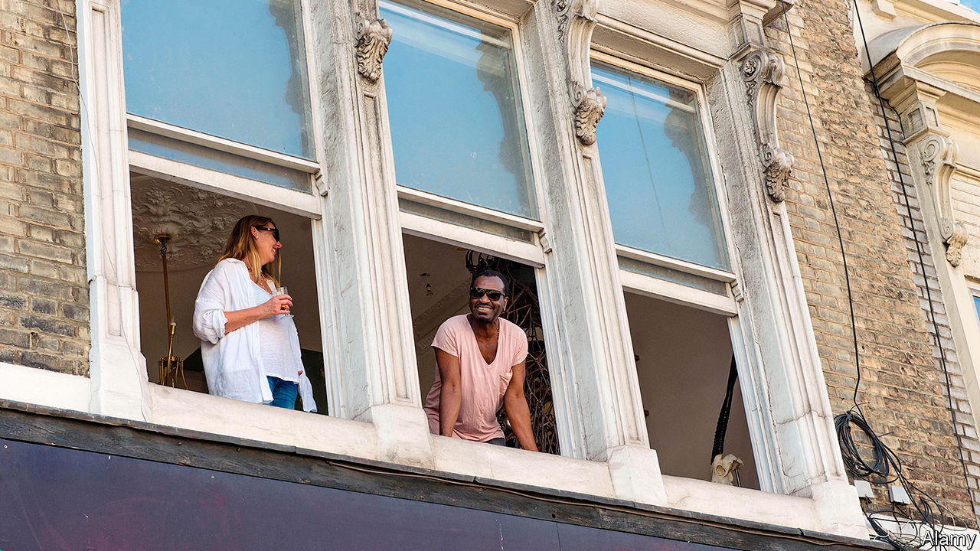

GEORGE BERNARD SHAW, a playwright and activist, thought that the best way to bring about social equality was “to keep the entire community intermarriageable”. He was primarily concerned with relationships across the class divide but, when he visited South Africa in 1935, he caused a stir by suggesting the same idea for race. The Daily Telegraph, for one, was taken aback. “Marriages of white and black: Startling plan by Mr Shaw”, its headline read.

What was once startling is now commonplace. The number of Britons who say they have a mixed-ethnic background almost doubled between the census of 2001 and 2011, to about 1.2m, or slightly more than 2% of the overall population. That figure is probably an undercount, since not all children of mixed marriages will have ticked one of the mixed categories, and the number is likely to have grown since the census. An analysis by Alita Nandi of Essex University and Lucinda Platt of the London School of Economics suggests that the true figure could be three times as high. If that is right, mixed-race people constitute a larger proportion of the population than any ethnic group.

And that share is still growing. Fewer than 1% of Britons aged 50 or over in 2011 had a mixed-ethnic background, according to an analysis of official statistics by Rob Ford of Manchester University. Among the youngest cohort—under fives—6% had one. The proportion of cohabiting couples that are interracial shot up from 2.6% in 2001 to 4.5% by 2011. Both patterns suggest that the next census, due next year, is almost certain to report an even larger number of mixed-race Britons.

This demographic shift coincides with the resurgence of race as a central political theme. In Britain, as in America and continental Europe, this year will be remembered not only for covid-19 but also for a reassessment of the state of race relations. As statues were felled and historic anthems reappraised, the idea of “white privilege” leapt from the campus to the streets. Yet much of the focus on symbolic and systemic racism overlooks the growing significance of mixed-race Britons, who often defy labels. The attitudes of this group will be crucial in determining the future direction of identity politics.

This is truer of Britain than of other rich countries. London appears to have a far more ethnically mixed population than Paris, Berlin or Rome, though since France, Germany and Italy do not collect data on race, it is impossible to be sure. Certainly, mixed-race people make up a greater share of all non-whites in Britain (16%) than in America (11%). And the pattern of marriage is different, too. Most Americans of mixed parentage settle down with a partner from a minority group, but 50% of Britons with black African and white parents—and 75% whose parents were white and black Caribbean—marry a white partner.

A poll for The Economist by Ipsos MORI suggests that mixed-race Britons are, in general, less wary of Britain’s institutions and history than black Britons (see chart). They are marginally less likely to support Black Lives Matter (BLM), less likely to agree with the proposition that “Britain is a racist country” and much less likely to think most British cops are intentionally racist. Though a plurality of all ethnic groups surveyed thought the British Empire should be a source of neither shame nor pride, considerably more mixed-race than black Britons were proud of it. Sunder Katwala of British Future, a think-tank, believes that BLM will pursue different policies in Britain than in America in part because of the disparity in the rates of inter-ethnic relationships. “This policing of the boundaries requires a high level of social distance between the groups,” he says.

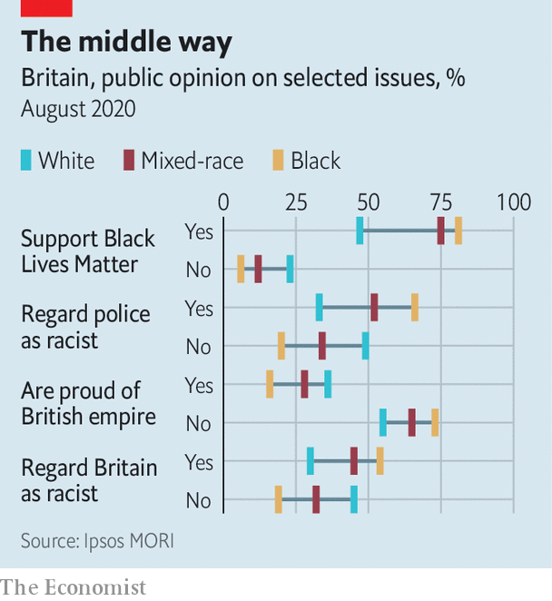

That is much rarer in Britain than it once was. Consider Marvin Rees, the mixed-race mayor of Bristol. He is proud of his Jamaican ancestry and, growing up in the 1980s, he often faced racial abuse. Yet he would return home each evening to his white mother, who left school at 14 to work as a hairdresser. “There is such a thing as white privilege but my white family did not grow up with privilege,” he says. He remembers a school friend asking him during one of the city’s race riots, when they were both about 13, “‘in a war between black and white whose side are you going to be on?’...The idea of going to war with white people didn’t sit well with me. At the same time, I recognised the physical threat to my safety was coming from white people.”

Mr Rees, whose wife is white, credits his background for his nuanced approach to racial issues. His city made headlines around the world in June when protesters toppled a statue of a city father who was a notorious slave trader. But Mr Rees was wary of such direct action, arguing that symbols were far less important than measures to tackle entrenched inequality. “I will talk about race and racism in all its fullness,” he says. “But I’m not going to go home and give mum a hard time for being white or ask her to feel guilty.”

Maya, a 30-year-old university teacher in London, also says her ancestry—mixed white and south Asian—makes her aware that “identity is in part changing and contextual”. That she can count ancestors on either side of Britain’s colonial history emphasises the complexity of racial politics and makes her ambivalent about “rigid identity positions”. Another Londoner reckons his mixed-race parentage gives him “a sense of perspective on how arbitrary identity politics is”.

It is not inevitable that, as ethnicities mix, identities get watered down. Mr Rees points out that, as people feel their connection to a particular identity weakening, they may well seek to reassert it. “People crave simplicity and certainty.” If that were to happen, the growth in intermarriage could eventually make racial politics more, not less, divided.

But our polling suggests the opposite is happening. Trevor Phillips, a former chairman of the Equality and Human Rights Commission, argues that rather than being forced to choose one ethnic identity or another Britain’s mixed-race citizens are increasingly claiming “both sides of their heritage”. His children have Indian, French and Caribbean ancestry, with cousins from each branch of the family. “Wherever they are at Christmas,” he says, “they know what to do.” And, as Mr Katwala has written, “that is only a threat to those whose views of race depend on telling everybody else how to think about who they are.” ■

This article was downloaded by calibre from <https://www.economist.com/britain/2020/10/03/britains-mixed-race-population-blurs-the-lines-of-identity-politics>

|  |  |  |  |
| --- | --- | --- | --- |
|  | Articles | Sections | Next |

|  |  |  |  |
| --- | --- | --- | --- |
| Previous | Articles | Sections | Next |

#### Cars in the capital

# The battle over London’s road closures

Old London pitted against new

Oct 3rd 2020 |

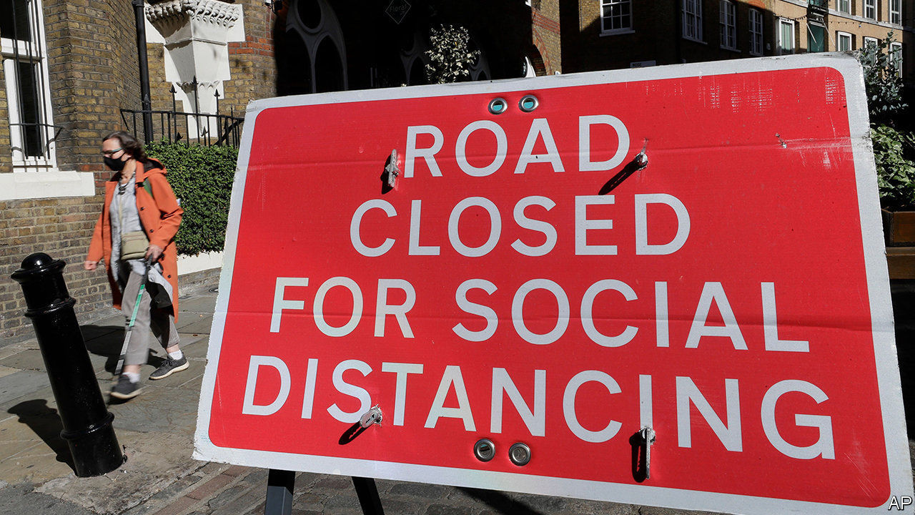

ON SEPTEMBER 26TH a few dozen people gathered in Bethnal Green in the East End of London to protest against road closures. Whistles blew and passing drivers honked as speakers railed against Tower Hamlets council. Restrictions on driving (some planned, others already in place) were awful, they said. Banning cars from some roads merely increased traffic on others; local businesses were dying for want of customers; the disabled could not get about. It was all very harmonious, until a suspicious group of men was spotted nearby. “Cyclists!” hissed a protester. “They might be looking for trouble.”

When covid-19 hit Britain in the spring, several London councils moved to head off an expected surge in driving as people tried to avoid public transport. New planning rules allow them to close roads to cars without holding lengthy consultations—they can act first and then, over the next 18 months, ask people what they think of the changes. Councils have duly blocked some roads with bollards and large wooden planters, and erected cameras on others to photograph and fine errant drivers.

This should not have been unexpected. Driving in London has become ever more challenging, and in the 2018 local elections Labour Party councillors in some boroughs pledged to deter it even further. But the sudden changes have been too much for some. Protests have been held, traffic signs have been spray-painted over, bollards and planters have been vandalised and oil has been tipped onto bike lanes.

Ostensibly, supporters and opponents of the new low-traffic neighbourhoods, sometimes called “mini-Hollands”, disagree about facts. Does banning cars from local streets discourage driving or merely displace it to other roads? Does it slow down ambulances and fire engines or speed them up? But the dispute over road closures is really about something bigger.

“It’s social cleansing,” argues Mohammad Rakib, who organised the protest in Bethnal Green. He believes the car bans are designed to create a village atmosphere that will entice more young, bicycle-riding professionals to a mostly poor district. He thinks it is revealing that advocates of low-traffic neighbourhoods laud cities such as Amsterdam and San Francisco: “Those places have already been gentrified.”

The argument, which other protesters also make, that car bans disproportionately affect working-class Londoners is wrong. The wealthy drive cars (and ride bicycles) more than the poorest, who tend to walk or take buses. What is true, however, is that veteran Londoners drive. People who moved to the capital several decades ago are much more likely to own a car than new arrivals (see chart). The opponents of low-traffic neighbourhoods are fighting to save the old, chaotic, dirty London. One group, in Hackney, has embraced the slur that its supporters are “rat-runners”.

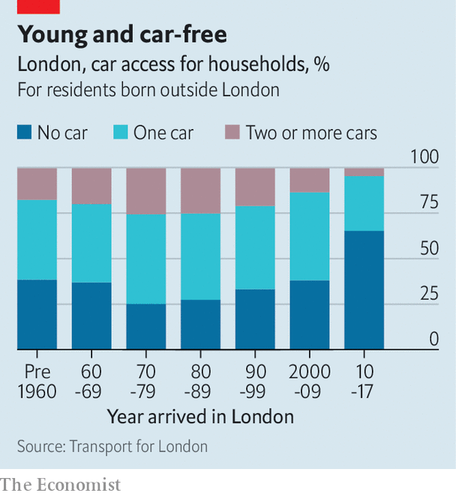

The struggle between old and new, between those defending their way of life and those who want a greener city, is London’s version of the cultural divide that gave Britain Brexit and propelled Boris Johnson to power. Jody Graber, a leader of the protests against road closures in Islington, certainly hopes the parallel holds. He plans to stand as a councillor in that heavily Labour borough. “Boris smashed the red wall up north,” he says. “I’m going to smash it in north London.”■

This article was downloaded by calibre from <https://www.economist.com/britain/2020/10/03/the-battle-over-londons-road-closures>

|  |  |  |  |
| --- | --- | --- | --- |
| Previous | Articles | Sections | Next |

|  |  |  |  |
| --- | --- | --- | --- |
| Previous | Articles | Sections | Next |

#### Freshers’ covid

# British universities may be particularly susceptible to covid-19

A rash of outbreaks greets returning students

Oct 3rd 2020 | LEEDS

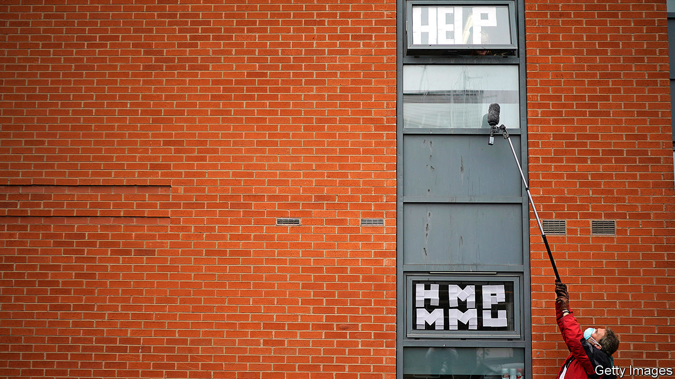

THE ANNUAL journey of more than 2m students to British universities is, as David Willetts, a former higher-education minister, has put it, a mass migration: “All it needs is Sir David Attenborough to provide an excited commentary as the convoys of heavily laden estate cars roll by.” This year, the migration has happened as case counts rise during a pandemic—with predictable consequences.

The impact is clear at the University of Leeds. Even in the autumnal sun, few students mingle beneath the hulking brutalism of its campus. With lectures cancelled and most socialising banned, life is to be found elsewhere. Helena Foulger, for one, is in her student flat. The first-year criminologist arrived in Leeds on September 16th. Eight days later she took a covid test, which came back positive. Two of her five flatmates have developed symptoms; all are isolating. “I think there’s one out of nine flats in our block now that hasn’t got corona,” she says.

The peculiarities of British higher education may make it especially vulnerable to the pandemic. More than a third of the country’s universities have already recorded cases. Despite plenty of warning, outbreaks appear to have taken national governments and many universities by surprise. At the start of September, the official Scientific Advisory Group for Emergencies (SAGE) dedicated a meeting to the return of universities. A paper prepared for the get-together warned that “it is highly likely that there will be significant outbreaks associated with [higher education], and asymptomatic transmission may make these harder to detect.”

The experience of other countries provided additional warning. According to the New York Times, more than 130,000 cases have been recorded at American colleges, which tend to go back earlier. And whereas in America and Europe plenty of students go to their local institution, living at home while studying, in Britain the medieval model of a young scholar travelling to study still dominates. Four in five students leave home to go to university, where they live in cramped digs well-suited to transmission of the virus.

Some universities, including Glasgow and Manchester Metropolitan, have responded to outbreaks by locking students in their halls en masse. Ms Foulger says Leeds has been helpful, but elsewhere imprisoned students have set up Instagram accounts detailing the dismal food they have received. Nicola Sturgeon, Scotland’s first minister, was criticised for instructing students to avoid pubs and restaurants (restrictions which were not imposed on other social groups).

Higher-education funding follows student recruitment; over the summer the government outlined a tough bail-out regime for universities in England that get into trouble. Responding to these incentives, vice-chancellors have sought to offer at least some face-to-face teaching—but growing numbers are now accepting defeat. Students who are being taught entirely online are wondering why they have returned. “9k 4 what?” reads a homemade sign, referring to the annual £9,250 ($11,900) tuition fee, in Manchester.

The government lacks the capacity to put in place screening tests for asymptomatic cases. Some universities, including Cardiff, Cambridge and UCL, have stepped into the breach. At Cardiff, arrivals are asked to take spit tests. The university then has the capacity to carry out 1,000 or so a day. “It’s similar to the moonshot for the country,” says Colin Riordan, its vice-chancellor. “We’ve done it for the university.” If the programmes are successful, more will follow. But their cost is a barrier. Cardiff spent £800,000 setting up its laboratory.

SAGE is concerned by what happens when students return home, when there is the potential for them to seed the virus among more vulnerable populations. Denying reports that students would have to remain at university over Christmas, Gavin Williamson, the education secretary, said in-person teaching may stop a few weeks before the end of term to ensure this is not necessary. Which would mean that students would cap off a term mostly spent in their dorms with even more time spent in their dorms. ■

Editor’s note: Some of our covid-19 coverage is free for readers of The Economist Today, our daily [newsletter](https://my.economist.com/user#newsletter). For more stories and our pandemic tracker, see our [hub](https://www.economist.com/news/2020/03/11/the-economists-coverage-of-the-coronavirus)

This article was downloaded by calibre from <https://www.economist.com/britain/2020/10/03/british-universities-may-be-particularly-susceptible-to-covid-19>

|  |  |  |  |
| --- | --- | --- | --- |
| Previous | Articles | Sections | Next |

|  |  |  |  |
| --- | --- | --- | --- |
| Previous | Articles | Sections | Next |

#### Skills

# Another promise to improve vocational education in Britain

From a prime minister with a classics degree

Oct 3rd 2020 |

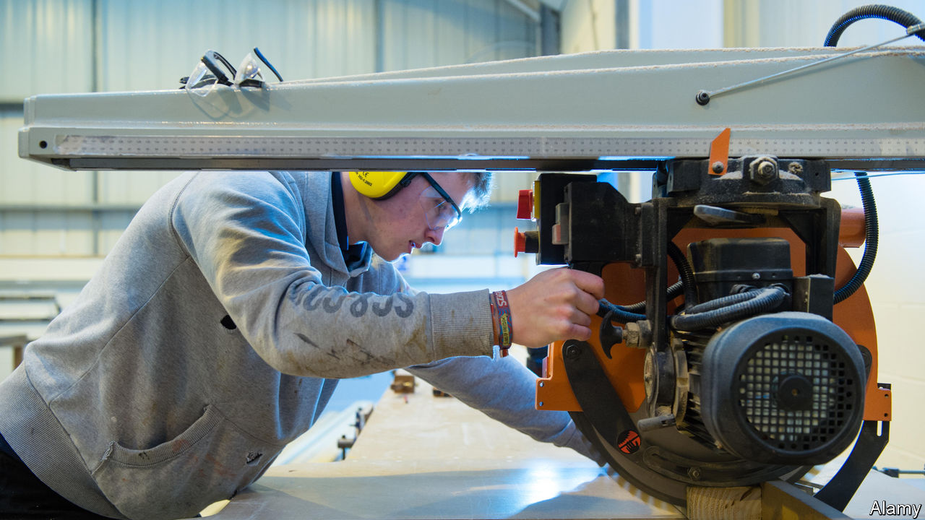

IN 1896 A delegation of businessmen travelled from Manchester to Germany to learn the secrets of its industrial success. The answer, they reckoned, lay in Germany’s superior system of technical education. “It is high time”, they argued, “the effort was made in this country to give our youth the educational advantages enjoyed by their rivals abroad.”

The Mancunians would be unimpressed by the direction of travel in recent years. Universities have expanded hugely; vocational education has not. The Augur review of post-18 education, which reported in 2019, found that there were 50 times as many undergraduates as there were young people studying for higher national diplomas and higher national certificates, the key vocational qualifications. Only 24% of British 16- to 18-year-olds did apprenticeships in 2017, according to the OECD, compared with 59% in Switzerland and 41% in Germany.

Not surprisingly, Britain is shorter of skills than other rich countries. It does badly in 22 of the 31 categories tracked by the OECD (see chart). While Britain is well supplied with sales, marketing, economics and accountancy skills, it is sorely lacking in people who know their onions in construction, engineering, mechanics and technology.

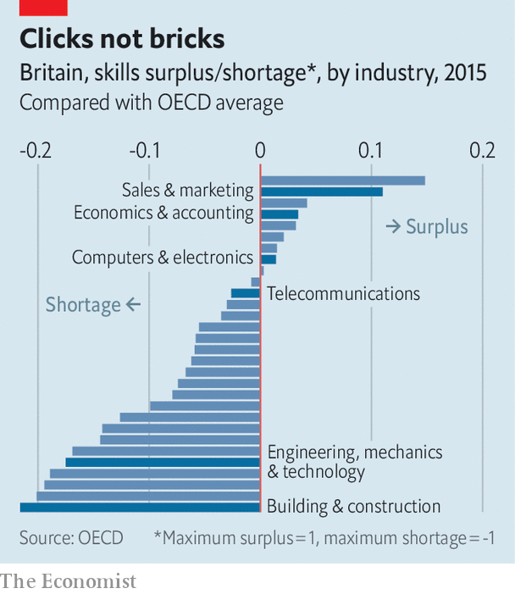

On September 29th Boris Johnson, who studied classics at Oxford University, lectured an audience of further-education college students on the importance of technical, hands-on qualifications. “All of us in this country need you to have those practical skills…more than ever.” He noted that “a significant and growing minority of young people leave university, get non-graduate job and end up wondering whether they did the right thing.” He promised to spend £1.5bn ($1.9bn) on upgrading vocational colleges and to introduce a Lifetime Skills Guarantee that will fund technical courses for adults from April next year.

That sounds encouraging; but the money is dwarfed by the £14bn budget for universities, and British history is littered with similar, failed, initiatives. The Education Act of 1944 created technical schools, but few ever opened and most had closed by the 1960s. Industrial Training Boards were established to oversee vocational training in the late 1960s but had petered out by the 1980s when they were replaced by around 150 Industry Training Organisations to drive technical skills. They, in turn, were mostly folded into the 26 Sector Skills Councils in 2002. Employers used a scheme set up in 2009 to promote apprenticeships to get the government to subsidise their wage bills.

Ewart Keep, an educationalist at Oxford University, reckons that a focus on adult education and providing alternative routes for young people makes a great deal of sense. But he notes that while the promised money will be welcome in the sector, “it is only partially repairing the damage of a decade of real-terms cuts in adult-education funding.” And bringing about the fundamental change in attitudes needed to embed change in the system is difficult, since the reverence for universities is “deep-rooted and class-based”. It is easy for Mr Johnson to make speeches celebrating technical education, but harder to imagine him pushing his own children towards a diploma in construction skills.■

This article was downloaded by calibre from <https://www.economist.com/britain/2020/10/03/another-promise-to-improve-vocational-education-in-britain>

|  |  |  |  |
| --- | --- | --- | --- |
| Previous | Articles | Sections | Next |

|  |  |  |  |
| --- | --- | --- | --- |
| Previous | Articles | Sections | Next |

#### Wheels within wheals

# Cornish miners hope to profit from the shift to electric cars

A domestic supply of lithium could help Britain’s carmakers survive

Oct 3rd 2020 | ST AUSTELL

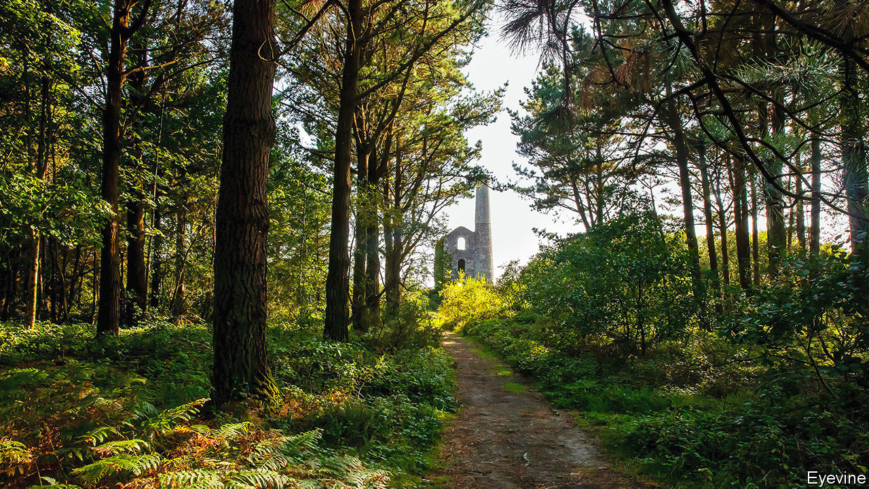

IN THE MIDDLE of the 19th century copper-miners at Wheal Clifford, now the site of picturesque ruins not far from Redruth in Cornwall, chanced upon waters rich with lithium. At the time there was no commercial use for the metal. The underground springs were a nuisance they had to work round. These days lithium is an essential component of the batteries that drive electric cars, and deposits across Cornwall are attracting prospectors. Locals hope for a revival of the county’s mining industry, two decades after its last metal mine closed.

Two companies with different approaches are investing. Cornish Lithium plans to extract the metal from brine it will retrieve by drilling wells. It is building a pilot plant a short walk from Wheal Clifford that will be ready within 18 months, says Jeremy Wrathall, its boss. British Lithium, a competitor, says it will get its product by crunching up rocks from a quarry it wants to dig outside St Austell. Roderick Smith, the company’s chairman, says that hole will be “big but not gigantic”, in an area that has already been scarred by china-clay works. Both teams talk of starting commercial production in three to five years.

Global demand for lithium is expected to increase five-fold in the next 15 years, as petrol and diesel cars give way to electric ones. At present most of it comes from Chile, Argentina and Australia. A lot of it must pass through China for processing. Most analysts agree that there will eventually be enough to go round. But carmakers worry that there will be bottlenecks as production expands, and are keen to see a more diverse bunch of suppliers, says Andy Leyland of Benchmark Mineral Intelligence, a consultancy. Carmakers are also eager to bring down the number of miles that raw materials must travel. They worry that weak environmental standards in some lithium-producing countries will cause them problems down the line.

Cornwall’s lithium companies claim that their projects can boost British carmaking. In a report published in March the Faraday Institution, a government-funded research outfit, warned that more than 100,000 jobs could be lost by 2040 if Britain’s carmakers fail to bag the talent and investment needed to switch from making old-fashioned cars to electric ones. It says that attracting battery-makers is the most important task. Stephen Gifford, of the Faraday Institution, thinks battery firms would find Britain a slightly more tempting place to plonk their factories if they knew they could secure “maybe one-quarter or one-fifth” of their lithium from within the country’s borders. British Lithium says it hopes its quarry will be able to produce enough lithium annually to make 350,000 electric vehicles.

The past two decades have seen no shortage of plans to exploit Cornwall’s various remaining minerals. So far they have all hit the rocks. Some of the people involved in the sector have proved more skilled at promotion than at getting useful stuff out of the ground, says Kip Jeffrey of Camborne School of Mines (now part of Exeter University). But he thinks the present contenders look more adept. They have done a good job of consolidating mineral licences and they offer newer technologies. They also enjoy much local support. Kim Conchie of the local chamber of commerce says the Cornish have never felt as fondly of tourism as they do of farming, fishing and mining. Those, he explains, are “the things we sing about”.■

This article was downloaded by calibre from <https://www.economist.com/britain/2020/10/03/cornish-miners-hope-to-profit-from-the-shift-to-electric-cars>

|  |  |  |  |
| --- | --- | --- | --- |
| Previous | Articles | Sections | Next |

|  |  |  |  |
| --- | --- | --- | --- |
| Previous | Articles | Sections | Next |

#### Scotland

# Rewilding in the Scottish Highlands

In the battle between rewilders and traditionalists, the Scottish government is walking on the wild side

Oct 3rd 2020 | AVIEMORE



THE PURPLE of the Highlands in early autumn can drive the dourest of Scots to poetry, but Renwick Drysdale, who with his brothers will inherit an estate in Fife, can’t see the landscape as beautiful any more. “Rolling through all these valleys,” he says, should be the “rich, biodiverse woodlands” that were there 5,000 years ago.

To Jamie Williamson, the 73-year-old owner of Alvie and Dalraddy, an estate near Aviemore, it is as lovely as it ever was. “What is more natural,” he asks: “moorland, which we’ve had for the last thousand years, or dense woodland?” Scotland’s tree cover, he points out, had fallen to 4% by as early as 1350.

Behind this disagreement lies the idea of “rewilding”, which is gaining traction. Boris Johnson promised on September 27th to protect 30% of Britain’s land “to support the recovery of nature”, and the most extreme interpretation of this is returning the land to its pre-human state. That is happening in small ways in bits of England; but Scotland, with its vast uncultivated Highlands, has greater potential.

The main obstacles to the revival of woodland are deer, which browse on saplings and so stop trees from growing. The wolves, bears and lynx that used to keep their numbers down are long gone, and although the idea of reintroducing them has been mooted, the prospect of wolves and bears roaming the Scottish suburbs appeals to few. In March Lynx UK applied to NatureScot, Scotland’s environmental agency, for permission to reintroduce those elegant cats, but the response was lukewarm; so for now, keeping deer numbers down means organised culling.

But deer-stalking is an important source of income for Highland estates. Landowners can charge up to £1,000 per stag shot and many times that for accommodation and catering. Asking them to cull their deer is like asking a farmer to burn corn. And these vast estates are not generally separated by fences, so when deer numbers drop on one estate, the neighbouring estate’s deer move in, and its income falls.

Sometimes the argument over deer- culling pits older people who like the familiar Highland landscape, such as Mr Williamson, against younger people who have bought into a newer, green agenda, such as Mr Drysdale. Wealth is another faultline. Among Scotland’s most enthusiastic rewilders are very rich people with unlimited funds, who sometimes find themselves in opposition to the less wealthy.

Anders Povlsen, the Danish owner of ASOS, a clothing company, is now Scotland’s biggest landowner. Tom MacDonell manages Glenfeshie, Mr Povlsen’s 45,000-acre estate near Aviemore. Since 2004, he has cut deer numbers from 45 per square kilometre to two. Keeping the numbers down, says Donald Rowantree, who manages Corrour, a 57,000-acre estate owned by Lisbet Rausing, another Scandinavian conservationist billionaire, is a full-time job. Fences, he says, are not the answer: they are expensive to maintain and defy the principle of “natural” restoration.

On both estates, the sharp outlines of the moorland are now softened by birch, rowan, alder and willow. Something like woodland is, slowly, growing. But running an estate is expensive. Corrour is subsidised by newly installed hydro plants. Glenfeshie loses £3m a year. The estate will probably never turn a profit, says Mr MacDonell. In Victorian times, the mega-rich bought Scottish estates for bloodsports. Today, conservation is more popular.

With a 13,000-acre-estate, Mr Williamson does not claim poverty, but he is not mega-rich, either. Alvie, which has been in his family for a century, is not a conservation project but a business. It needs to make money, so Mr Williamson eyes Glenfeshie nervously. Over the past decade, since Mr MacDonell’s team started culling all year round, Alvie’s annual stag bag has gone from 30 to 20. Another estate next to land owned by Mr Polvsen has fared worse, with stag numbers falling from 45 to seven. Now it is up for sale.

Pressure on deer populations is mounting not just from the rewilders but also from the Scottish government. The government offers grants to keep numbers down, and in 2016 Scottish National Heritage (now NatureScot) got powers to fine those failing to hit annual cull targets up to £40,000. Earlier this year, an independent review into deer management commissioned by the Scottish government called for deer numbers to be limited to ten per square kilometre. Some areas now have 20.

Rewilders argue that restoring Scotland’s natural fauna and flora will encourage tourism, which will generate jobs that can replace traditional employment in hill-farming and deer stalking. Bear and lynx could be an attraction: Germany’s national parks have used their lynx populations as a marketing tool, even though the chances of seeing one are negligible.

Others argue that a burgeoning carbon market will make rewilding economic. “Ecosystems services” which were previously deemed worthless, such as habitat creation, “are now being given monetary values”, says Mr Drysdale, who as well as being a prospective landowner runs KF Forestry, a green consultancy. In future, he believes, carbon credits produced by planting native broadleaf trees will be more profitable than commercial timber or traditional farming.

In the long run, they may. In the short term, deer are a better bet, but making money from them is getting harder. Mr Williamson shares many of the rewilders’ green ambitions—he wants to build wind turbines at Alvie—but is bewildered by their desire to return to a prelapsarian idyll. “For what purpose?” he asks.■

This article was downloaded by calibre from <https://www.economist.com/britain/2020/10/03/rewilding-in-the-scottish-highlands>

|  |  |  |  |
| --- | --- | --- | --- |
| Previous | Articles | Sections | Next |

|  |  |  |  |
| --- | --- | --- | --- |
| Previous | Articles | Sections | Next |

#### Bagehot

# The Tories launch a culture war

It may not do them or the country much good

Oct 3rd 2020 |

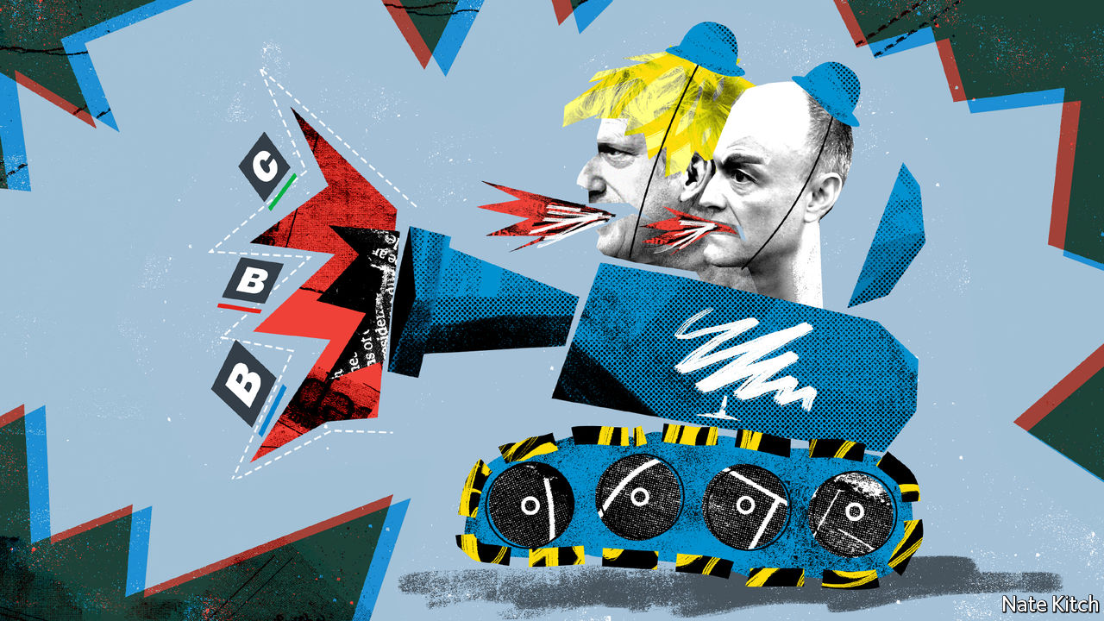

IN THE LONG-FORGOTTEN days of Cool Britannia, Downing Street was packed with left-leaning intellectuals scoffing prime ministerial canapés as Tony Blair sought to dominate not just the country’s politics but also its culture. David Cameron, like most Tories, was more interested in economics: he focused on squeezing public expenditure while hugging hoodies and huskies to blur the cultural distinction between Conservative and Labour parties.

Now the parties’ positions are reversed. Sir Keir Starmer, the Labour leader, is copying the Tories’ cultural attitudes, not fighting them. His recent address to his party conference was a paean to flag and family. The Conservatives, meanwhile, acknowledge that ceding culture to the left was a mistake: in the arts, broadcasting and higher education, Toryism is not just dead but damned.

Downing Street has let it be known that it is thinking of appointing two right-of-centre journalists, Lord (Charles) Moore and Sir Paul Dacre, to the most powerful cultural thrones in the land: chairman of the BBC and head of the media regulator, Ofcom. Oliver Dowden, the culture secretary, has told museums and galleries that they could lose grants if they take down controversial statues and artefacts. The Department for Education is banning teaching materials provided by “anti-capitalist groups”. This is part of a broader push from the right. Andrew Neil, a fearsome political interviewer, is helping found a new television channel, GB News, featuring American-style TV anchors “with a bit of edge”. Laurence Fox, a rare anti-woke actor, is founding a new political party, Reclaim, which he hopes will do for culture what UKIP did for Brexit.

Leadership is one reason for the new approach. The people who now run the Tory party are more interested in culture than economics: Boris Johnson, a former Daily Telegraph journalist (and underling of Lord Moore) who specialised in tweaking liberal tails, Michael Gove, a journalist influenced by America’s neo-conservative movement, and Dominic Cummings, a combative aide consumed by hatred of the metropolitan elite. Another is the shift in economic strategy, which started with the mantra of “levelling up” poorer areas of the country and has been completed by coronavirus. The Tories, like Labour, are now a party of the big state, so economics no longer divides the parties so clearly.

Fighting on the cultural battlefield has not, in the past, served the Tories well. Margaret Thatcher preached “Victorian values” only to be embarrassed when one of her favourite ministers, Cecil Parkinson, fathered a child by his mistress. John Major called for a return to basics only to see a succession of his colleagues, and eventually himself, damaged by sex scandals. “Family values” were a problem for the Tories not only because adulterers lived in fear that they would be exposed but also because closeted gays, of whom the party had many, bridled at their enforced hypocrisy.

As the father of at least six children by three different women, Mr Johnson does not look like the ideal leader to rally conservative troops in a culture war. But the issues are different today. Marriage is a minority pursuit. Gays are no longer closeted. Identity politics has united the party against a cultural left that treats the term “white” as an accusation rather than a description and regards Britain’s past as one of unrelieved villainy. The Conservatives are much better prepared this time around, too. The parliamentary party is diverse enough to rebut the charge that it is just a bunch of reactionary white men: the likes of Kemi Badenoch and Kwasi Kwarteng would no doubt welcome the chance to go toe-to-toe with Black Lives Matter (BLM) spokesmen. Many backbenchers are fired up. “Johnson should instruct a team of ministers to wage war on woke,” says Neil O’Brien, a cerebral MP for Harborough. And right-of-centre think-tanks are ready to roll out materials on everything from the statue wars to BBC bias.

This points to the biggest reason for the Tories’ confidence: the left’s over-reach. It is partly a matter of taking reasonable ideas too far. Acknowledging Britain’s role in the slave trade should not stretch to removing the name of David Hume, a colossus of the Enlightenment, from a building in Edinburgh University—a demand to which the university, to its shame, acceded. It is also a matter of style. The harassment of J.K. Rowling by trans-rights activists is an abomination. De-platforming has no role in universities.

Yet launching a culture war may do the Tories less good than they think. The sure-footed Sir Keir has sidestepped traps they have laid for him, such as over the singing of patriotic songs, and some Tories worry that it will unleash the “crazies” on their side. America’s experience suggests Britain may not benefit either.

## America the angry

A louder Conservative voice in cultural debates is all to the good. Cultural institutions decay if they are nothing more than echo chambers. Pressure groups such as BLM drift into self-indulgent extremism unless subjected to rigorous debate. Taxpayers grow rebellious if they are forced to support institutions that know more about New York than old York. But America’s experience offers a warning. The booing and bellowing of its culture warriors has coarsened discourse and divided the polity so that Republicans and Democrats can no longer work together on practical matters such as combating covid-19 or fixing the infrastructure.

Britain has defences against such developments. Parliamentary government is less prone to paralysis. Broadcasting laws make it more difficult to create highly partisan TV stations. But the Tories’ urge to fight on this new front will test these defences.

Culture is a legitimate area for political argument, but if it is to be constructive the government needs to bear two principles in mind. It should try to broaden the debate, not to disrupt it. The decision to ban literature created by anti-capitalist groups from being taught in schools is, thus, wrong. And the aim of reforming great cultural institutions should be to strengthen them, not to punish them for past misdeeds, imagined or real.■

This article was downloaded by calibre from <https://www.economist.com/britain/2020/10/03/the-tories-launch-a-culture-war>

|  |  |  |  |
| --- | --- | --- | --- |
| Previous | Articles | Sections | Next |

|  |  |  |
| --- | --- | --- |
| Britain | Sections | Technology ... |

International

Parenting: The rugrat race

.

|  |  |  |
| --- | --- | --- |
| Britain | Sections | Technology ... |

|  |  |  |  |
| --- | --- | --- | --- |
|  | Articles | Sections | Next |

#### The rugrat race

# Working-class parents are becoming more like middle-class ones

They have adopted their child-rearing habits

Oct 3rd 2020 | NEW YORK

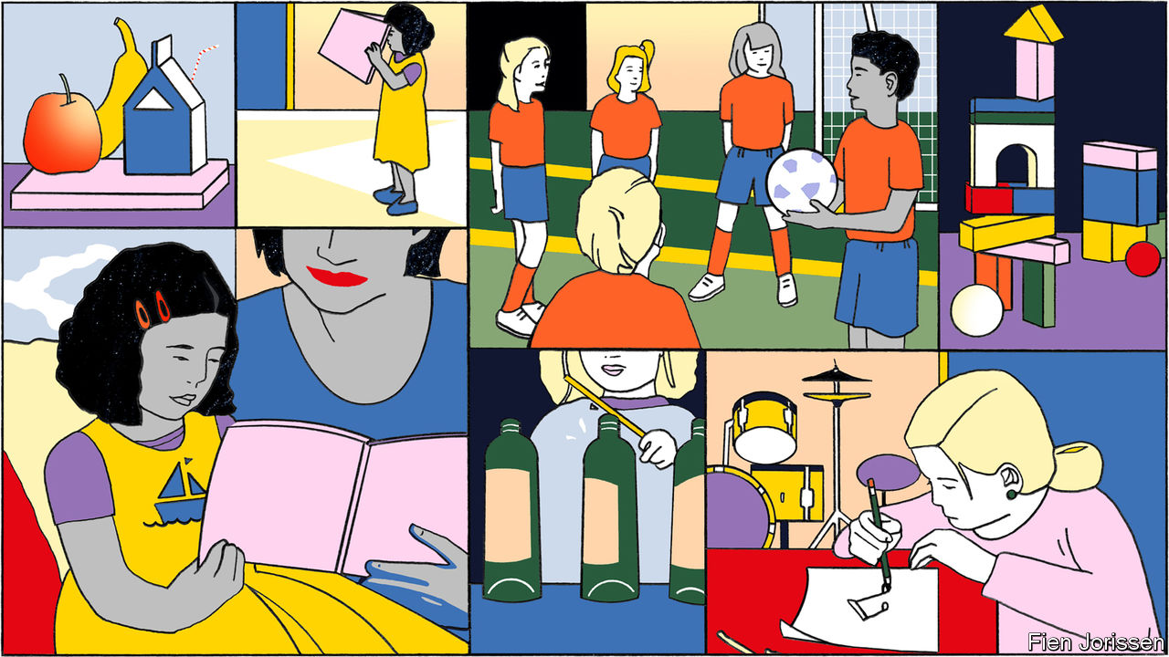

LIKE MANY children around the age of two, Madison has decided not to do what her mother wants. She will not speak above a whisper. She does not want to read “Big Red Barn”. She will not identify her colours or her shapes, even though she knows them. So, for half an hour, her mother patiently cajoles, persuades, distracts and redirects. “You want me to read to you? What kind of sound does the cow make? Are you going to sing? What’s this?”

It would be a familiar scene in a pushy, upper-middle-class home. But this is a working-class black family in a poor district of Long Island, east of New York City. The careful cultivation of Madison reflects a change in her household. Her mother, Joy, says that she did little to prepare her two older children for school, assuming that they would be taught everything they needed to know. She is determined not to make the same mistake again.

Across the rich world, working-class parents have reached the same conclusion. They expect more of their children than in the past, and treat them differently. Gradually, they have adopted child-raising habits normally associated with middle-class parents. That largely unheralded change has probably mitigated the harm done to poorer children by covid-19 and the school closures it prompted. Unfortunately, some damage has been done anyway.

In 2003 Annette Lareau, a sociologist at the University of Pennsylvania, published an astonishing book about child-raising. “Unequal Childhoods” showed that working-class parents—whether they were white or black, poor and welfare-dependent or with steady jobs—thought and behaved differently from middle-class ones. Most assumed that their children would develop naturally, and that their job was to keep them happy and safe. Middle-class parents, by contrast, engaged in what Ms Lareau called “concerted cultivation”, stimulating, stretching and scheduling their progeny to within an inch of their lives.

Middle-class child-raising habits such as endlessly pointing out new things and answering children’s questions with other questions are easily mocked. They are also highly effective. Jill Gilkerson is the chief researcher at LENA, an organisation that measures children’s and adult’s speech using small digital recorders. By controlling for social class, she finds that 14% of the variance in adolescents’ IQ scores can be explained by the frequency of “conversational turns” in their speech at 18-24 months—a measure of their interactions with adults. The effect of toddler talk on adolescents’ verbal comprehension was stronger: it explained 27% of the variance.

Fortunately, the ideal of concerted cultivation seems to have spread. In 2018 Patrick Ishizuka of Cornell University presented American parents with domestic vignettes and asked what they thought of them. In one vignette, a girl who complains about being bored after school is told to go outside and play with her friends; in another, the bored girl is pushed into music lessons and sport. Mr Ishizuka found that highly educated and thinly educated parents differed hardly at all in their responses to these scenarios. Almost all thought the pushy parent was better.

Poorer parents are putting in more time, too. Sociologists Giulia Maria Dotti Sani and Judith Treas have data for 11 Western countries. In all but one (France) mothers without university educations are spending more time caring for their children than in the past. The Centre for Time Use Research has found a concertina pattern in Britain. In the mid-1970s highly educated and thinly educated mothers alike spent little time interacting with their children. Over the following decade the highly educated changed their behaviour, opening a large lead over everyone else. The less-educated then closed the gap (see chart).

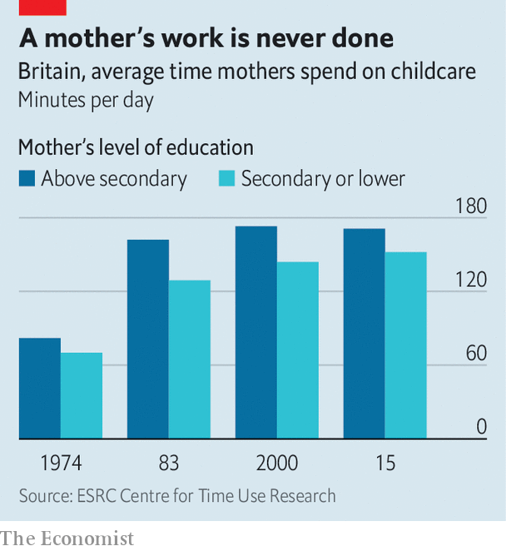

Tomás Cano, a sociologist at the University of Frankfurt, suggests that child-raising norms are trickling down the social scale, much as liberal attitudes to divorce did in the second half of the 20th century. He has found that working-class Spanish parents are putting in more time on “developmental” child-care activities (such as reading and playing). Fathers in particular began to do more following the financial crisis, which hit Spain especially hard. They may have had more time for playing because so many had lost their jobs.

All this attention may be helping children at school. Two scholars, Sean Reardon and Ximena Portilla, have shown that in America the gap between the test scores of the most privileged and least privileged children upon entry to nursery closed slightly between 1998 and 2010. In Britain all children in year one of school—aged five or six—are doing better in phonics tests than they were a decade ago. Those who are entitled to free school meals because of their parents’ poverty have advanced more.

## All they wanna do is go the distance

Working-class parents might have changed their behaviour in response to market forces. In America the wage premium for completing a college degree has risen from 29% to 45% since 1979. Not surprisingly, poorer parents have become more ambitious for their children. The proportion of parents in the poorest quintile of America’s population who expect their children to get no further than high school fell from 24% in 1998-99 to just 11% in 2010-11.

Another possibility is that training has changed attitudes and behaviour. Joy is being assisted by an organisation called ParentChild+, which has been sending books and toys to poor families, and guiding parents to play in more stimulating ways, since the 1960s. It now caters to 8,500 households in America each year and is expanding elsewhere. Evaluations of ParentChild+ and similar programmes have mostly shown that they work. They are too small to have much of an impact nationally. But they may have helped change norms by spreading the idea that reading and playing with children are important.

Day care, which usually happens outside children’s homes, is common enough to make a difference. It is becoming more so as governments promote it. In the OECD the proportion of three-year-olds enrolled in pre-primary education rose from 62% in 2005 to 70% in 2014. As well as affecting children directly, these programmes could be changing their parents’ behaviour. A large evaluation of Head Start, America’s programme for poor children, found that enrolling three-year-olds raised the proportion who were read to at home.

Another possible explanation for the change is that the working class is different. Sarah Walzer, the chief executive of ParentChild+, says that her outfit encounters many more immigrant families than it used to. Immigrant parents are often ambitious for their offspring, enduring hardship and loneliness to give them better lives. Dina, the mother of a three-year-old boy, moved to America from El Salvador. She does not have a job, and her husband works in a pizza parlour, making the family squarely working class. But Dina, who went to college in El Salvador, has the aspirations of a middle-class parent.

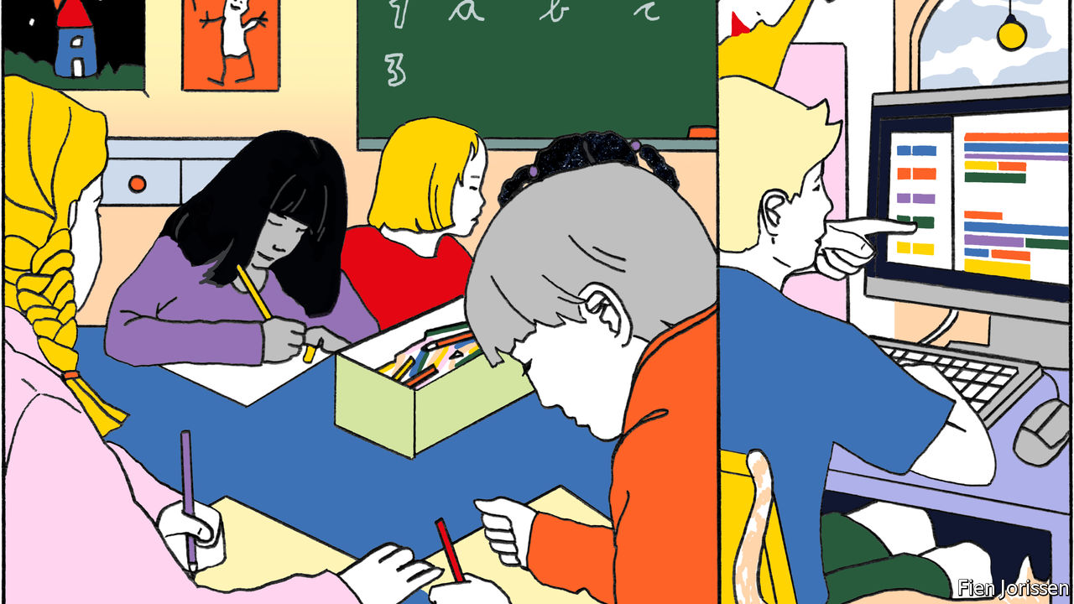

Just as working-class children were catching up, covid-19 hit. School-age children were sent home to households where parents were already juggling pre-school children and their own work. This has been hardest on the poor. Academics at Harvard University discovered that American children did less work on a popular maths website in March and April, with the biggest decline in poor areas. The National Foundation for Educational Research surveyed British teachers in May, two months after the lockdown began. More than half reported that poor children were less engaged with their homework than others.

But if the teachers were right about poorer children doing less work during lockdown (and they might not have been—few kept close tabs on their charges), it was probably not because parents lacked dedication or ambition. A British survey of almost 3,700 people, known as Understanding Society, found that 30% of parents with no more than GCSE qualifications spent at least two hours a day helping with home schooling during the lockdown. That proportion is a little higher than the 28% of parents with degrees who said the same. The parents might be exaggerating. But another survey, of children, found the same pattern. As in Spain after the financial crisis, they may have had more time because so many were furloughed or laid off.

## Can you tell me all I need to know?

A likelier explanation for the widening gap is that schools asked less of poorer children. Another study of Britain by two sociologists, Sait Bayrakdar and Ayse Guveli, confirmed that the children of less-educated parents did less work during lockdown. Bangladeshi and Pakistani children (who are mostly working class) did especially little. But the researchers found that the single biggest influence on how much work children did was not how educated their parents were but how much work their schools assigned.

Working-class parents have learned to bring up their children in a more stimulating way. The next thing they need to learn from the middle classes is how to nag their children’s teachers. ■

This article was downloaded by calibre from <https://www.economist.com/international/2020/10/03/working-class-parents-are-becoming-more-like-middle-class-ones>

|  |  |  |  |
| --- | --- | --- | --- |
|  | Articles | Sections | Next |

|  |  |  |
| --- | --- | --- |
| International | Sections | Business |

Technology Quarterly

Virtual realities: Reaching into other worlds

.

Simulation: Reality bytes

.

Hardware: The promise and the reality

.

Health care: Getting better

.

Brain scan: Lord of the Metaverse

.

The future: What is real, anyway?

.

|  |  |  |
| --- | --- | --- |
| International | Sections | Business |

|  |  |  |  |
| --- | --- | --- | --- |
|  | Articles | Sections | Next |

#### Virtual realities

# Computer-generated realities are becoming ubiquitous

And no headset is required says Alok Jha

Oct 1st 2020 |



AS OTHER MUSICIANS were settling down on their sofas during lockdown, Travis Scott was seizing the virtual moment. On April 23rd the American hip-hop star staged a concert that was attended live online by more than 12m people within the three-dimensional world of “Fortnite”, a video game better known for its cartoonish violence. As the show began, the stage exploded and Mr Scott appeared as a giant, stomping across a surreal game landscape (pictured). He subsequently turned into a neon cyborg, and then a deep-sea diver, as the world filled with water and spectators swam around his giant figure. It was, in every sense, a truly immersive experience. Mr Scott’s performance took place in a world, of sorts—not merely on a screen.

Meanwhile, as other betrothed couples lamented the cancellation of their nuptials, Sharmin Asha and Nazmul Ahmed moved their wedding from a hip Brooklyn venue into the colourful world of “Animal Crossing: New Horizons”, a video game set on a tropical island in which people normally spend their time gardening or fishing. The couple, and a handful of friends, took part in a torchlit beachside ceremony. Mr Ahmed wore an in-game recreation of the suit he had bought for the wedding. Since then many other weddings, birthday parties and baby showers have been celebrated within the game.

Alternative venues for graduation ceremonies, many of which were cancelled this year amid the pandemic, have been the virtual worlds of “Roblox” and “Minecraft”, two popular games that are, in effect, digital construction sets. Students at the University of California, Berkeley, recreated their campus within the game to stage the event, which included speeches from the chancellor and vice-chancellor of the university, and ended with graduates tossing their virtual hats into the air.

People unversed in hip-hop or video games have been spending more time congregating in more minimal online environments, through endless work meetings on Zoom or family chats on FaceTime—ways of linking up people virtually that were unthinkable 25 years ago. These many not seem anything like virtual realities—but they are online spaces for interaction and the foundations around which more ambitious structures can be built. “Together” mode, an addition to Teams, Microsoft’s video-calling and collaboration system, displays all the participants in a call together in a virtual space, rather than the usual grid of boxes, changing the social dynamic by showing participants as members of a cohesive group. With virtual backgrounds, break-out rooms, collaboration tools and software that transforms how people look, video-calling platforms are becoming places to get things done.

Though all these technologies existed well before the pandemic, their widespread adoption has been “accelerated in a way that only a crisis could achieve,” says Matthew Ball, a Silicon Valley media analyst (and occasional contributor to The Economist). “You don’t go back from that.”

This is a remarkable shift. For decades, proponents of virtual reality (VR) have been experimenting with strange-looking, expensive headsets that fill the wearer’s field of view with computer-generated imagery. Access to virtual worlds via a headset has long been depicted in books, such as “Ready Player One” by Ernest Cline and “Snow Crash” by Neal Stephenson, as well as in films. Mark Zuckerberg, Facebook’s boss, who spent more than $2bn to acquire Oculus, a VR startup, in 2014, has said that, as the technology gets cheaper and more capable, this will be “the next platform” for computing after the smartphone.

But the headset turns out to be optional. Computer-generated realities are already everywhere, not just in obvious places like video games or property websites that offer virtual tours to prospective buyers. They appear behind the scenes in television and film production, simulating detailed worlds for business and training purposes, and teaching autonomous cars how to drive. In sport the line between real and virtual worlds is blurring as graphics are super-imposed on television coverage of sporting events on the one hand, and professional athletes and drivers compete in virtual contests on the other. Virtual worlds have become part of people’s lives, whether they realise it or not.

## Enter the Metaverse

This is not to say that headsets do not help. Put on one of the best and the immersive experience is extraordinary. Top-of-the-range headsets completely replace the wearer’s field of vision with a computer-generated world, using tiny screens in front of each eye. Sensors in the goggles detect head movements, and the imagery is adjusted accordingly, providing the illusion of being immersed in another world. More advanced systems can monitor the position of the headset, not just its orientation, within a small area. Such “room-scale VR” maintains the illusion even as the wearer moves or crouches down.

Tech firms large and small have also been working on “augmented reality” (AR) headsets that superimpose computer-generated imagery onto the real world—a more difficult trick than fully immersive VR, because it requires fancy optics in the headset to mix the real and the virtual. AR systems must also take into account the positions and shapes of objects in the real world, so that the resulting combination is convincing, and virtual objects sitting on surfaces, or floating in the air, stay put and do not jump around as the wearer moves. When virtual objects are able to interact with real environments, the result is sometimes known as mixed reality (XR).

Despite several false dawns, there are now signs that, for some industries, these technologies could at last be reaching the right price and capability to be useful. A report in 2019 by PWC, a consultancy, predicts that VR and AR have the potential to add $1.5trn to the world economy by 2030, by spurring productivity gains in areas including health care, engineering, product development, logistics, retail and entertainment.

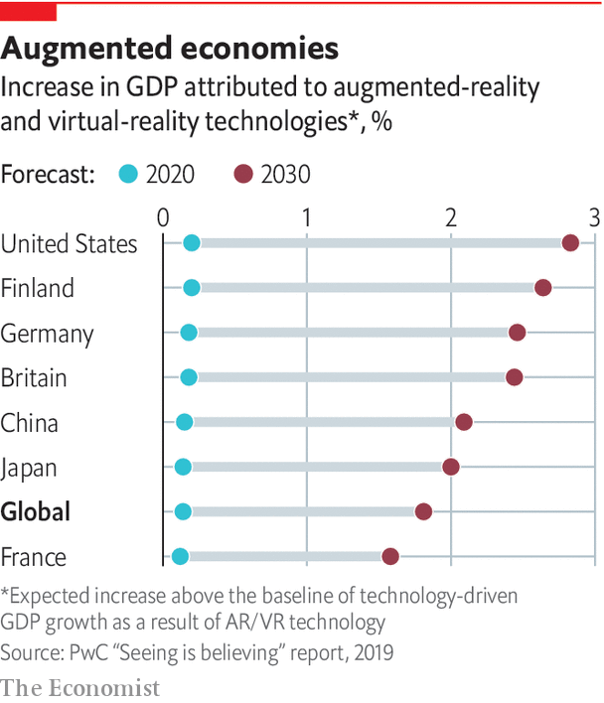

Because the display of information is no longer confined by the size of a physical screen on a desktop or a mobile device, but can fill the entire field of vision, the use of VR and AR “creates a new and even more intuitive way to interact with a computer,” notes Goldman Sachs, a bank, which expects the market for such technology to be worth $95bn by 2025. And these predictions were made before the pandemicinduced surge of interest in doing things in virtual environments.

Progress in developing virtual realities is being driven by hardware from the smartphone industry and software from the video-games industry. Modern smartphones, with their vivid colour screens and motion sensors, contain everything needed for VR: indeed, a phone slotted into a cardboard viewer with a couple of lenses can serve as a rudimentary VR headset. Dedicated systems use more advanced motion sensors, but can otherwise use many of the same components. Smartphones can also deliver a hand-held form of AR, overlaying graphics and virtual items on images from the phone’s camera.

The most famous example of this is “Pokémon Go”, a game that involves catching virtual monsters hidden around the real world. Other smartphone AR apps can identify passing aircraft by attaching labels to them, or provide walking directions by superimposing floating arrows on a street view. And AR “filters” that change the way people look, from adding make-up to more radical transformations, are popular on social-media platforms such as Snapchat and Instagram.

On the software front, VR has benefited from a change in the way video games are built. Games no longer involve pixelated monsters moving on two-dimensional grids, but are sophisticated simulations of the real world, or at least some version of it. Millions of lines of code turn the player’s button-presses into cinematic imagery on screen. The software that does this—known as a “game engine”—manages the rules and logic of the virtual world. It keeps characters from walking through walls or falling through floors, makes water flow in a natural way and ensures that interactions between objects occur realistically and according to the laws of physics. The game engine also renders the graphics, taking into account lighting, shadows, and the textures and reflectivity of different objects in the scene. And for multiplayer games, it handles interactions with other players around the world.



In the early days of the video-games industry, programmers would generally create a new engine every time they built a new game. That link was decisively broken in 1996 when id Software, based in Texas, released a first-person-shooter game called “Quake”. Set in a gothic, 3D world, it challenged players to navigate a maze-like environment while fighting monsters. Crucially, players could use the underlying Quake Engine to build new levels, weapons and challenges within the game to play with friends. The engine was also licensed to other developers, who used it to build entirely new games.

Using an existing game engine to handle the job of simulating a virtual world allowed game developers, large and small, to focus instead on the creative elements of game design, such as narrative, characters, assets and overall look. This is, of course, a familiar division of labour in other creative industries. Studios do not design their own cameras, lights or editing software when making their movies. They buy equipment and focus their energies instead on the creative side of their work: telling entertaining stories.

Once games and their engines had been separated, others beyond the gaming world realised that they, too, could use engines to build interactive 3D experiences. It was a perfect fit for those who wanted to build experiences in virtual or augmented reality. Game engines were “absolutely indispensable” to the growth of virtual worlds in other fields, says Bob Stone of the University of Birmingham in England. “The gaming community really changed the tide of fortune for the virtual-reality community.”

Two game engines in particular emerged as the dominant platforms: Unity, made by Unity Technologies, based in San Francisco, and Unreal Engine, made by Epic Games, based in Cary, North Carolina. Unity says its engine powers 60% of the world’s VR and AR experiences. Unreal Engine underpins games including “Gears of War”, “Mass Effect” and “BioShock”. Epic also uses it to make games of its own, most famously “Fortnite”, now one of the most popular and profitable games in the world, as well as the venue for elaborate online events like that staged in conjunction with Mr Scott.

Epic’s boss, Tim Sweeney, forecast in 2015 that there would be convergence between different creative fields as they all adopted similar tools. The ability to create photorealistic 3D objects in virtual worlds is not just attractive to game designers, but also to industrial designers, architects and film-makers, not to mention hip-hop stars. Game engines, Mr Sweeney predicted, would be the common language powering the graphics and simulations across all those previously separate professional and consumer worlds.

That is now happening, as the tools of virtual-world-building spread into many areas. This Technology Quarterly will explore where computer-generated realities are already starting to make an impact—work, entertainment and health are all seeing changes—and where the technology is heading.

Building a complex, immersive, virtual social space, like the “Metaverse” depicted in “Snow Crash” is the goal for many serious minds in technology today. Mr Sweeney sees the Metaverse, or something like it, as the next iteration of the web, where people can go to work, play games, shop or just pass the time.

Similarly, Mr Ball reckons game engines will become a base layer for digital 3D worlds, a standard upon which new industries will be built. Rather than predict specific future results of this standardisation, he cites the introduction of railways as a way to think about the many opportunities that lie ahead. “What happens when you layer the country with railroad infrastructure?” he asks. “What happens when you massively drop the friction to experimentation and creation?” When it comes to virtual worlds, that is now a very real question. ■

This article was downloaded by calibre from <https://www.economist.com/technology-quarterly/2020/10/01/computer-generated-realities-are-becoming-ubiquitous>

|  |  |  |  |
| --- | --- | --- | --- |
|  | Articles | Sections | Next |

|  |  |  |  |
| --- | --- | --- | --- |
| Previous | Articles | Sections | Next |

#### Simulation

# Virtual environments are being used everywhere

Film-making is one of the biggest beneficiaries

Oct 1st 2020 |

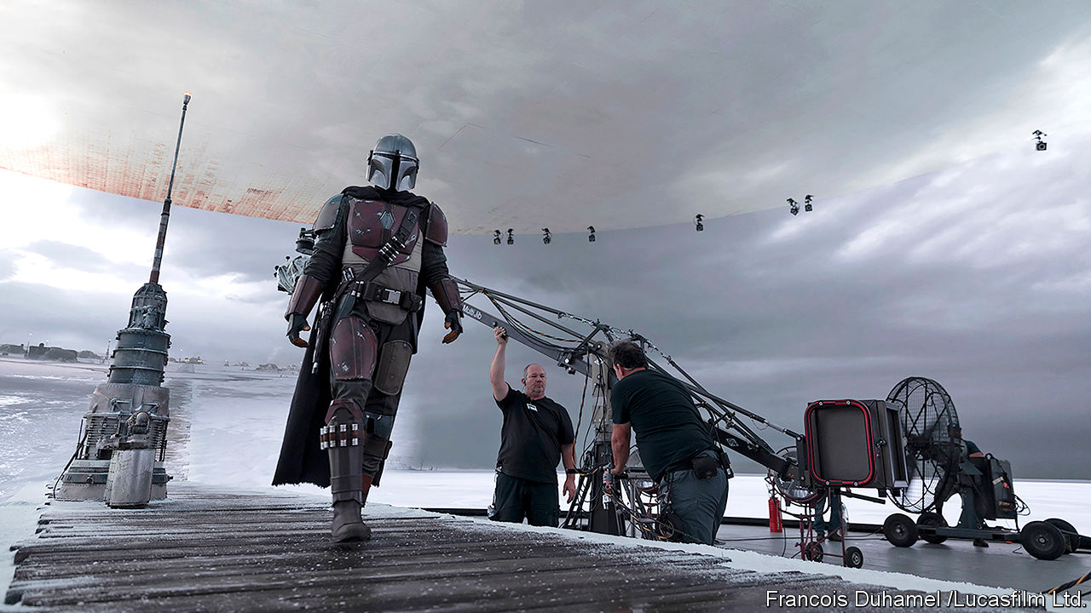

IN AN EARLY scene from Disney’s new television series, “The Mandalorian”, a door opens to reveal a barren, icy landscape. The camera swoops outside to follow the titular character, a solitary gunslinger in silver armour, making his way across the vast expanse of ice. It is an impressive, expensive-looking shot, of the kind you might expect for a show set in the “Star Wars” universe.

The “Star Wars” franchise has been pushing the limits of film-making technology for more than 40 years. Its creator, George Lucas, set up a now-iconic special-effects company, Industrial Light and Magic (ILM), specifically to serve the fantastical effects needs of his space opera. ILM went on to create special effects for dozens of films, including some of the earliest computer-generated 3D characters in “The Abyss”, “Terminator 2” and “Jurassic Park”, pioneering a new industry in the process. Now ILM is at the forefront of using computer-generated reality to bring cinematic special effects to the small screen—and it is using game engines to do it.

The shot of the Mandalorian walking across the ice was one of many created on a film set in Manhattan Beach, California, using its “StageCraft” technology (pictured). This is a facility (or a “volume”, as ILM calls it) in which a giant curved video wall is positioned behind the actors. The wall is 6 metres (20 feet) high by 55 metres wide, and composed of more than a thousand individual LED screens. The photorealistic imagery that appears on the screen is generated from a 3D virtual world (Unreal Engine was used during the development process). As the camera moves, the view on the screen changes accordingly. The result is that the video wall, from the camera’s perspective, behaves exactly like a window looking onto a 3D environment. This approach also helpfully lights the actors realistically, with the scenery reflecting off the Mandalorian’s silver armour, for example. That would not have been possible using conventional green-screen techniques, says ILM’s general manager, Janet Lewin, who co-produced the show.

“The Mandalorian” is filmed in a partially virtual world. Though tested beforehand, producers had their doubts about the set-up. “The Mandalorian was the first time that we had used real-time graphics at this scale to completely wrap around a set and photograph it directly and put it right in the show,” says Rob Bredow, chief creative officer at ILM. “And to be honest, we weren’t sure that it was going to work when we started. [But] it really exceeded all of our expectations.”

The techniques pioneered by “The Mandalorian” are now spreading across the industry, because they allow for cinema-quality special effects within the tighter budgetary and time constraints of television production. For the third season of HBO’s “Westworld”, producers digitally recreated the City of Arts and Sciences complex in Valencia, which stood in for the headquarters of one of the main companies in the series, using the Unreal Engine. On set in Los Angeles, the digital images were rendered on an LED wall, 15 metres by six, showing the view from the floor-to-ceiling office windows of one of the lead characters. Look at a window and move your head from side to side, and you will notice the scene framed by the window changes slightly. Similarly, the images shown on the LED wall changed as the camera moved, perfectly mimicking a window onto a 3D world.

ILM recently announced plans to build a second StageCraft volume at Manhattan Beach and a third at Pinewood Studios in Britain. A fourth—in Sydney, Australia—will mark StageCraft’s arrival into major feature films for Marvel’s upcoming “Thor: Love and Thunder”. Mr Bredow says there are more volumes in the pipeline. “Our technology has just advanced so much from what everyone is familiar with from the first season of ‘The Mandalorian’,” he says.

Watching a sci-fi series is one situation where you may not be surprised to learn that the images you see have been conjured from a virtual world. But the same thing is happening in more mundane situations. Open a catalogue from IKEA, a giant furniture retailer, and you will see images of kitchens, living rooms and other interiors. They look perfectly realistic, if spotlessly clean. The vast majority of these photographs are in fact computer-generated from detailed 3D models, saving the company time and money.

Photographing kitchens is particularly challenging because they look so different from one country to the next. Ensuring that each country’s catalogue reflected local tastes meant bringing appliances from all over the world to a studio in Europe to create multiple sets, and then sending everything back at the end. Assembling virtual kitchens using 3D digital models of furniture and other items is far easier. Software lets designers mimic the way lights reflect and scatter across surfaces, making the computer-generated scenes indistinguishable from the real thing. Different versions of products, in different colours, can be easily swapped in and out. Images shot in a virtual world are also easier to fix if a piece of furniture gets redesigned or withdrawn from sale—its digital version can simply be replaced or removed in the image, which is preferable to the expense and hassle of reassembling a roomful of furniture for a fresh photo shoot.

3D product rendering has been adopted by other industries as a convenient way to produce flawless photorealistic images and videos for advertisements, websites or in-store displays, for everything from cars to industrial machinery to smartphones. Taking pictures in the virtual world, rather than the real one, makes it possible to zoom in on tiny details, fly through a product, or show it in exploded form that then reassembles itself.

Having 3D models of its entire product range to hand also meant that it took IKEA just seven weeks to build IKEA Place, an augmented reality (AR) app that lets customers drop virtual furniture into spaces in their homes and see whether they fit and how they look on the screen of a smartphone. It was one of the first apps to appear after Apple added support for AR to iOS, the software that powers the iPhone, in 2017. The app’s success prompted the company to add AR features (powered by the Unity engine) directly into the latest version of its main shopping app.

The techniques and engines used to create realistic game worlds can do more than just produce images, however. As video games have become more sophisticated, so their underlying world simulations have become more capable and realistic. “Right now, the world is increasingly understanding that these game engines aren’t toys,” says Matthew Ball, a media analyst. “They’re actually hyper-capable.”

## Help from your twin

Architects can use the technology to simulate, rather than simply render images of, the buildings they are working on. The operators of Hong Kong International Airport, for example, have produced a “digital twin” of one of its terminals—a virtual replica of a physical asset—using Unity. On their computers, they can wander through a photorealistic 3D model that integrates real-time data from sensors all over the terminal, including information on passenger and baggage flows, staff movements and equipment status. The model displays the state of the terminal at any given time and can provide alerts for areas that need attention or maintenance.

Such models can also be used to look into the future, by using the data collected about the real-world operation of the airport as the basis of simulations. It is then possible to evaluate how a new construction project might affect the operation of the airport, or model people-flow in the event of a terrorist attack or the simultaneous arrival of several large aircraft. Engineering and rendering software is not designed to do that. What that actually requires is simulation technology, which is precisely the type of situation that games have been focusing on.

Virtual environments are also increasingly used for simulation-based training. The US Army uses immersive environments, including VR helmets, for training in areas such as infantry combat and the operation of weapons systems. Its spending on VR and AR simulation has increased from $1.6bn in 2015 to an expected $3bn in 2020, according to Bloomberg Government. Globally, the military training and simulation market is worth over $9bn, says Frost & Sullivan, a market-research firm, and will be worth nearly $20bn by 2027, it predicts. The same technology also has peaceful uses. Network Rail, a British railway operator, uses simulations built using Unreal Engine to plan maintenance and track-renewal operations. VR Perspectives, a company based in Ohio, uses simulations of office environments for diversity and inclusion training, enabling trainees to experience the same events from the perspectives of different people.

Sometimes it is machines, not people, that are trained in virtual environments, as in the case of autonomous vehicles. For self-driving cars to become a reality, their software needs to understand busy urban environments. They need to recognise street signs, traffic lights and road markings. They need to be able to deal with dozens or hundreds of moving objects (including people, cars, lorries, bikes, animals) at complex junctions. They need to be ready for emergencies such as a rogue driver barrelling down the wrong side of the road or a child suddenly jumping into the road. All that needs training—billions of miles of it.

Physically training autonomous cars on the streets is expensive and time-consuming—and dangerous, if things go wrong. Computer simulations and racing games have long been used to train autonomous cars’ vision systems, by testing them with highly realistic computer-generated streetscapes. But more advanced simulators can replicate the complexity of city driving, with its rules, intersections and pedestrians. One such system is CARLA, built by researchers at the Computer Vision Centre in Barcelona, Spain, with support from Intel, a chipmaker, and the research arm of Toyota, a Japanese car giant. To create test scenarios for their autonomous-vehicle algorithms, carmakers can customise several aspects of CARLA’s world, from vehicle and pedestrian density to weather conditions, time of day and illumination. It is now the leading open-source simulator for autonomous driving.

Oxbotica, an autonomous-vehicle startup created by engineers from Oxford University, built a virtual environment in Unity in which to test its algorithms. Software agents in the simulation perform tasks such as driving from one place to another, stepping out onto zebra crossings and obeying (or disobeying) traffic lights. Oxbotica’s autonomous vehicle is then placed in this virtual world and tricked into believing it is real. “Our gaming simulation helps us to train the software to understand what it can do in difficult scenarios that are almost impossible to create in real life,” says Todd Gibbs, the company’s head of simulation development. Almost all development in the self-driving algorithm is now put through the simulator first before being unleashed on a real road.

Realistic simulated worlds have a promising future. In 2018 Unity announced a partnership with DeepMind, an AI-research firm owned by Google. Danny Lange, Unity’s vice-president of AI and machine learning, said at the time that the game engine would become “a primary research platform for creating complex virtual environments that will enable the development of algorithms capable of learning to solve complex tasks”. Unity’s platform can create simulated environments that are rich in sensory complexity and contain multiple intelligent agents that can all interact with each other. These virtual worlds can set up the cognitive challenges that AI researchers need to improve their algorithms for everything from computer vision and natural-language processing to industrial robots.

Simulated worlds could help architects design more user-friendly and liveable buildings. By populating proposed designs with intelligent virtual occupants, designers can identify potential problems before having to break ground, for example, by watching how well the virtual inhabitants are able to navigate around the floors of the buildings. In future, these kinds of simulations could also help fundamental researchers. Chemists might use virtual environments to carry out billions of experiments using virtual chemicals as a way of winnowing down interesting leads for potential drugs or other industrial uses.

Anyone raising an eyebrow that such serious uses for simulated worlds could come from not-so-serious gaming roots should perhaps bring to mind the words of Chris Dixon of Andreessen Horowitz, a venture-capital firm, who wrote a decade ago that “the next big thing will start out looking like a toy”. Mr Ball points to a few more examples. “Look at the Wright Flyer. It was dinky. It could barely stay in the air, and it could only hold one person. It looks like a toy, in that regard. The early mobile phones, or even a BlackBerry, to some extent. Snapchat felt like a toy.” ■

This article was downloaded by calibre from <https://www.economist.com/technology-quarterly/2020/10/01/virtual-environments-are-being-used-everywhere>

|  |  |  |  |
| --- | --- | --- | --- |
| Previous | Articles | Sections | Next |

|  |  |  |  |
| --- | --- | --- | --- |
| Previous | Articles | Sections | Next |

#### Hardware

# Headset technology is cheaper and better than ever

But it has yet to go mainstream

Oct 1st 2020 |

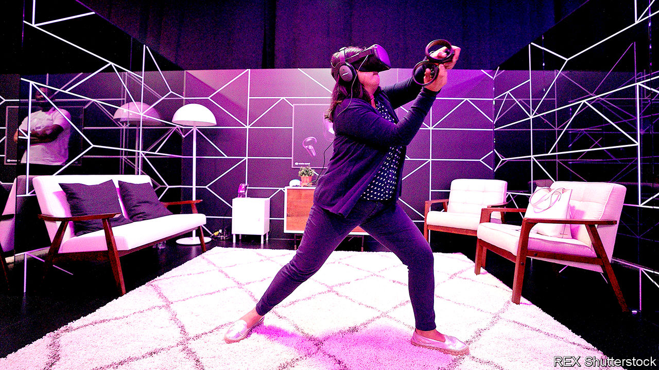

THE CUBES fly towards your correspondent slowly at first, then quickly gather pace as the music speeds up. On his head he wears a chunky set of goggles. In each hand, he holds an imaginary laser sword that can chop the cubes in half before they reach his body. Each cube is marked with an arrow (designating the direction in which it must be sliced) and a colour (for which hand has to do the slicing—blue for right, red for left). The more vigorously the cubes are sliced in time with the music, the more points are scored. Horizontal and vertical barriers, mixed in with the cubes, must be avoided at all costs. A few minutes of swinging the imaginary swords around is tiring but oddly diverting. The simulation breaks down only when your correspondent gets too energetic with his jabs and crashes into a nearby (non-virtual) bookshelf.

Welcome to “Beat Saber”, one of the most popular games available on the Oculus Quest, a virtual-reality headset. Though it is possible to experience and explore virtual worlds without having to put on a headset, doing so provides a new level of immersion, as screens in front of each eye, and sensors that map the movement of the wearer’s head, create the illusion of being inside a 3D environment. It is magical—but the awkwardness and cost of VR headsets is the main reason why there has always been a gulf between the promise of VR and the reality.

Every few years a new headset comes along that is hailed as the device that will finally bring VR into widespread use. The Oculus Quest headsets, the first of which was launched in 2019 at $399, are the latest. Compared with previous headsets it is cheap and light and can detect the position of the wearer’s head, not just its orientation. It is an impressive piece of kit, but has not broken through with consumers. Facebook, which paid more than $2bn for Oculus in 2014, has just announced a cheaper and more powerful version.

The VR headset, also known as a head-mounted display (HMD), traces its origins to a device called the Sword of Damocles. Developed in 1968 by Ivan Sutherland and Bob Sproull, two computer scientists who were working at the time at Harvard University, it consisted of a pair of cathode-ray tubes, one for each eye, that were updated with images at 30 times per second. Users could move within a six-foot square and had a 40-degree field of view while wearing the headset, which was so heavy that it had to be suspended from the ceiling, like the mythical sword. Mechanical and ultrasonic sensors detected the position and orientation of the user’s head in space. The cathode-ray tubes could display simple wireframe graphics, and could also superimpose them on real-time video of the wearer’s surroundings.

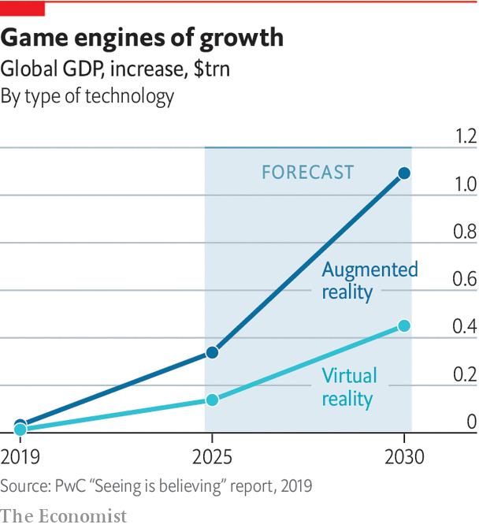

HMDs have been steadily decreasing in weight and improving in capability since the 1970s, and have been available commercially since the 1980s. “There are people that have worked in the VR industry now for almost 40 years,” says Anthony Steed of University College London. But the technology has still not moved far beyond academic labs and bespoke uses in training, engineering and design. When Dr Steed entered the field in the 1990s a breakthrough seemed imminent, at least as far as the media were concerned: “It was on front pages of national newspapers”. When the breakthrough did not come, Dr Steed says, the public concluded that the technology was terrible. “And to some extent it was,” he admits, but “it was just way ahead of its time.”

## Goggles box

Industrial early-adopters kept plugging along. Jaguar Land Rover used VR in the early 2000s to test and iterate the designs of its upcoming vehicles. Rather than using HMDs, though, its system required users to enter an immersive virtual environment in a small room whose walls and ceilings had high-definition, stereo displays. The technology, based on an idea known as the Cave Automatic Virtual Environment (CAVE), allows several people to share the same virtual experience. The displays rapidly show a pair of images, one for the right eye and another for the left. By wearing glasses that are synchronised with the displays, so that each eye sees only the image meant for it, users in the CAVE see three-dimensional objects apparently floating in the centre of the room.

This form of VR was very expensive to set up, and needed a dozen or more computers to drive the images on the walls. But it helped designers and engineers share ideas for the interior spaces of their vehicles, observe ergonomics (how easy was it for the driver to reach for controls, for example, or interact with other passengers?), and judge the lines of sight out of the vehicle. In any engineering task where people need to share complicated 3D ideas with others, says Dr Steed, it can help to have a VR visualisation. But the cost was prohibitive except in rare situations.

Bob Stone, a 33-year veteran of academic and industry VR at the University of Birmingham in England, has also been through multiple cycles of hype around the technology. “I hope and pray after all these years, we’re on the cusp of something that’s really going to make a difference,” he says. In 1992 he built a virtual model of a Rolls-Royce jet engine that users could explore using a VR headset. “To do that jet engine, we had to have a piece of software that cost £75,000 ($132,000 at the time) and required at least £5,000 a year on maintenance, and we were running it on a million-pound Silicon Graphics supercomputer,” he recalls.

In the past decade, smartphones and video games have made the hardware and software needed for VR much more cheaply and widely available. A crucial moment a few years ago was when consumer devices became capable of generating real-time graphics quickly enough to create a realistic sense of immersion, says Dr Steed. In the 1990s a VR headset in Britain cost around £6,500 (roughly $10,700 at the time) the system to track the wearer’s position cost another £5,000, and VR gloves could cost up to £13,000. The latest generation of VR headsets have been able to take advantage of powerful processors, vivid colour screens, cameras and sensors borrowed from the smartphone industry, while game engines have made virtual environments and their contents much easier to construct.

Today consumer headsets range in price from $400 to $1,200, and the VR systems Dr Stone builds, for use in research and education, are driven by laptops that cost less than $1,200. In some cases his students have built VR systems in a few months, with no prior experience of the technology. “They’ve been producing all kinds of fantastic demonstrations, industrial demonstrations, health care, you name it,” he says. “And that really is testament to the way in which these toolkits have matured.”

A sense of immersion depends on more than just fancy graphics. Another crucial factor is latency—the time delay between a user’s head movement and the images shown on the headset’s screens being updated accordingly. In the 1990s the latency was often as high as 150 milliseconds. Today, even consumer headsets have latency of less than 20 milliseconds, thanks to faster chips and improved sensors. That makes movements more natural and less likely to cause motion sickness (thought to be caused by a discrepancy between what the user sees and expects to see).

Even as consumer-grade VR headsets such as the Oculus Quest, HTC Vive and Sony PlayStation VR are improving in quality and falling in cost, a problem remains: a lack of content for them. The big video-games studios have been reluctant to invest in VR titles because, they argue, there are not enough headset owners to justify it. Consumers, in turn, are reticent to buy technology that has no associated games. Things may be starting to shift. A spokesperson for Oculus says that more than 20 of the titles in its store have now generated more than $1m. “Beat Saber” has surpassed 2m sales across various VR devices and now has a new version, “Fitbeat”, to take advantage of the growing interest in fitness. Another big hope in the gaming world is the recent release of “Half-Life: Alyx” by Valve, a new entry in a popular franchise, that has been made specifically for VR headsets.

“We are in a really nice place now, a place where VR is developing nicely, with ecosystems forming, with successful VR headsets emerging,” says George Jijiashvili, an analyst at Omdia, a research outfit. But, he adds, “it will take time for this to become a mass market opportunity”. He predicts there could be around 55m users with the latest VR headsets by the end of 2024, up from around 13m at the end of 2019. That is a big jump, but is still just a niche market.

## The eyes have it

As consumer headsets have improved, the fancier models used in industry show where the technology is going next. Varjo, a Finnish company, makes high-end headsets that claim to have “human-eye resolution”. Most VR headsets use the same kinds of screens found in smartphones, with a typical resolution of 500 pixels per inch (pixels are the coloured picture elements that make up the image). When such screens are placed close to the eye, individual pixels can be easily discerned. Varjo’s headsets have an extra set of high-resolution screens, with a resolution of 3,000 pixels per inch, to cover the centre of each eye’s field of view, where most detail is perceived. Specialist optics combine the images from both sets of screens. The result is that images look much sharper.

Varjo’s founder, Niko Eiden, says this makes it possible to examine fine details in the virtual environment, such as text labels, dials and buttons in a car interior or a flight simulator (Boeing uses the VR-2 when training astronauts to operate its Starliner spacecraft). The headset also has a gaze tracker, so instructors can monitor whether or not the wearer has been looking in the right places during training. But it does not come cheap: it costs €5,995 and is intended for business and academic use, not gaming.

And then there are the augmented-reality or mixed-reality headsets, which overlay virtual imagery onto the real world, a trick pioneered by the Sword of Damocles. One way to do this is to place cameras on the front of a VR headset, and then augment their real-time video with extra graphics. But nobody wants to wear a VR headset in public, and true believers in AR imagine a lightweight headset, like a pair of glasses, that overlays information and graphics on the wearer’s field of vision, so that virtual objects are realistically blended into the real world.

One company pursuing this vision is Magic Leap, a secretive startup based in Florida whose backers include Google, AT&T and NTT DoCoMo. In 2018, after years of speculation and rumour, it finally released a headset, resembling a pumped-up set of sunglasses, which cost $2,295. But its capabilities fell short of the grand claims that had been made about it, and only a few thousand units were sold, according to The Information, a tech-industry news site. A less ambitious but more successful approach to AR is that taken by Microsoft’s HoloLens 2, a $3,500 device that resembles a chunky set of skiing goggles, and is considered the most capable AR headset on the market. Researchers use it in fields from military simulation and medical training to education and gaming. But its high cost and limited field of view suggest that AR headsets with broad appeal to consumers are still a distant prospect. ■

This article was downloaded by calibre from <https://www.economist.com/technology-quarterly/2020/10/01/headset-technology-is-cheaper-and-better-than-ever>

|  |  |  |  |
| --- | --- | --- | --- |
| Previous | Articles | Sections | Next |

|  |  |  |  |
| --- | --- | --- | --- |
| Previous | Articles | Sections | Next |

#### Health care

# Health care is already benefiting from VR

Surgery and mental-health treatment are leading the way

Oct 1st 2020 |

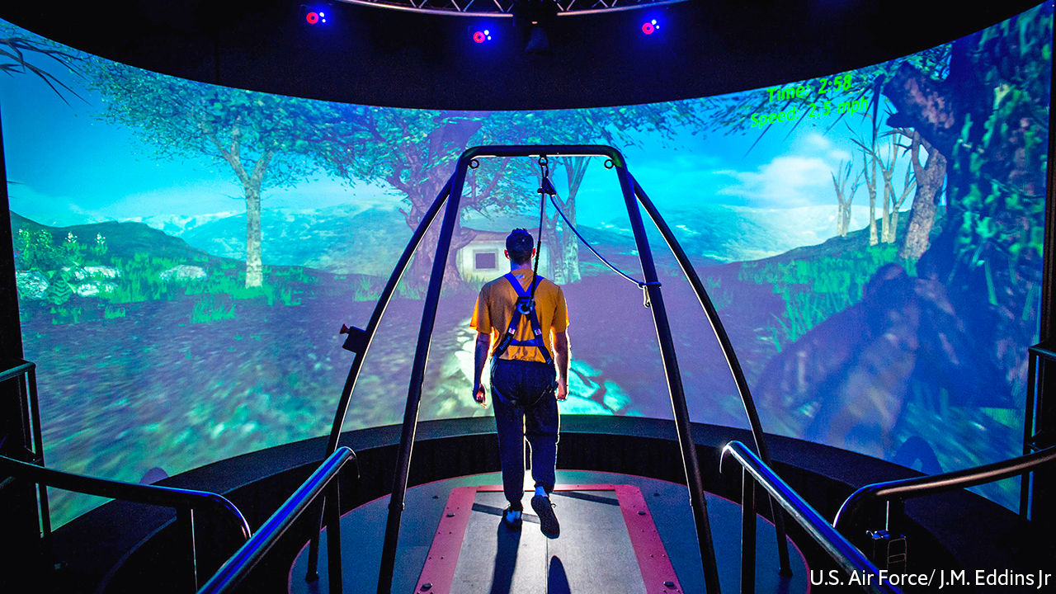

A SOLDIER WATCHES a car approaching a check-point on a hot, dusty road. As the vehicle slows to a stop in front of him, he asks the driver to get out and show his identification. Seconds later, the rattle of gunfire pierces the air, followed by a bang and an intense, searing flash. Knocked to the ground and scrambling to safety, the soldier turns to see a flaming wreck where the car had been just moments before.

The scene pauses. A voice in the soldier’s ear says: “Let’s rewind the simulation to the seconds just before the explosion—describe exactly what happened.” The voice is a therapist, speaking to a veteran who is placed in a virtual environment. The simulation they are watching has been modelled on the veteran’s own experiences in a war zone, events that have led him to develop post-traumatic stress disorder (PTSD).

This is the Bravemind system, developed in 2005 by Albert “Skip” Rizzo and Arno Hartholt, experts in medical virtual reality at the University of Southern California, to treat soldiers returning home from the wars in Iraq and Afghanistan. Immersed in a virtual environment that mimics their traumatic experiences, veterans narrate the scene to a therapist, who can control how the events in the simulation unfold. The sounds, time of day and number of people or vehicles on the scene can all be customised. Over several sessions, the veteran is exposed to increasingly intense scenarios that get closer to reliving the memory of the original trauma. The aim of the therapy is to steadily dampen the veteran’s negative reactions to the memory. Bravemind is now used in around 60 treatment centres around the world.

Bravemind builds on a well-established psychological technique known as exposure therapy, in which people are brought to face their fears in a controlled way. VR adds a way of creating detailed, carefully tuned scenarios that can elicit different levels of fear. It works because, even when people know they are watching computer graphics, their brains nonetheless react to virtual environments as if they were real.

Someone who is afraid of heights will find that their heartbeat quickens and palms get clammy even if the precipitous drop they can see is clearly a computer graphic in a VR headset. This is because the brain’s limbic system, which controls the fight-or-flight response, activates within milliseconds in response to potential threats, long before the logical part of the brain—which knows the VR experience is not physically real—can intervene.

## May contain graphic content

Scientists have used VR systems to create and control complex, multi-sensory, 3D worlds for volunteers in their labs since the 1990s. Rather as an aircraft simulator can train and test pilots in a wide variety of settings, virtual worlds allow psychologists and neuroscientists to watch people’s cognitive and emotional responses in situations that are difficult to set up or control in the real world. But the technology has usually been too clunky and expensive for widespread clinical use.

That has started to change, thanks to the falling costs of computing and the increasing capability of the new generation of VR systems. At the same time, the scientific evidence base for the clinical uses of VR has grown. The technology has been successfully applied to tackling schizophrenia, depression and phobias (including the fear of flight, arachnophobia, social anxiety and claustrophobia), and reducing pain in cancer patients undergoing chemotherapy. It can help train spatial-navigation skills in children and adults with motor impairments and assist in rehabilitation after a stroke or traumatic brain injury. The kit can also be used to monitor people and identify medical problems: VR has been used to diagnose attention-deficit hyperactivity disorder (ADHD) and Parkinson’s and Alzheimer’s diseases.

Though each condition is unique, researchers have found common ground rules for designing virtual experiences that work: therapists need to be in control of the scene, deciding what a patient sees and hears in order to modify the strength of the fearful stimulus; the therapy works best when the patient is embodied within an avatar, rather than floating, so that they feel present within the scene; and the patient needs agency, so that they can leave the scene if it gets too overwhelming for them. All this adds up to giving the patient the illusion of control and makes the VR experience feel psychologically “real”.

In some cases the therapeutic regime is so robust that, instead of a real-life therapist guiding a patient through an anxiety-inducing simulation, an animated avatar can do the job instead. A clinical trial showed that such an automated system, designed by Daniel Freeman, a psychiatrist at the University of Oxford, helped people reduce their fear of heights. In the simulation, a virtual counsellor guided patients up a virtual ten-storey office complex, where the upper floors overlooked a central atrium. At each floor, the counsellor set the patient tasks designed to test and help them manage their fear responses, such as walking to the edge of a balcony while the safety barrier was lowered or riding on a moving platform over the space above the atrium.

Dr Freeman found that six sessions of virtual, automated therapy over two weeks significantly reduced people’s fear of heights, compared with people who had no therapy. A similar automated virtual therapy for arachnophobia, developed by Philip Lindner at Stockholm University, helped patients eventually touch spiders. The reduction in fear was still apparent when the participants were followed up a year later.

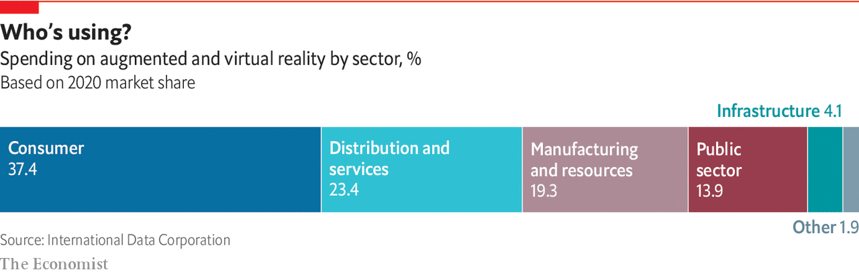

For doctors, virtual environments also provide a risk-free way to practise important procedures. Surgeons operate in high-pressure environments with a lot of cognitive demands. “You’ve got to learn very rapidly, and you’ve got to make decisions under time pressure, with millimetre precision,” says Faisal Mushtaq, a cognitive neuroscientist at the University of Leeds in England.

Practising with computer simulations can help. In the NeuroVR system, developed by a group of Canadian hospitals and universities, surgeons can use MRI scans from their patients to rehearse removing brain tumours before going in with the knife for real. The surgeon gets a 3D view of the tumour on screens and practises cuts and movements by manipulating instruments attached to a robotic arm that responds with haptic feedback. This allows users to sense whether they are cutting through hard or soft material, or through a tumour versus healthy tissue. An advantage of such a system is that, once a doctor is trained, the technology can be used to perform remote surgery. Both virtual training and remote procedures for patients are useful at a time when covid-19 has forced health-care systems around the world to keep doctors and non-emergency patients apart.

## In operation

When surgeons try to reconstruct a limb, a key problem is identifying important blood vessels that need to be protected during the surgery. In the past a surgeon would try to identify those vessels using an ultrasound probe, but the process is lengthy and imprecise. So James Kinross, a consultant surgeon at Imperial College London, has been experimenting with Microsoft’s HoloLens, an augmented-reality headset, which can overlay computer-generated text and images onto the real world.

Dr Kinross has used a CT scan of a patient’s limb to highlight the most important blood vessels. He reconstructed that scan as a 3D model in Unity, a games engine. The HoloLens then overlaid that simulation onto the patient’s real limb in the operating theatre during treatment. “What it meant was that the surgeon could immediately visualize, and very precisely map, the anatomy of these blood vessels, and very quickly identify them and protect them,” says Dr Kinross, who has also used this technique during cancer surgery to help surgeons identify and protect healthy tissue. The adoption of the technology has proceeded very smoothly, he adds, because it is easy to learn and provides “an immediate and very obvious advantage to the clinician”.

He thinks the technology could be pushed much further and wants to try some real-time collaboration with his colleagues during a surgical procedure. “So if you’re running an operation that’s challenging, or you want to have a discussion with a peer, it’s very easy to do and they can have a first-person view of what you’re looking at,” he says.

Medical uses for computer simulations are promising, but how useful they are will take time to evaluate. That will require robust clinical trials and discussions of frameworks for data protection on technologies that could, if their potential is achieved, become a new type of medical device.

“We don’t want to poison the well,” says Dr Mushtaq. “We don’t want to put out systems that are ineffective, that are going to cost our health-care system, and that are going to negatively impact on the growth of this sector.” His research focuses on closing some of those knowledge gaps by examining how the lessons users learn from practising on virtual simulators translate into skills in the real world. Surprisingly, the fidelity of the images to real surgery is not so important. “Something can look very, very, flashy…it’s got all the blood spewing everywhere and so on,” he says. “But it doesn’t necessarily translate to better learning.”

Defining the validity of a simulator can take several forms. The most basic is “face validity”, which reflects how well a simulation looks like the task in the real world. “Construct validity” is a way of comparing performance differences on the simulation between experts and novices. Finally, “predictive validity” is most useful, because it measures how well a person’s performance on a simulator predicts their ability to do the same task in the real world.

## Just like real life

This can also be used to flag when learners are struggling, and provide early intervention and support. Dr Mushtaq and his colleagues have demonstrated both construct and predictive validity for the Nissin (formerly Moog) Simodont dental-surgery simulator, used by the University of Leeds to train its students. In research published in 2019, they found that scores on the simulator predicted someone’s performance in a clinic two years later.

Video-game engines have made face validity easier to achieve for simulators. The next step is to measure construct and predictive validity more robustly. Unfortunately, precious little of this kind of validation work is undertaken by academics or companies selling simulators. To help grease the wheels and encourage researchers to build a body of knowledge, Dr Mushtaq and his colleagues recently created a set of tools and protocols that streamline human-behaviour research and make use of the Unity game engine as a platform. This Unity Experiment Framework takes care of the tedious programming steps—downloading files that track all of a user’s movements, for example, or anonymising participants—needed to turn the game engine into an environment optimised for studying people.

Mark Mon-Williams, a cognitive psychologist at the University of Leeds who has worked with VR for more than two decades, reckons simulated worlds have huge potential for improving education and physical and mental health. “But if you’re going to make the most of that powerful set of tools,” he says, “then use the scientific process to ensure that it’s done properly.” ■

This article was downloaded by calibre from <https://www.economist.com/technology-quarterly/2020/10/01/health-care-is-already-benefiting-from-vr>

|  |  |  |  |
| --- | --- | --- | --- |
| Previous | Articles | Sections | Next |

|  |  |  |  |
| --- | --- | --- | --- |
| Previous | Articles | Sections | Next |

#### Brain scan

# A novelist’s vision of the virtual world has inspired an industry

Neal Stephenson is lord of the Metaverse

Oct 1st 2020 |

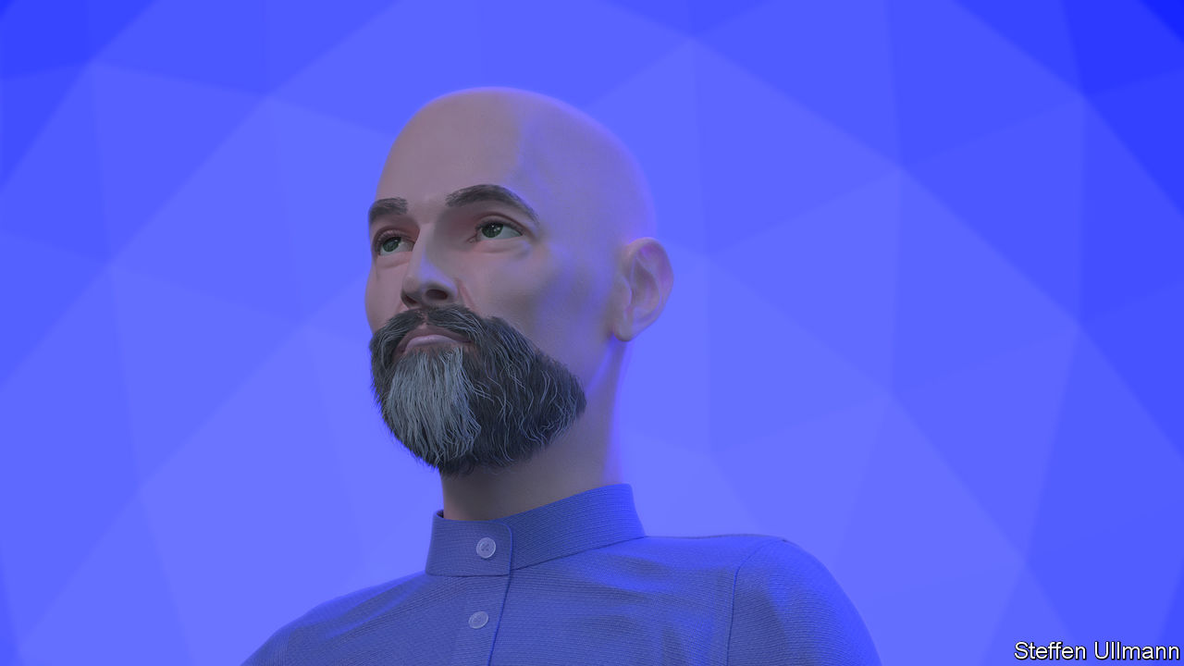

IN THE LATE 1980s, a young author named Neal Stephenson was working on a project to create a graphic novel. He typed in some code on his Apple Macintosh II and a pair of spherical mirrors appeared on the screen, hanging in space. To make the images look more realistic, the code he used calculated how light bounced off the objects in the frame, so each mirror featured on it a convincing reflection of the other.

“At the time it was unbelievable that you could use code to generate that kind of an image,” he recalls. He remembers having two conflicting thoughts: 3D computer graphics presented a tremendous opportunity to create a whole new medium, but they were too expensive and too difficult to make.

“And so I got to thinking about what could make it cheap,” he says. Television had started out as an expensive curiosity and then became cheap and accessible by becoming a mass-broadcast medium. Mr Stephenson began to imagine what might be necessary to bring about a similar transition for 3D computer graphics. “I was trying to imagine what a popular medium would look like, centred on the use of the 3D graphics technology. And the Metaverse was my best guess as to what something like that might look like.”

Introduced to the world in 1992 in his novel, “Snow Crash”, the Metaverse was a persistent virtual world—accessible to individuals via special goggles—in which people could meet, claim territory, build things, make money and more.

The impact of Mr Stephenson’s idea on the real, non-fictional world has been profound. Ask anyone working to create interactive 3D virtual environments what has inspired them, and “Snow Crash” will be somewhere on that list.

That explains why Mr Stephenson is also a sought-after futurist in Silicon Valley. Over the years he has been tapped by firms including Blue Origin, Jeff Bezos’s space-launch company, and most recently as “chief futurist” for Magic Leap, a startup making augmented-reality glasses.

Today it is Mr Stephenson’s vision—a social, persistent, virtual-reality 3D space accessible to anyone and which will one day be a successor to today’s internet—that many tech companies are seeking to build. One of the biggest supporters of Mr Stephenson’s idea of a Metaverse is Tim Sweeney, boss of Epic Games and creator of Unreal, the game engine that powers “Fortnite” and many other popular games. Mr Sweeney’s stated ambition is to turn such games into some version of the persistent virtual world described in “Snow Crash”.

“One thing I got wrong…was assuming a television model for the development of this medium,” says Mr Stephenson. “What grew instead was games.” Still, he reckons that what makes science fiction useful to people in the real tech world is plasticity—leaving some room for interpretation, so that people who try to implement it can incorporate their own ideas and point of view.

“I think that where Tim and the Epic folks are going with it, is based on an understanding that you do have to start with a game engine if you’re going to build a Metaverse,” says Mr Stephenson. “Because just having a game engine that works, and that is sustainable as a business, is kind of the table stakes. If you can’t do that, you can’t build a multi-user realistic 3D platform.”

This article was downloaded by calibre from <https://www.economist.com/technology-quarterly/2020/10/01/a-novelists-vision-of-the-virtual-world-has-inspired-an-industry>

|  |  |  |  |
| --- | --- | --- | --- |
| Previous | Articles | Sections | Next |

|  |  |  |  |
| --- | --- | --- | --- |
| Previous | Articles | Sections | Next |

#### The future

# The Metaverse is coming

But people need to be kept at the centre of it

Oct 1st 2020 |

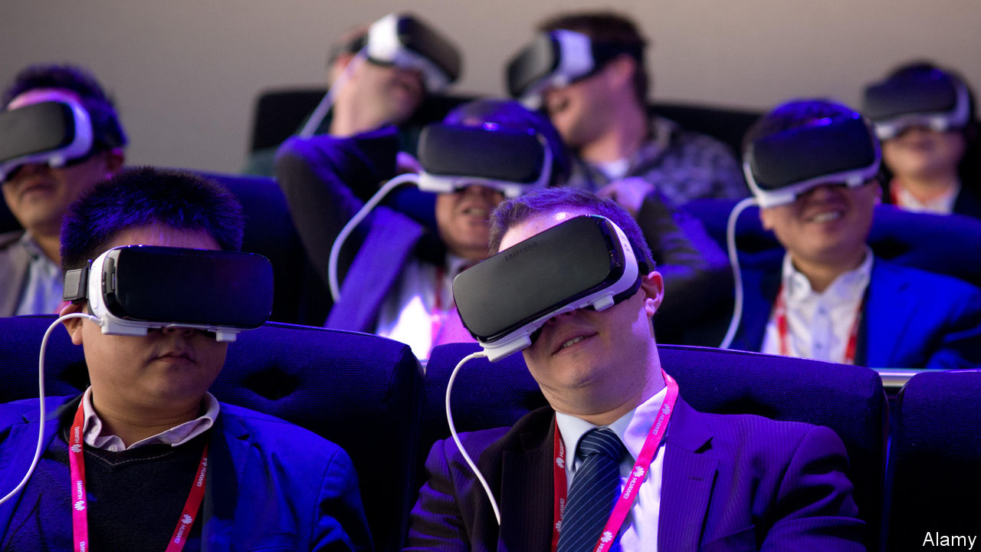

WITNESS ANY videoconference call, and it is striking how awkward it still is—everyone is in boxes, looking off in random directions. Microsoft tried to fix this recently with “Together” mode for its Teams application. Created by Jaron Lanier, a virtual-reality pioneer, it does away with boxes and puts everyone in a shared virtual space such as an auditorium. All participants see the whole group at once, as if they were all being reflected in a huge virtual mirror. Mr Lanier says this allows social and spatial awareness functions in the brain to work more naturally, and makes it harder to notice irregularities in eye contact.

For Mr Lanier, “Together” mode is a small contribution to a philosophy he holds dear—that, as technology develops, it should keep people in mind. Instead of asking “is videoconferencing good or bad?” or “is VR good or bad?”, he says, the real question is “how can we make this more human-centred?” He sees virtual realities as a path to that goal, by making computing more human-friendly.

Take posture, for example. Sitting at a keyboard, locked in position for hours and focusing on a fixed screen is a recipe for a range of physical complaints, from sore necks to tingling hands. “Humans have not evolved to sit for long periods of time at a desk, staring at a screen whilst hammering away on a keyboard,” says Mark Mon-Williams of the University of Leeds. Humans evolved to walk around and use their hands to explore the world that is in front of them. Virtual and augmented realities afford the option of using more natural movements when interacting with computer-generated environments—grasping and pointing at text or objects, for example, and physically moving them around a workspace.

Alex Kipman, a computer engineer at Microsoft and inventor of the company’s Kinect and HoloLens devices, poses a similar question: why are humans required to conform to the needs of computers, rather than the other way around? “Why don’t we flip it?” he asks. “Why don’t we ask technology to understand our world? How do we get digital technology to come out into our analogue space, as opposed to trying to get us into the digital space?” His inventions are specifically aimed at tackling those challenges. The Kinect sensor’s microphones and infrared cameras let people use speech and gestures to control games and other functions on Microsoft Xbox devices. The HoloLens extends that by mapping and understanding the user’s environment, too. Both devices bring technology out of screens and into the real world.

These sorts of ideas will bring increased ease and richness to interactions between humans and computers. The same technologies could also be used to push people beyond their own, or even any, human experiences. Scientists know that, as long as an avatar in a virtual world is programmed to respond in real time to a user’s actions, those users will often co-opt the avatars as almost-real extensions of their own bodies. People can easily inhabit avatars of a different gender or ethnicity, for example. They can even easily learn to control drastically different bodies, soaring over landscapes as virtual eagles or munching grass as virtual cows.

This is more than just a curiosity. Mr Lanier wants to know what would happen if inhabiting different bodies in virtual reality gave people access to new forms of human intelligence and understanding—the kind that “peeks out once in a while with a great athlete or with somebody playing jazz piano”. And if that could be made more accessible, he believes, then it might get interesting. “Can you turn yourself into a mathematical equation…in order to gain the kind of rapid body intelligence that’s possible?”

That is the future of extending human experience. Travis Scott’s concert in “Fortnite” hinted at some of the creative opportunities already available. His was not the first concert in that virtual world. In 2019 Marshmello, a DJ and producer, performed a set in the game watched by more than 10m fans, but that was just a musician playing a concert on a virtual stage in a game world. By contrast, Mr Scott’s event played with the idea of how a concert might look if it did not have to take place in the real world. The audience could therefore fly around beaches, in outer space and underwater. “You can think of this as, how would you tele-concert if you were God?” says Matthew Ball, a tech guru. “If you controlled physics.”

## Virtual mosh pit

That the event took place during a pandemic, when this was the only type of concert people could participate in, is important. Such events might in the past have been dismissed as “video-game experiences”. But as interactions through Zoom and other services come to be seen as “legitimate” meetings, parties and performances, so events such as Mr Scott’s should also be seen as legitimate concerts, says Mr Ball. “We can’t go to physical concerts,” he says. “So, either we have to say it’s a concert or we have to accept that there are no more concerts.”

There are still many technical hurdles to making the digital and physical worlds work together. As fast and capable as computer graphics have become, for example, VR focuses only on just two of the senses through which people experience reality: sight and sound. In the physical world, it would be difficult to imagine life without the other senses and, in particular, touch—grasping and manipulating objects is a fundamental part of the way people experience and gather information about their surroundings.

If history is a guide, computing platforms and internet connectivity will become faster and more widespread, latency will go down, input and output devices will improve and game engines (and their successors) will be able to create customised virtual worlds on the fly. At some point in the future, anyone who wants to may be able to switch in and out of fully immersive virtual worlds, flitting in and out of whatever the real version of Neal Stephenson’s Metaverse turns out to look like.

What seems certain is that sophisticated 3D digital worlds will appear on ever more of the screens of successive generations of devices that people already use every day. As activities, particularly interactions between people, in virtual realities can generate practical and aesthetic outcomes that have moral consequences and personal meanings, the idea that the “real” world is limited to that which is physically present nearby will seem increasingly bizarre. What, after all, is real, anyway? ■

This article was downloaded by calibre from <https://www.economist.com/technology-quarterly/2020/10/01/the-metaverse-is-coming>

|  |  |  |  |
| --- | --- | --- | --- |
| Previous | Articles | Sections | Next |

|  |  |  |
| --- | --- | --- |
| Technology ... | Sections | Finance & economics |

Business

Tata Sons: Endangered species

.

Epic v Apple: Storing up trouble

.

Fracking: Shelling out on shale’s sale

.

A luxury tiff: Letting go lightly

.

Measuring sustainability: In the soup

.

Bartleby: Why we need to laugh at work

.

Schumpeter: All the president’s moolah

.

|  |  |  |
| --- | --- | --- |
| Technology ... | Sections | Finance & economics |

|  |  |  |  |
| --- | --- | --- | --- |
|  | Articles | Sections | Next |

#### Endangered species

# Can Tata Sons regain its footing?

The Indian conglomerate’s structure is straining under internal and external pressure

Oct 3rd 2020 |

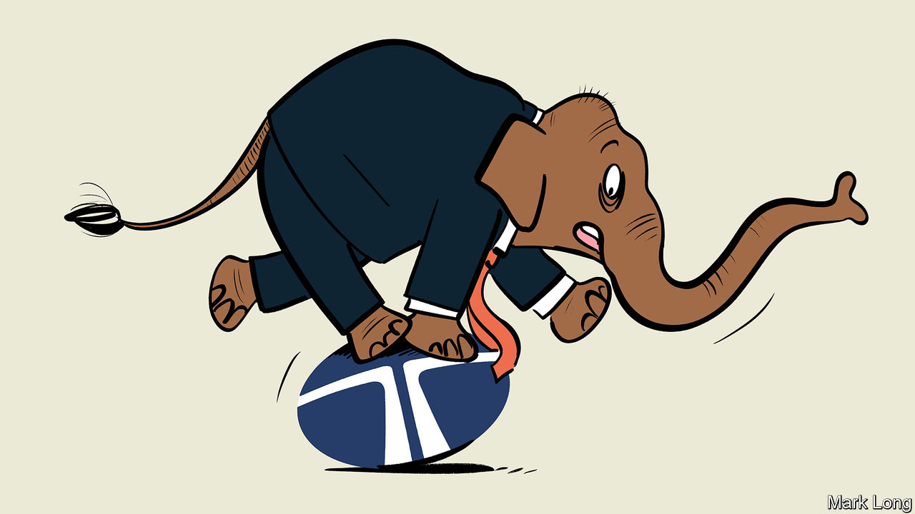

IN THE PANICKY initial days of India’s covid-19 lockdown, the country could count on one venerable institution. Tata, a 152-year-old conglomerate, bought millions of dollars’ worth of medical supplies for clinics and hospitals. Its shut businesses did not lay off a single worker. A new subsidiary was conjured up to develop a one-hour coronavirus test using gene-editing technology, which was approved last month. Each of these was a feat in its own right. Collectively, they look remarkable.

That is what Indians have come to expect from Tata since its founding in 1868. The group’s holding company, Tata Sons, and the seven charities which today own 66% of its shares, have been a pillar of India’s philanthropy, donating $156m last financial year, as well as its industry. The group thrived by helping India through its challenges, accruing businesses as it went.

Legend has it that Jamsetji Tata, the group’s progenitor, who died in 1904, built the magnificent Taj Mahal hotel after being denied a room at one of Bombay’s existing establishments because he was an Indian, not a European. Today Indian Hotels, which owns the Taj Mahal, is South Asia’s biggest chain. Less apocryphally, Tata Power and Tata Steel were founded to cope with India’s chronic electricity shortages and the paucity of heavy industry. It is a similar story for Tata Chemicals (from soda ash to hybrid seeds), Tata Motors (cars and lorries) and Tata Consumer Products (tea to turmeric). Tata Consultancy Services (TCS), India’s leading information-technology firm, was born in 1968 to manage payroll and inventory for Tata’s burgeoning portfolio of businesses.

The Tata name thus pervades all aspects of Indian life. An outside appraisal cited by Tata Sons values the brand, for the use of which the parent charges affiliates a royalty, at $20bn. That makes it Tata Sons’ second-most-valuable asset behind only its $89bn stake in TCS. But the lattice of business, do-goodery and trust, all wrapped up in a beloved brand, now faces problems of its own, from inside its corporate structure and from stiffer competition beyond it.

Start with the structure. Because for much of its history capital was in short supply in India, Tata Sons holds only partial stakes in big affiliates. In the 1980s the parent company reportedly let executives create an affiliate, Titan, to take on the state wristwatch monopoly on the condition that they could find funding themselves (which they did). During another scramble for money in the volatile 1920s the roots were planted for what has turned into the group’s biggest headache of late.

The details are fuzzy. But a loan secured at the time has evolved into an equity stake held by the Shapoorji Pallonji Group—a name that, like Tata’s, resonates in India Inc. SP Group, as it is known for short, built many of Mumbai’s landmark buildings, including the central railway station and the old reserve (central) bank. Its controlling Mistry family is, like the Tatas, drawn from old Bombay’s Parsi elite. Close ties between the clans (including by marriage) meant that when a Tata wanted to offload a stake, the Mistrys were seen as friendly buyers. Today SP Group holds 18.4% of Tata Sons.

In 2012 Ratan Tata, the current patriarch, stepped down as chairman of Tata Sons. He installed Cyrus Mistry, who then headed SP Group, as his successor. Mr Tata owed the Mistrys a debt of gratitude from early in his tenure, when Mistry money helped ward off hostile bidders for Tata businesses as India opened up its economy in the 1990s, after the interventionist decades of the Licence Raj. But he left behind a mixed legacy, having used readier access to capital in the roaring 2000s, when India’s economy looked on course for China-like growth, to bankroll a shopping spree. In 2007 he bought Britain’s Corus Steel for $12bn. A year later he paid $2.3bn for Jaguar Land Rover (JLR), an iconic British carmaker. He splurged millions on telecoms networks, power generation and chic hotels, including the Pierre in New York.

Many deals proved to be duds. Tata Steel is losing money. JLR has struggled to carve out a niche in the premium car market. A vast coal-fired power project in the state of Gujarat, begun in 2006 with government encouragement, has generated mostly losses. All this has fuelled a bonfire of value destruction. Since 2007 the market capitalisation of Tata Steel (into which Corus was folded) has gone from $14.5bn to $5.4bn; Tata Motors has declined from $7.3bn to $5.7bn; Tata Power from $7.4bn to $2.3bn; and Indian Hotels from $2.4 to $1.5bn. Today nearly 90% of Tata Sons’ worth is tied up in its lucrative stake in TCS, India’s second-most-valuable company (see chart 1).

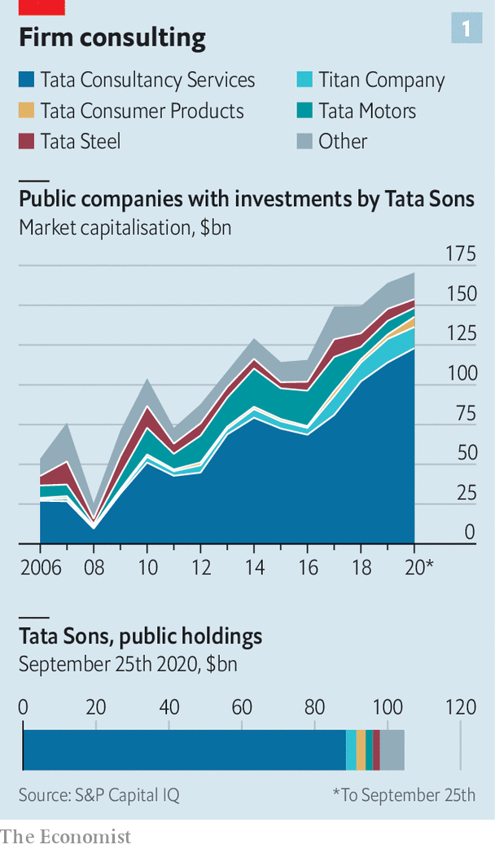

In 2016 Mr Mistry was ousted as chairman, apparently at the urging of Mr Tata, who did not think he was doing a good job. The Mumbai rumour mill has it that the two fell out because Mr Tata declined to loosen his grip through the controlling trusts. (Mr Tata’s views on this matter are not known.) Whoever is right, Tata Sons handed the top job to Natarajan Chandrasekaran, TCS’s able boss, to right the ship. Mr Chandrasekaran continued Mr Mistry’s clean-up, writing off investments in a telecoms operation, cutting steel capacity, recapitalising subsidiaries and selling some loss-making assets, including a chain of car dealerships.

That is not the end of it for Mr Chandrasekaran. Out of Tata Sons’ 15 big publicly listed affiliates, only five have returns on capital of over 10%. The debts of four subsidiaries, including Tata Motors and Tata Steel, exceed their equity—by more than twice in the case of Tata Power (see chart 2). Although Tata Sons holds minority stakes in many divisions, markets and bankers appear to assume that it stands entirely behind all its operating companies, in effect taking on full risk for partial reward.

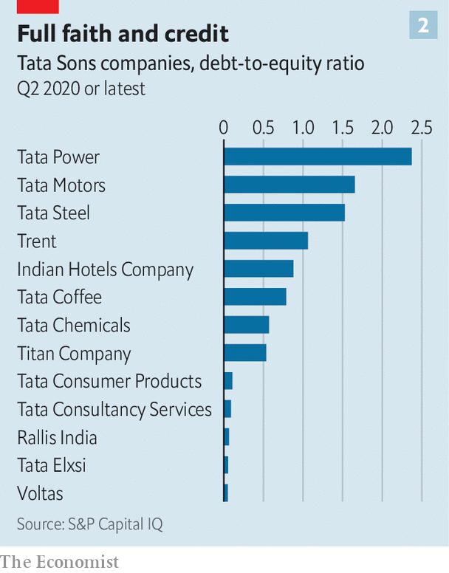

Even if Mr Chandrasekaran’s restructuring plan succeeds, another problem looms in the form of increased competition. Tata’s corporate structure makes it hard for its various arms to collaborate—by linking its hotels, airlines (Tata Sons holds stakes in two) and a coffee-shop joint-venture with Starbucks, say. That could increase efficiency and help fend off global rivals that offer appealing products. The alternative to the Taj Mahal is no longer some fusty Mumbai lodge but the Four Seasons. Tata Motors must take on not just the rickety Hindustan Ambassador but BMW.

In more ordinary times, Tata could tap a reservoir of goodwill, plus returns from TCS, to tackle these challenges patiently. But India’s growing financial strains, exacerbated by covid-19, have opened up fissures. SP Group, whose real-estate investments have been particularly hard-hit, is struggling to roll over debts. A default on its obligations to a small listed subsidiary, Sterling and Wilson Solar, raised concerns about SP Group’s overall debt, estimated at $4.1bn. In response to the cash crunch it reached an agreement with Brookfield, a Canadian private-equity firm, for capital. Collateral included the Mistrys’ shares in Tata Sons. Tata Sons sued to block the transaction, arguing it was not permitted under the shareholding agreements. India’s Supreme Court has suspended the deal until a hearing on October 28th.

Tata’s options are unappealing. SP Group has offered to take direct stakes in subsidiaries in proportion to its overall holdings. But that would dilute Tata Sons’ stakes just as Mr Chandrasekaran is trying to consolidate control by increasing holdings. For the same reason he is reluctant to buy the SP stake outright with money from a sale of assets—the price of which would anyway be depressed by the downturn. Tata Sons’ 30-odd direct holdings, including a financial-services arm, a home-builder and a biotech firm, are worth perhaps $6bn all told. But most are tricky to value at the best of times—which these are not. And Mr Chandrasekaran is understandably loth to reduce its ownership of TCS, and the accompanying juicy dividend.

A third option is to raise fresh capital. For all its problems, Tata’s portfolio of assets may look attractive to a private-equity giant or a sovereign-wealth fund. But outside investors may demand things unbecoming of Tata Sons, like redundancies or divestments. It may be the price for preserving an Indian icon. ■

This article was downloaded by calibre from <https://www.economist.com/business/2020/10/03/can-tata-sons-regain-its-footing>

|  |  |  |  |
| --- | --- | --- | --- |
|  | Articles | Sections | Next |

|  |  |  |  |
| --- | --- | --- | --- |
| Previous | Articles | Sections | Next |

#### Storing up trouble

# The Epic-Apple courtroom battle commences

A judge in California hears the opening arguments in what promises to be a drawn-out—and consequential—dispute

Oct 3rd 2020 |

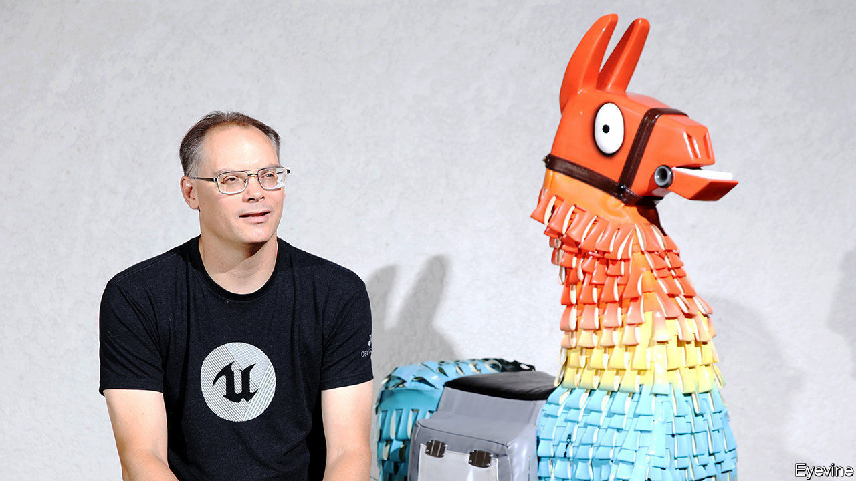

FITTINGLY, THE legal deathmatch is happening online. On September 28th a court in California heard arguments, via video call, in a case that pits Apple against Epic Games, the maker of “Fortnite”, a hit video game. At issue is whether the tight control Apple exerts over the software that can run on its smartphones amounts to a monopolistic abuse of power. The verdict, when it comes, may determine what other digital marketplaces can and cannot do.

Apple’s software practices have seen challenges before (see table). But Epic’s is the most brazen. In August Epic offered “Fortnite” players 20% off in-game purchases on iPhones if they paid Epic directly, not via Apple’s App Store, which takes a 30% cut on most transactions made in apps. This violated App Store terms; “Fortnite” was booted from the platform. Expecting this, Epic responded with the lawsuit (and a cheeky PR campaign).

The hearing concerned the narrow question of whether Epic could force Apple to return “Fortnite” to the App Store while the case proceeds. But it offered a preview of both sides’ arguments. Epic contends that Apple’s “walled garden”—in which iPhone software can be downloaded only via the App Store—stifles competition. In 2018 Epic launched a PC games store, charging a 12% commission. Steam, the dominant store, then dropped its cut from 30% to 20% for top-selling games. Tim Sweeney, Epic’s feisty boss, argues that Apple prevents something similar on iPhones.

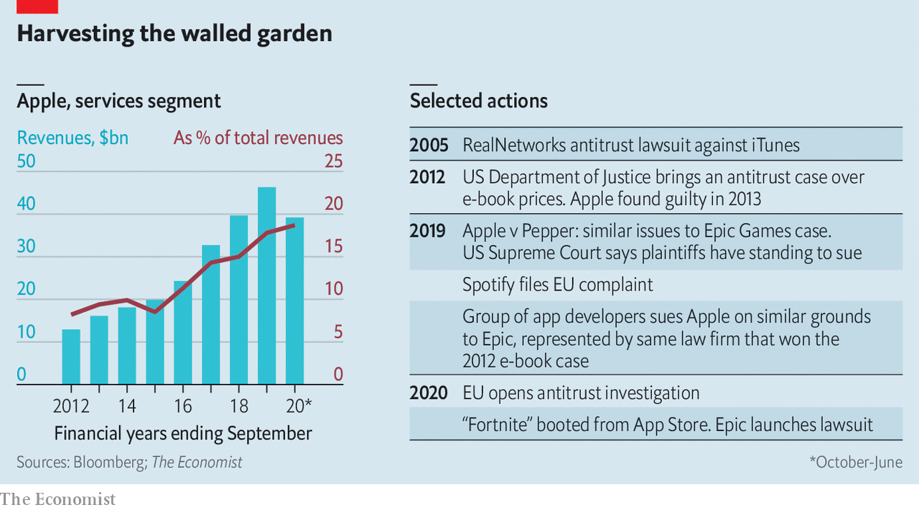

Apple retorts that those who dislike its rules have plenty of alternatives. “Fortnite” is available on desktop PCs, games consoles and smartphones that run on Android, a rival operating system made by Google. In a statement, Apple accused Epic of forcing its hand and “putting customers in the middle of their fight”. It has countersued Epic for breaching its App Store contract.

Mark Patterson of Fordham University sees parallels with Microsoft’s run-in with trustbusters in 2001. The software giant’s bundling of a web browser with its Windows operating system was eventually found to be anticompetitive. Apple exerts more power over iPhones than Microsoft did over Windows PCs, Mr Patterson says. But its market share in smartphones is smaller than Microsoft’s was in desktops.

The Epic case may hinge on how the court defines the relevant market. In Apple’s eyes the App Store is part of a broader universe of digital platforms in which it can reasonably claim not to be a monopolist. Epic takes a narrower view, arguing that iPhones are a market unto themselves.

Most lawyers think Apple had the better of the initial exchanges. The judge seemed unconvinced by Apple’s attempts to stop Epic from updating the iPhone version of the software behind “Fortnite”, which is licensed to other gamesmakers. But she reserved her strongest words for Epic, which she admonished for inviting trouble.

The case looks likely to go to a jury trial next year. With no clear precedent, big ramifications for the tech industry and the odds that the losing party will appeal, the dispute may end up in the Supreme Court.

In the meantime, Apple is facing other pressures. Epic is being cheered on by fellow members of the “Coalition for App Fairness”, like Spotify, a music-streamer, and Match Group, owner of Tinder and other dating apps. In June, at Spotify’s urging, the EU opened an antitrust probe into the App Store, and David Cicilline, who chairs a committee in America’s Congress that examines antitrust issues, described Apple’s fees as “highway robbery” and lamented the lack of “real competition” on iPhones.

While it battles Epic in the courts, Apple may tweak its rules to placate some developers. It has done so on occasion in the past, for instance exempting Amazon from the 30% commission on in-app purchases for the e-commerce giant’s Prime Video streaming app. On September 25th, following criticism from Facebook, Apple announced a temporary waiver on the 30% fee on in-app purchases for companies that had been forced by the covid-19 pandemic to switch to online-only events.

Such concessions may be as far as Apple will go, at least willingly. When Steve Jobs launched the App Store in 2008, he didn’t think it would ever make much money. He was wrong. Although the company does not break out the platform’s financial results, it probably makes up the bulk of its services business, which accounts for nearly 20% of revenues—and rising (see chart), as iPhone sales slow. Seeing what a promising profit engine it has turned into, Apple’s late boss would doubtless have fought tooth and nail to hang on to it. ■

This article was downloaded by calibre from <https://www.economist.com/business/2020/10/03/the-epic-apple-courtroom-battle-commences>

|  |  |  |  |
| --- | --- | --- | --- |
| Previous | Articles | Sections | Next |

|  |  |  |  |
| --- | --- | --- | --- |
| Previous | Articles | Sections | Next |

#### Shelling out on shale’s sale

# Why Devon Energy wants to buy WBX Energy

The merger between two frackers is a rare example of consolidation in a fragmented industry

Oct 3rd 2020 | NEW YORK

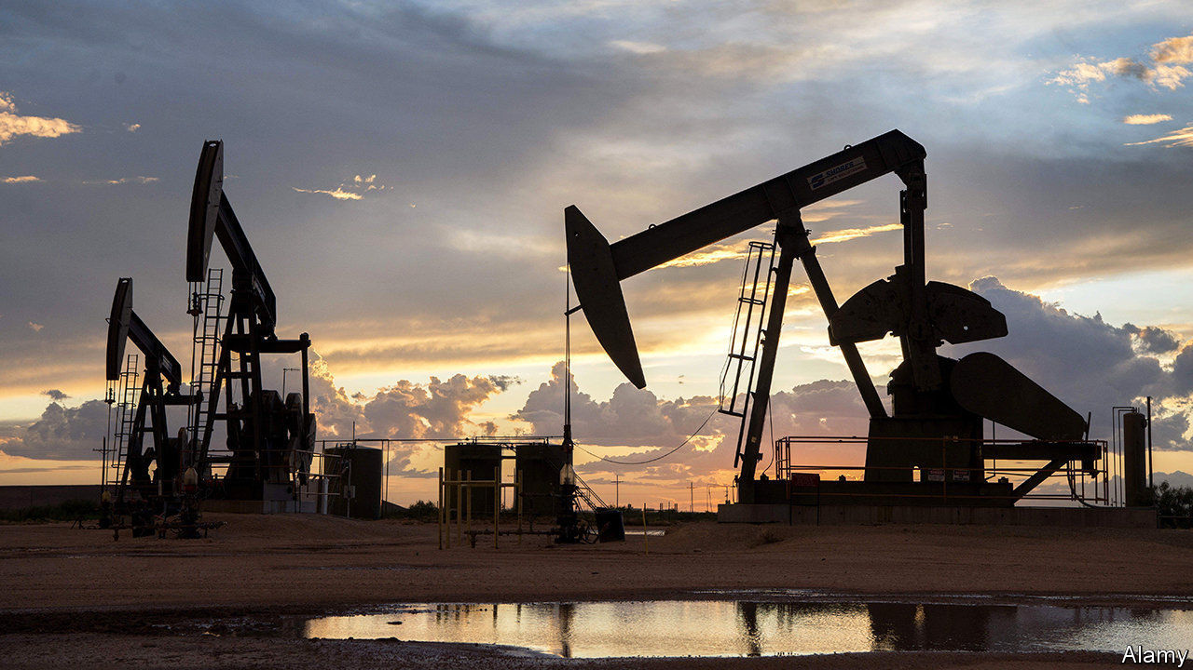

TO CALL 2020 tough for shalemen is to call a monsoon a mist. Covid-19 has halved the value of fracking firms this year. Rig counts are down (see chart). A perfect time for consolidation, then. Yet besides Chevron’s $5bn bid for Noble Energy in July, deals have been sparse. Buyers fret that investors will punish them for overpaying. Targets fear selling amid sinking oil prices. Many bosses’ yearly pay exceeds rewards from a sale, notes Devin McDermott of Morgan Stanley, a bank. So all eyes are on Devon Energy’s $2.6bn offer to buy WPX Energy, a smaller rival, announced this week.

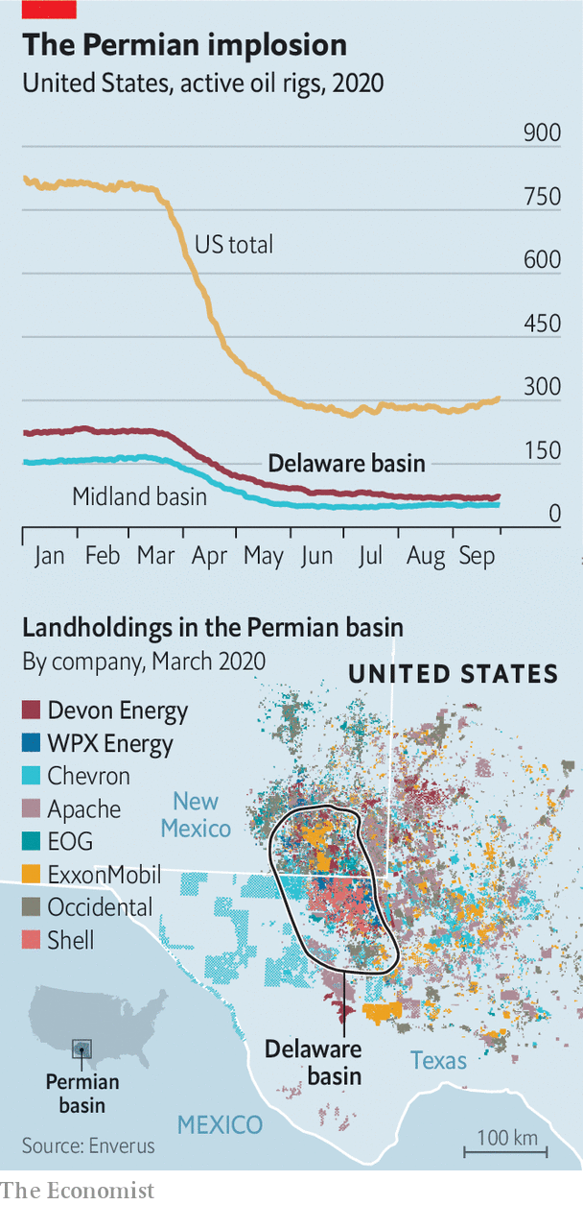

The merged entity will have 400,000 acres in the Delaware basin and, it is hoped, $575m in annual savings. Andrew Dittmar of Enverus, an analytics firm, says Devon will rely less on wells on federal land, where Joe Biden wants to curb drilling if he becomes president. Devon’s share price jumped by 11% on the news. Fellow frackers will take note.

This article was downloaded by calibre from <https://www.economist.com/business/2020/10/03/why-devon-energy-wants-to-buy-wbx-energy>

|  |  |  |  |
| --- | --- | --- | --- |
| Previous | Articles | Sections | Next |

|  |  |  |  |
| --- | --- | --- | --- |
| Previous | Articles | Sections | Next |

#### Letting go lightly

# Why the rocky engagement between Tiffany and LVMH might survive

Investors are betting on the American jeweller’s corporate nuptials

Oct 3rd 2020 | PARIS



THE MOST ardent romances result in the most acrimonious divorces. In the case of Tiffany and LVMH, rancour preceded the nuptials. In the amorous phase the French luxury giant behind Louis Vuitton had described the American purveyor of engagement rings as a corporate jewel, agreeing to a $17bn takeover ten months ago. It used an altogether less romantic tone in a Delaware court filing this week as it tried to break the match. Investors, meanwhile, are betting on a happy ending.

Rumours had swirled since the start of the covid-19 pandemic in March that Bernard Arnault, boss of LVMH, wanted to renegotiate the punchy price tag agreed on in November. On September 9th LVMH announced it could not go ahead with the deal, for an unexpected reason: a letter from the French minister of foreign affairs, Jean-Yves Le Drian, had asked it to defer the planned takeover of its American target to January 2021, beyond the agreed closing date. The delay would apparently give France more cards in a festering transatlantic trade spat.

Tiffany accused LVMH of engineering the supposed block from the foreign ministry—which soon insisted its letter was merely a polite recommendation, not an order. LVMH vehemently denied asking the authorities to intervene. Unhelpfully, on September 22nd Mr Le Drian told the French parliament he had indeed stepped in only after LVMH had come to him.

The American jeweller has thus sued LVMH to pony up. On September 28th LVMH countersued, saying that Tiffany was no longer worth buying. It called Tiffany’s performance since covid-19 broke out “catastrophic”. This, LVMH claimed, had left the jeweller with “dismal” prospects. The pandemic, it added, amounted to a “material adverse effect” that gave the putative buyer grounds for termination.

Tiffany is having none of it. It responded that LVMH was still legally committed to walk down the corporate aisle. Though covid-19 has indeed dented profits, things are already perking up, Tiffany says, whatever its erstwhile admirer may claim. LVMH was dragging its feet before the foreign ministry’s intervention, for example by delaying notifying antitrust authorities.

Delaware courts usually take a dim view of buyer’s remorse. Only once before have they agreed to a deal being broken off on grounds of material adverse effect. That might explain Tiffany’s buoyant share price. At around $116, it is well down on the $135 LVMH agreed to pay, but comfortably above the $90 at which it traded before Mr Arnault came along.

The premium suggests Tiffany remains a takeover target. Indeed, the most likely suitor is still thought to be LVMH. Most investors think the two sides will kiss and make up before a trial planned in January, perhaps arriving at a slightly lower price. There are few obvious rival buyers for the jeweller, whose brand could use some of Mr Arnault’s marketing nous. The luxury tycoon still craves legendary marques to add to the LVMH harem. Once the lawyers exhaust themselves, expect love—not least of profits—to find a way. ■

This article was downloaded by calibre from <https://www.economist.com/business/2020/10/03/why-the-rocky-engagement-between-tiffany-and-lvmh-might-survive>

|  |  |  |  |
| --- | --- | --- | --- |
| Previous | Articles | Sections | Next |

|  |  |  |  |
| --- | --- | --- | --- |
| Previous | Articles | Sections | Next |

#### In the soup

# The proliferation of sustainability accounting standards comes with costs

Thankfully, there are early signs of consolidation

Oct 3rd 2020 |

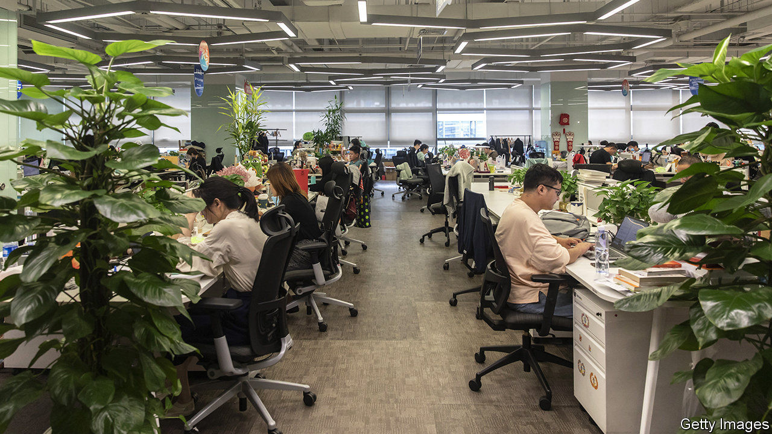

NOWHERE IS CORPORATE do-goodery more on show than in a firm’s sustainability report. Today 58% of companies in America’s S&P 500 index publish one, up from 37% in 2011, according to Datamaran, a software provider. Among the photos of blooming flowers and smiling children, firms sneak in environmental, social and governance (ESG) data, such as their carbon footprint or the share of women on boards. But the information differs wildly from firm to firm.

The Reporting Exchange, a website that helps corporations disclose sustainability data, tracks various ESG-related guidelines, such as regulations and standards. Across the world the number grew from around 700 in 2009 to more than 1,700 in 2019. That includes more than 360 different ESG accounting standards.

Some observers, then, may have rolled their eyes on September 22nd when the World Economic Forum (WEF) announced—with the backing of the big four accounting firms, Deloitte, EY, KPMG and PwC—a new set of ESG metrics for firms to report. Those involved are at pains to stress that this is not yet another new standard, but instead a collection of useful measures picked from other standards. The intention, they claim, is to simplify ESG reporting, not to add to the confusion.

Simplification is sorely needed. Investors complain that the proliferation of standards hinders comparability. Environmental activists note that it lets companies cherry-pick flattering results. And corporate bosses moan that they do not know what to disclose and that the array of options is confusing. Many want an ESG equivalent to the Generally Accepted Accounting Principles used in financial reporting. But these took years to agree on. Today, says the boss of a big pension fund with a large ESG portfolio, “there is greater urgency” to coalesce around a set of common standards. Even so, this is expected to take at least five to ten years, slowed by competing interests and disagreements about what to measure.

Four standards dominate ESG’s alphabet soup. The Global Reporting Initiative (GRI) focuses on metrics that show the impact of firms on society and the planet. By contrast, the Sustainability Accounting Standards Board (SASB) includes only ESG factors that have a material effect on a firm’s performance. The Task Force on Climate-related Financial Disclosures (TCFD) and the Carbon Disclosure Project (CDP) are chiefly concerned with climate change—specifically companies’ exposure to its physical effects and to potential regulations to curb carbon emissions.

GRI is the most popular of these, in part because it is the oldest, founded in 1997. It has been embraced by perhaps 6,000 firms worldwide. According to Datamaran, 40% of S&P 500 companies cite GRI in their sustainability reports. But SASB is gaining ground in America. One in four members of the S&P 500 makes reference to it, up from one in 20 two years ago. TCFD has experienced a similar uptick. It is backed by the Financial Stability Board, a global group of regulators. Both SASB and TCFD have risen partly thanks to support from large asset managers, including BlackRock and State Street.

Further simplification may be afoot. In September five big standard-setters announced that they would try to co-operate more and harmonise some measures. But few observers expect the end result to be a single standard. Among the five are SASB and GRI, each of which claims that it could coexist with the other.

How long such coexistence can last is unclear. As well as the WEF, other global bodies are taking an interest. The International Financial Reporting Standards Foundation, a global financial-accounting standard-setter, is considering its own ESG standard. Moreover, the EU is planning rules that will force big companies to disclose more ESG information; it is still thinking about which measures to use. If the ESG standard-setters cannot decide which metrics matter most, others may decide for them. ■

This article was downloaded by calibre from <https://www.economist.com/business/2020/10/03/the-proliferation-of-sustainability-accounting-standards-comes-with-costs>

|  |  |  |  |
| --- | --- | --- | --- |
| Previous | Articles | Sections | Next |

|  |  |  |  |
| --- | --- | --- | --- |
| Previous | Articles | Sections | Next |

#### Bartleby

# Why we need to laugh at work

The place that launched a thousand quips

Oct 3rd 2020 |

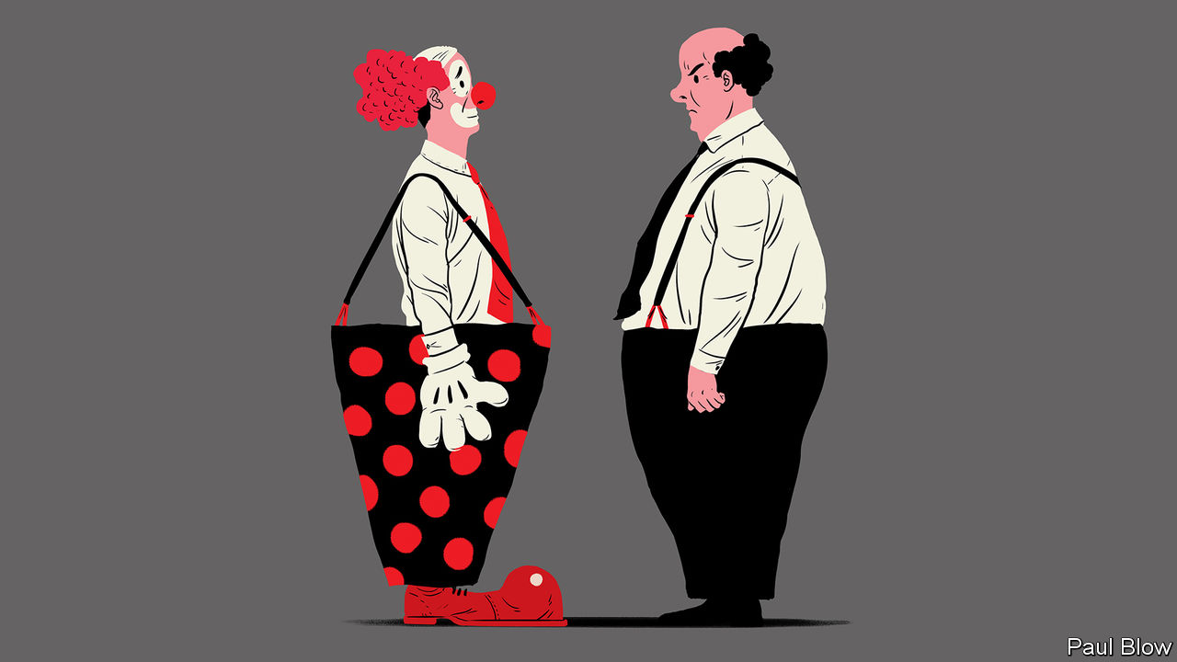

WHEN BARTLEBY reflects on life’s lessons, he always remembers his grandfather’s last words: “A truck!” Bartleby’s uncle also suffered an early demise, falling into a vat of polish at the furniture factory. It was a terrible end but a lovely finish.

Whether you find such stories amusing will depend on taste and whether you have heard them before. But a sense of humour is, by and large, a useful thing to have in life. A study of undergraduates found that those with a strong sense of humour experienced less stress and anxiety than those without it.

Humour can be a particular source of comfort at work, where sometimes it can be the only healthy reaction to setbacks or irrational commands from the boss. Classic examples can be found in both the British and American versions of the TV sitcom “The Office”, where workers have to deal with eccentric, egotistical managers, played respectively by Ricky Gervais and Steve Carell. The comedy stems, in part, from the way that the office hierarchy requires the employees to put up with the appalling behaviour of the manager.

And those programmes also illustrate the double-edged nature of workplace humour. When the bosses try to make a joke, they are often crass and insensitive, making the situation excruciating for everyone else (these are shows best watched through the fingers). The healthiest kind of workplace humour stems from the bottom up, not from the top down. Often the most popular employees at work are those who can lighten the mood with a joke or two.

Of course, humour can be used, even by non-managers, in a cruel or condescending way. What one man may mean as a laddish joke comes across to women as a disrespectful put-down. A better source of humour are the shared gripes that most workers face. Everyone can appreciate a quip about the cramped commuter trains, the officious security guard, the sluggish lifts or the dodgy canteen food. In that sense, workers can feel they are all (bar the security guard) “in it together”. This helps create team spirit and relieve stress.

Both soldiers and schoolchildren tend to create “in jokes” as a way of subtly subverting the hierarchy of their organisations. In the first world war, British soldiers published a newspaper called the Wipers Times. A typical poem began: “Realising men must laugh/Some wise man devised the staff.” Troops in the trenches dubbed themselves the PBI (poor bloody infantry). The TV comedies “Sergeant Bilko” and “Blackadder Goes Forth” both relied on wily soldiers finding ways of subverting the orders of their clueless, or callous, commanding officers. Schoolchildren, for their part, give their teachers nicknames which are only used out of earshot; at Bartleby’s school, Mr Canard was known as “Quack” because his surname was the French word for duck.

A downside of remote working is that moments of shared humour are harder to create. Many a long meeting at The Economist has been enlivened by a subversive quip from a participant. These jokes only work when they are spontaneous and well-timed. Trying to make a joke during a Zoom conference call is virtually impossible; by the time one has found the “raise hand” button and been recognised by the host, the moment has inevitably passed. This is a shame, as most of us could do with a laugh now and again to get through the pandemic.

Work is a serious matter but it cannot be taken seriously all the time. Sometimes things happen at work that are inherently ridiculous. Perhaps the technology breaks down just as the boss is in mid-oration, or a customer makes an absurd request. (Remember the probably apocryphal story of a person who rang the equipment manufacturer and asked them to fax through some more paper when the machine ran out?)

There is also something deeply silly about management jargon. Most people will have sat through presentations by executives who insist on calling a spade a “manual horticultural implement”. Too many managers use long words to disguise the fact they have no coherent message to impart. Such language is ripe for satire or at the very least a collective game of “buzzword bingo”.

But satire should not just be applied to other people. Perhaps the most important thing is not to take one’s own work too seriously. As the late, great gag-writer and comic Bob Monkhouse recalled at the height of his career, “They laughed when I said I wanted to be a comedian. Well, they’re not laughing now.”

This article was downloaded by calibre from <https://www.economist.com/business/2020/10/03/why-we-need-to-laugh-at-work>

|  |  |  |  |
| --- | --- | --- | --- |
| Previous | Articles | Sections | Next |

|  |  |  |  |
| --- | --- | --- | --- |
| Previous | Articles | Sections | Next |

#### Schumpeter

# How good a businessman is Donald Trump?

The tax revelations only provide a piece of the puzzle

Oct 3rd 2020 |

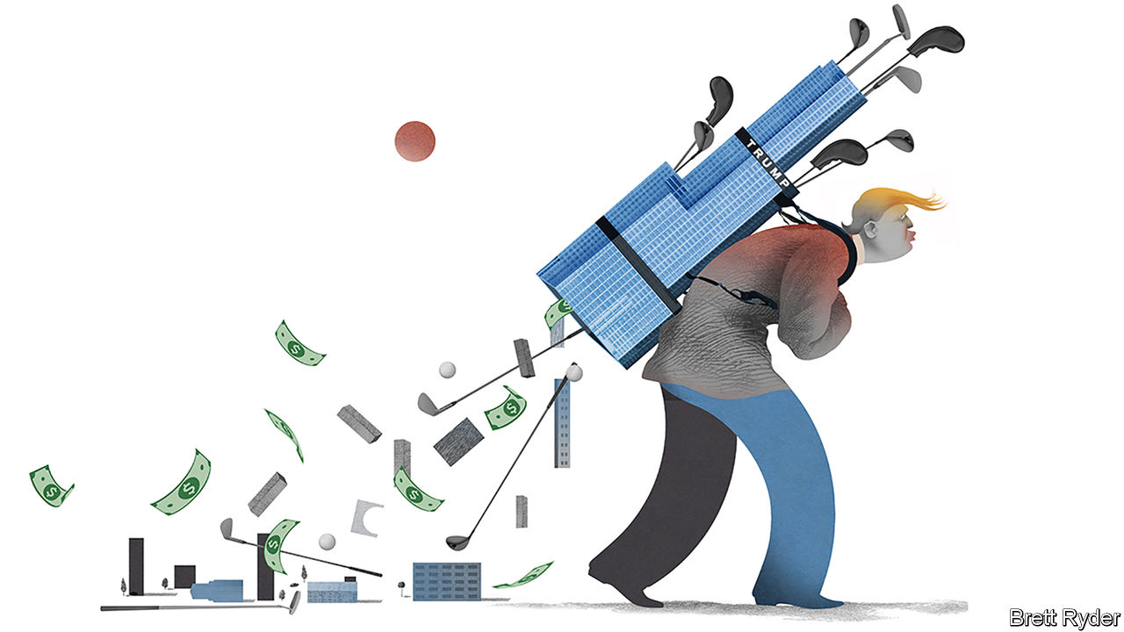

“THE APPRENTICE makes me $3m a day. Ker-ching. That’s the music it makes. It sure beats bricks and mortar, hey?” So a British businessman, imitating Donald Trump’s distinctive drawl, recalls a conversation the two men had by telephone years before Mr Trump became president. It was a high point of their relationship that the Brit still savours.

Broadly speaking, Mr Trump was right. As the New York Times reported on September 27th, after trawling through almost two decades of his long-concealed tax records, the president’s 50% stake in the reality-TV show, which helped craft his image as a successful tycoon and catapult him to the White House, was the shrewdest business move of his career.

Yet the self-styled property Midas almost blew the windfall on bricks and mortar. Before becoming president Mr Trump spent much of his money on golf courses, hotels and other trophy assets that the Times says have since racked up huge tax losses. Thanks to that red ink, it said he paid a mere $750 in federal income taxes in both 2016, the year he was elected, and his first year in office—and not a cent in ten of the previous 15 years.

In the presidential debate on September 29th Mr Trump disputed the account, saying he had paid “millions” in income taxes. A lawyer for the Trump Organisation told the Times that “most, if not all, of the facts appear to be inaccurate” but only directly questioned the amount of tax the president reportedly paid. In the past Mr Trump might have shrugged it all off. In 2016 he said minimising his taxes “makes me smart”. But even if the revelations hurt him politically, many businesspeople will see them in a kinder light. For them, the most intriguing question is not whether Mr Trump is a boy scout but whether he is a good businessman.

It is a hard question to answer. Mr Trump has never released his tax returns, and his businesses are privately held. The financial disclosures he made as president last year covered more than 100 business entities, ranging from skyscrapers to books. He can inflate assessments of his own wealth by billions of dollars just in the course of a conversation. The Times scoop provides another important piece of the jigsaw puzzle. But because it refers to tax accounts, it probably represents what Mr Trump wants the taxman to believe, rather than the full reality.

To get the measure of the business, it helps to consider the Trump Organisation, Mr Trump’s main vehicle, as a relatively modest, America-centric enterprise. Its bedrock is property. Its biggest assets are two buildings in New York and San Francisco in which Mr Trump owns a minority stake, and his two Manhattan stalwarts, 40 Wall Street and Trump Tower. The Times says that these four have produced big profits—until the pandemic, that is. But if Mr Trump, like other property barons, uses the wear and tear on his buildings, known as depreciation, to generate tax deductions, it is possible that they have done even better than the tax records make out.

Then there is “The Apprentice”. According to the tax records, his appearance on the show generated $200m, which is a spectacular result. He also reported $230m of additional income from the licensing and endorsement deals that came out of it, on everything from Trump-branded hotels to Oreo cookies. Beyond that are some puny international branding endeavours on buildings in other countries, some of which are white elephants. The tax records indicate that his biggest losses have come from golf courses, into which he has poured money over the past decade. The Times says some of the biggest ones, including two in Scotland and one in Ireland, are loss-making even before depreciation.

How solid the Trump business remains depends on four factors about which the full picture is still unclear. The first is debt. The Times reports that he has $300m in loans coming due in the next few years for which he is personally liable. It is not known whether he mortgaged these borrowings against solid assets. If he did, they are probably manageable. If not, the debt could become contagious—but it doesn’t have to. Banks will nevertheless be jumpy. In a compliance-obsessed era, few are keen to engage with politicians of any stripe—particularly one with Mr Trump’s profile. There may be other liabilities. Mr Trump is the subject of an ongoing federal tax audit for a $73m refund he claimed a decade ago—and which he may need to return. Of immediate concern is covid-19. Many of his commercial tenants will be reeling from the pandemic. Hotels are suffering from low occupancy; high-density office buildings in New York could fall in value because of remote working; footfall has fallen among luxury retailers who occupy his buildings at street level.

## In the 18th hole?

Ultimately, the future will depend on the durability and value of the Trump brand. “The Apprentice” showed how lucrative it could be. But whether he could get a similar television deal in America whenever he leaves power may depend on his popularity at the end, and the manner in which he leaves the White House. He could look for TV opportunities abroad, where his recognition is far higher now than it ever was during “The Apprentice”. There are plenty of international media moguls who would be keen to profit from another chapter in the Trump soap opera. Or he may simply retire, handing over the keys of the kingdom to his children to manage or to liquidate.

That is unlikely. The best time to do so would have been before taking office. In a new book about the president’s business interests, “White House, Inc”, Dan Alexander, a journalist at Forbes magazine, calculates that had Mr Trump done so back then and invested the proceeds in the S&P 500 stockmarket index, by March of this year he would have been richer by $415m—twice what he earned on “The Apprentice”. To a businessman that must rankle, whether he is an astute one or not. ■

Dig deeper:  
Read the [best of our 2020 campaign coverage](https://www.economist.com/us-election-2020) and explore our [election forecasts](https://projects.economist.com/us-2020-forecast/president), then sign up for Checks and Balance, our [weekly newsletter](https://www.economist.com/checksandbalance/) and [podcast](https://play.acast.com/podcasts/2020/01/24/checks-and-balance-our-new-weekly-podcast-on-american-politics) on American politics.

This article was downloaded by calibre from <https://www.economist.com/business/2020/10/03/how-good-a-businessman-is-donald-trump>

|  |  |  |  |
| --- | --- | --- | --- |
| Previous | Articles | Sections | Next |

|  |  |  |
| --- | --- | --- |
| Business | Sections | Science & ... |

Finance & economics

Global housing markets: The three pillars

.

Evergrande: Not forever grand

.

Digital payments: If you can’t bill them

.

Investment banking: Spoof proof

.

Employment in Germany: Nature v nurture

.

Investment in India: Sticking plaster

.

Buttonwood: Gifts that keep giving

.

Free exchange: Marching bans

.

|  |  |  |
| --- | --- | --- |
| Business | Sections | Science & ... |

|  |  |  |  |
| --- | --- | --- | --- |
|  | Articles | Sections | Next |

#### The three pillars

# Why, despite the coronavirus pandemic, house prices continue to rise

Monetary policy, fiscal measures and buyers’ preferences explain the unlikely boom

Sep 30th 2020 |



DURING THE global recession a decade ago, real house prices fell by an average of 10%, wiping trillions of dollars off the world’s largest asset class. Though the housing market has not been the trigger of economic woes this time, investors and homeowners still braced for the worst as it became clear that covid-19 would push the world economy into its deepest downturn since the Depression of the 1930s.

That pessimism now looks misplaced. House prices picked up in most middle- and high-income countries in the second quarter. In the rich world they rose at an annual rate of 5% (see chart 1). Share prices of developers and property-traders fell by a quarter in the early phase of the pandemic, but have recovered much of the fall.

Some markets are fizzing. In August house prices in Germany were 11% higher than the year before; rapid growth in South Korea and parts of China has prompted the authorities to tighten restrictions on buyers. In America growth in the median price per square foot accelerated more quickly in the second quarter of 2020 than in any three-month period in the lead-up to the financial crisis of 2007-09. Three factors explain this strength: monetary policy, fiscal policy and buyers’ changing preferences.

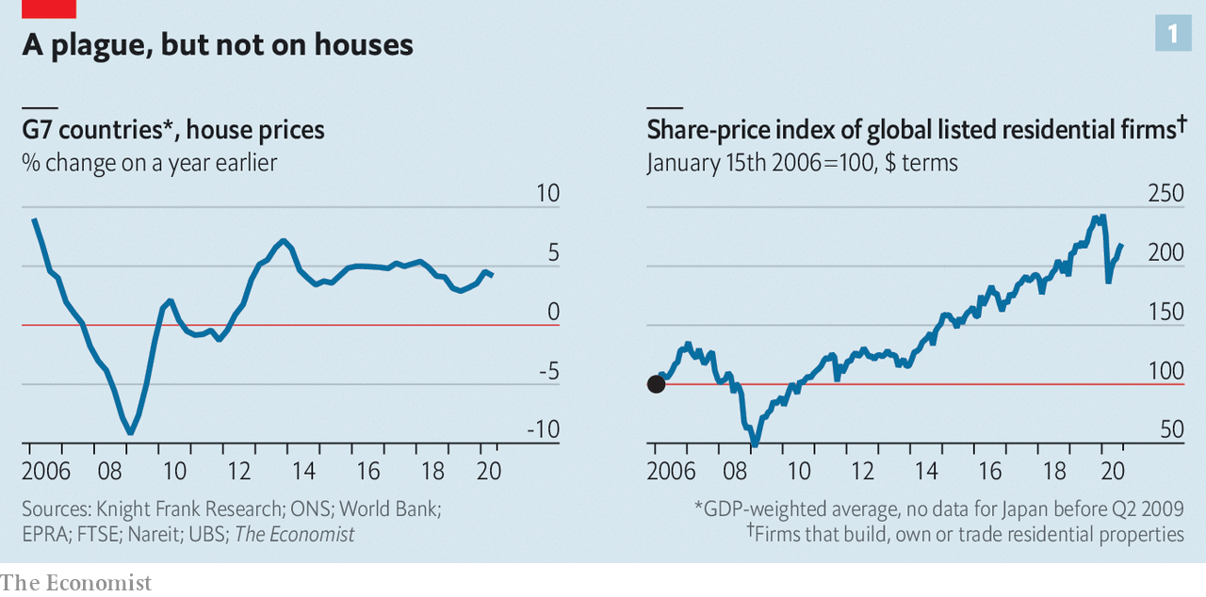

Consider monetary policy first. Central bankers around the world have cut policy rates by two percentage points on average this year, reducing the cost of mortgage borrowing. Americans can take out a 30-year fixed-rate mortgage at an annual interest rate of just 2.9%, down from 3.7% at the beginning of the year. Studies suggest a strong link between falling real interest rates and higher house prices. Some borrowers can afford to take out bigger mortgages; others find it easier to manage their existing loans. Landlords are willing to pay more for property, because yields on other assets have dropped. In both America and Britain, mortgage lending is running at post-financial-crisis highs.

That is not to say that it has become easier for everyone to borrow. In fact, obtaining a mortgage has become harder for many. Brokers, fearful of the long-term economic impact of covid-19, have pulled back on riskier lending. British banks, for instance, are offering fewer high-loan-to-income mortgages. In America few loan officers at banks said they were tightening lending standards before the pandemic; now 60% do. In contrast with previous periods of strong house-price growth, there is little evidence of lax lending standards.

Fiscal policy, the second factor, may therefore be more important in explaining buoyant prices. In a normal recession, as people lose jobs and their incomes fall, foreclosures drag house prices down—not only by adding to the supply of houses on the market, but also by leaving ex-homeowners with a blemish on their credit history, making it harder for them to borrow again. But this time governments in rich countries have preserved households’ incomes. Handouts through wage subsidies, furlough schemes and expanded welfare benefits amount to 5% of GDP. In the second quarter of the year households’ disposable incomes in the G7 group of large economies were about $100bn higher than they were before the pandemic, even as jobs disappeared by the millions.

Other measures directly support the housing market. Spain, for instance, has allowed borrowers to suspend their mortgage repayments. Japan’s regulators have asked banks to defer principal repayments on mortgages, and the Netherlands temporarily banned foreclosures. In the second quarter the number of owner-occupied mortgaged properties that were repossessed in Britain was 93% lower than in the same period in 2019, the result of policies that dissuade repossessions. In America foreclosures, as a share of all mortgages, are at their lowest level since 1984.

The third factor behind the unlikely global housing boom relates to changing consumer preferences. In 2019 households in the median OECD country devoted 19% of spending to housing costs. With a fifth of office workers continuing to work from home, many potential buyers may want to spend more on a nicer place to live. Already there is evidence that people are upgrading their household appliances.

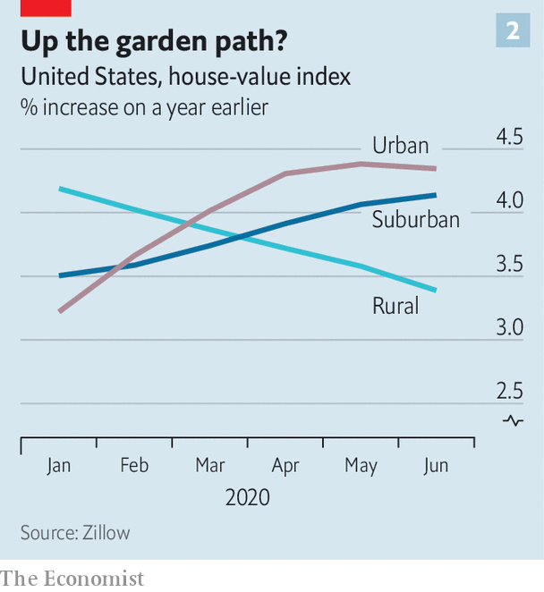

People also seem to be looking for more space—which, all else being equal, raises house prices. Though the New York and San Francisco housing markets look weak, there is little wider evidence to support the idea that people are fleeing cities for the suburbs, at least in America. Data from Zillow, a housing marketplace, suggest urban and suburban property prices are rising at roughly the same pace; price growth in the truly get-away-from-it-all areas is actually slowing (see chart 2). It seems more likely that people are looking for bigger houses near where they already live. In Britain prices of detached houses are rising at an annual rate of 4%, compared with 0.9% for flats, and the market for homes with gardens is livelier than for those without.

Can house prices continue their upward march? Governments are slowly winding down their economic-rescue plans, and no one knows what will happen once support ends. But lower demand for housing may run up against lower supply. High levels of economic uncertainty deter investment: in America housebuilding has fallen by 17% since covid-19 struck. The experience of the last recession suggests that even when the economy recovers, construction lags behind. It may take more than the deepest downturn since the Depression to shake the housing market’s foundations. ■

Editor’s note: Some of our covid-19 coverage is free for readers of The Economist Today, our daily [newsletter](https://my.economist.com/user#newsletter). For more stories and our pandemic tracker, see our [hub](https://www.economist.com/news/2020/03/11/the-economists-coverage-of-the-coronavirus)

This article was downloaded by calibre from <https://www.economist.com/finance-and-economics/2020/09/30/why-despite-the-coronavirus-pandemic-house-prices-continue-to-rise>

|  |  |  |  |
| --- | --- | --- | --- |
|  | Articles | Sections | Next |

|  |  |  |  |
| --- | --- | --- | --- |
| Previous | Articles | Sections | Next |

#### Not forever grand

# Is China’s biggest property developer truly too big to fail?

Regulators want Evergrande to save itself by raising cash and cutting its debts

Oct 3rd 2020 | SHANGHAI

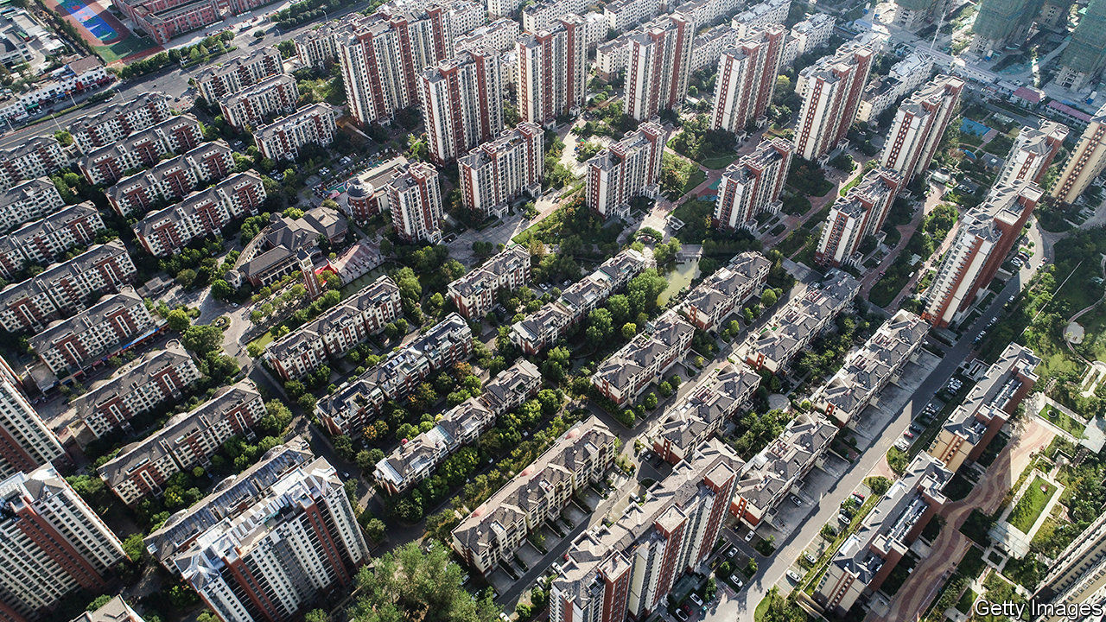

EARLY IN SEPTEMBER Evergrande, China’s biggest home-builder, announced the kind of sale more commonly seen in clothing stores: “30% off all properties, one month only!” Some debated whether it was a gimmick or a genuine discount. But its motivation was clear. Deep in debt, Evergrande needed cash—and quickly. Events since then have highlighted the urgency, and also raised the question of whether its struggles threaten the wider economy.

Evergrande, after all, has more debt—nearly $120bn—than any other non-financial listed company in China. Having built as many as 600,000 homes annually, it has amassed a debt load 56 times bigger than a decade ago. And it has strayed far from its core business, founding a colossal football academy, a bottled-water brand (which it later sold) and an electric-car company.

On September 24th a letter spread online suggesting that its giant edifice was shaky. Written on Evergrande stationery, it warned of a cash crunch and appealed to the government of Guangdong, its home province, to push through approval of a backdoor-listing plan. According to a previous agreement, Evergrande would owe investors 130bn yuan ($19bn) if its subsidiary failed to list on the Shenzhen stock exchange, where it would obtain a higher valuation than it currently has in Hong Kong, before the end of January. Evergrande has said that the letter, seen by reporters for Bloomberg and Reuters, is a fabrication.

The part of the letter that attracted most attention was its prediction that Evergrande’s failure would lead to “systemic financial risks”. Has it truly achieved too-big-to-fail status? The letter, whether authentic or not, made a straightforward case. First, if Evergrande were to collapse, the impact on the economy would be severe. The letter estimated that the developer, with projects in 229 cities, generates more than 3m jobs. Second, the financial fallout would be far-reaching. Evergrande reportedly owes money to 171 domestic banks and 121 other financial firms, on top of all of its bondholders. The letter seemed calculated to elicit a helping hand from a government that prizes stability, both social and financial.

The Chinese government regularly rescues ailing firms, especially its state-owned enterprises. But for a private-sector company, any bail-out is likely to involve at least partial nationalisation. Evergrande may have thought it had one factor in its favour: it was not asking for money, just approval for a stock listing.

Yet a listing is not simple—as Evergrande knows, having sought approval for its Shenzhen share sale since 2016. And it has only become tougher in recent weeks. The central bank and the housing ministry introduced a new policy to restrict funding for developers, measuring them against three “red lines” for indebtedness, such as too heavy a reliance on short-term funding. Evergrande is one of a handful of developers that cross all three.

The government is, in other words, trying to limit, not facilitate, the growth of indebted companies. Authorities have reason to think that Evergrande’s woes will have less systemic fallout than those of a big overleveraged bank. Evergrande is huge, but its debt nonetheless amounts to just 0.5% of total Chinese bank loans. And it is developing land worth about $170bn, 50% more than its debts, according to S&P Capital IQ, a data provider. It could, in theory, be wound down.

In practice, though, it would still be messy. Far better to rein it in before it fails. That, for the moment, seems to be the focus. Evergrande has reached an agreement with most of its investors who expected the Shenzhen listing, securing itself more time. It is likely to raise money by spinning off its property-management arm. And most crucially, the September sale has brought an influx of homebuyers to its showrooms. For a change, China’s biggest builder has to build down, not up. ■

This article was downloaded by calibre from <https://www.economist.com/finance-and-economics/2020/10/03/is-chinas-biggest-property-developer-truly-too-big-to-fail>

|  |  |  |  |
| --- | --- | --- | --- |
| Previous | Articles | Sections | Next |

|  |  |  |  |
| --- | --- | --- | --- |
| Previous | Articles | Sections | Next |

#### If you can’t bill ’em

# Mastercard and Visa seek to get the most out of the digital-payments boom

The credit-card duopoly is crashing the faster-payments party

Oct 3rd 2020 |

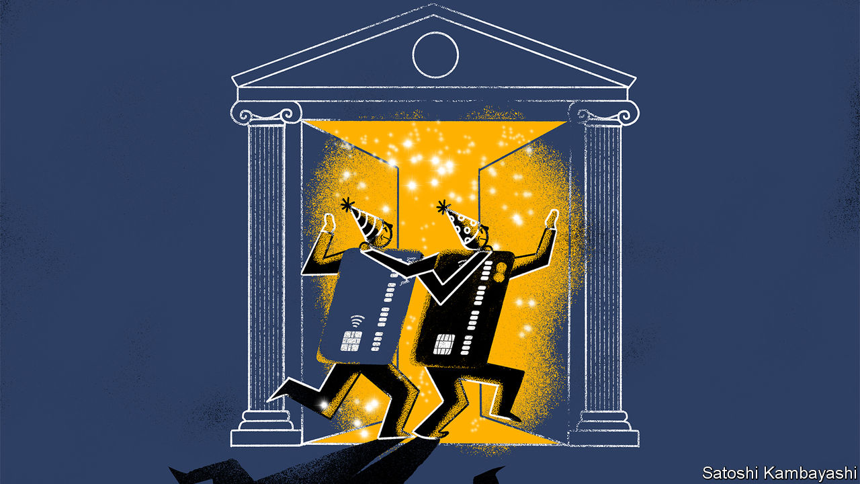

THE GREATEST accolade a payment system can aspire to is to be forgotten about. “People don’t want to make payments,” says Diana Layfield, an executive on Google’s payments team. “They want to do what a payment facilitates.” The industry’s biggest battles therefore often happen in the shadows. The latest struggle, which sees card networks, tech firms and governments vie to control the virtual pipes along which digital money flows, is no exception. Recent manoeuvres by governments, card networks and even SWIFT, the main interbank messaging service for cross-border payments, show how the battle lines are shifting.

An electronic-payment system used to resemble a postal service for money. Many countries have a low-cost, national payment network, mandated by the government, that transfers funds between banks. Like post, the money could take days to arrive; tracking it was tricky. So automated clearing-houses (ACH), as the national systems are known, were mostly used to disburse recurring payments, such as payrolls or benefits, which do not need immediate authorisation. For one-off transactions, like shopping, people used private card networks, which allow for instant checks via technology embedded in terminals.

As the digital economy has boomed, however, many governments have upgraded the pipes so they can clear and settle online transactions in seconds. Today 55 countries, from Canada to Singapore, have “real-time” bank-to-bank payment systems. Half a dozen more are close to launching theirs. In addition to money, “fast ACH” also allows a lot of data to travel, so senders and recipients can keep tabs on the whole process, potentially preventing fraud. Central banks think they are reliable and more resilient. Tech firms, like Google, have built their own payments apps on top of such “rails”. And users enjoy moving and tracking money seamlessly.

Credit-card firms, though, sense a threat. So Mastercard and Visa, which together handle 90% of global card payments outside China, have found a clever response: to get in on the action. On September 29th Mastercard said it would collaborate with ACI Worldwide, which makes software for real-time payments systems, to provide such services globally. That continues an attempt to shift away from plastic that Mastercard embarked upon in 2016, when it bought Vocalink, a software firm that built and now runs Britain’s fast ACH, and also powers those in other countries. For its part, Visa has set up its own alternative to fast ACH, called Visa Direct, and offers services, such as security tools, to help strengthen countries’ payment networks.

For now national payment systems remain just that—national. Though built along similar principles, most cannot work together (European systems are the exception). That leaves space for others. Some specialist firms have built their own set of rails that help banks in one country connect to local payment networks in another. SWIFT, which has long been criticised for its slow speed and high cost, is upping its game. On September 17th it unveiled a strategy to “facilitate instant, seamless, secure payments” using cloud technology. That would be like leaping from the costly and cumbersome process of sending a parcel abroad to the convenience of email.

SWIFT’s plans could fast gain traction; the co-operative has more than 11,000 members, most of which are banks. But the card networks see an opening here too. Last year both Mastercard and Visa acquired firms that process bank-to-bank transfers by connecting directly into local clearing systems. Plastic is becoming less of a mainstay: this week Mastercard called itself a “global multi-rail payments technology company”. Paul Stoddart, who is in charge of new payment platforms at the firm, describes its forays as a way of offering customers choice. With both card and fast ACH payments growing at double-digit rates in recent years, the boom in digital payments should mean there are plenty of gains to go around. Just in case, though, the card networks are betting on every horse. ■

This article was downloaded by calibre from <https://www.economist.com/finance-and-economics/2020/10/03/mastercard-and-visa-seek-to-get-the-most-out-of-the-digital-payments-boom>

|  |  |  |  |
| --- | --- | --- | --- |
| Previous | Articles | Sections | Next |

|  |  |  |  |
| --- | --- | --- | --- |
| Previous | Articles | Sections | Next |

#### Spoof proof

# JPMorgan Chase faces a fine of $920m for market manipulation

Traders are alleged to have used “spoofing” to rig markets

Oct 3rd 2020 | NEW YORK

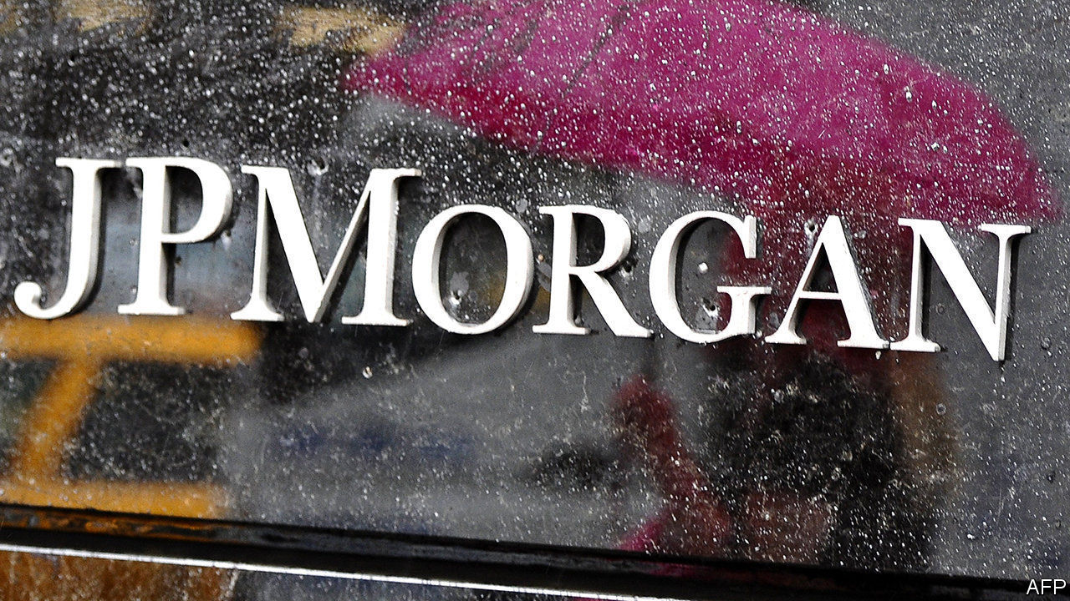

MANY OF THE big market-manipulation scandals over the past decade have much in common: huge fines for the investment banks, criminal charges for the traders and an embarrassing paper trail revealing precisely what bank employees got up to. Interest-rate traders who manipulated the London Interbank Offered Rate (LIBOR) messaged each other with pleas to put their fixes in low. Foreign-exchange traders infamously called a chat room in which they discussed rigging exchange rates “the cartel”.

The case against JPMorgan Chase for manipulating precious-metals and Treasury markets has many of the usual features. On September 29th it admitted to wrongdoing in relation to the actions of employees who, authorities claim, fraudulently rigged markets tens of thousands of times in 2008-16. The bank agreed to pay $920m to settle various probes by regulators and law enforcement; this includes a $436.4m fine, $311.7m in restitution to parties harmed by the practices and $172m in disgorgement (ie, paying back unlawfully earned profits). Some of the traders involved face criminal charges. If convicted, they are likely to spend time in jail.

The traders are alleged to have used “spoofing”, a ruse where a marketmaker seeking to buy or sell an asset, like gold or a bond, places a series of phoney orders on the opposite side of the market in order to confuse other market participants and move the price in his favour. A trader trying to sell gold, for instance, might place a series of buy orders, creating the illusion of demand. This dupes others into pushing prices higher, permitting the trader to sell at an elevated price. Once accomplished, the trader cancels his fake orders.

The practice was explicitly outlawed in America in 2010, but the rise of algorithmic traders—which rapidly analyse order books to work out where prices might move next—has made it more tempting for human traders to spoof them. According to prosecutors one JPMorgan trader described the tactic as “a little razzle-dazzle to juke the algos”. In the past two years Deutsche Bank, HSBC, Merrill Lynch and UBS have all paid penalties on spoofing charges.

Though JPMorgan’s case shares similarities with past infringements, regulators and prosecutors have also become tougher. The penalty meted out to the bank is the largest ever for spoofing. The Department of Justice (DoJ) said that when it considered the appropriate punishment it took into account the fact that JPMorgan had pleaded guilty to manipulating foreign-exchange markets in 2015, suggesting that repeated offences would be punished more severely.

The penalties for the traders alleged to have run spoofing schemes are also likely to be harsher than usual. Four—including Michael Nowak, the bank’s former head of precious-metals trading, and Gregg Smith, a senior gold trader alleged to have introduced the practice at JPMorgan—have been indicted under the Racketeer Influenced and Corrupt Organisations (RICO) Act. (Mr Nowak and Mr Smith have pleaded not guilty to all charges.)

The RICO statute was formulated to target organised crime, the core business practices of which are illegal. But in 2019 Brian Benczkowski, then the head of the DoJ’s criminal division, said that the law had been used against JPMorgan because spoofing was so “widespread” at its metals-trading desk. That is a charge no one will want repeated. ■

This article was downloaded by calibre from <https://www.economist.com/finance-and-economics/2020/10/03/jpmorgan-chase-faces-a-fine-of-920m-for-market-manipulation>

|  |  |  |  |
| --- | --- | --- | --- |
| Previous | Articles | Sections | Next |

|  |  |  |  |
| --- | --- | --- | --- |
| Previous | Articles | Sections | Next |

#### Nature v nurture

# Why east and west German women still work vastly different hours

Thirty years after reunification, eastern women are still more likely to work full-time

Oct 3rd 2020 |

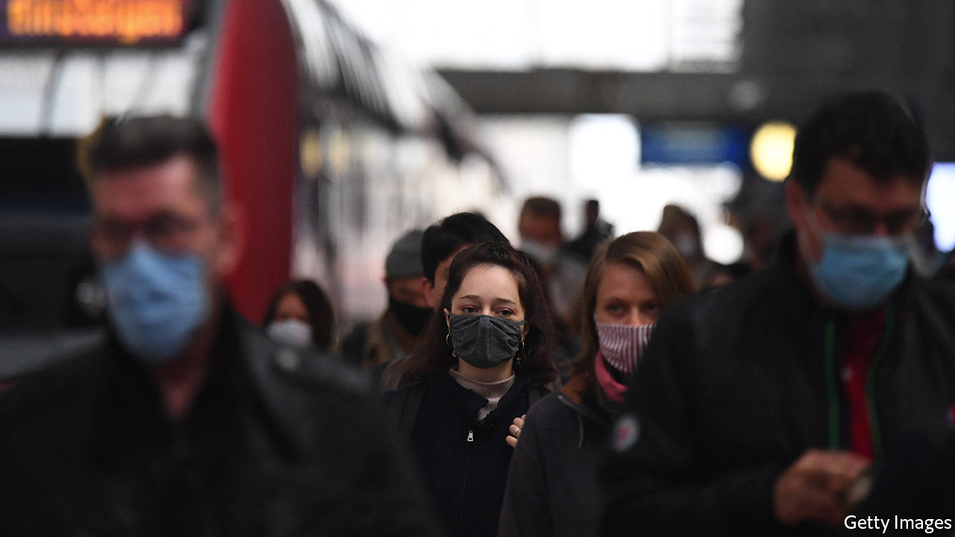

SCHOLARS ARE often greatly excited by “natural experiments”, events that end up separating two groups of people, allowing wonks to compare their subsequent behaviour. Much like the study of twins adopted into different households, the postwar division and eventual reunification of Germany could be seen as such an experiment. A report by the German Institute for Economic Research on working mothers, published ahead of the 30th anniversary of reunification on October 3rd, reveals the interplay between policy and attitudes that influences the decision to work.

When the German Democratic Republic (GDR) in the east united with the Federal Republic of Germany (FRG) in 1990, the mothers of young children led very different lives. Life expectancy and incomes were much lower in the east, but communism did at least seem to lead to greater gender equality in labour-market outcomes. Encouraged by state policies and party ideology, mothers were almost as likely to work as fathers, and most worked full-time. In the west, where state and church encouraged mums to stay at home, less than half were in paid employment, and most of those worked part-time.

Three decades on, how has the picture changed? Two things stand out. First, behaviour has changed drastically since unification: the share of eastern women with young children working full-time fell from over half in 1990 to just under a third in 2018 (see chart 1). More women across Germany are working part-time. Second, east-west differences still exist. The share of eastern mums in full-time work is more than double that in the west. As a result, whereas women in the east earn 7% less than men, the gap in the west is 22%. The report argues that policy and attitudes together explain these trends.

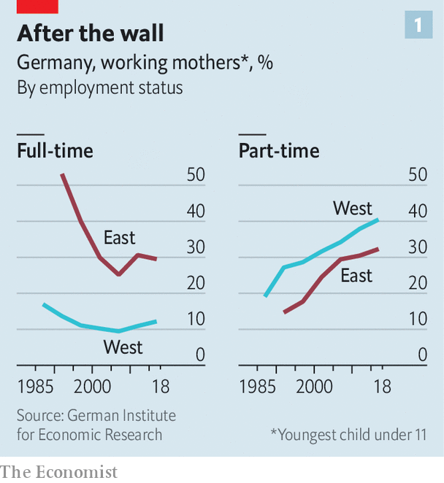

Policy seems to play a powerful role in explaining the collapse in full-time employment in the east. Despite some recent changes, the policies of unified Germany, like those of the FRG, still assume that women are wives and mothers first. Joint taxation of married couples, free co-insurance for spouses and tax breaks for “mini jobs”, or low-hours contracts, probably did little to encourage women in the west to up their hours, and put those in the east off full-time work.

Attitudes, meanwhile, may help explain part of the lasting hours gap between east and west: 30 years after unification, eastern women are still more likely to approve of full-time working mums (see chart 2). This chimes with earlier findings that east Germans are more likely to have an egalitarian view of the roles of the sexes.

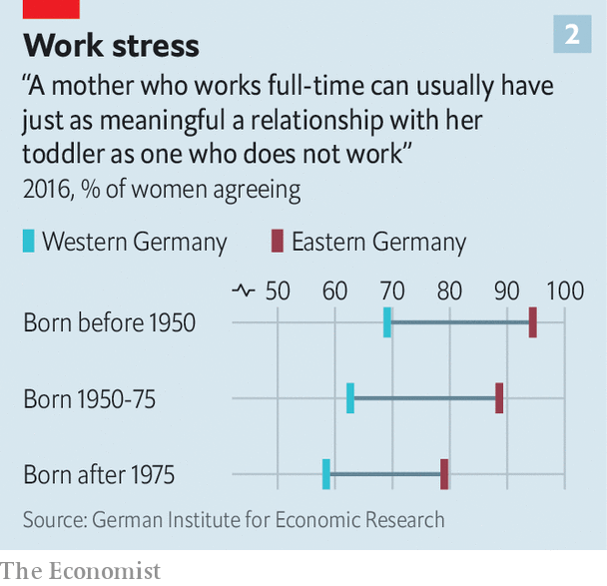

Attitudes have also changed over time, though. Strikingly, women born after 1975 in both the east and west are more likely to disapprove of mothers in full-time work than older ones, putting paid to the idea that younger women are keener on work. Perhaps women’s views are shaped by the policies they face. Katharina Wrohlich, one of the report’s authors, also suspects that the shift marks a rejection by younger women of both the dual-earner model of the GDR and the single-earner model of the FRG. “Instead the younger generation seems to be aspiring to the one-and-a-half jobs model,” she says—a preference that policy may need to respond to in turn.

The unification “experiment” hardly took place in laboratory conditions. Many women migrated from east to west. The regions differ in many other respects—incomes per head are lower in the east, for instance—that also affect the number of hours women work. But the episode still says something about the power of policy and the endurance of attitudes, long after walls are torn down. ■

This article was downloaded by calibre from <https://www.economist.com/finance-and-economics/2020/10/03/why-east-and-west-german-women-still-work-vastly-different-hours>

|  |  |  |  |
| --- | --- | --- | --- |
| Previous | Articles | Sections | Next |

|  |  |  |  |
| --- | --- | --- | --- |
| Previous | Articles | Sections | Next |

#### Sticking plaster

# Foreign capital helps ease India’s credit drought

As risk capital dries up at home, foreign institutional investors are proving influential

Oct 3rd 2020 |

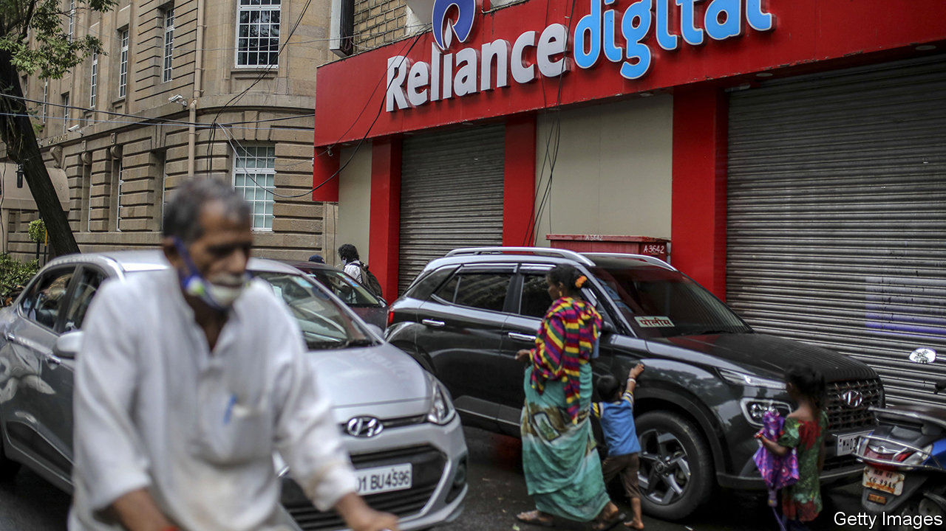

WITH THE economy battered by coronavirus, risk capital has dried up in India. In the past six months assets in credit-focused mutual funds, which play a crucial role as buyers forAA- to A-rated bonds, have declined from $13bn to $4bn. Lending by commercial banks, burdened by dud loans even before the pandemic, has withered. Thankfully, for some companies this domestic dry spell is being offset by a stream of foreign capital.

Reliance, a telecoms and energy giant, is a glitzy example of overseas equity investment made on the premise of growth. But a quieter wave of capital is seeking out different sorts of assets, serving to stabilise local companies while offering foreign investors high returns. As a result, many of the world’s largest insurers, private-equity (PE) firms and pension and sovereign-wealth funds have become influential.

Such inflows have been a boon for India’s financial institutions. Edelweiss, a big lender and asset manager, had already been suffering after the collapse of one non-bank, IL&FS, tightened domestic credit for the others. Covid-19 only made matters worse. But over the summer Edelweiss has struck a series of deals, selling, for instance, its corporate loans to Singaporean and American asset managers, and a majority stake in its wealth-management division to a Hong Kong-based PE firm. Its share price has doubled since May.

Banks have followed a roughly similar path. Several large private-sector lenders, including Axis, Kotak Mahindra and ICICI, along with HDFC, a non-bank mortgage lender, have raised capital from foreign investors. Sources of cash include: the Canada Pension Plan Investment Board; two Singaporean funds, Temasek and GIC; and funds associated with banks such as Morgan Stanley and Société Générale.

Foreign interest has also been piqued by operating assets that generate predictable annual dividends, rendering them similar to fixed-income investments. In July a 49% stake in GMR Airports, which controls airports in Delhi and Hyderabad, was sold to a French operator. In August Brookfield, a Canadian PE firm, along with GIC, agreed on a $3.4bn purchase of 135,000 mobile-phone towers from Reliance—India’s largest-ever PE deal. Along with Ontario’s municipal-pension fund and Actis, a PE firm, Brookfield is bidding for SoftBank’s 80% stake in a large solar-power company.

The list goes on, and more transactions are being negotiated. At a time when interest income has all but disappeared in the rich world, India’s credit squeeze lets foreign investors buy assets that could produce annual returns nearing double digits. For Indian firms the money provides desperately needed breathing room. It will not solve the systemic problems of Indian finance. Nor will it fuel investment-led growth; that would require foreigners to plough cash into new, productive projects instead of existing ones. But it does provide a welcome stop-gap at a difficult time. ■

This article was downloaded by calibre from <https://www.economist.com/finance-and-economics/2020/10/03/foreign-capital-helps-ease-indias-credit-drought>

|  |  |  |  |
| --- | --- | --- | --- |
| Previous | Articles | Sections | Next |

|  |  |  |  |
| --- | --- | --- | --- |
| Previous | Articles | Sections | Next |

#### Buttonwood

# Lessons from the endowment model

There is more to it than buying alternatives and being contrarian

Oct 3rd 2020 |

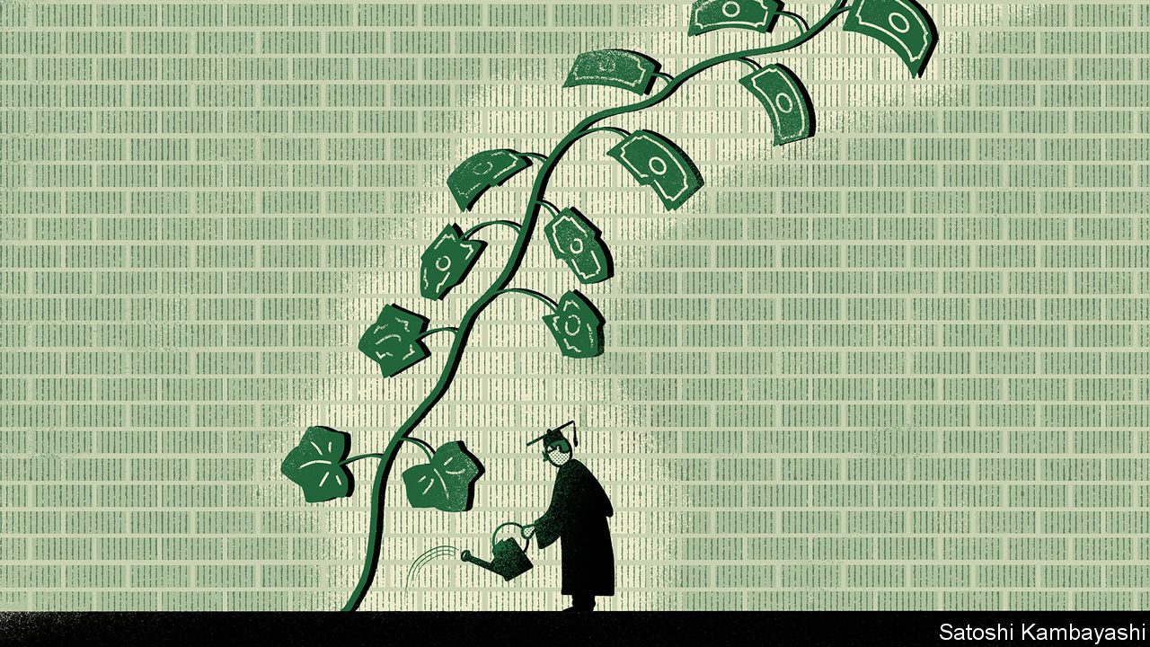

IN THE WEEKS following the stockmarket crash in October 1987, the investment committee of Yale University’s endowment fund convened two extraordinary meetings. Just after the crash its newish chief investment officer, David Swensen, had bought up stocks (which had become much cheaper) paid for by sales of bonds. Though in line with the fund’s agreed policy, this rebalancing appeared rash in the context of the market gloom—hence the meetings. One committee member said there would be “hell to pay” if Yale got it wrong. But the original decision stood. And it paid off handsomely.

A lot of investors say they have a long horizon. A new study by David Chambers, Elroy Dimson and Charikleia Kaffe, of Cambridge University’s Judge Business School, finds that America’s big endowment funds have lived up to the claim.* They have been pioneers in allocating to riskier assets, most notably to “alternatives” such as private equity. When others flee risk, they have embraced it. They are supposed to see the farthest, after all: their goal is to meet the needs of beneficiaries for generations.

Other investors seek to emulate the success of Yale and the other Ivy League endowments. Every other pension plan says it wants to plough more money into alternatives. Yet this is only one strut of the endowment model. It also requires smart people to design and implement a sound investment policy. And, as Mr Swensen’s experience in 1987 attests, it is vital that they are allowed to follow it without interference.

University endowments are among the world’s longest-lived managed funds. In the late Middle Ages, Britain’s Oxbridge colleges received gifts of farmland intended to provide lasting financial support. For centuries the focus was on preserving capital. But since the start of the 20th century the dozen wealthiest endowments in America have done a lot more than that. The Cambridge study finds that the elite posted an average annual real return of 5.6% between 1900 and 2017. Harvard’s endowment, the largest, is now worth a stonking $41.9bn.

A key to their success is asset allocation. Beginning in the 1930s (for the Ivy League) and the 1940s (for the rest), they shifted markedly from bonds into equities. By the 1950s over half of American endowment assets were in stocks, compared with around a tenth half a century earlier. This shift looks obvious in hindsight but was radical at the time. (An earlier paper by Messrs Chambers and Dimson shows that John Maynard Keynes, who managed the endowment of King’s College, Cambridge, was even further ahead of the game, allocating well over half of assets to equities in the 1920s-40s.) A second big shift in endowments’ asset allocation, starting in the 1980s, was from equities to alternatives. That change was led by the big three Ivy League schools: Harvard, Princeton and, of course, Yale.

Such boldness is aided by a long-term focus. If you have few immediate claims on your purse, you can afford to care less about the day-to-day price of your assets. Only their long-term value really matters. So endowments should be prepared to buy risky assets when they are cheap. And the Cambridge trio find this to be the case. In the aftermath of six major crises, beginning with the panic of 1907, endowments added significantly to their equity exposure. They also lightened their exposure in the run-up to the two big stockmarket busts of the 2000s.

The endowment approach might be reduced to two injunctions: hold alternatives and be contrarian. But there are other lessons. One is the importance of having the best people. It greatly helps your returns if you happen to have someone of Keynes’s calibre knocking about. Mr Swensen was persuaded by James Tobin, a Nobel-prize-winning Yale economist, to forgo a lucrative career on Wall Street. Canada’s big public-pension funds have been able to implement many of the tenets of the endowment model by paying good salaries. Selecting the right private-equity managers, for instance, requires expertise. And expertise costs.

The other big lesson is that, once an investment policy is agreed upon, the smart people have to be allowed to execute it. This comes under the dry heading of “governance”, but it is crucial. It is emotionally taxing to buy risky assets when everyone else is gloomy or to sell them when others are giddy. And, as Mr Swensen’s tale from 1987 shows, an institution with even the longest horizons can be tempted to think short-term.

*“Seventy-five years of investing for future generations”, Financial Analysts Journal (2020).

This article was downloaded by calibre from <https://www.economist.com/finance-and-economics/2020/10/03/lessons-from-the-endowment-model>

|  |  |  |  |
| --- | --- | --- | --- |
| Previous | Articles | Sections | Next |

|  |  |  |  |
| --- | --- | --- | --- |
| Previous | Articles | Sections | Next |

#### Free exchange

# Outright bans can sometimes be a good way to fight climate change

Studies show prospective bans on petrol-powered cars may be less inefficient than you think

Oct 3rd 2020 |

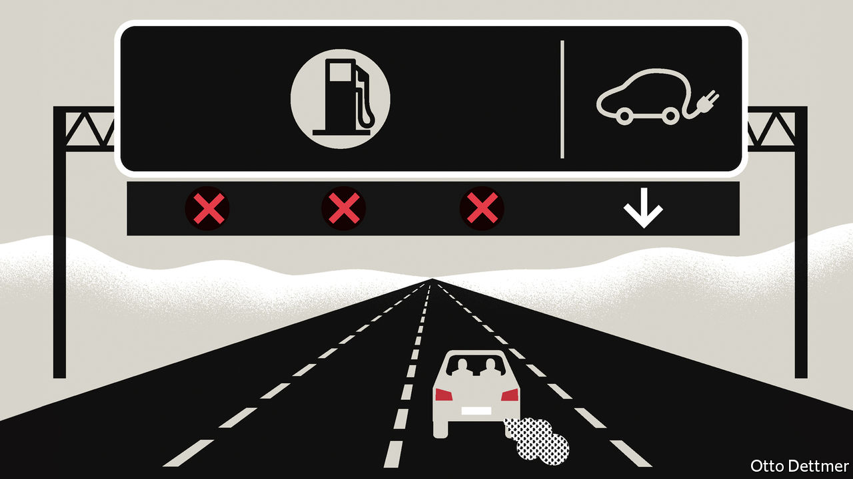

WHEN SET against the grave threat posed by climate change, the green policies favoured by economists can seem convoluted. Carbon prices, beloved of wonks, require governments to estimate the social cost of carbon emissions, a nebulous concept. Green subsidies put politicians in the position of picking promising innovators and praying that bets with taxpayers’ money pay off. Faced with these fiddly alternatives, you might ask, would simply banning the offending technologies be so bad? In fact a growing number of governments are bowing to this logic. More than a dozen countries say they will prohibit sales of petrol-fuelled cars by a certain date. On September 23rd Gavin Newsom, California’s governor, pledged to end sales of non-electric cars by 2035. Such bans may look like window-dressing, and that could yet in some instances prove to be the case. But in the right circumstances, they can be both effective and efficient at cutting carbon.

It is easy to see why politicians are attracted to prospective bans. They sound tough and neither impose immediate hardship on consumers, as a carbon price would, nor drain the treasury, as subsidies do. It is just as easy to see why economists might disapprove. Carbon prices and green subsidies aim to redress markets’ failure to take account of the global costs of climate change while preserving choice for consumers. Bans are a far blunter instrument and—in the absence of good substitutes for the banned technology—can lead to economic losses, potentially offsetting the benefits of reduced emissions. But a ban could also accomplish too little, if a government’s commitment does not seem credible. Manufacturers who suspect that future politicians may renege on a pledge will not bother to make the investments needed to comply. A mandate introduced by Californian regulators in 1990, specifying that zero-emission vehicles should account for 2% of annual sales by 1998, rising to 10% by 2003, was revised substantially in 1996 when it became clear that the cost and performance of batteries were not improving fast enough to meet the targets.

Technology has advanced impressively since then. Fully electric vehicles are not yet a perfect substitute for petrol-consuming alternatives. They are often more expensive, depreciate faster, and have a lower range of travel and more limited supporting infrastructure, like charging stations or properly equipped mechanics. But the number of available electric models is growing, and performance gaps are closing. A recent analysis by Stephen Holland of the University of North Carolina at Greensboro, Erin Mansur of Dartmouth College and Andrew Yates of the University of North Carolina at Chapel Hill concludes that in such conditions—when electric vehicles are good but not perfect substitutes for petrol-guzzlers—a ban on the production of petrol-fuelled cars is a much less inefficient way to reduce emissions than you might think.

If electric vehicles were in every way as satisfactory as alternatives, it would take little or no policy incentive to flip the market from petrol-powered cars to electric ones. If, on the other hand, electric cars were not a good substitute at all, the cost of pushing consumers towards battery-powered vehicles would not be worth the savings from reduced emissions. Somewhere in between those extremes, both electric and petrol-powered cars may continue to be produced in the absence of any emissions-reducing policy even though it would be preferable, given the costs of climate change, for the market to flip entirely from the old technology to the new. Ideally, the authors reckon, this inefficiency would be rectified by a carbon tax, which would induce a complete transition to electric vehicles. If a tax were politically impossible to implement, though, a production ban would achieve the same end only slightly less efficiently—at a loss of about 3% of the annual social cost of petrol-vehicle emissions, or about $19bn over 70 years.

In practice, the degree to which electric vehicles are good substitutes for petrol-fuelled ones changes over time, and depends on more than just the capabilities of the cars themselves. This too may be a point in favour of sensibly structured bans on dirty technologies. Drivers of petrol-powered cars know that when the low-fuel warning light comes on, a filling station is probably nearby. The lack of a widespread network of charging points may put some potential buyers off electric cars (although in practice they would probably mostly charge their cars at home or at work). But charging stations are subject to a chicken-and-egg problem: when there are few electric cars on the road there is little incentive to build new stations, which in turn depresses demand for the vehicles.

Without policy guidance, the market might grope its way towards balance. Shanjun Li and Lang Tong of Cornell University, Jianwei Xing, now of Peking University, and Yiyi Zhou of Stony Brook University estimate that a 10% rise in the availability of charging stations boosts sales of electric vehicles by 8%, and a 10% increase in the number of electric cars on the roads raises the construction of new charging points by 6%. A promise to ban sales of petrol-powered cars at a certain date stands to accelerate this process and reduce its cost by co-ordinating the expectations of firms and consumers. Both firms and households would be less likely to waste money on capital goods the lifespan of which may be unexpectedly shortened by the disappearance of complementary technologies. Other scale economies might be realised: carmakers may feel more comfortable shifting the bulk of their R&D spending towards electric vehicles, for instance, and mechanics might start preparing to service electric cars. Meanwhile, the investment in services linked to petrol-powered vehicles would shrink rapidly.

## Just what I needed

Conditions in markets vary, and politicians should think carefully before applying the lessons from cars more widely. An announced ban on fossil-fuel-powered aeroplanes, for example, would most likely backfire in the absence of alternative technologies. In some cases, though, a shove may work as well as a nudge. ■

This article was downloaded by calibre from <https://www.economist.com/finance-and-economics/2020/10/03/outright-bans-can-sometimes-be-a-good-way-to-fight-climate-change>

|  |  |  |  |
| --- | --- | --- | --- |
| Previous | Articles | Sections | Next |

|  |  |  |
| --- | --- | --- |
| Finance & economics | Sections | Books & arts |

Science & technology

Hybrids and evolution: Match and mix

.

|  |  |  |
| --- | --- | --- |
| Finance & economics | Sections | Books & arts |

|  |  |  |  |
| --- | --- | --- | --- |
|  | Articles | Sections | Next |

#### Match and mix

# How hybrids have upturned evolutionary theory

The origin of species is more complex than Darwin envisaged

Oct 3rd 2020 |



IN 1981 PETER and Rosemary Grant, a husband-and-wife team of evolutionary biologists, spotted something odd on Daphne Major. Every year for the previous decade they had travelled from Princeton University to this island in the Galápagos, to study its three endemic tanager species, part of a group known colloquially as “Darwin’s finches”. On this occasion their eyes were drawn to an unusual male that sported dark feathers and sang a unique song. Genetic analysis later identified him as a large cactus finch, probably blown in from Española, another part of the archipelago that is over 100km away.

Intrigued, the Grants followed the castaway as he explored his new home. They watched him mate with a local female medium ground finch. That produced five fit, healthy offspring. Those offspring were also surprisingly sexually selective. A single male excepted, they and their descendants mated only among themselves—and they have continued to do so ever since.

Despite this heavy inbreeding, the hybrids (two of which are pictured above) have been successful. They have carved out a niche in which they use their size and their deep beaks to exploit the large woody fruits of the Jamaican feverplant, which grows locally. They have, to all intents and purposes, become another species of Darwin finch, of which 13 were previously recognised. Though they do not yet have a Latinised scientific name, they are known to all as the “Big Bird” lineage.

## Heretical thinking

This story would once have been considered deeply implausible. Evolution’s orthodox narrative does not suggest that hybridisation is how new animal species emerge. But, as genetic testing has proliferated, biologists have been confronted with an unexpected fact. Hybrids are not an evolutionary bug. They are a feature.

That knowledge is changing the way people think about evolution. The neat family trees envisaged by Charles Darwin in one of his early notebooks (see picture below) are turning into webs, and the primacy of mutation in generating the variation which natural selection then winnows is being challenged. The influx of genes accompanying hybridisation creates such variation too—and the harder people look, the more important that seems to get. Hybridisation also offers shortcuts on the long march to speciation that do not depend on natural selection at all. As the example of the Big Bird lineage shows, instead of taking millennia to emerge, a new species can appear almost overnight.

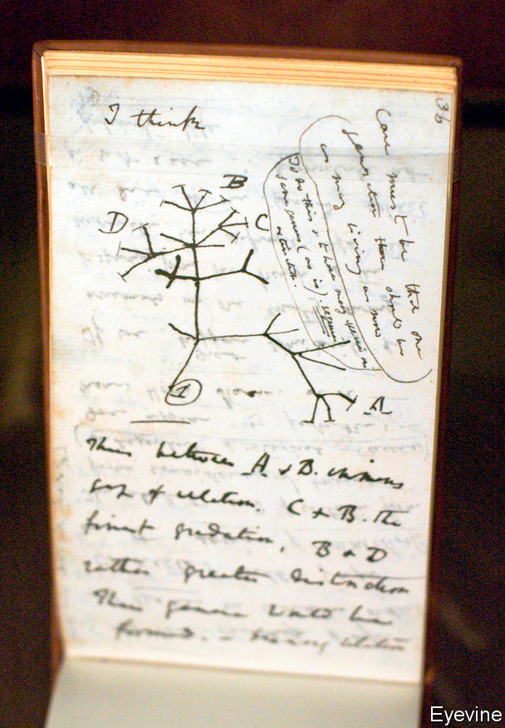

As Darwin saw it

In truth, all this had already been recognised for simple organisms like bacteria. These exchange genes promiscuously between both more and less related individuals. But bacteria were unknown when Darwin came up with natural selection, and, ever since then, the subject of speciation has been dominated by examples drawn from animals and plants. To recognise that what is true for bacteria is also true for these multicellular organisms has profound implications, not least for how human beings understand their own origins. It seems appropriate, then, that the birds whose diversity helped inspire Darwin still have evolutionary tales to tell.

The conventional view of evolution is that mutations happen at random. Maladaptive ones are then eliminated by competitive pressure while adaptive ones proliferate. The result, over long periods of time and assisted by populations sometimes being split up by external circumstances, is change which eventually crystallises into new and separate species.

That process does leave the door open to hybrids. The genomes of closely related species may remain sufficiently similar to produce viable offspring. But these genes often fit together less well than those of parents from the same species. As a consequence, even viable hybrids are frequently infertile (think mules) and are also at higher risk of developmental and other types of illnesses. In fact, infertility in male hybrids is so common that it has a name—Haldane’s rule. This sort of thing was enough to persuade most of Darwin’s 20th-century disciples that the need to avoid hybridisation was actually a driving force which caused natural selection to erect reproductive barriers between incipient species, and thus encouraged speciation.

There is, though, another way of looking at hybridisation. Mixing the traits of two parent species might actually leave their hybrid offspring better off. This is called hybrid vigour, or heterosis. The interplay of two species’ genes can even produce traits displayed by neither parent. This is known as transgressive segregation and the resulting hybrid may be surprisingly well adapted to a completely new niche, as was the case with the Big Birds.

Both the maleficent and beneficent effects of hybridisation are real. The question is, which wins out more often in practice? In plants, it is frequently the beneficent. This is a consequence of plants’ unusually malleable genetics. The nuclear genomes of complex organisms (animals, plants, fungi and single-celled organisms such as amoebae) are divided into bundles of DNA called chromosomes. Such organisms are generally either haploid or diploid, meaning that each cell nucleus contains either one or two copies of every chromosome. Human beings are diploid. They have 23 chromosomal pairs, for a total of 46 individual chromosomes. But there are exceptions. Plants, for instance, are frequently polyploid—meaning that each nucleus contains copies in greater multiples than two. To take one example, Californian coastal redwoods have six copies. Since redwood cell nuclei have 11 distinct types of chromosome, they host a total of 66 chromosomes altogether.

Sometimes, polyploidy is a result of an organism’s genome spontaneously doubling. Often, though, it is a consequence of hybridisation, with the chromosomes of both parents ending up in a single nucleus. However it arises, polyploidy provides spare copies of genes for natural selection to work on while other versions of them continue with their original function. And if it is also the result of hybridisation, it brings the additional possibilities of heterosis and transgressive segregation.

On top of this, by changing an organism’s chromosome count polyploidy has another pertinent effect. It creates an instant barrier to breeding with either parent species. That gives a new, incipient species a chance to establish itself without being reabsorbed into one of the parental populations. The results can be spectacular. Recent evidence suggests, for example, that hybridisation between two plant species in the distant past, followed by a simple doubling of the number of chromosomes in their offspring, may be responsible for much of the extraordinary diversity in flowering plants that is seen today.

Plants seem to be easy beneficiaries of hybridisation. For many animals, however—and for mammals in particular—extra chromosomes serve not to enhance things, but to disrupt them. Why, is not completely clear. Cell division in animals seems more easily confounded by superfluous chromosomes than it is in plants, so this may be a factor. Plants also have simpler cells, which are more able to accommodate extra chromosomes. Whatever the details, animal hybrids appear to feel the effects of genetic incompatibility far more acutely than do plants, and are therefore less able to benefit from heterosis. Evolutionary biologists therefore assumed for a long time that hybridisation played a negligible role in animal evolution—and there was little evidence to suggest otherwise.

Advances in DNA sequencing have changed that by letting people look under the bonnet of evolutionary history. This has uncovered a steady trickle of animals breathed into life entirely by hybrid speciation. They include some familiar names. The European bison, for instance, is the result of hybridisation, over 120,000 years ago, between two now extinct species—the ice-age steppe bison and the auroch. The latter were the wild antecedents of modern domestic cattle, and survived in Jaktorow Forest, in Poland, until 1627.

Something similar is true of the Atlantic Clymene dolphin. Genetic analysis has revealed that this cetacean, which roams the briny between west Africa, Brazil and the Gulf of Mexico, owes its existence to a hybridisation that happened between two globe-trotting others, the striped dolphin and the spinner dolphin.

At least one hybrid animal, moreover, traces its ancestry to three species. Genetic analysis shows that Artibeus schwartzi, a Caribbean fruit bat, is a result of hybridisation, within the past 30,000 years, of the Jamaican fruit bat (Artibeus jamaicensis), the South American flat-faced fruit-eating bat (Artibeus planirostris) and a third, as yet unidentified animal, which researchers speculate may now be extinct.

## A different kettle of fish

It also appears that, as in the case of flowering plants, hybridisation can fuel explosive radiations of novel animals. The best-known example is the case of the cichlids of Africa’s Great Lakes—particularly Lake Victoria, Lake Tanganyika and Lake Malawi. Great Lake cichlids are a group of thousands of closely related fish, famous for their panoply of shapes, sizes and colours (see picture). Each is adapted to a different depth and ecological niche.

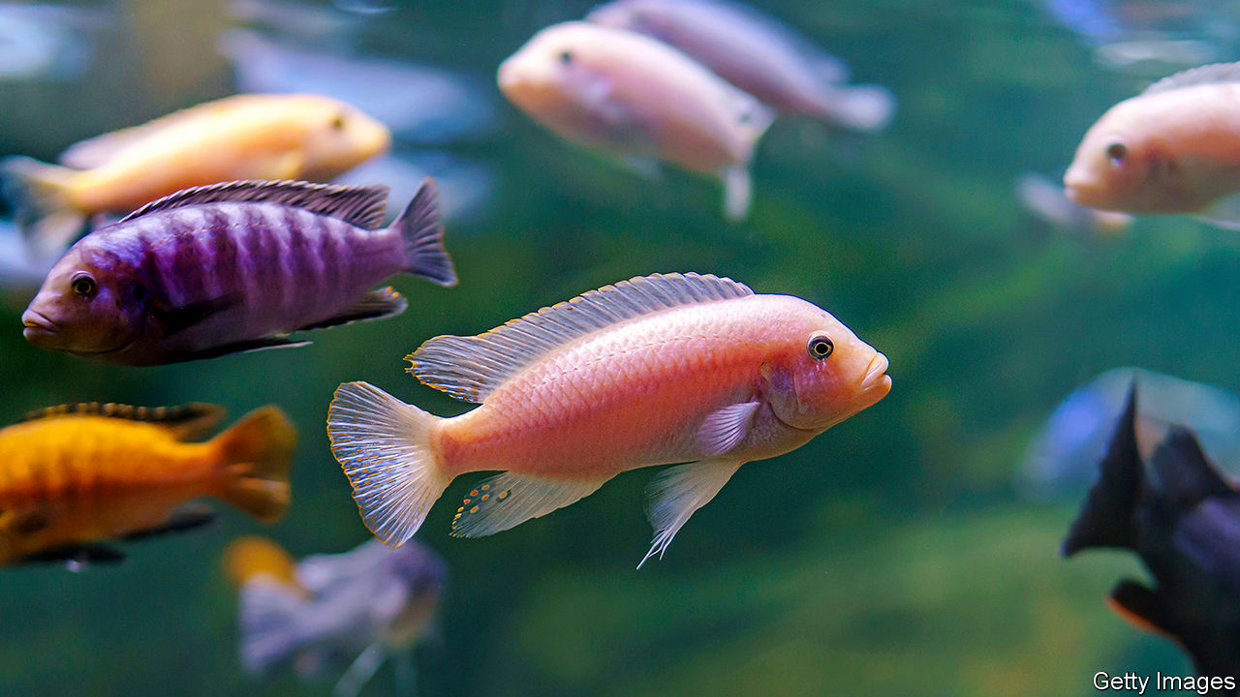

Gone fishing

Cichlids’ evolutionary history has long puzzled biologists. Lake Victoria, in particular, comes and goes with the climate. Its current instantiation is less than 15,000 years old. In evolutionary terms this is the blink of an eye, but in that time the lake’s cichlids have diversified into more than 500 species.

The reason is hybridisation. Using genetic analysis to place Lake Victoria’s cichlids within the broader cichlid family tree, researchers have discovered that they descend from a tryst between two distinct parental lineages, one that swam in the Congo and the other in the Nile.

The value of being such a genetic mosaic is apparent from the history of one of the best-studied cichlid genes, which encodes a protein called long-wave-sensitive opsin that is found in the retina of the eye. This protein determines the eye’s sensitivity to red light. That matters because red-light levels decline steeply in deeper water. Consequently, fish which live at different depths need eyes that are tuned differently from one another.

The cichlid lineage from the Congo had eyes which were optimised for clear, shallow water. Nile-lineage vision was more attuned to the deep and murky. Hybrids were able to chop and change these genetic variants to produce a range of sensitivities to light. This let them colonise the full depth of the water column in Lake Victoria as it developed. The new lake, for its part, offered the cichlids a host of empty ecological niches to fill. The result was a sudden and explosive process dubbed “combinatorial speciation”.

Elsewhere in the natural world, combinatorial speciation seems to have contributed to the striking diversity of Sporophila, a genus of 41 Neotropical songbirds, and of the munias, mannikins and silverbills of the genus Lonchura, a group of 31 estrildid finches that ranges across Africa and South-East Asia. Nor is it just in vertebrates that this phenomenon rears its head. Heliconius, a genus of 39 flamboyant New World butterflies, also owes its eye-catching diversity to combinatorial speciation.

## Raining cats, dogs and bears

These findings muddy Darwin’s concept of speciation as a slow and gradual process. Biologists now know that in the right circumstances, and with the help of hybridisation, new species can emerge and consolidate themselves in a mere handful of generations. That is an important amendment to evolutionary theory.

It is nevertheless true that, for animals, hybrid speciation in its full form remains rare. It requires an unlikely congruence of factors to keep a new hybrid population reproductively isolated from both parental species. The survival of the Galápagos Big Bird lineage, for example, involved physical isolation from one and strong sexual selection against the other.

More commonly, an incipient hybrid population is reabsorbed by one or both parental species before it can properly establish itself. The result is a percolation of genes from one species to another, rather than a full hybrid. This is called introgressive hybridisation—or, simply, introgression. DNA analysis of a long list of closely related animals shows that this version of hybridisation is far more common than the full form. It may even be ubiquitous.

The North American grey wolf, for example, owes its gene for melanism—the deep black fur displayed by some wolves—to introgression from domesticated dogs brought 14,000 years ago from Asia by America’s first human settlers. In wolves that inhabit forests this gene has undergone strong positive selection, suggesting it is adaptive. The most obvious explanation is that melanism provides better camouflage in the stygian depths of North America’s woodlands. Alternatively, female wolves may simply prefer their males tall, dark and handsome.

Panthera—the genus to which most big cats belong—is yet more impressive in the scope of its introgressive entanglement. It has five members: lions, tigers, leopards, snow leopards and jaguars. These have long been known to interbreed successfully in captivity, yielding crosses called ligers (lion x tiger), jaglions (jaguar x lion) and so on. But recent analysis shows that this has also happened in the wild. Researchers have identified at least six past introgressive episodes in the genus, with every member involved in at least one of them.

The most promiscuous of the five appears to be the lion. Gene variants have percolated between lions and tigers, lions and snow leopards, and lions and jaguars. There is also evidence that at least some of this gene flow has been adaptive. Three lion genes incorporated into jaguar genomes are known to have been strongly selected for. Two of these are involved in vision—specifically, they help guide the development of the optic nerve.

Genetic analysis also reveals a long history of hybridisation between polar bears and grizzlies, the largest of their brown bear cousins. It is not yet clear whether this has had adaptive value—but it may soon have a chance to prove itself. As climate change warms the polar bear’s Arctic home, the species may have to adjust rapidly. A splash of grizzly, a group used to more temperate climes, might help that happen.

The best-studied case of introgression in animals is, though, closer to home than wolves, big cats and bears. It is looking back at you from the mirror. The most up-to-date evidence suggests that Homo sapiens arose more than 315,000 years ago from gene flow between a series of interlinked population groups spread across Africa. Whether these populations were different enough to be considered distinct species is still debated. In the grasslands of the African Pleistocene, however, these ancestral groups were not alone. Their world was interspersed with a menagerie of other hominins. And interspecies mating seems to have been rife.

## My family and other hominins

Several members of this human menagerie appear to have descended from Homo heidelbergensis, a species that spread through eastern and southern Africa around 700,000 years ago before crossing the Middle East into Europe and Asia. This species—a possible ancestor of the progenitor groups of Homo sapiens—also gave rise to at least two others, the Neanderthals (Homo neanderthalensis) and the Denisovans (Homo denisova). The former survived in Europe until 28,000 years ago, while the latter, an Asiatic group, lasted until roughly 50,000 years ago.

Other hominin species around at the time emerged directly from Homo erectus, a more primitive creature that was also the ancestor of Homo heidelbergensis and which, a million years beforehand, had blazed a similar transcontinental expansionary path to that of heidelbergensis. The local descendants of erectus were largely displaced by heidelbergensis when it arrived. But some holdouts survived in corners of the Old World that heidelbergensis never reached. These included the islands of Flores in Indonesia and Luzon in the Philippines. It was here that diminutive Homo floresiensis and Homo luzonensis—the island “hobbits”—lasted, like the Denisovans, until 50,000 years ago. There were probably isolated descendants of even older cousins too. At least one is known, Homo naledi, which predated the emergence of Homo erectus and still roamed southern Africa around 230,000 years ago.

This grand hominin circus ultimately came to an abrupt end. The record in Africa is opaque. But in Europe, Asia and Oceania it is clear that the arrival of modern humans coincided with a great vanishing of local hominins. Whether through disease, competition for scarce resources or perhaps even genocide, a few thousand years of contact with Homo sapiens was enough to snuff out every other hominin species.



Ghosts from a distant past

Even a few millennia, though, proved enough for Homo sapiens to get to know its cousins intimately. The record of these romantic entanglements remains in the DNA of almost everyone alive today. In 2010 a team led by Svante Pääbo of the Max Planck Institute’s campus in Leipzig published the first draft sequence of the Neanderthal genome. This led to the discovery that stretches of Neanderthal DNA constitute 1-4% of the modern human genome in all populations outside sub-Saharan Africa. That is consistent with a string of hybridising liaisons in Europe, the Middle East and Central Asia from around 65,000 years ago.

Neanderthal inheritance helped Homo sapiens adapt to the demands of the environments of these unfamiliar places. There seems to have been strong selection, for example, in favour of Neanderthal genes related to skin and hair growth. These include bnc 2, a gene linked to skin pigment and freckling that is still present in two-thirds of Europeans. There also appears to have been selection for Neanderthal-derived genes that deal with pathogens. Some govern the immune system’s ability to detect bacterial infections. Others encode proteins which interact with viruses.

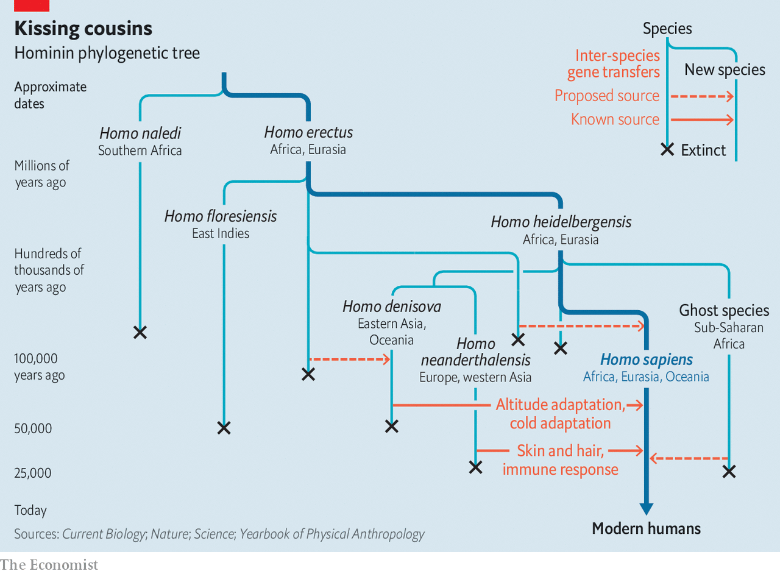

The Denisovans, and their contribution to Homo sapiens, were another of Dr Pääbo’s discoveries. In 2009 one of his team sequenced DNA from a fossil finger bone excavated from Denisova cave in the Altai Mountains of Siberia. This bone turned out to belong to a previously unknown species that was then named after the cave it was found in. Physical specimens of this species remain rare. Examination of living people, however, reveals that stretches of Denisovan DNA make up 3-6% of the genome of contemporary Papuans, Aboriginal Australians and Melanesians. Many Chinese and Japanese also carry Denisovan DNA, albeit at lower rates.

As with Neanderthals, this inheritance has brought advantages. The Denisovan version of a gene called epas1 modulates production of red blood cells, which carry oxygen. This helps modern Tibetans to survive at high altitudes. Denisovan tbx 15 and wars 2 similarly help Inuit survive the harsh cold of the Arctic by regulating the amount of metabolic heat they produce.

## We contain multitudes

That the Denisovans could lurk in modern human DNA yet leave so little fossil trace has caused geneticists to wonder what other ghosts they might find. The genomes of sub-Saharan Africans, in particular, reveal evidence of at least one further entanglement. In 2012 a genomic analysis of members of the Baka, Hadza and Sandawe, three groups of people of ancient lineage, suggested an archaic introgression. In 2016 a deeper analysis focused on the Baka pinpointed this to within the past 30,000 years. This February, a study of members of two other groups, the Yoruba and Mende, confirmed that between 2% and 19% of their genomes can be traced to an unidentified archaic species. Whether this is the same as the one which has contributed to the Baka, Hadza and Sandawe is unclear, but it appears to have diverged from the line leading directly to Homo sapiens not long before the Neanderthals and Denisovans—an African Neanderthal, if you will.

The same genetic tools have revealed deeper ghosts, too. Denisovans show signs of hybridisation with a “superarchaic” lineage—perhaps Homo erectus itself. This makes up 1% of the species’ genome. About 15% of this superarchaic inheritance has, in turn, been passed on to modern humans. There is even evidence of a minute genetic contribution to African populations by a similarly superarchaic relative.

To be human, then, is to be a multispecies mongrel. As the example of the big cats in particular shows, though, Homo sapiens is not, in this, an exception. Hybridisation, once seen as a spear-carrier in evolution’s grand theatre, is rapidly becoming a star of the show. Meanwhile, Darwin’s idea of a simple, universal family tree is relegated to the wings.

In its place, some experts now prefer the idea of a tangled bush of interconnected branches. But this, too, is an imperfect comparison. A more fitting analogy is a frayed rope. Species are braided from individual strands. Where evolution proceeds in an orthodox Darwinian manner, braids unravel, strands split and new species result. But the rope does not fray neatly. Filaments of introgression criss-cross from braid to braid and, occasionally, two tangle to form a new braid altogether. This is a more complex conception of evolutionary history, but also a richer one. Few things in life are simple—why should life itself be? ■

This article was downloaded by calibre from <https://www.economist.com/science-and-technology/2020/10/03/how-hybrids-have-upturned-evolutionary-theory>

|  |  |  |  |
| --- | --- | --- | --- |
|  | Articles | Sections | Next |

|  |  |  |
| --- | --- | --- |
| Science & ... | Sections | Economic & ... |

Books & arts

Mexico’s chroniclers: The other half of history

.

The CIA and the cold war: Original sins

.

Geography and imagination: Water all around

.

Japanese fiction: I don’t belong here

.

Johnson: Justice and just slips

.

|  |  |  |
| --- | --- | --- |
| Science & ... | Sections | Economic & ... |

|  |  |  |  |
| --- | --- | --- | --- |
|  | Articles | Sections | Next |

#### Latin American letters

# Mexico’s chroniclers tell the other half of history

A classic literary genre is gradually receiving the attention it deserves

Oct 3rd 2020 | TONALÁ

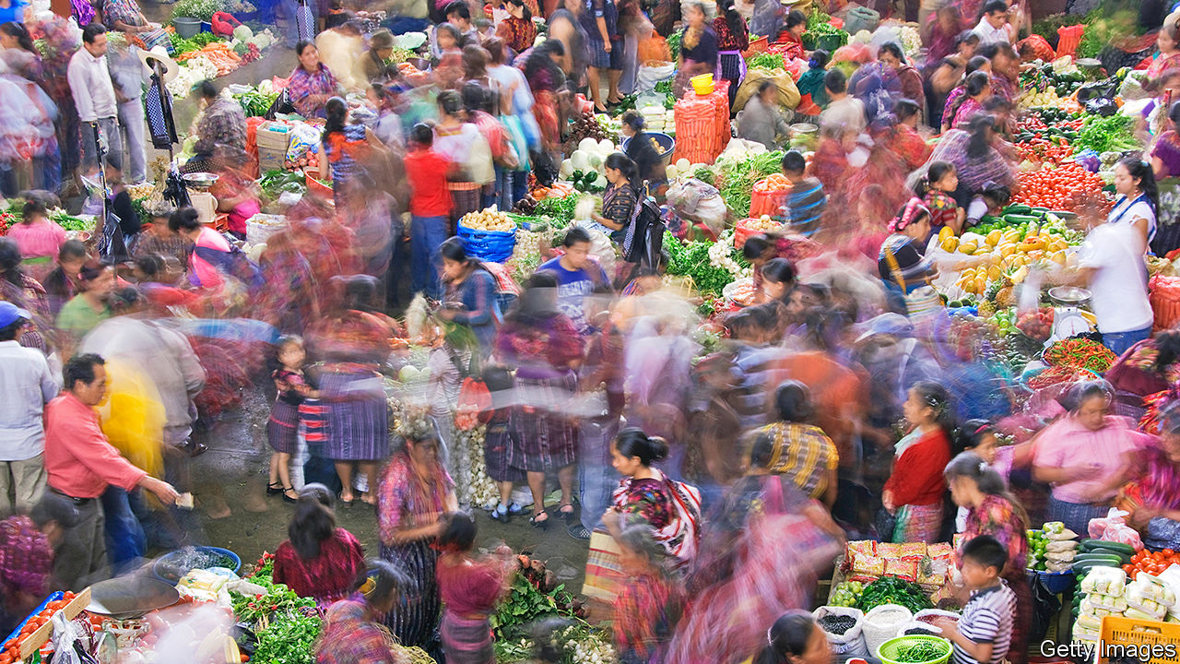

BEFORE REVOLUTION swept Mexico in 1910, the most tumultuous episode in the history of San José de Gracia, a tiny town in the state of Michoacán, was neither a battle nor a reform. It was a rumour that the world would come to an end on December 31st 1900. Decades later Luis González y González, a native son of San José, described the ensuing pandemonium:

The church was filled with despairing people. No one wanted to be caught unshriven, but the priest could not hear everyone’s confession at once. He announced that he would begin with mothers who had babes in arms. There was uproar in the church when it was discovered that one of the women had been holding a pillow in her arms instead of a child.

“Pueblo en Vilo” (“Town on Edge”), the biography of San José from which this tale comes, is one of Mexico’s greatest books. González, a historian by training, turned the town’s recollections and archival documents into a story. “I have the feeling of being the official chronicler of the people, the compiler and constructor of collective memory,” he said. Cities and villages across Mexico have since appointed writers to be exactly that: hundreds of municipal governments now have an official cronista. Their job is to record noteworthy happenings on their patch, in the way they see fit.

Isn’t that, sceptics might ask, the job of historians and journalists? A good cronista will indeed stray onto their turf, and that of sociologists and poets. That flexibility is the point. Juan Villoro, a writer of chronicles, calls the form “the platypus of prose”: a mix of elements, but undeniably its own creature. The best examples weave a narrative, defer to the truth, appeal to emotions and—above all—evoke an intense sense of place and time.

In Latin America the chronicle predates many of the genres with which it can overlap. The first literature of New Spain was the victory cry of the conquistador. Observers such as Bernal Díaz del Castillo sent accounts of indigenous societies to the king even as conquest disfigured them. Nineteenth-century politicians such as Guillermo Prieto energetically chronicled daily life. Modern Latin American literature charmed the world by building on this tradition, argues J.M. Servin in the preface to his latest chronicle of Mexico City.

In some ways, the cronista’s role is a distinguished one. Mexicans frequently hurry politicians out of office after a single term, but many cronistas retain their positions until the day they die. In 20th-century Mexico City, when (unlike now) the mayor selected a single cronista for the whole capital, the street he lived on would be renamed after him. So influential was Carlos Monsiváis, the city’s chronicler in the 1970s, that when a notable Mexican died, the director of the Institute of Fine Arts would call him to determine whether the deceased merited a public funeral inside the exalted Palacio de Bellas Artes.

Yet the chronicles themselves had a narrow audience. “For most Mexican families, buying a book is an impossible luxury. Rich Mexicans do not read either,” Elena Poniatowska, an author of chronicles as well as essays and novels, has lamented. Often these municipal microhistorians are not only unread but unknown among locals, never mind outsiders. Many are wizened sages. Others are friends appointed by the mayor and “don’t know which year their town was founded”, sniffs Sofía Mireles Gavito, a cronista in Tonalá, on the scorching southern coast of Chiapas.

## Chronicle of a country untold

However big their readership, each faces the daunting task of deciding what to chronicle. In many small towns basic history books with dates and names remain unwritten, giving the cronistas a blank slate. In her most recent volume Ms Mireles Gavito elected to focus on the “spiritual conquest” of coastal Chiapas in the 16th century. María de Jesús Real García, cronista for the Benito Juárez municipality in Mexico City, is writing about Mexican radio ahead of its centenary in 2021. Some choose to penetrate society’s upper crust, as in Artemio de Valle Arizpe’s entertaining account of “La Güera Rodríguez”, a redheaded socialite who brought powerful men to their knees at the turn of the 19th century. By contrast, Héctor Castillo Berthier has shown how the chronicle can ennoble the voiceless. He trudged through Mexico City’s rubbish dumps to speak to underlings of Rafael Gutiérrez Moreno, the powerful and monstrous boss of a trash-men’s union in the 1980s.

“When” is as important a choice for the chronicler as “who”. Monsiváis described his work as “a critique of the present, with one foot in the past”. But many writers plunge headfirst into nostalgia. In 2016 the National Congress of Cronistas released “Cultural Patrimony at Risk”, a tour of threats to the country’s cultural riches—buildings in Durango, indigenous courtship rituals in Chiapas and musical instruments in Nuevo León. On a pleasant afternoon stroll in El Plateado de Joaquín Amaro, a hilly municipality in Zacatecas, Eliezer Márquez Vela, the local cronista, points wistfully to a large stone basin. Women once gathered here to do laundry, he says. But when washing machines arrived, a key network for gossip faded away.

Often, though, the allure of the cronista’s work lies in overlooked details of the present. One such jewel is a monologue from a graffiti artist in Tuxtla Gutiérrez, the capital of Chiapas, which appears in a chronicle by José Luis Castro Aguilar. The artist spent his life being chased by local police, until the government asked him to spray legally. Teresa Zerón-Medina Laris’s chronicle of a clandestine boxing bout in Mexico City “without gloves, bandages, judges, rules, or rounds” is another. “Miss Narco” by Javier Valdez describes the lives of 23 Sinaloan women who were dragged into organised crime. One of them, Yoselín, struggles to break away from narco boyfriends with gold chains and bottomless wallets when her high-school sweetheart returns from America. (Also a courageous journalist, Valdez was murdered in 2017.)

For outsiders, the chronicle’s greatest joy may be an ingredient used sparingly in Mexican literature: humour. The form is often “a refuge for witty ideas that wouldn’t seem serious enough in a drama or novel”, says Mr Villoro. Take the deadpan opening of a recent newspaper column by Armando Fuentes Aguirre, the cronista of Saltillo, headlined “History of a crash”: “Sabinas Hidalgo, Nuevo León, prides itself on being the only place in the world where a horse and a plane have collided.” After rhapsodising for five pages over the local culinary delights whipped up at a street market in the capital, Salvador Novo ends his chronicle in a huff: “And, of course, there are hot dogs. But I will not stain these pages other than to note their inconceivable existence.”

Cronistas find satisfaction in telling the other half of history, the part missed by sweeping national narratives of great men and seismic events. More than that, their craft is at last enjoying global recognition. The Nobel prize for literature, usually reserved for novelists and poets, has recently been won by two exponents of the chronicle, Svetlana Alexievich of Belarus and Turkey’s Orhan Pamuk. In 2013 Ms Poniatowska’s oeuvre earned her the Cervantes prize, the Spanish-speaking world’s highest literary honour. The spotlight may fade. But if anyone knows how to savour a moment, it is cronistas. ■

This article was downloaded by calibre from <https://www.economist.com/books-and-arts/2020/10/03/mexicos-chroniclers-tell-the-other-half-of-history>

|  |  |  |  |
| --- | --- | --- | --- |
|  | Articles | Sections | Next |

|  |  |  |  |
| --- | --- | --- | --- |
| Previous | Articles | Sections | Next |

#### Original sins

# An indictment of the CIA, through the lives of four spies

But might they not have helped win the cold war?

Oct 3rd 2020 |

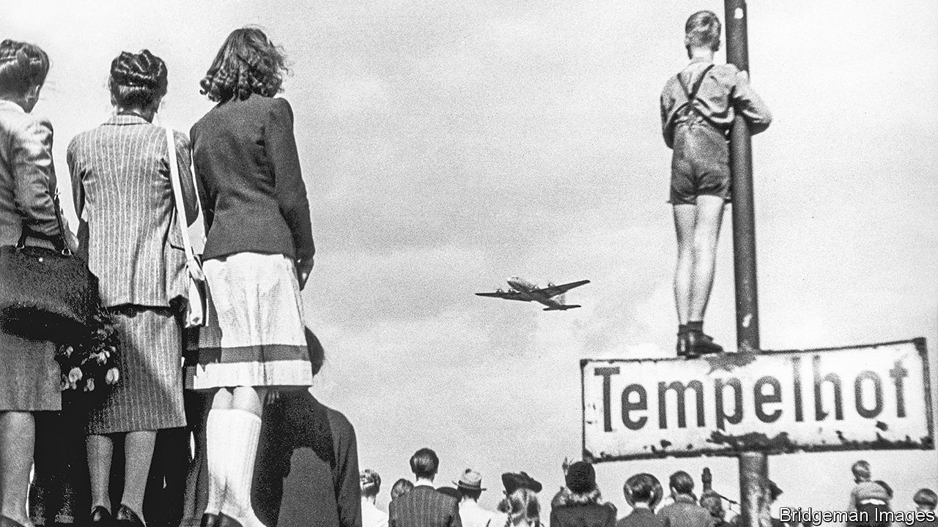

The Quiet Americans. By Scott Anderson.Doubleday; 576 pages; $30. To be published in Britain by Picador in February 2021; £20.

THIS INTRIGUING book is an indictment. From its first page it argues that the CIA lost its way, in all senses, in the first decade of the cold war. Its witnesses are four courageous and initially idealistic patriots. Frank Wisner oversaw some of the earliest efforts to “roll back” communism in Europe. Michael Burke was a daredevil figure in the same game. Edward Lansdale (pictured) was an éminence grise in the Far East. Peter Sichel, a German-born Jewish wine-merchant and Wunderkind—and the only one of the four still alive—held his nose as he co-opted former Nazis into the agency, an initiative cited as one of its original sins.

Scott Anderson, a veteran foreign correspondent and novelist, weaves a beguiling if sometimes puzzling narrative from their criss-crossing careers. He takes in the Philippines, Vietnam and the CIA’s early venality in Central America. He traipses along the Iron Curtain to unveil a string of early disasters in eastern Europe. His verdict is damning, yet also imprecise.

All four agents had brave, brilliant starts in the Office of Strategic Services, the CIA’s forerunner, during the second world war, and were driven largely by principle. The author shows how they were all laid low, in moral and career terms, by the wrong-headedness of their political overlords, which they only occasionally resisted. The villains include J. Edgar Hoover, the FBI boss who, jealous of the CIA, stoked paranoia among allies as well as enemies, and Senator Joseph McCarthy, who ruined hundreds of lives in his quest for reds under the bed; but also, less predictably, the Dulles brothers, John Foster as secretary of state and Allen as head of the CIA. Presidents Harry Truman and Dwight Eisenhower are castigated. Ronald Reagan, Richard Nixon and even Barack Obama take a few knocks.

Of the four spies, Lansdale and Burke ultimately left the CIA in despair, “stricken by the moral compromises they had been asked to make”. Wisner committed suicide. The agents whom he and Burke infiltrated into Romania, Poland, the Baltic states and East Germany all disappeared; most were probably killed. Worse, in Mr Anderson’s view, were the results of two early successes, the coups against democracy in Iran and Guatemala, which tarnished the CIA for ever in the eyes of many in the Middle East and Latin America.

Telling this tale of woe through the four men is a clever device, and Mr Anderson is a fine narrator. Each of the quartet had remarkable early achievements. Lansdale, a former adman in California with a gift for empathy, almost single-handedly steered Ramon Magsaysay into the presidency of the Philippines in 1953 (he died in an air crash). Lansdale then became the most trusted adviser to Vietnam’s president, Ngo Dinh Diem, who was ousted and killed in 1963. Many of the CIA’s failures stemmed from familiar shortcomings. “We all have this tendency to look for information that confirms our beliefs and to ignore what conflicts with them,” explains Mr Sichel. “It’s very hard to give somebody information he doesn’t want to hear, and the more senior they are, the worse it is.”

Early in his own career Mr Anderson witnessed the murderous brutality of a right-wing regime in El Salvador that was backed by the CIA. “The very phrase ‘anti-communist’”, he writes, “took on a squalid quality when I considered the crimes done in its name.” He duly dismisses out of hand the cold war strategy of Truman, Eisenhower and their successors—based on the threat of “massive retaliation”, including nuclear war, if the Soviets overstepped the mark, while the CIA undertook a constant lower-level pushback, including covert operations. He lambasts George Kennan, a fabled diplomat, for encouraging the CIA’s policy of containment, which was “designed to confront the Russians with unalterable counterforce”. This “anti-communist refrain”, he complains, lasted until communism collapsed. Oddly, he ignores the possibility that this outcome was precipitated at least partly by relentless outside pressure from the CIA and others.

More questionable still is his assertion that America’s over-zealous leaders and submissive spooks “undercut the moderate faction within the Kremlin and bolstered the militants”, and thus, especially after Stalin’s death in 1953, “missed a golden opportunity to dramatically alter the course of the cold war”. He even implicates the CIA in the suppression of the Hungarian revolt of 1956: by egging it on but backing away, Mr Anderson charges, the agency encouraged Moscow to crack down. Hungarian rebels may have picked up mixed signals from the Americans. But it is surely fanciful to suggest that Nikita Khrushchev was poised to “let Hungary go”, before the CIA’s machinations changed his mind.

Espionage, intelligence-gathering and covert operations are by definition dodgy trades, whatever the motives of their practitioners. Mr Anderson vigorously argues that his quartet epitomised America’s slide into moral ambiguity and strategic muddle. Intelligence officers like them “provided the fuel for the nuclear arms race” and “drove nations into the orbits of East or West”. Spies on both sides were “the cold war’s first frontline soldiers”.

But then Mr Anderson switches his animus back against the presidents and policymakers. “Virtually every major covert mission undertaken by the CIA from its inception until today”, he says, “has been done under the express, if unwritten, orders of presidents.” The agency is doomed to be “the ultimate fall-guy”. So were the flawed four both culprits and victims? A puzzling conundrum. ■

This article was downloaded by calibre from <https://www.economist.com/books-and-arts/2020/10/03/an-indictment-of-the-cia-through-the-lives-of-four-spies>

|  |  |  |  |
| --- | --- | --- | --- |
| Previous | Articles | Sections | Next |

|  |  |  |  |
| --- | --- | --- | --- |
| Previous | Articles | Sections | Next |

#### Water all around

# The magical allure of islands

They have always been inseparable from stories, writes Gavin Francis

Oct 3rd 2020 |

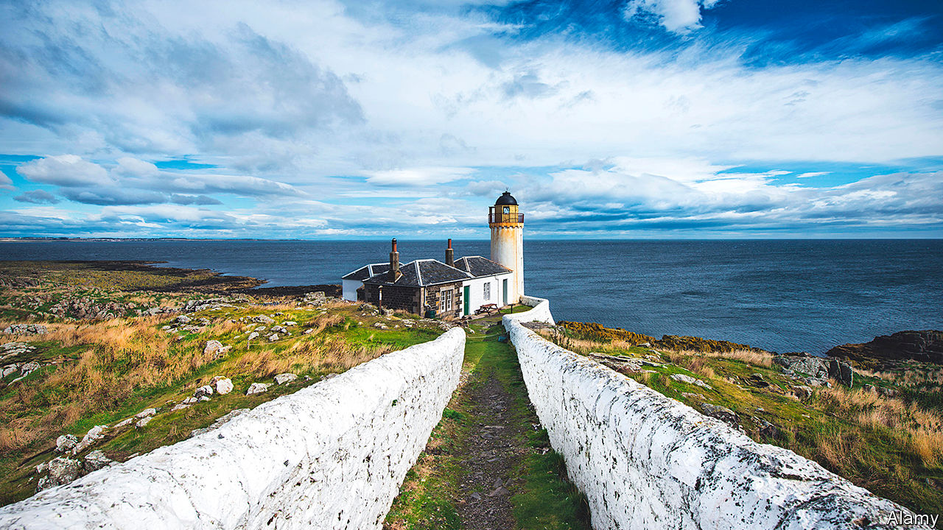

Island Dreams: Mapping an Obsession. By Gavin Francis.Canongate; 256 pages; $30 and £20.

AS A CHILD, Gavin Francis yearned for islands. On caravan holidays to the coast of Fife in Scotland, he was kept awake by the strobe of the lighthouse on the Isle of May (pictured). He pored over sketches of the island’s wildlife, picturing the far-flung journeys of its migrant birds. In its promise of isolation and self-fulfilment, the isle stood for the strange land of adulthood itself.

Islands are inseparable from stories. From Odysseus’s Ithaca to Prospero’s place of exile, they are way-stations for the imagination. They represent fantasies of wealth and are sites of political refuge or experiment. They have also been used to banish and maroon the ill, unwanted or unlucky. Many island communities are scarred by colonisation. Above all, Mr Francis notes, islands summon visions of separation and stillness, evoking “a sense of reverence, and an absence of distraction”. They offer a chance to breathe, and to think.

Mr Francis is a doctor as well as a writer, and for him the quiet simplicity of island living is a counterbalance to “the torrent of life through the clinic”. His meditative book tries to unpick this allure, combining as it does isolation, independence and flight.

Do not expect a straight cultural history. “Island Dreams” is stranger and richer than that. Composed of koan-like snatches of prose, it wanders between memoir and literature, steered by Mr Francis’s adventurous past and eclectic reading. It is illustrated with a gorgeous array of maps, pictures and diagrams. As with other experimental works of non-fiction such as Edmund de Waal’s “The White Road” or Maggie Nelson’s “The Argonauts”, the reader’s eye navigates the page as the text traverses the seas. At its best, Mr Francis’s writing is a catechism of desire for remote spots. Like his beloved island maps, it leaves “room for the imagination, and for dreams”.

Occasionally too much room: longer sojourns in places he has visited would sometimes have been welcome. They stretch from the South Sandwich Islands off the Antarctic coast to Moffen Island in the Svalbard archipelago, “a flat disc of shingle, the last spot before the North Pole”. His literary references range from the plight of Alexander Selkirk, the real-life inspiration for “Robinson Crusoe”, to the psychoanalyst Donald Winnicott’s theory of isolation versus insulation in childhood development. Winnicott’s notion that “the preservation of personal isolation is part of the search for identity” informs Mr Francis’s sense of the role of islands in his own life.

But his book is too subtle to baldly equate isolation and self-knowledge. Mr Francis eventually fulfilled his dream of living on the Isle of May, taking a job as a nature warden. “A condition of tolerating island life”, he realised there, “might well be the capacity to escape it.”

This article was downloaded by calibre from <https://www.economist.com/books-and-arts/2020/10/03/the-magical-allure-of-islands>

|  |  |  |  |
| --- | --- | --- | --- |
| Previous | Articles | Sections | Next |

|  |  |  |  |
| --- | --- | --- | --- |
| Previous | Articles | Sections | Next |

#### I don’t belong here

# The author of “Convenience Store Woman” returns

In “Earthlings”, Sayaka Murata again brings outsiders in Japan to life

Oct 3rd 2020 |

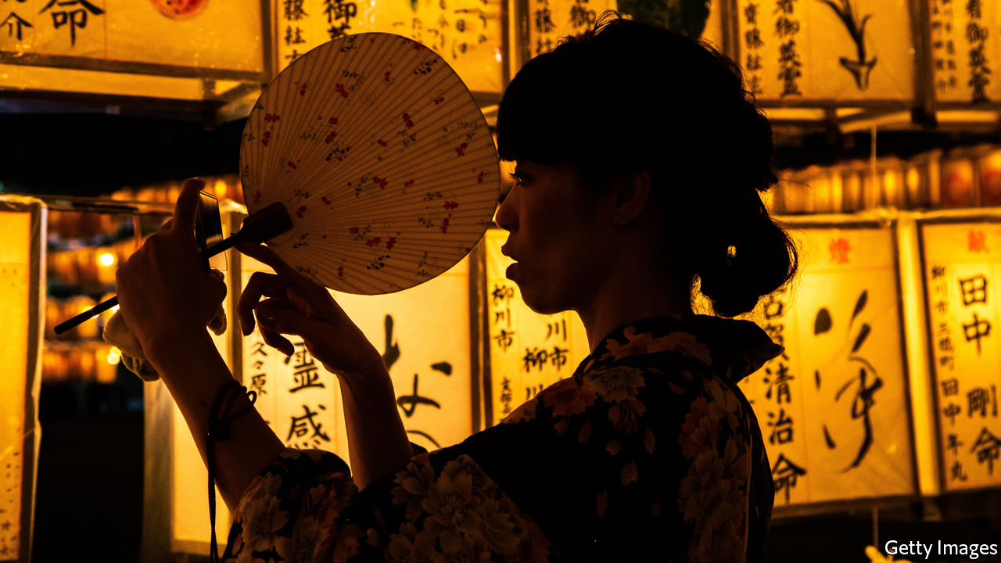

Earthlings. By Sayaka Murata. Translated by Ginny Tapley Takemori. Grove Press; 240 pages; $25. Granta; £12.99.

TWO YEARS ago Sayaka Murata won international acclaim after the English-language publication of “Convenience Store Woman”, in which a shopworker struggles to escape society’s pressures. For 18 years before Ms Murata wrote that book, she had herself worked part-time in a convenience store in Tokyo. “Earthlings”, her second novel to be translated into English by Ginny Tapley Takemori, is another offbeat tale about outsiders in Japan. This time, however, her characters are not only low-status; they are completely ostracised.

When the story begins, the narrator, Natsuki, is 11, and bullied by her mother and sister. “This child is so stupid and slow,” her mother tells a neighbour. “What a disgrace.” Natsuki replies: “Yes, it’s true.” A teacher sexually abuses her. She learns to detach herself from reality for protection, conversing with a toy hedgehog called Piyyut, who Natsuki thinks gives her “magical powers” to fend off violence. She is close only to her cousin Yuu, who is also mistreated by his mother and believes he is an extraterrestrial. In the mountains of Akishina, where each year the family gathers for the Obon festival, Natsuki and Yuu search for a spaceship, hoping it will fly them to a planet where they belong.

Natsuki’s experiences come to mirror the life-cycle of the silkworms kept in a special room at her grandparents’ house. As a child, she focuses on surviving (she and Yuu vow to “survive, whatever it takes”). As a young adult, she goes into a kind of cocoon, dodging expectations by marrying an asexual man. Eventually, in the most disturbing scenes of this uncomfortable yet unforgettable book, she attempts to escape the existence of a “brainwashed” earthling altogether, and live as an alien instead.

Throughout the story, her feelings of being an outsider are manifest in the world around her. From her perspective, shadows in forests and in the dark at bedtime are “tinged with the colour of outer space”. As Natsuki becomes more and more marginalised, the Japanese landscape grows increasingly otherworldly.

This is a novel about trauma—the trauma of bullying, childhood sexual abuse and of being blamed for that abuse. Ms Murata admonishes Japan for its conformism, as well as for the pressure put on women and couples to have children, and the way victims of sexual violence can be regarded with suspicion (both problems in other countries, too). In her unique, deadpan style, she shows how the treatment of people on society’s fringes can itself be a form of violence, irreparably damaging their connection to the world. ■

This article was downloaded by calibre from <https://www.economist.com/books-and-arts/2020/10/03/the-author-of-convenience-store-woman-returns>

|  |  |  |  |
| --- | --- | --- | --- |
| Previous | Articles | Sections | Next |

|  |  |  |  |
| --- | --- | --- | --- |
| Previous | Articles | Sections | Next |

#### Johnson

# The battle against racist language is too important to trivialise

The right and wrong targets in a linguistic struggle

Oct 3rd 2020 |

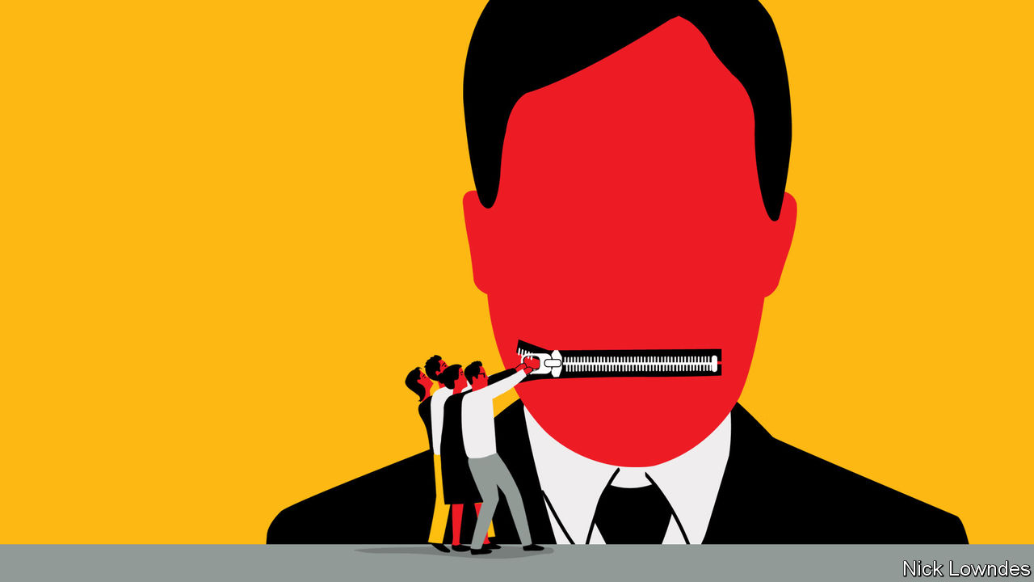

BACK IN 2002 The Economist mused about the rise of Brazil’s left-wing president-elect, Luiz Inácio Lula da Silva. “The meaning of Lula”, ran the cover line, prompting a great deal of mail—much of it from amused South Asian readers who wrote to say that the meaning of “lula” in Urdu is “penis”.

Amused—not outraged. It would have been absurd not to cover a soon-to-be president because his name is naughty in Urdu. Yet another complaint about a verbal coincidence, involving the trace of a graver kind of obscenity, recently had serious consequences at the business school of the University of Southern California (USC). Greg Patton, who teaches communication, was describing how repeating “erm, erm” can undermine a speaker’s effectiveness. He noted that other languages have similar pause-fillers; Chinese people, he mentioned, use the equivalent of “that, that, that”, or in Mandarin, “nei ge, nei ge, nei ge”.

Then came the whirlwind. An anonymous complaint from an unknown number of black students said that their “mental health has been affected”. The dean of the business school removed Mr Patton from the class, excoriating him in a leaked letter: “It is simply unacceptable for faculty to use words in class that can marginalise, hurt and harm the psychological safety of our students.”

Veterans of these brouhahas will recall a case from 1999 in which a Washington official was disciplined for using “niggardly” in a meeting. (The word probably comes from medieval Scandinavia and is unrelated to the racial slur.) Philip Roth turned a true story from 1985 into the crux of his book “The Human Stain” (2000). A professor inquires after two missing students, wondering aloud if they are “spooks”, meaning ghosts. But that term is also an old anti-black insult. The students are black (as, secretly, is he), and the fracas ends his career.

Firestorms like the one at USC are set to become more frequent. America and other countries are wrestling with a history of racism, and language is part of those reckonings. Some renamings and reframings are justifiable, even overdue. Others hit the wrong target, but do little damage. In a few counter-productive cases, aspersions are cast on well-intentioned people.

The problem runs deep. A host of negative words and expressions in English contain the modifier “black”; they are old, and are probably related to a primeval fear of darkness. Nonetheless the constant equation of “black” with danger or evil can weary black human beings: consider black magic, blackguard, black-hearted, black economy and so forth. Some, such as blackmail, are unavoidable fixtures. But not all: the computer types who are replacing “blacklist” (a list of e-mail addresses that cannot reach you) with “blocklist” are making a small but symbolic effort.

The same tech wizards deploying “blocklist” have proposed new terms for “master” and “slave” in computing (whereby one process or device controls another). This seems justifiable, too. The hunt for “masters” has ranged beyond power relationships, however. Harvard has dropped the name “house masters” for faculty members who live in student accommodation and have a pastoral role. Some property salesmen are ditching “master bedroom” in favour of “main bedroom”. These changes may be inessential, but they are harmless.

The harm comes only when sensitivity to offence goes so far that it undermines the assumption of good faith to which people are generally entitled. At a meeting of the Linguistic Society of America in 2018, for instance, Itamar Francez of the University of Chicago spoke on a panel about diversity in the discipline. He decried “formalchismo”: older scholars’ dismissal of new perspectives for being expressed without traditional formality. Many in the audience liked his coinage, but Mr Francez soon found himself retracting it: a listener had complained that it “creates a hostile environment in linguistics for Spanish speakers”. More and more academics say they are afraid to discuss controversial issues; that becomes harder still when even those trying to confront racism are vulnerable to a “call-out” over a triviality.

The losers could be those who need frank discussion most: minority students who should be able to decry the real harms they face, in forms large and small. One student at USC wrote on Instagram that the “nei ge” flap “is going to be used to gaslight us when we try to voice our actual grievances”. An ever-growing list of things you cannot say helps no one. Progress requires more open conversation, not less.

This article was downloaded by calibre from <https://www.economist.com/books-and-arts/2020/10/03/the-battle-against-racist-language-is-too-important-to-trivialise>

|  |  |  |  |
| --- | --- | --- | --- |
| Previous | Articles | Sections | Next |

|  |  |  |
| --- | --- | --- |
| Books & arts | Sections | Graphic detail |

Economic & financial indicators

Economic data, commodities and markets

.

|  |  |  |
| --- | --- | --- |
| Books & arts | Sections | Graphic detail |

|  |  |  |  |
| --- | --- | --- | --- |
|  | Articles | Sections | Next |

# Economic data, commodities and markets

Oct 3rd 2020 |

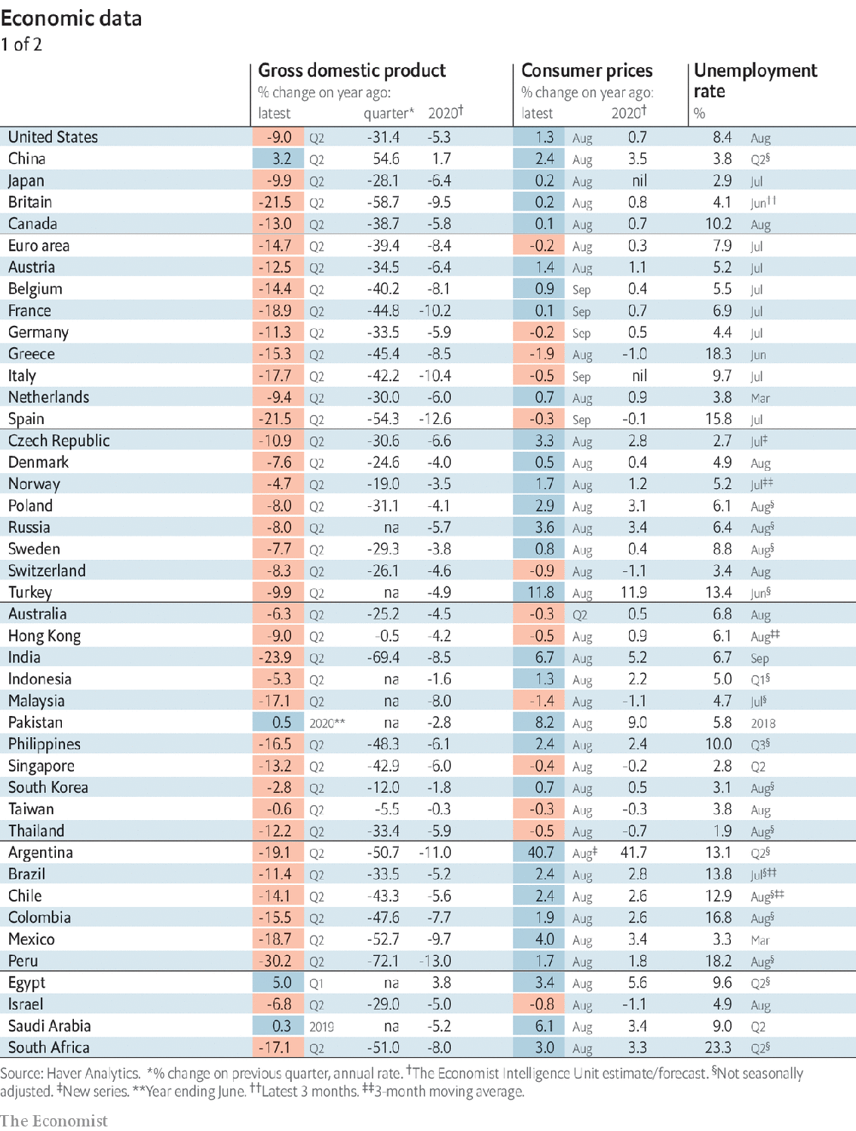

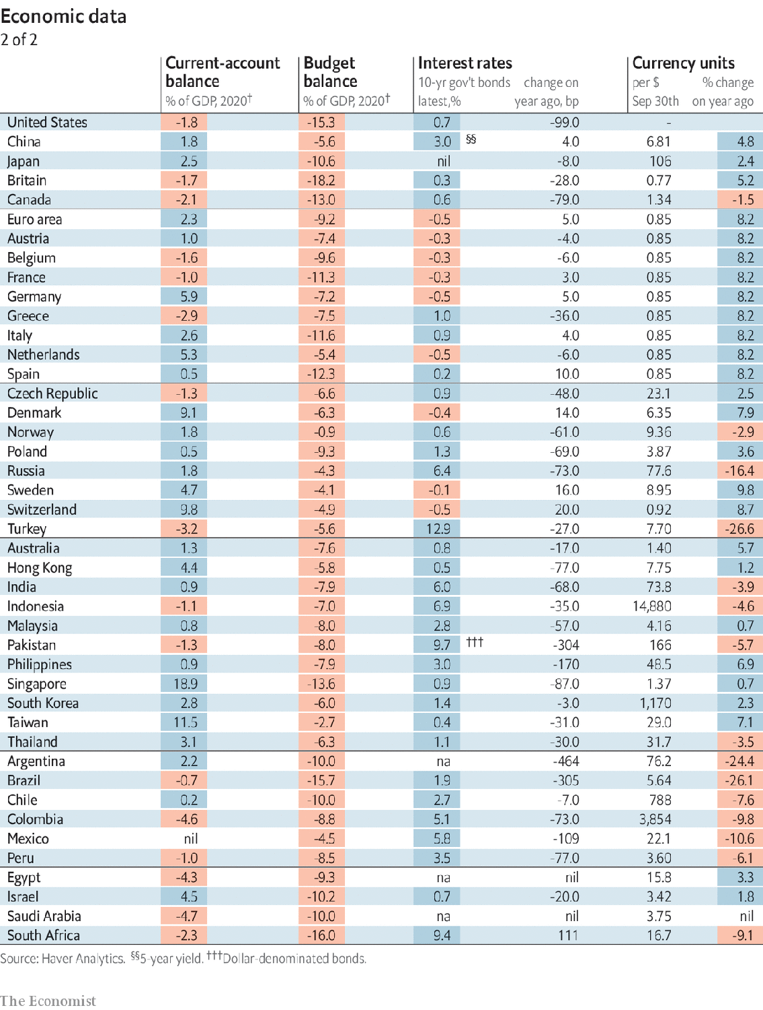

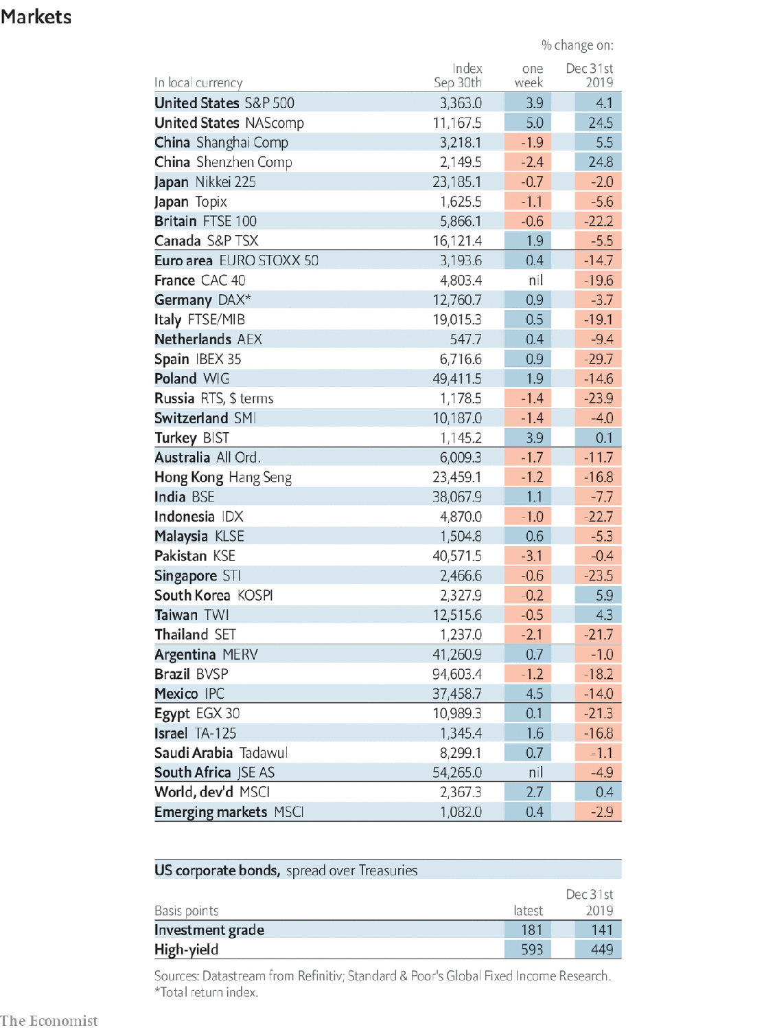

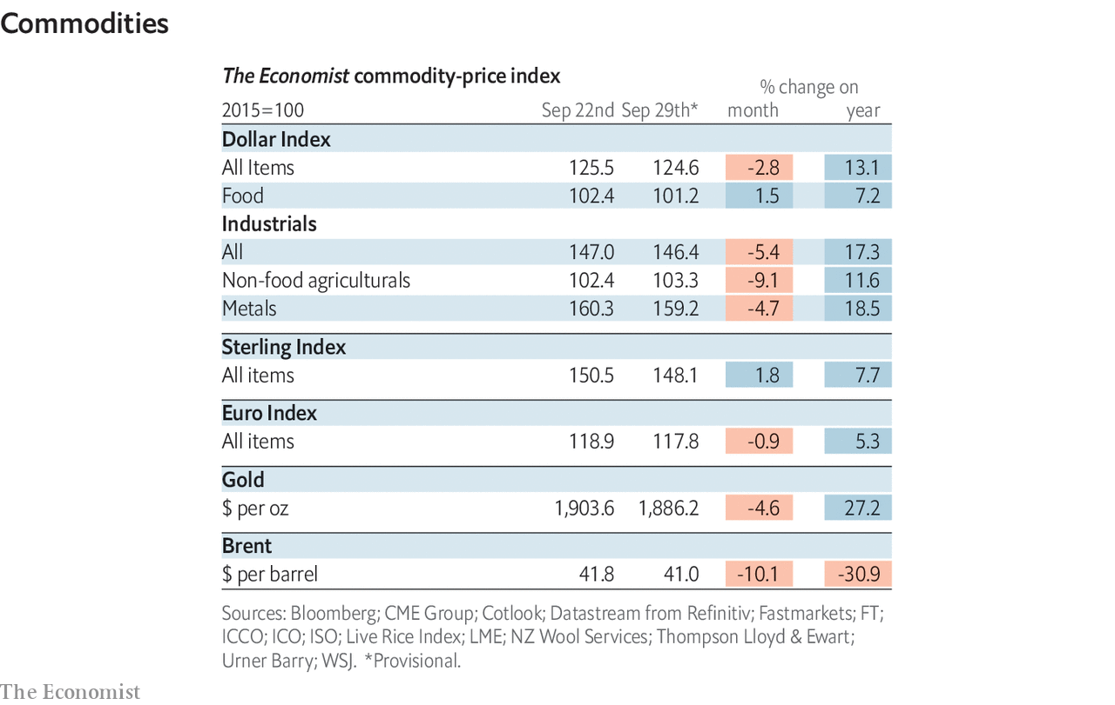

This article was downloaded by calibre from <https://www.economist.com/economic-and-financial-indicators/2020/10/03/economic-data-commodities-and-markets>

|  |  |  |  |
| --- | --- | --- | --- |
|  | Articles | Sections | Next |

|  |  |  |
| --- | --- | --- |
| Economic & ... | Sections | Obituary |

Graphic detail

Wealth and schooling: A rising tide

.

|  |  |  |
| --- | --- | --- |
| Economic & ... | Sections | Obituary |

|  |  |  |  |
| --- | --- | --- | --- |
|  | Articles | Sections | Next |

#### A rising tide

# It’s better to be a poor pupil in a rich country than the reverse

Country and family income are equally important for predicting students’ test scores

Oct 3rd 2020 |

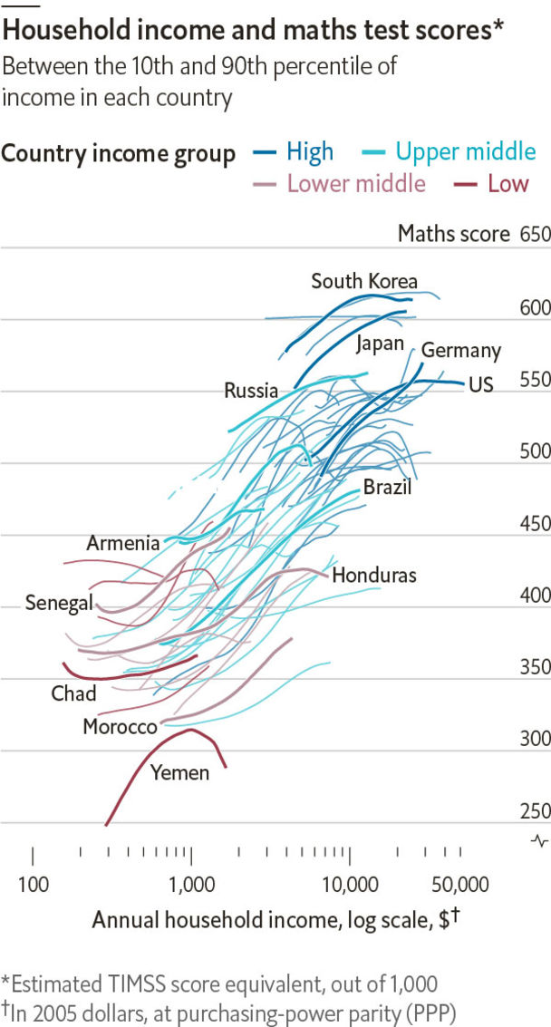

THERE ARE some things money can’t buy. Education, however, does not appear to be among them—at least as measured by performance on international exams. On average, pupils in wealthy countries obtain vastly higher test scores than those in developing ones. In turn, strong students tend to become productive workers, making the mostly rich economies they join richer still.

The exact mechanism by which knowledge is bought remains unclear. Do students in the rich world fare better because their governments provide superior schools? Or is the reason that they tend to have richer parents, and enjoy more educational resources at home? A new working paper by Dev Patel of Harvard University and Justin Sandefur of the Centre for Global Development, a think-tank, offers strong evidence that the wealth of a country affects exam results just as much as the wealth of a pupil’s household does.

Evaluating test scores around the world is harder than it sounds. Although pupils in the rich world mostly take one of a few big international exams, many developing countries rely on regional tests. This precludes apples-to-apples comparisons.

The authors surmounted this obstacle by fielding an exam in 2016 for 2,314 children in Bihar, in northern India. It included both questions from the leading tests and ones taken from smaller exams. Using answers from the same pupils on the same day to questions from different tests, they built a statistical model they called a “Rosetta Stone”. It can translate scores from a range of exams—such as one used solely in west Africa—into an equivalent mark on other common international tests.

Messrs Patel and Sandefur then used these equations to estimate how pupils in 80 different countries would fare on the benchmark Trends in International Mathematics and Science Study (TIMSS). Their data show that the wealth of a student’s country and family have similar impacts on test scores—meaning that big gaps in GDP per person matter more than small ones in household income do. For example, pupils from families that are very poor by rich-world standards—those earning $5,000 a year (measured in 2005 dollars)—were expected to score around 500 out of 1,000 on the TIMSS in America, and 560 in Japan. In contrast, those whose parents make $10,000 a year in an upper-middle-income country, such as Costa Rica, still manage only the equivalent of a 475.

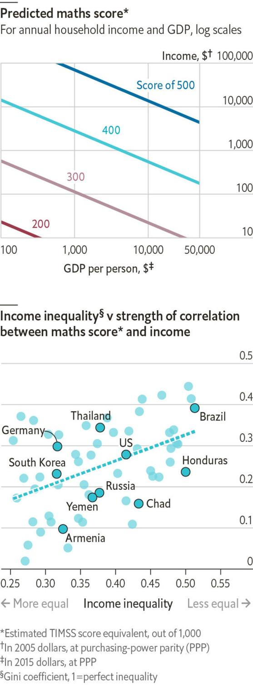

The study also found that the influence of parental earnings is not constant. Instead, an extra $1,000 in family income “buys” a larger increase in test scores in highly unequal countries than it does in ones that split their economic pie more evenly. One possible reason is that elites tend to educate their children privately in places where wealth is concentrated, such as Brazil. In contrast, in countries with relatively flat income distributions, like Croatia or Armenia, pupils from different social classes are more likely to attend the same schools. This could reduce the impact of family wealth on test scores. ■

Sources: “A Rosetta Stone for Human Capital”, by D. Patel and J. Sandefur; World Bank; The Economist

This article was downloaded by calibre from <https://www.economist.com/graphic-detail/2020/10/03/its-better-to-be-a-poor-pupil-in-a-rich-country-than-the-reverse>

|  |  |  |  |
| --- | --- | --- | --- |
|  | Articles | Sections | Next |

|  |  |  |
| --- | --- | --- |
| Graphic detail | Sections |  |

Obituary

Harold Evans: Attacking the devil

.

|  |  |  |
| --- | --- | --- |
| Graphic detail | Sections |  |

|  |  |  |  |
| --- | --- | --- | --- |
|  | Articles | Sections | Next |

#### Attacking the devil

# Harold Evans died on September 23rd

The legendary editor of the Sunday Times and president of Random House, was 92

Oct 3rd 2020 |

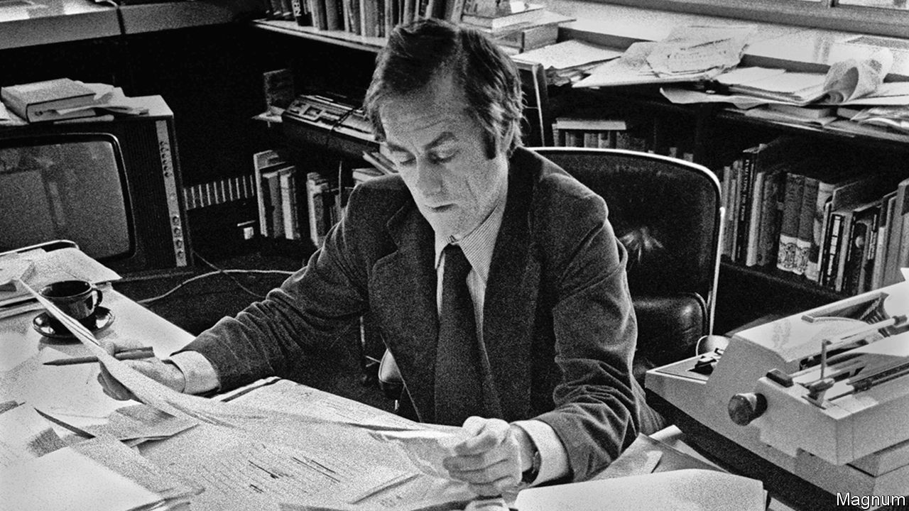

ON THAT DAY in 1981 when he first sat at the pinnacle of British journalism, the editor’s desk at the Times, and wrote his first policy editorial, Harold Evans heard Abraham Lincoln’s voice in his ear. In 1861 the president had said he knew of nothing more powerful than the Times, “except perhaps the Mississippi”.

Now the legendary paper was his to do what he liked with. He could remake it, relaunch it, liven it up, pouring all his wiry energy into it. No one was better suited or better placed. Over a 14-year stint at the Sunday Times he had turned a staid, class-bound broadsheet into a compelling, dramatic newspaper with—a first for Britain—a glossy colour magazine. He had also run bold, eye-catching, risky campaigns. The paper had unmasked Kim Philby as a Soviet spy, braving the fury of the intelligence services. After Bloody Sunday in Derry in 1972 he had sent his own team to Northern Ireland to uncover abuses by British soldiers, second-guessing the government inquiry. He challenged the oil companies that illegally supplied the apartheid regime in Rhodesia, and in 1975 published the diaries of Richard Crossman, a former Labour minister, in defiance of the Official Secrets Act. Most famously, he fought for eight years for proper compensation for children crippled in utero by the drug thalidomide—thereby exposing a heartbreaking scandal and making the manufacturers, Distillers, face justice.

Other editors hesitated to run these stories. He never did, whatever headaches they gave the lawyers. If the legal route was barred by injunctions or contempt of court, he made his cause a moral one. He ran the story over several pages under a banner headline, and week by week found a new human angle to keep it going. It became unignorable that way, and grew into a problem that had to be resolved. He would not stop until it was. Beside the text he ran photographs that were equally powerful, daring the reader to look away: Don McCullin’s unsparing portraits from war zones, or the dangling body-harness of a thalidomide child. He spent hours at the back bench, poring over pictures and layout to get that vital impact. Many thought him the most powerful editor in Britain well before the Times.

It was a pretty good outcome for a northern working-class boy, the product of a state school, who had felt ashamed for years of not speaking like the BBC. He was proud of his career as an editor, just as he was proud of his father’s rise from stoker to full-time train driver, and of the shop his mother ran from the front room. His parents had taught him to make the most of himself, so he had. Though he kept a certain working-class deference and friendliness, did not shout, was “Harry” to everyone and would quite kindly tell reporters their copy was hopeless, he had taken on almost every part of the establishment and made it quake.

But a year to the day after going to the Times his power was dust, when Rupert Murdoch fired him. Mr Murdoch had bought both the Times and the Sunday Times and had given him the Times job, but presumably the Evans style was too anti-Thatcher. At first he had liked Mr Murdoch’s Australian brashness, perhaps the best way to deal with the Luddite print unions who had kept both titles off the news-stands for a year. But he soon learned that the bonhomie could turn to malice in a minute. First the two great papers lost their independence; then the stiletto slid between his ribs.

People looked pityingly on him now. That was unbearable, so he left for the United States and a teaching job. His second wife, Tina Brown, soon joined him as editor of Vanity Fair, and he too took up the pen again, editing US News & World Report and founding Condé Nast Traveller before becoming, in 1990, president of Random House. There the copy on his desk was by Gore Vidal and Norman Mailer, William Styron and Richard Nixon, as well as the businessmen, artists and poets he added to the list. The glittering Manhattan literary scene revolved around their garden brownstone, enjoyably so. America performed its reinventing magic, and in 1993 he became a citizen. Yet the country’s deepest effect on him had happened years before, when he visited on a Harkness fellowship in 1956. He was already in love with newspapers; with the smell of printer’s ink, and with Hollywood’s depiction of brave small-town newspapermen standing up to crooks. Papers in America might be slackly edited and poorly designed, but they showed a crusading desire for openness that was still rare in Britain.

This was the way he meant to go. At the age of 12 he had found out that papers lied: that the haggard, dejected soldiers he saw lying on Rhyl beach in Wales, back from Dunkirk, were far from the gung-ho, battle-ready troops portrayed in the Daily Mirror. As a young reporter, he was urged to seek the truth directly: not just to retail the lazy he-said-she-said, but to find out who was actually right. From his first days as an editor, at the Northern Echo in Darlington, he put the paper on the map with dogged campaigns. One, on inadequate detection of cervical cancer, led to national screening; another, to get a pardon for a man who had been wrongly hanged, helped end the death penalty for murder. At the Sunday Times he deployed a whole force, the Insight team, to disinter the multiple aspects of a story. His motto was, “Keep digging”.

Truth also lay in photographs—often rawly so. But it depended on words. He wrote several books attacking the obfuscation or downright deception that lay like a fog over political discourse, government reports, court decisions, the internet, and over the everyday documents by which people were duped. Truth lived in clarity: a lesson he had first learned as he strived to fit his words into the iron chase of the page-planner, and went on applying as he marked up copy, day by day, excising the unnecessary.

A newspaper editor’s job was like a searchlight. In the digital age that power had dimmed; Lincoln’s words had a poignant ring now, generally as well as personally. But he hoped he had still shed a little light into deliberately darkened places. And the remark of his great hero W.T. Stead, a campaigning Victorian editor of the Echo, seemed as valid as ever. Running a newspaper gave him “a glorious opportunity of attacking the devil”. ■

This article was downloaded by calibre from <https://www.economist.com/obituary/2020/10/03/harold-evans-died-on-september-23rd>

|  |  |  |  |
| --- | --- | --- | --- |
|  | Articles | Sections | Next |